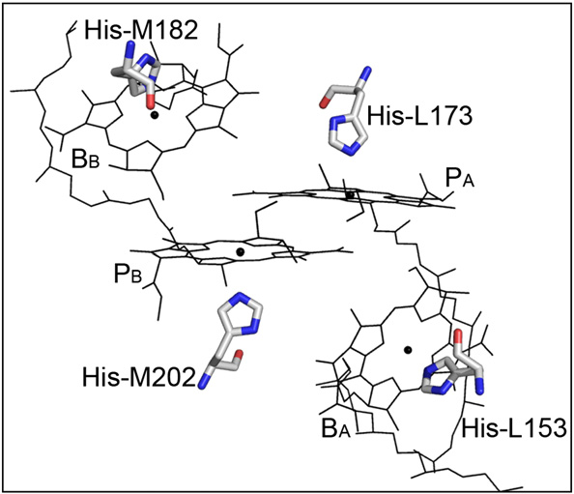

BCL 283 HIS L153 patch HETA 283 PROA 153 noangle nodihedral

BCL 310 HIS M202 patch HETE 310 PROB 202 noangle nodihedral

BCL 282 HIS L173 patch HETA 282 PROA 173 noangle nodihedral

BCL 309 HIS M182 patch HETE 309 PROB 182 noangle nodihedral

FE HIS L190

HIS L230

HIS M219

HIS M266

Glu M234

patch HETD 308 PROA 190 PROA 230 PROB 219 PROB 266 PROB 234 noangle nodihedral

ATOM 13040 MG_1 BCL 283 7.060 15.185 7.755 1.00 0.00 HETA

ATOM 2383 N HSD 153 7.855 17.880 14.745 1.00 0.00 PROA

ATOM 13717 MG_1 BCL 310 9.301 2.835 10.619 1.00 0.00 HETE

ATOM 7575 N HSD 202 16.204 5.583 8.752 1.00 0.00 PROB

ATOM 12900 MG_1 BCL 282 1.982 5.710 11.304 1.00 0.00 HETA

ATOM 2690 N HSD 173 -4.986 2.599 9.418 1.00 0.00 PROA

ATOM 13577 MG_1 BCL 309 4.885 -6.387 7.938 1.00 0.00 HETE

ATOM 7249 N HSD 182 4.180 -9.432 14.719 1.00 0.00 PROB

ATOM 13576 FE FE2 308 5.459 4.552 -17.137 1.00 0.00 HETD

ATOM 2958 N HSD 190 7.220 -1.389 -12.114 1.00 0.00 PROA

ATOM 3560 N HSD 230 -0.371 2.351 -14.839 1.00 0.00 PROA

ATOM 7831 N HSD 219 3.574 10.180 -11.923 1.00 0.00 PROB

ATOM 8547 N HSD 266 11.362 6.420 -15.743 1.00 0.00 PROB

ATOM 8051 N GLU 234 4.758 3.847 -23.784 1.00 0.00 PROB