Imagine you have to build a data center and also optimize the costs. Imagine there are 5 hubs which will access this datacenter. Each hub is situated as follows, along a straight path:

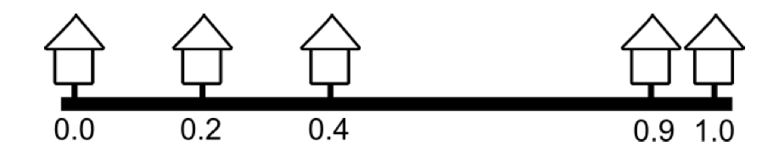

The first house is built at marking 0, the second – at marking 0.2, the third – 0.4, fourth – 0.9 and fifth – 1.0.

The price of each cable piece is somehow dependent on the distance between the house and the centre.

Cost= ${\left(w-0\right)}^{2}+{\left(w-0.2\right)}^{2}+{\left(w-0.4\right)}^{2}+{\left(w-0.9\right)}^{2}+{\left(w-1\right)}^{2}$, here w is the position of data centre on the road and can be any number between 0 to 1.

You need to find out the value of w at which the cost will be least. Use gradient descent to solve for this.