**REPORT – CSD_2103**

Group – PB_SOFTWARE_DEVELOPERS

Group Members:-

* Sukhdev Singh (895314)
* Gunraj Singh (893229)
* Deepankshudeep Singh (8932965)
* Maneet Pal Singh (893295)

**CSS styles that we have made and how they are applied to our pages:-**

* Fonts:

Play fair Display, Roboto Condensed, and Roboto Slab fonts are imported and applied to different elements using font-family.

* Body and Select Styling:

The box-sizing property is set to border-box for all elements and Custom styling for select, input, and text area elements

* Header Styling:

Styles for the header, top bar, navigation, and social icons. Moreover Responsive adjustments using media queries for smaller screens.

* Footer Styling:

Styling for the footer, including colour, padding, and section layouts.

Responsive adjustments for smaller screens.

* Button Styling:

Styling for buttons, including a custom gradient on hover.

* Shop Item Grid:

Styling for a shop item grid, incorporating responsive adjustments.

* Testimonials:

Styles for testimonial cards.

* Checkout Form Styling:

Styles for a checkout form, with specific attention to input fields and responsiveness.

* About Us Page Styles:

Social links are styled as circles with a border, and they change background colour and text colour on hover or focus.

The background colour of the container with the class .about container is set to 'whitesmoke'.

Icons inside the .about container are forced to have black colour.

* Contact Us Page Styles:

Styles for section titles (.sec-title) with a horizontal line before them.

The colour, font size, and styling for various elements in the contact page section, including form elements.

The form has a dark background, and input fields have a black border. There are styles for focus states, error states, and form labels.

Social icons in the contact page have a white colour.

Styling for the slider controls and form container for the sign-up and login page.

* Sign Up and Login Page Styles:

The wrapper has a fixed width, background colour, and padding.

The title text is divided into two parts, and there's a transition effect on it.

Slide controls, including labels and the sliding tab.

Form input fields with placeholder and focus styles.

Styling for the submit button, including a gradient effect on hover.

Various utility styles for elements such as links, images, and containers.

These styles are applied to the web pages by including the corresponding CSS file in the HTML documents. The CSS rules define the visual presentation of HTML elements, contributing to the overall look and feel of the website. The use of media queries ensures that the styles are adapted appropriately for different devices and screen sizes.

**The challenges you had for this project and your solution:-**

One potential challenge in the project was achieving a responsive design to ensure optimal user experience across various devices. With users accessing websites from different screen sizes, resolutions, and orientations, ensuring that our website looks and functions well on desktops, tablets, and mobile phones is crucial. Implementing media queries in CSS was a solution, allowing us to define different styles for different devices and screen sizes.

Another challenge was managing the complexity of the JavaScript code, especially if our website includes interactive elements such as dynamic product listings, image sliders, or a shopping cart. Organizing our JavaScript code into modular functions and using proper naming conventions enhanced readability and maintainability. Additionally, leveraging JavaScript frameworks or libraries provided a structured approach to handling complex interactions.

Another challenge was ensuring fast-loading times for better user experience. In order to resolve this issue we Optimized images, minify and bundle CSS and JavaScript files, utilize caching strategies, and employ lazy loading for non-essential content.

Apart from that Ensuring that our codebase is maintainable in the long term was a challenge too so we Adopted a consistent coding style, document your code, and organize files and folders logically. Consider using version control systems like git

**Website map:**

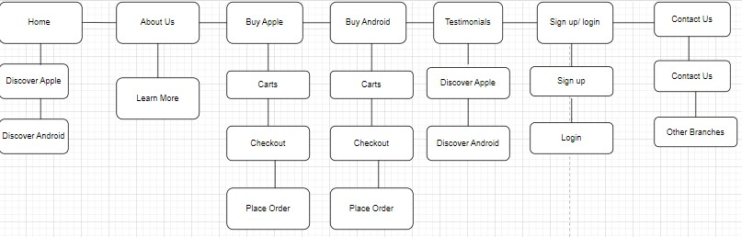

|  |  |  |  |  |
| --- | --- | --- | --- | --- |
| Feature | Code line # | Browser/Platform 1 compatibility comments  chrome | Browser/Platform 2 compatibility comments  mozilla | Browser/Platform 3 compatibility comments  safari |
| Feature 1 | Index.html line – 42  hamburger for mobile view | working | working | working |
| Feature 2 | Index.html  Line – 42  Website logo and menu content center | working | working | working |
| Feature 3 | Index.html  Line – 131  Shop items will show one item per row | working | working | working |
| Feature 4 | Index.html  Line – 292  Footer alignment changed | Working | working | working |
| Feature 5 | Contact_us.html  Line – 135  Telephone feature added | Working | Working | Working |
| Feature 6 | Contact_us.html  Line – 154  Section hidden | Working | Working | Working |
| Feature 7 | Cart.html  Line – 96  Respnosive cart table | Working | Working | Working |
| Feature 8 | Testimonial.html  Line – 101  Testimonial card layout changed | Working | Working | Working |
| Feature 9 | Sign_Login.html  Line – 129  Form will scroll to top if error | Working | Working | Working |
| Feature 10 | Buy_apple.html  Line – 114  Only one line of text will be shown on mobile view | working | working | working |

Thank you