**Wireframe Documentation**  
 **AQI Prediction System**

|  |  |
| --- | --- |
| **Written by** | **Gunaseelan V** |
| **Documented Version** | **1.0** |
| **Last Revised Date** | **18 December 2024** |

### ****Overview****:

The interface consists of two primary sections:

1. **Input Section** – Users provide data through input fields for pollutants like Ozone (O3), Nitrogen Dioxide (NO), PM10, and Carbon Monoxide (CO).
2. **Visualization and Output Section** – Displays the predicted AQI value along with two visualizations:
   1. **Pollutant Levels vs AQI**
   2. **Pollutant Contribution vs AQI Value**

### ****1. Input Section****:

#### ****Position****:

* The input fields (e.g., Ozone (O3) AQI, NO AQI, PM10 AQI, CO AQI) are placed at the **top of the screen** in a **vertical column layout**.
* These fields are grouped together for ease of use and to encourage users to input their data in a structured manner.

#### ****Behavior****:

* **Interactive Fields**:
  + The **Ozone (O3) AQI**, **NO AQI**, **PM10 AQI**, and **CO AQI** are **numeric input fields** with range sliders to adjust the pollutant levels.
  + The **“Predict”** button activates the AQI prediction process once clicked.

#### ****Purpose****:

* The input section allows users to enter pollutant data, which is used by the system to generate AQI predictions.

#### ****Workflow****:

1. The user inputs data for all pollutants: **Ozone (O3) AQI**, **NO AQI**, **PM10 AQI**, and **CO AQI**.
2. Once all fields are filled, the user clicks the **“Predict”** button.
3. The system processes the input data through the AQI prediction model and returns the predicted AQI value.
4. The predicted AQI value is displayed in a **dedicated output field** below the input section.

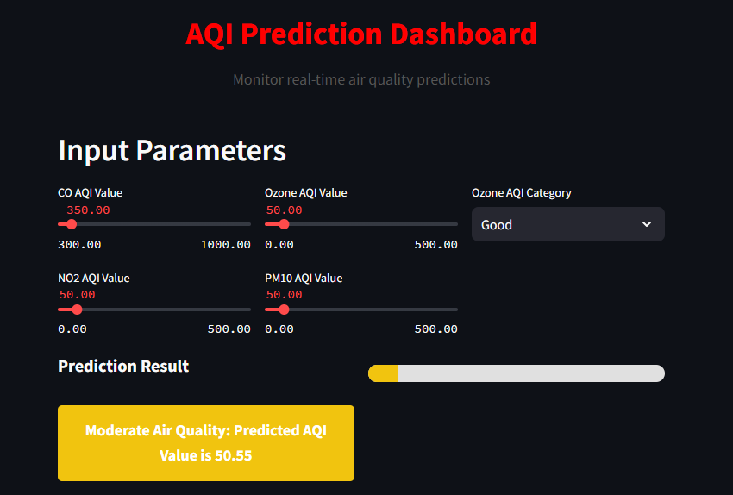

### ****2. Visualization and Output Section****:

* + If the user changes the input values and clicks **“Predict”** again, both visualizations automatically update to reflect the new prediction, providing real-time feedback.

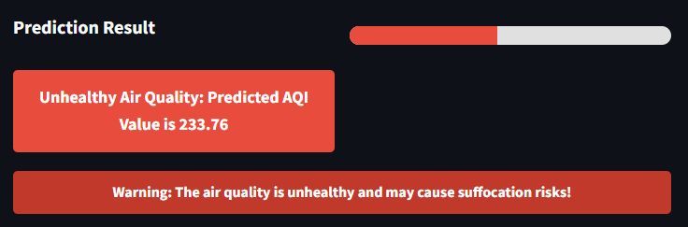

### ****Wireframe Summary****:

#### ****1. Input Section****:

* Positioned at the top of the page for ease of data entry.
* Fields include:
  + **Ozone (O3) AQI**, **NO AQI**, **PM10 AQI**, and **CO AQI**: Numeric input fields with range sliders.
  + **Predict**: Button to trigger AQI prediction.

#### ****2. Visualization and Output Section****:

* Positioned below the input section to keep the UI clean.
* Includes two visualizations:
  + **Pollutant Levels vs AQI**: Graph showing the relationship between pollutant levels and AQI values.
  + **Pollutant Contribution vs AQI Value**: Graph demonstrating the contribution of each pollutant to the AQI value.

**Prediction is Done lively**