https://swing.fit.cvut.cz/projects/stx-libjava

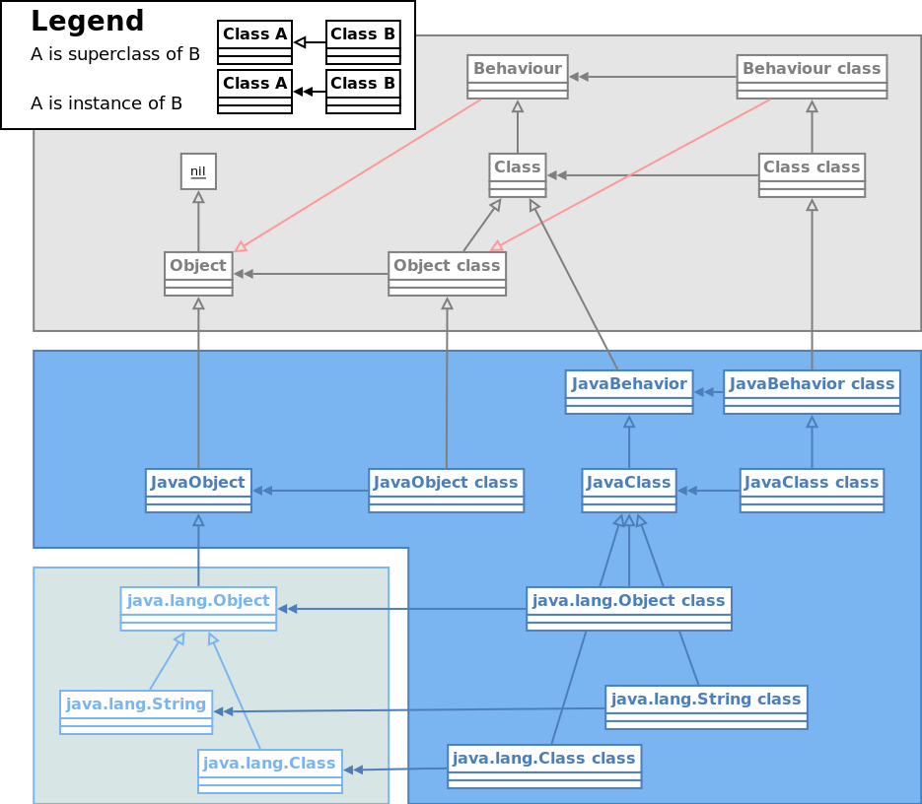
stx:libava is a tiny Java Virtual Machine implementation for Smalltalk/X allowing Java programs to run directly under Smalltalk/X.

Lorem ipsum dolor sit amet, consectetur adipiscing elit. Aenean urna est, commodo quis rhoncus sit amet, sagittis vel diam. Mauris eget dolor et dolor bibendum fermentum nec in nisl.

Bachelor's and Master's Thesis
- Lorem ipsum dolor sit amet, consectetur adipiscing elit.
- Sed bibendum mi ac ligula sodales eu gravida ante pharetra.
- Phasellus malesuada laoreet est, eget accumsan risus malesuada in.
- Donec pretium semper dolor, quis ornare ipsum lacinia eu.
- Nam vitae eros et sem fringilla tincidunt sit amet eget leo.

Contacts
If you are interested in the project, you may contact us
Ing. Jan Kurš
kursjan@fit.cvut.cz
http://webdev.fit.cvut.cz/~kursjan
Ing. Jan Vraný Ph.D.
jan.vrany@fit.cvut.cz
http://users.fit.cvut.cz/~vranyj1

