What the F\*ck is API?

Application Programming Interface

Interface 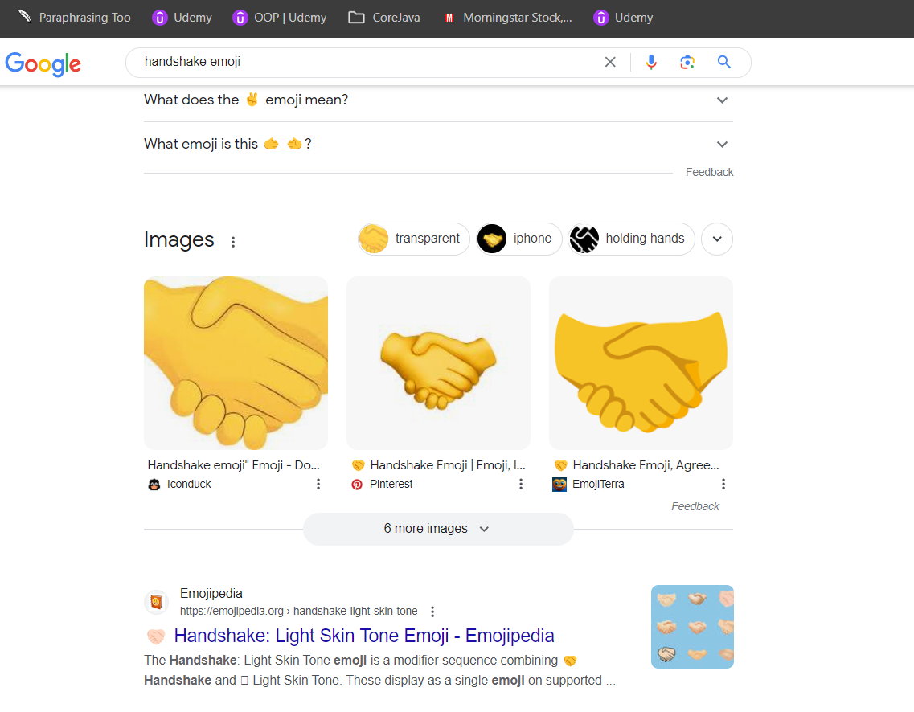 Contract

API means, functionalities provided by companies to fetch the data. e.g. let’s take an example of Instagram, if you open the app now VS if you open the app 2 hours later. will insta-post not be the same right? post will be kept on changing.

Set of methods | URL’s | Endpoints | functionalities provided by the application in order to interact with the data i.e perform operations like.

( CREATE | GET | UPDATE | DELETE ) 🡪 CRUD operations

JSON ( Java Script Object Notation ) : It is most widely used the format of data in which we interact.

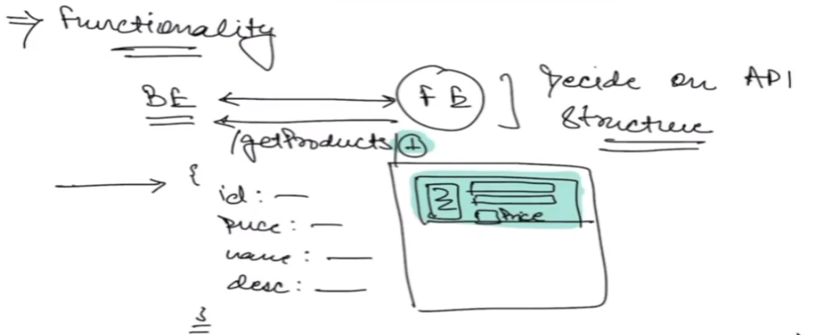

In API’s the Endpoints are important.

