AUTOMATED SOLUTIONS TO REDUCE TEST CYCLE TIMELINES

AUTOMATION TESTING

***Sindhujaa Guntupalli***

Sept 02, 2022

Version 0.1

Table of Contents

1) Using external extensions to plot elements in Angular application. 2

Problem Statement 2

Solution 2

Advantages 2

Installation Process 2

Quick-copy feature 2

View & test your locator with POM Builder tab 2

2) Collapse or Un-Collapsed testcases and functions in the WDIO framework, this saves huge manual effort and provides accuracy. 2

Problem Statement 2

Solution 2

Installation Process 2

Short Cut keys 2

**Summary**:

The document provides two quick solutions to reduce the overall Test set-up timelines and test execution. Below listed are the detailed steps to be followed to set up and implement these solutions. Once implemented these solutions will increase the resource efficiency and lead as best practise across the project.

# Using external extensions to plot elements in Angular application.

## Problem Statement

It is Time Consuming while locating elements manually and leads to rework when elements id is not available

## Solution

Using this **POM Builder-Auto-generate CSS/XPath Locator Extension**

POM Builder is a powerful browser extension that instantly generates robust web element locators (XPath, CSS selector, ID, Name, etc.) for all test automation frameworks.

You can use these locators for all automation frameworks including Selenium, Protractor, Robot Framework, webdriver.io, Test Architect Enterprise and Test Architect Gondola.

## Advantages

1. Measurements were performed on long and complex XPath locators.
2. This tool helps us cut down the locator building time by half using a smart pattern-recognition algorithm.
3. And the best part: it’s free.
4. It’s readable and user-friendly.
5. Flexible to use.

**ReqtID-4247**- FY21 Annual Report update - Part 2 (Review Tool)- Trust- PMR Module.  
For Above Mentioned CR I have taken More than 120 Elements.

|  |  |  |
| --- | --- | --- |
|  |  | **Time Consumption (minutes)** |
| **AS IS** | Manually element locators | 180 |
| **TO BE** | Automated POM Builder | 30 |
|  | **Total Saving/Efficiency** | **150** |

* Currently the task involves manually efforts and consumes more than ~180 minutes to collect the element locators and check if it is working as expected.
* With usage of the POM builder extension, plotting all the Elements is completed in 30 minutes including the Syntax and fetching the elements.
* Overall saving is 150 minutes

## Installation Process

1. Open the extension link on Chrome Web

Store: [**https://chrome.google.com/webstore/detail/pom-builder-auto-generate/akcejfbfkkjnghlfngighgncolfaghco**](https://chrome.google.com/webstore/detail/pom-builder-auto-generate/akcejfbfkkjnghlfngighgncolfaghco)

1. Click “Add to Chrome” button

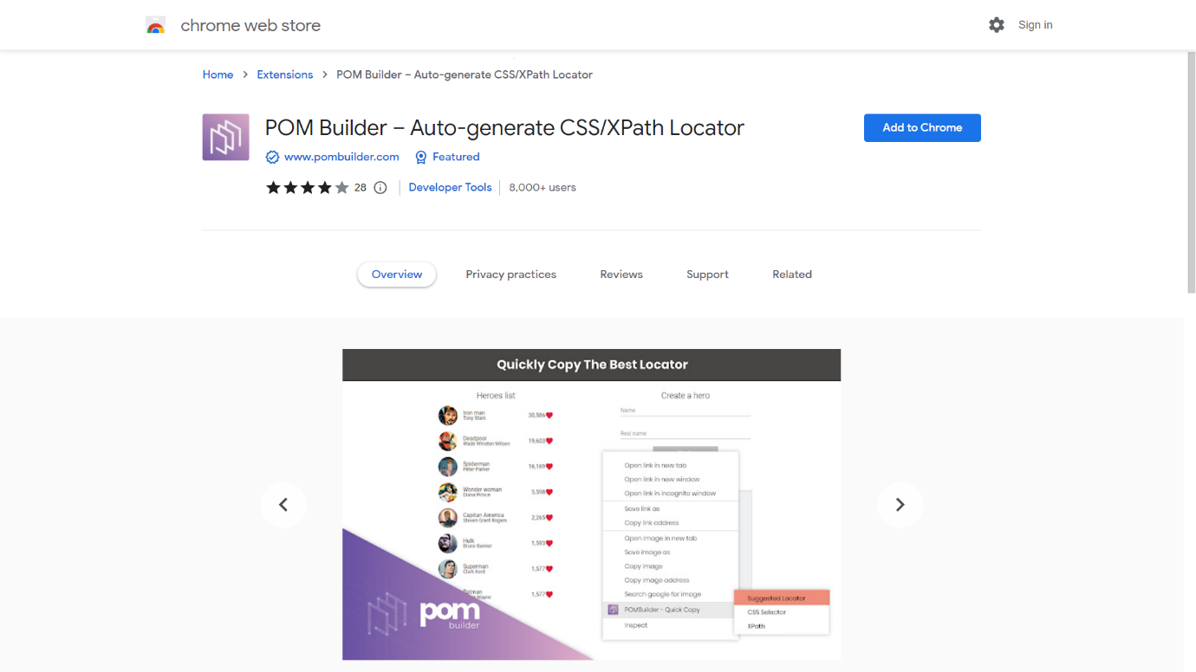

1. Click “Add Extension”

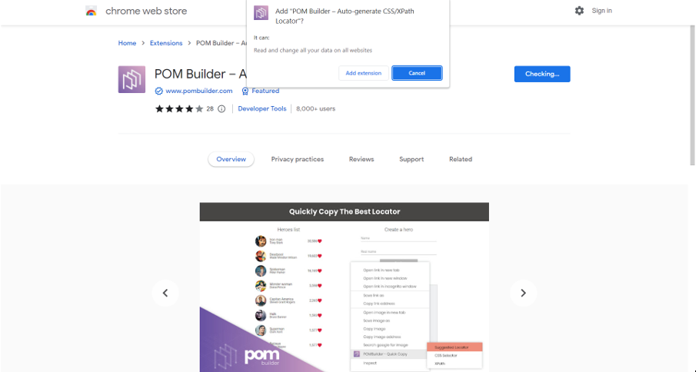

1. POM Builder has been installed into your Chrome browser successfully.

### Quick-copy feature

1. Right-click on an element of your interest on your webpage under test
2. Select “POM Builder — Quick Copy” > <your desired selection>
3. There are 3 available selections:
4. Suggested Locator: the most reliable locator recommended by POM Builder, you should use it for better performance and stability. It could be a single attribute locator, CSS Selector or XPath locator.
5. CSS Selector: the CSS selector that uniquely identifies the selected element
6. XPath: the XPath locator that uniquely identifies the selected element

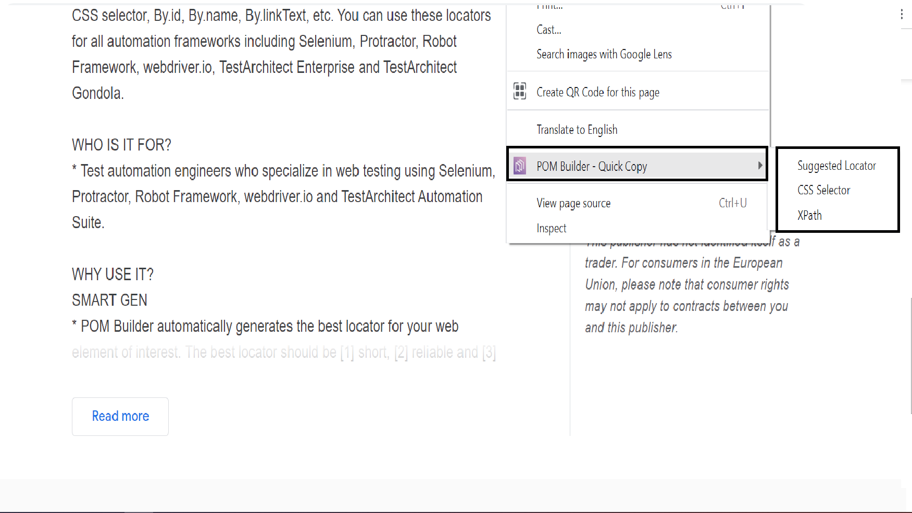

1. After selecting your desired selector, the appropriate locator will be saved to clipboard.
2. Freely paste it anywhere to use the generated value



### View & test your locator with POM Builder tab

1. Right-click on an element on your webpage
2. Select Inspect

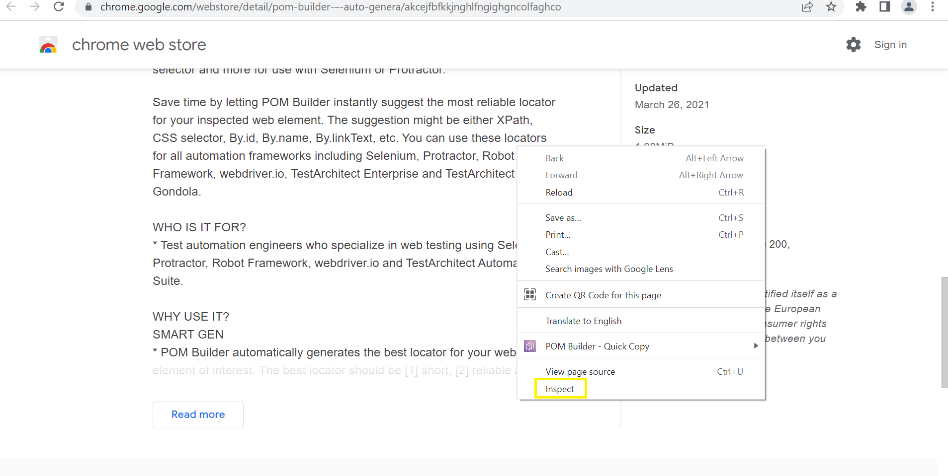

1. On the Elements tab, select the POM Builder sub-tab

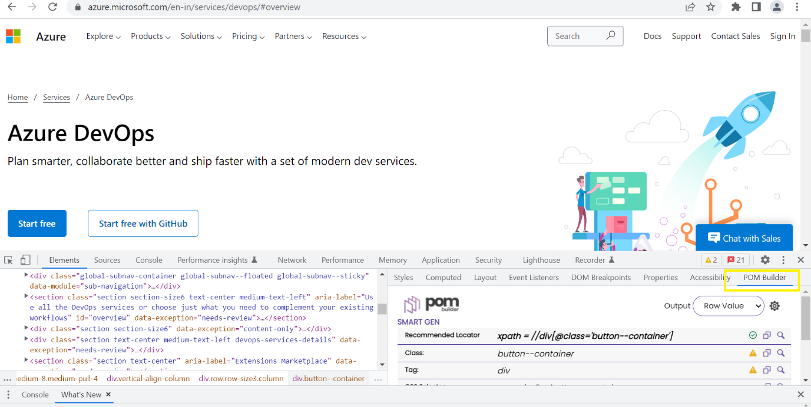

1. You can now view a variety of locators that may uniquely identify the selected element on the POM Builder tab.

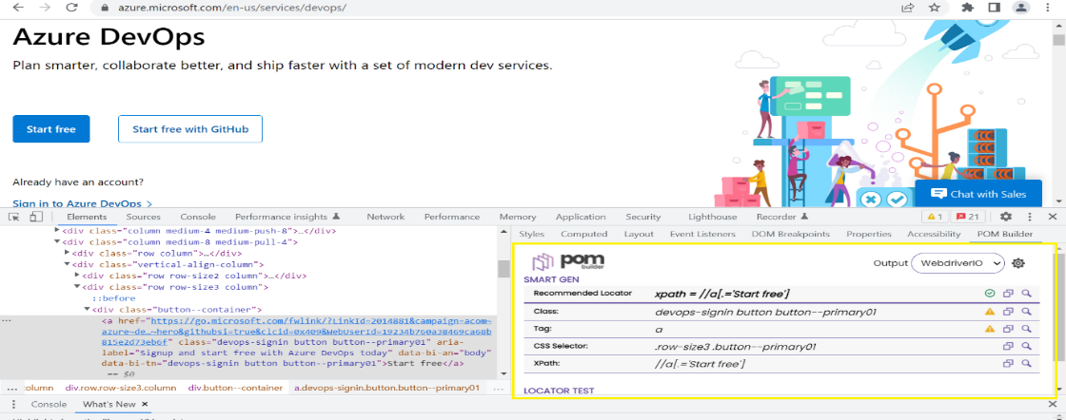

1. You can click on an element directly displayed on the DOM tree or use the inspect function to select another element.
2. The appropriate locator(s) will be generated on the POM Builder tab
3. Click the Copy icon to copy its value

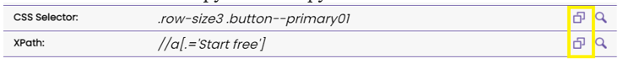

1. Click the Find icon to test it with the Test Locator feature



1. You can define your own locator and test it with Test Locator of POM Builder
2. Select the type of locator (XPath/CSS)
3. Type your locator in the search box then hit Enter. Ideally, you’d expect to see that only ONE element that matches the specified locator is found.
4. POM Builder will show the searching result info,
5. how many matching element(s)
6. matching element(s)

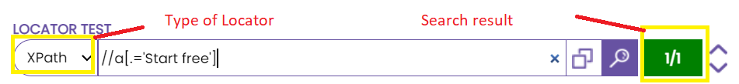

1. You can click on arrow button to change matching element and locate it on the webpage and DOM tree
2. You can edit your locator and start new search.

# Collapse or Un-Collapsed testcases and functions in the WDIO framework, this saves huge manual effort and provides accuracy.

## Problem Statement

**In Some Modules We Have More than 360 Testcases To collapse each testcase individually- It is Time Consuming Process.**

## Solution

Using this **Notepad++ Keymap** Extension.

We can fold all the testcases at a time by using **alt+0** and unfold by using **alt+shift+0.**

|  |  |  |
| --- | --- | --- |
|  |  | **Time Consumption (S*ample 360 test cases*)** |
| **AS IS** | Manually Effort | 30 Minutes |
| **TO BE** | Automated Notepad++ Keymap Extension | 2 Seconds |
|  | Total Saving/Efficiency | **~28 Minutes** |

* Manual effort to collapse 360 testcases is—Time taken process it is consuming around 30 minutes.
* By using Notepad++ Keymap Extension –Will complete with in 2 seconds.
* Overall time saving is 28 minutes.

## Installation Process

1. Open Visual Studio Code, Once Visual Studio Code is open.
2. To install a **Notepad++ Keymap,** open the extensions search bar by pressing (Ctrl+Shift+X) Or click on extension icon.

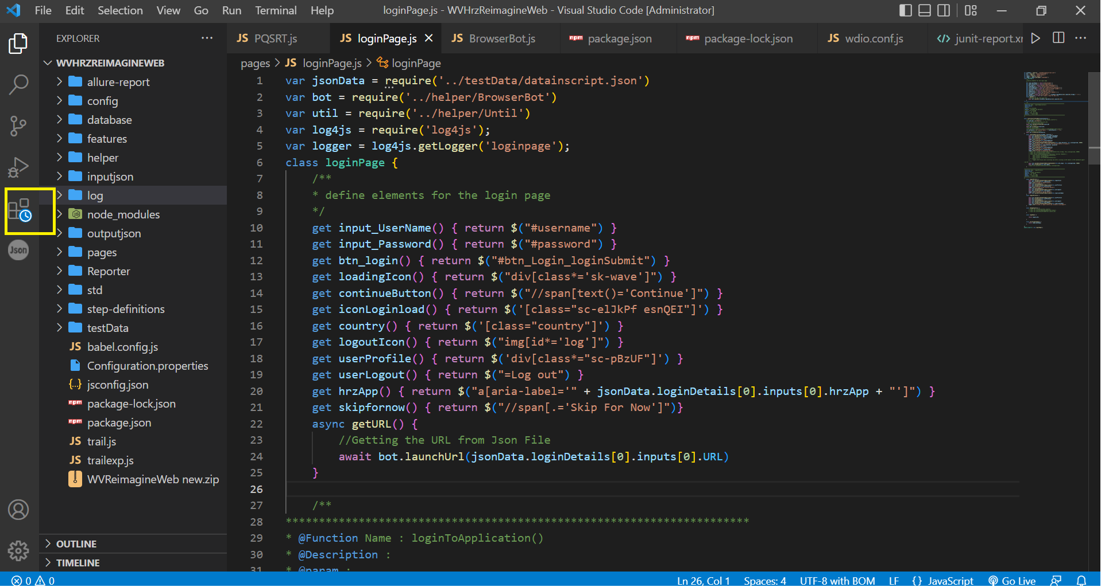

1. And your cursor focuses the search bar.

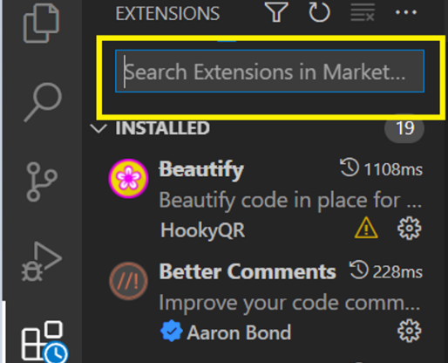

1. Then search for “**Notepad++ Keymap**”.

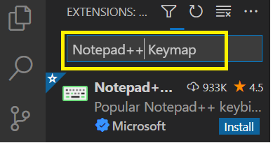

1. You see now a “**Notepad++ Keymap**” click on it, will open in a new window.

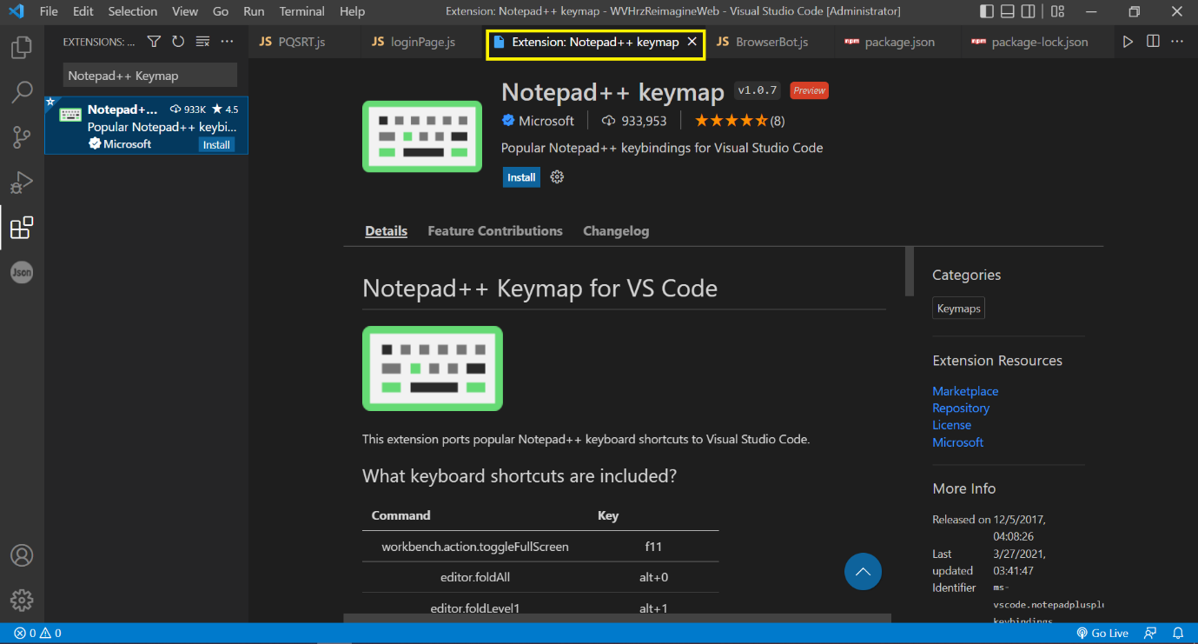

1. Click on “Install” button.

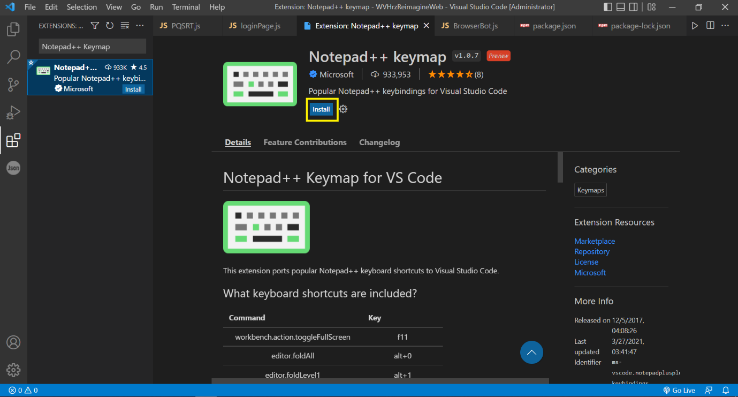

1. “**Notepad++ Keymap**” has been installed into your Visual Studio Code successfully.

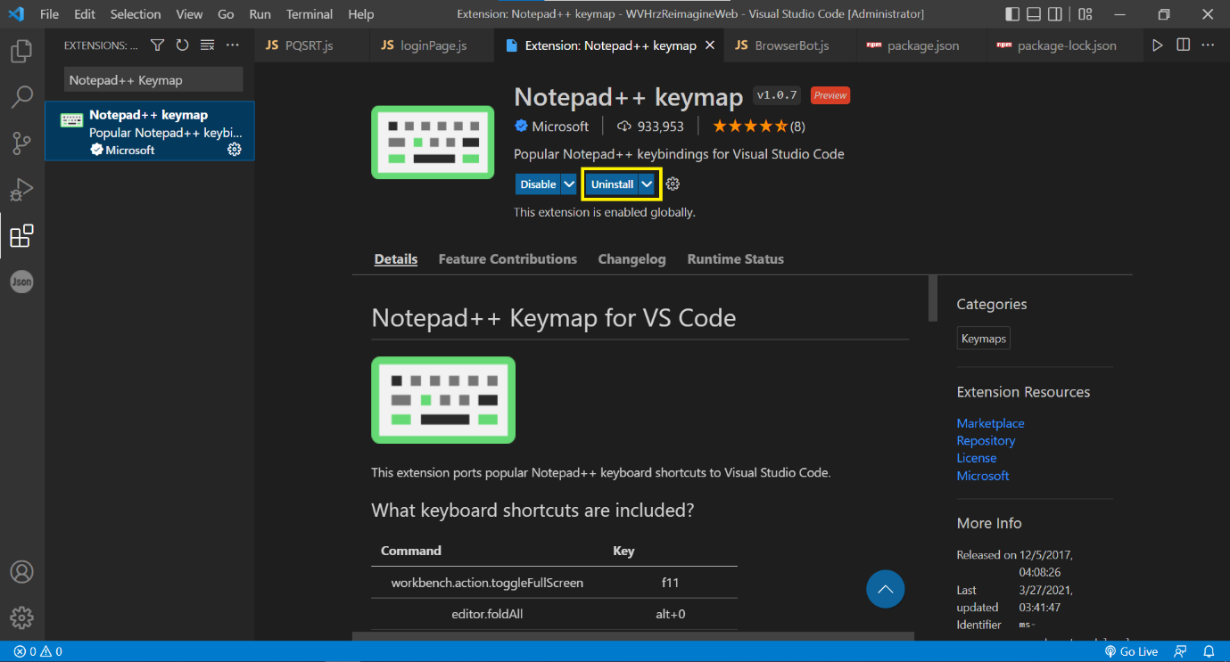

## Short Cut keys

1. Collapsed view: Editor.foldAll 🡪 alt+0
2. Un-Collapsed view: Editor.unfold 🡪 shift+alt+0

