**LOAN CALCULATOR**

TABLE OF CONTENTS

ACTIVITY -1 1

1- Requirements: 1

Research 1

My Software 1

SWOT Analysis 2

High-Level requirements: 2

Low-Level requirements: 2

2 - High-Level Diagram 2

3 - Design: 3

High-Level Design: 3

Behavioral 3

Structural 3

Low-Level Design: 4

Behavioral 4

Structural 4

4 - Test Plan 5

Integrated test plan 5

Unit test plan 5

ACTIVITY-2 (CALCULATOR) 6

1- Requirements: 6

Research: 6

My Application 6

SWOT Analysis 6

High-Level requirements 7

Low-Level requirements 7

2 – Design 7

3- Test Plan 10

4 – GIT Hub Working 11

# 1- Requirements:

## Research:

1. The Aim of the project is to calculate and assign the loan amount to the customer. The system provides two different types of loans: gold loan, car loan. Using various factors such as age, rate of interest and amount required, the total loan amount is calculated and given as output to the customer. The system has gone through various test cases and found efficient to use.
2. The components/parameters used in this system are: gold in grams, age, interest, Emi and it returns.

## My Software:

* Loan banking facility
* Saves customer time
* Easy interaction with customer

## SWOT Analysis:

Figure 1: SWOT Analysis

## High-Level requirements:

* Principal Amount.
* Rate of interest.
* Loan period.
* Income tax returns

## Low-Level requirements:

* Calculate the total loan period in months.
* Calculate the interest by using rate of interest formula (A = P (1 + rt)).
* Set the yearly interest rate
* Set the initial amount.

# 3 - Design:

## High-Level Design:

### Behavioral

Figure 3: User interaction with system

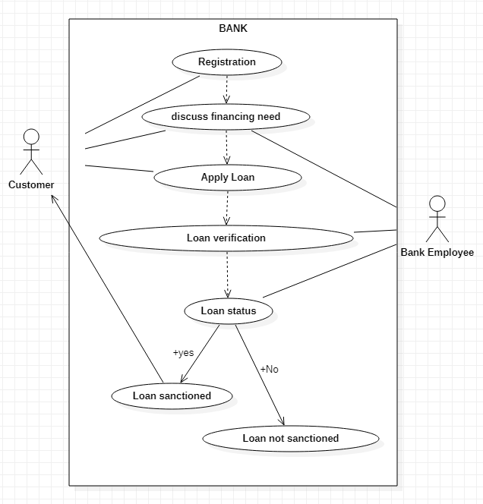

### Structural:

Figure 4: User registration and actions performed

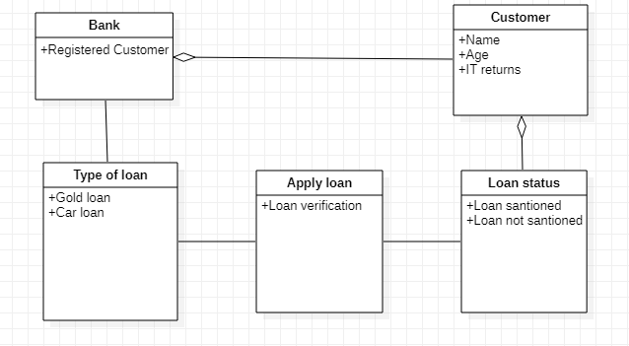

## Low-Level Design:

### Behavioral

User registration

### Structural:

Figure 4: User registration and actions performed

# 4 - Test Plan

|  |  |  |  |  |  |
| --- | --- | --- | --- | --- | --- |
| **Test ID** | **Description** | **Exp IN** | **Exp OUT** | **Actual Out** | **Type Of Test** |
| H_01 | **verification** input age is greater than 18 | 19 | eligible | eligible | Requirement based |
| H_02 | **Gold** To Multiply the grams of gold and amount for each gram and display result | 80000 | Not eligible | Not eligible | Requirement based |
| H_03 | **Gold** To Multiply the grams of gold and amount for each gram and display result | 2*2500 | 5000 | 5000 | Requirement based |
| H_04 | **Car** To check the It returns greater than 1 lakh and less than 5 lakhs. display the loan amount | 1,20,000 | 500000 | 500000 | Requirement based |
| L_01 | **Total** To calculate the rate of interest and add to principle amount and display the result | 7 , 25000 | 27325 | 27325 | Boundary based |
| L_02 | **Rate of interest :**To calculate the rate of interest using loan period | 7,53 | 43036 | prime | Scenario Based |
| L_03 | **Factorial** To find factorial of a given number | 6 | 720 | 720 | Boundary based |
| L_04 | **Total** To calculate the rate of interest and add to principle amount and display the result | 7 , 25000 | 27325 | 27325 | Boundary based |
|  |  |  |  |  |  |

# 4 – GIT Hub Working

Link to access repository: <https://github.com/Gunturuvenkatasubbarao/Group-8_ltts>

Screenshot of cppcheck (before)

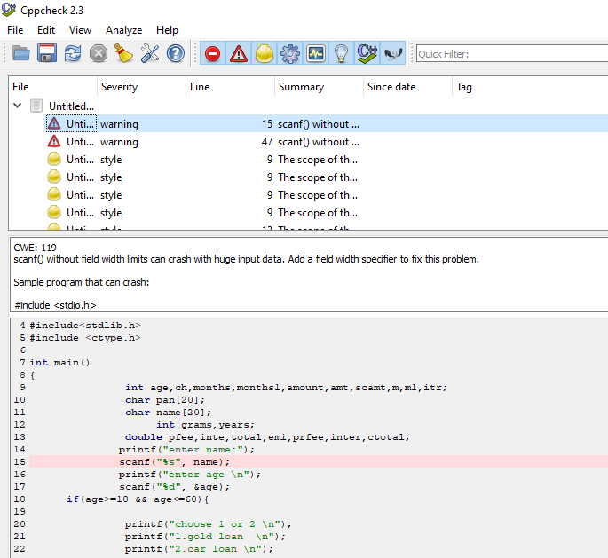

FigureScreenshot of cppcheck (after)

