/*********************************************************************************

* ITC5202 – Assignment 2

* I declare that this assignment is my own work in accordance with Humber Academic Policy.

* No part of this assignment has been copied manually or electronically from any other source

* (including web sites) or distributed to other students.

*

* Name: Guo Xinfu

Student ID: n01611988

Date: 2024/2/11

*

********************************************************************************/

## Question 1

1. /books/book[type="Hardcover"]/title

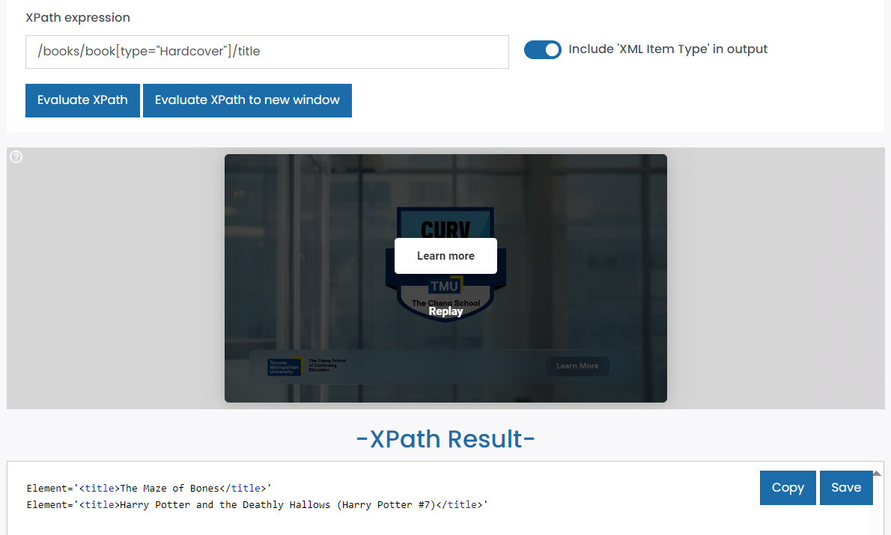

1. /books/book[ last() ]/author/firstName | /books/book[ last() ]/author/lastName

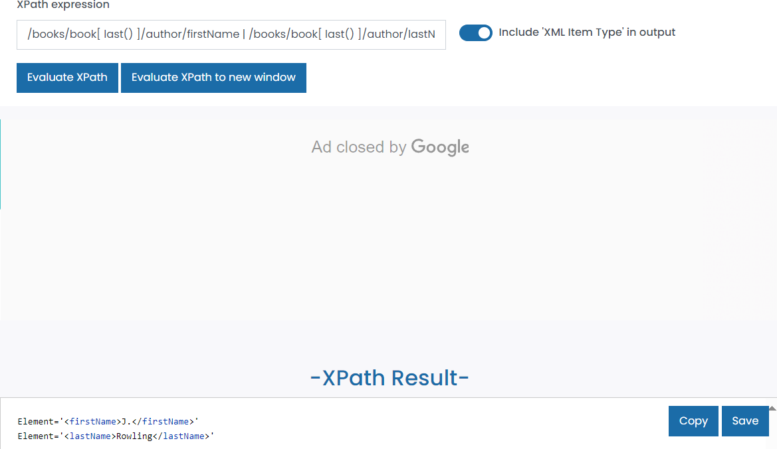

1. /books/book[categories/category="adventure"]/title | /books/book[categories/category="adventure"]/sellPrice | /books/book[categories/category="adventure"]/publisher

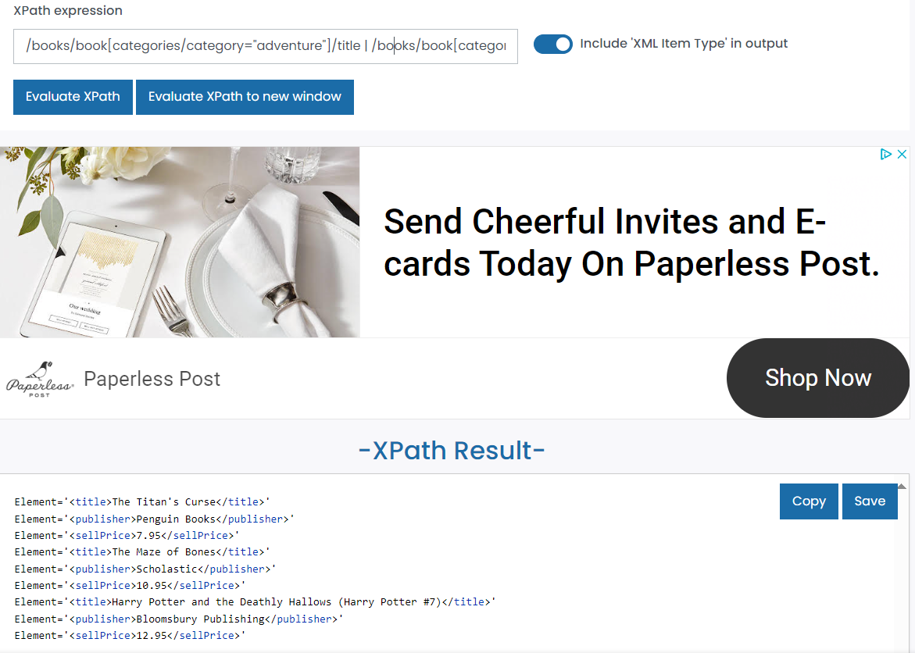

1. /books/book[sellPrice<10]/@ISBN | /books/book[sellPrice<10]/type

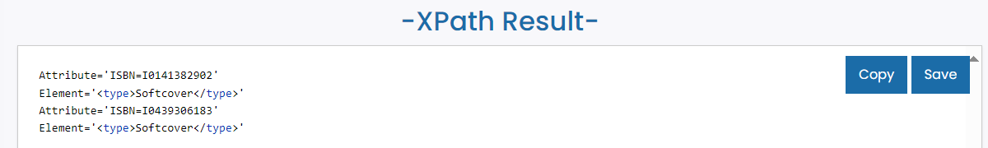

## Question 2

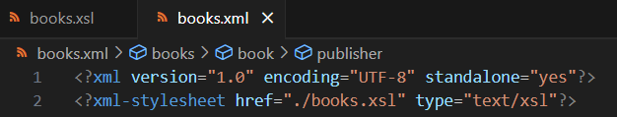

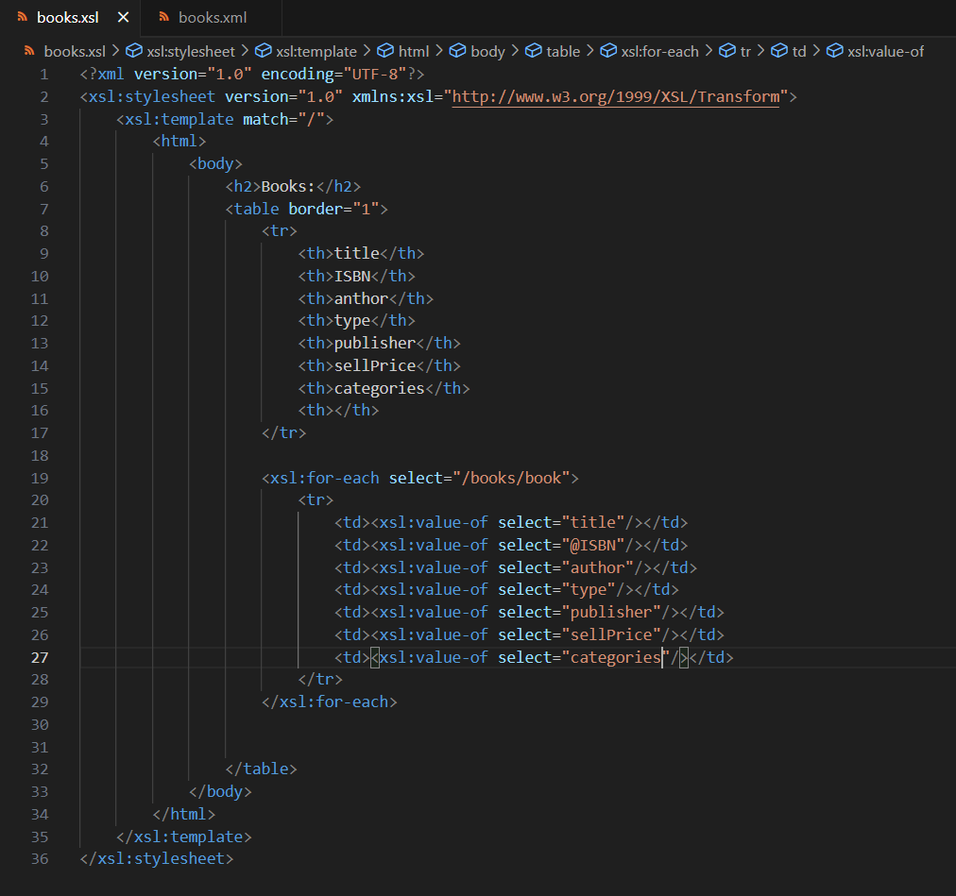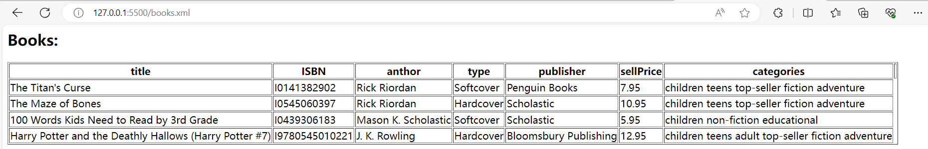

1. 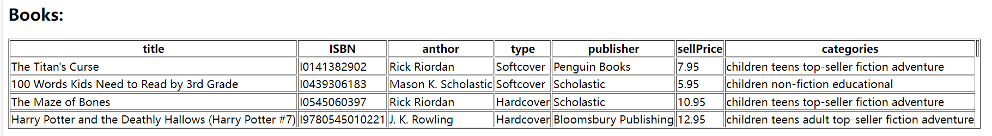

## Question 3







In this line of code, I use getElementsByTagName, and index to get the first “li” element, the first node of this element is text node, the content of this element.

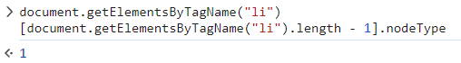

The result of Document,getElementByTagName(“li”) is an array, I could use .length to get the length of this array, and minus 1 is the index of last “li” element. The result is “1” which means this is an element node.

1: Element Node  
2: Attribute Node  
3: Text Node  
8: Comment Node  
9: Document Node  
11: Document Fragment Node

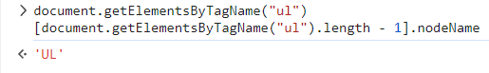

nodeName returns the tag name of an element node (such as "div", "p", "li", etc.). For other types of nodes, nodeName may return specific values, such as attribute nodes returning the attribute name, text nodes returning "#text", comment nodes returning "#comment", and so on.



This line of code select the last node in div element, which is a text. In JS, whitespace or newline characters are considered as part of text nodes. Therefore, document.getElementsByTagName("div")[0].lastChild returns a text node #text, rather than any other element or comment node within the <ul> element.

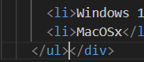



Without that new line character, the last node is “ul” element.



According to the code, we can know comment is the second node inside of “li” element.

