## Q1

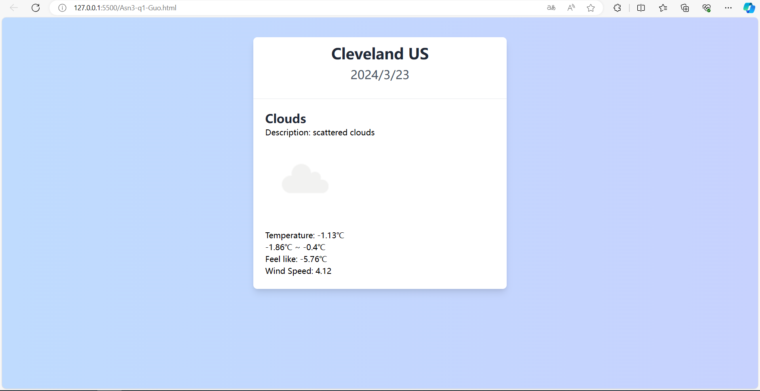

## Q2

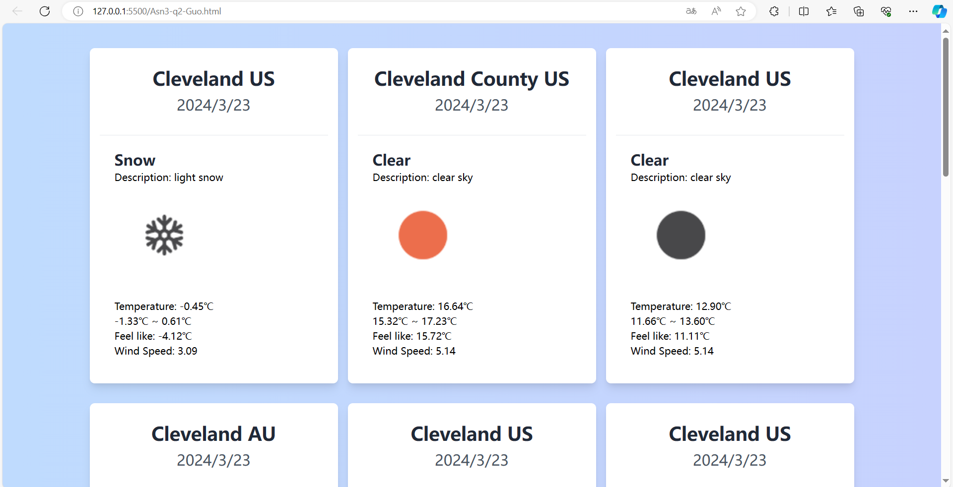

cnt is count.

In this Url, we can notice that there is just the name of Cleveland instead of latitude or longitude.

Because there are serval of place called Cleveland, we use cnt to get how many different place with same name.

In my code, there is a variable called cnt which I can set to manage how many different place I want.