ITC5202: Project 1 Report

Created by: <YOUR NAME>

Student ID: <YOUR ID>

Date: <THE DATE>

# Table of contents

Answer 1 2

Answer 2 3

Answer 3 and 4 4

Answer 5 5

Answer 6, 7 and 8 6

Answer 9 7

Answer 10 8

Summary 9

## Answer 1

Answer Question 1 here

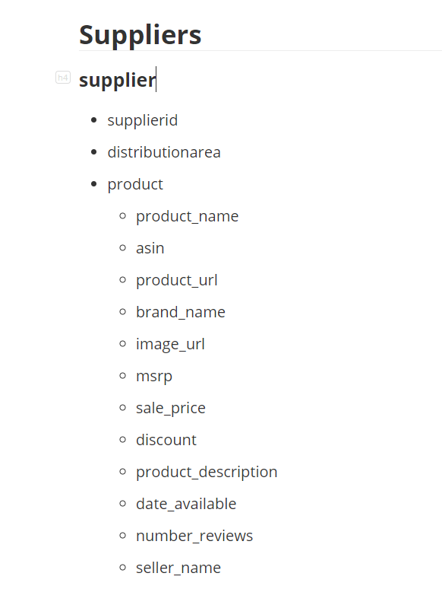

## Answer 2

Answer Question 2 here. How did you prove the document is well-formed and valid? Add screenshots here

This means the XML document follows the syntax rules of XML, which means there’s no error in this document. If I can open it in browser successfully, it’s well-formed. 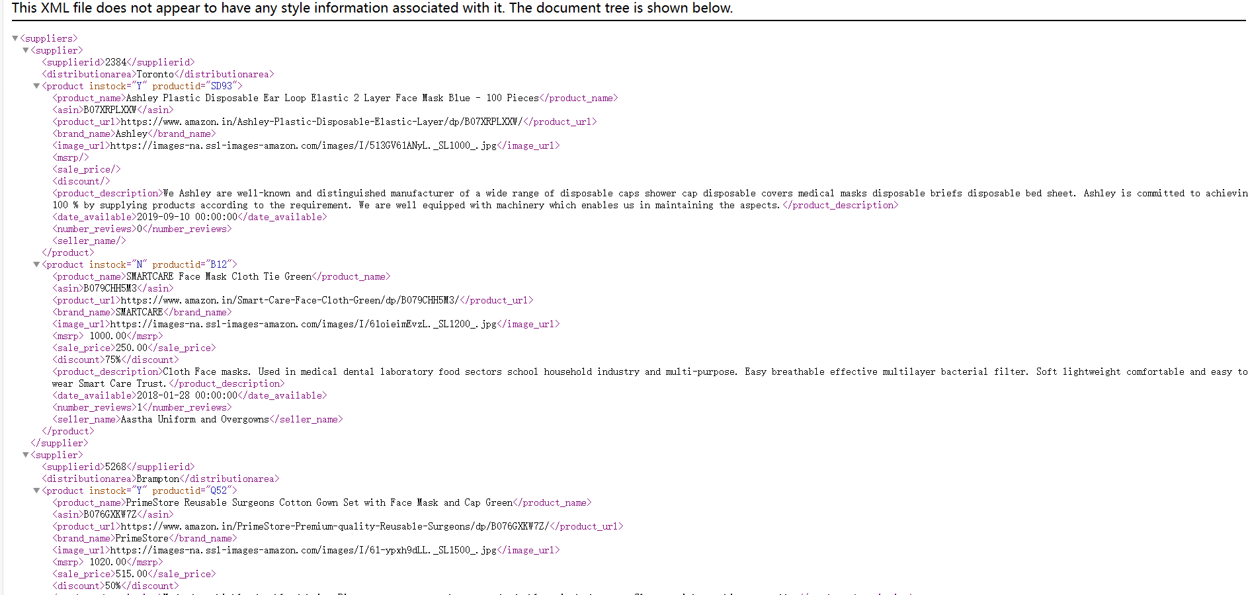

But it’s not valid. Validity refers to whether the XML document conforms to a specific Document Type Definition (DTD) or XML Schema Definition (XSD). There’s no DTD or XSD in this document.

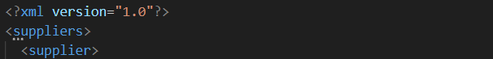

## Answer 3 and 4

Explain the major steps that you take to create DTD. Did you create a .dtd file, or did you keep the DTD declaration inside the XML file? Why?

Explain the major steps that you take to create XML Schema.

Explain how you validated them? Add screenshots.

Compare the DTD and XML Schema and show how DTD declarations are matched with XML Schema.

1. Firstly, I need to create a head based on the syntax of DTD.

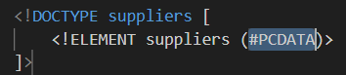

After that, according to the every element and child element, create the DTD. I’d like to user in line DTD, because I don’t need to create other DTD file and link it.

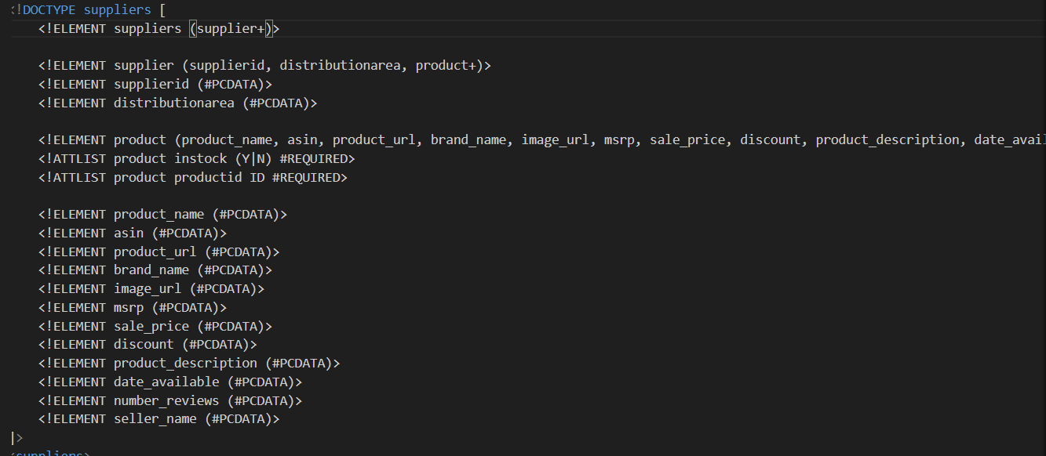

1. To create XSD file, I use online tool:

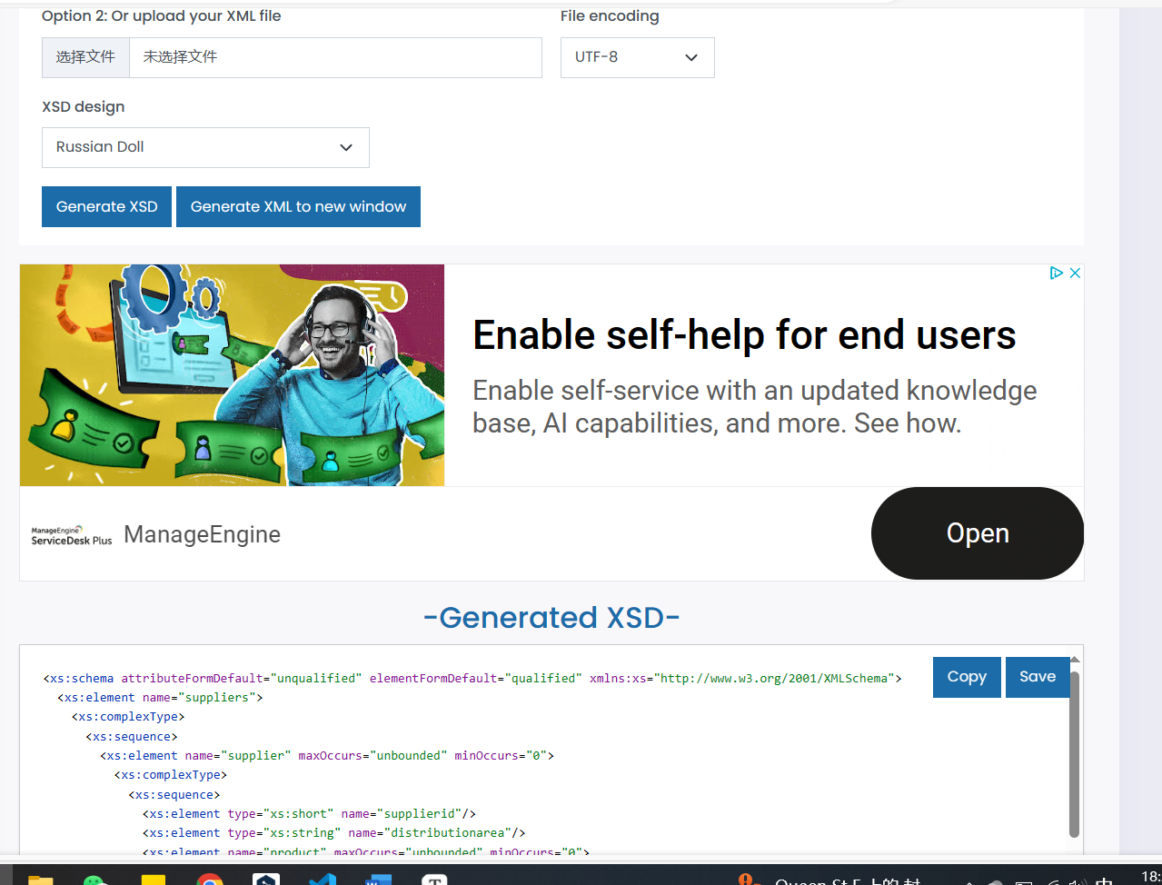

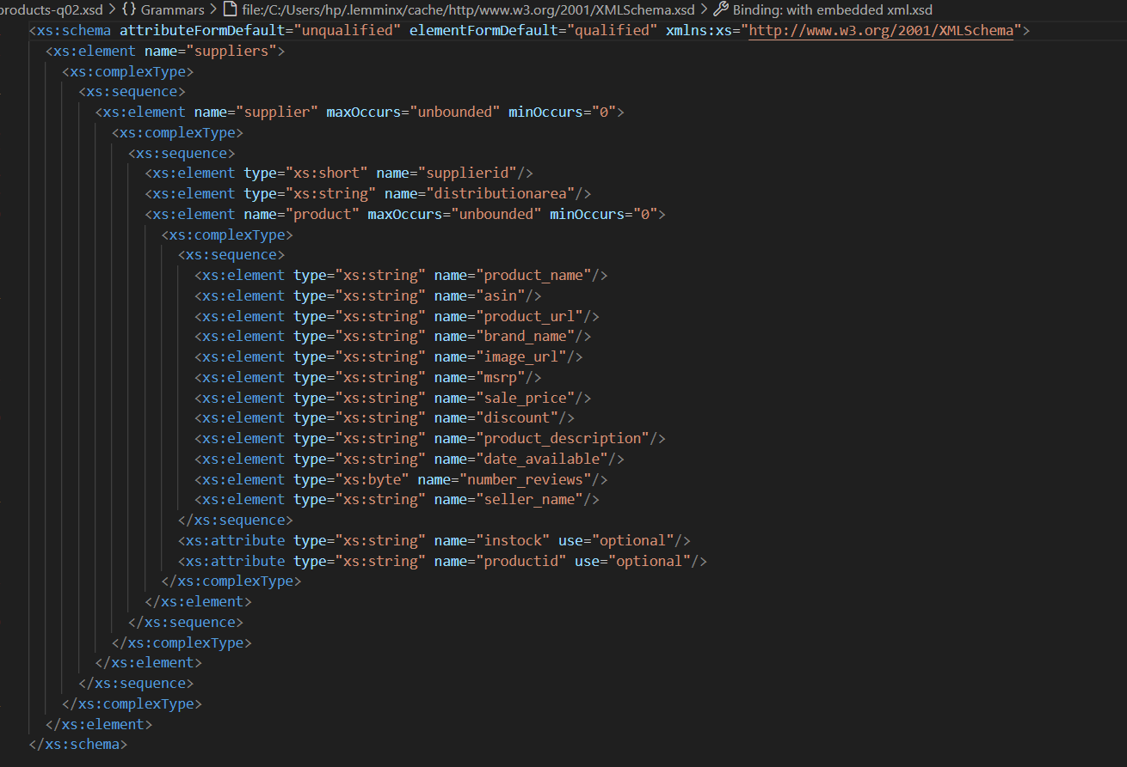

Save this file, and link it.

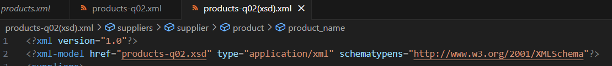 

## Answer 5

Describe the major steps for designing the XSLT. Add a screenshot of the html output

Create the basic syntax of XSL file:

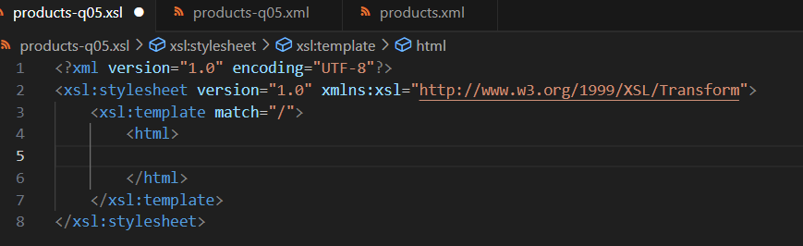

Write down the html, and use XSL comment and the XPath:

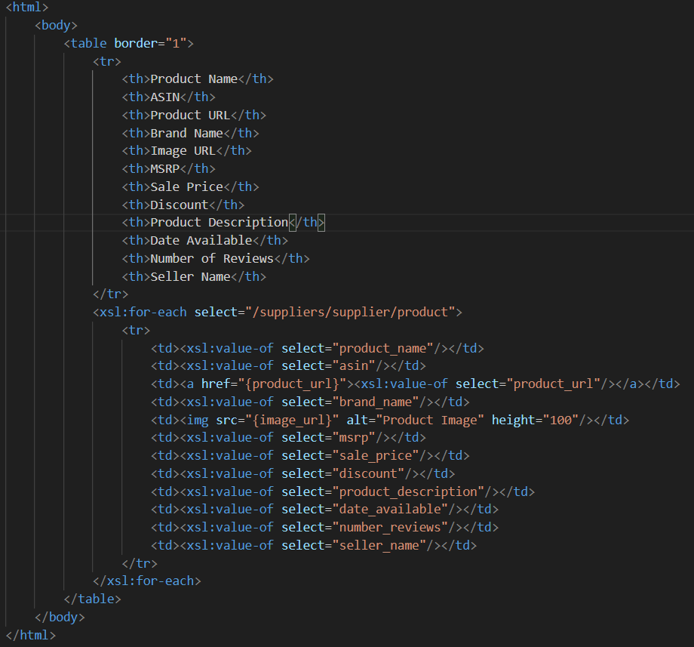

link:



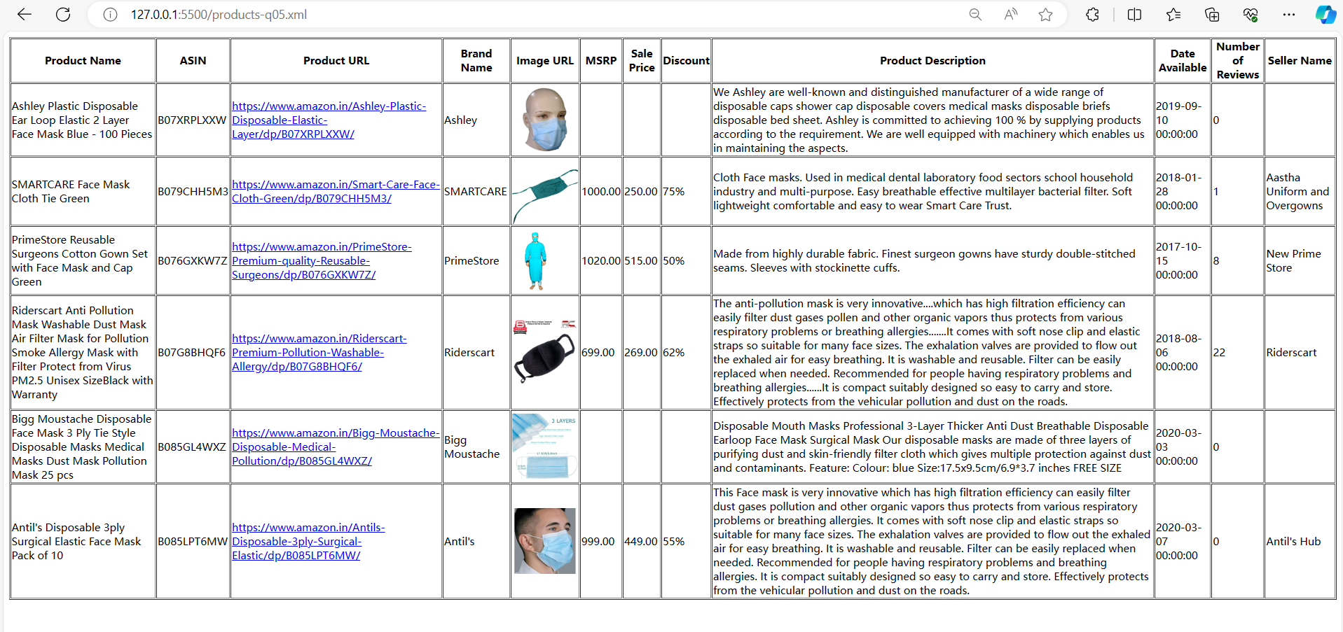

## Answer 6, 7 and 8

Describe the major steps for designing the JavaScript function(s) and how you tested this program. Add some screenshots of the output

create a html file, and write a listener function, to load the information table, and get XML file named as xslDoc as variable when the browser is loading.

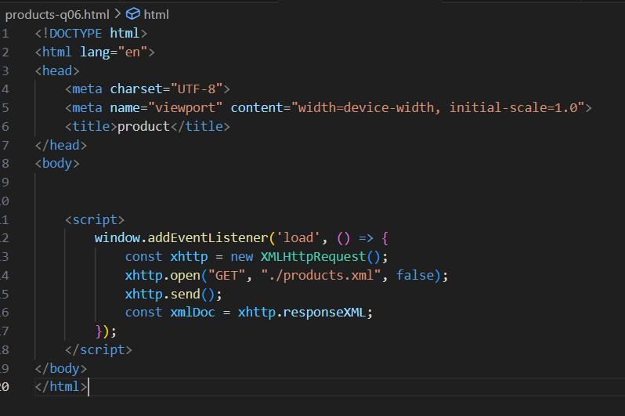

Create a container to load the table:



Create a function to load these information:

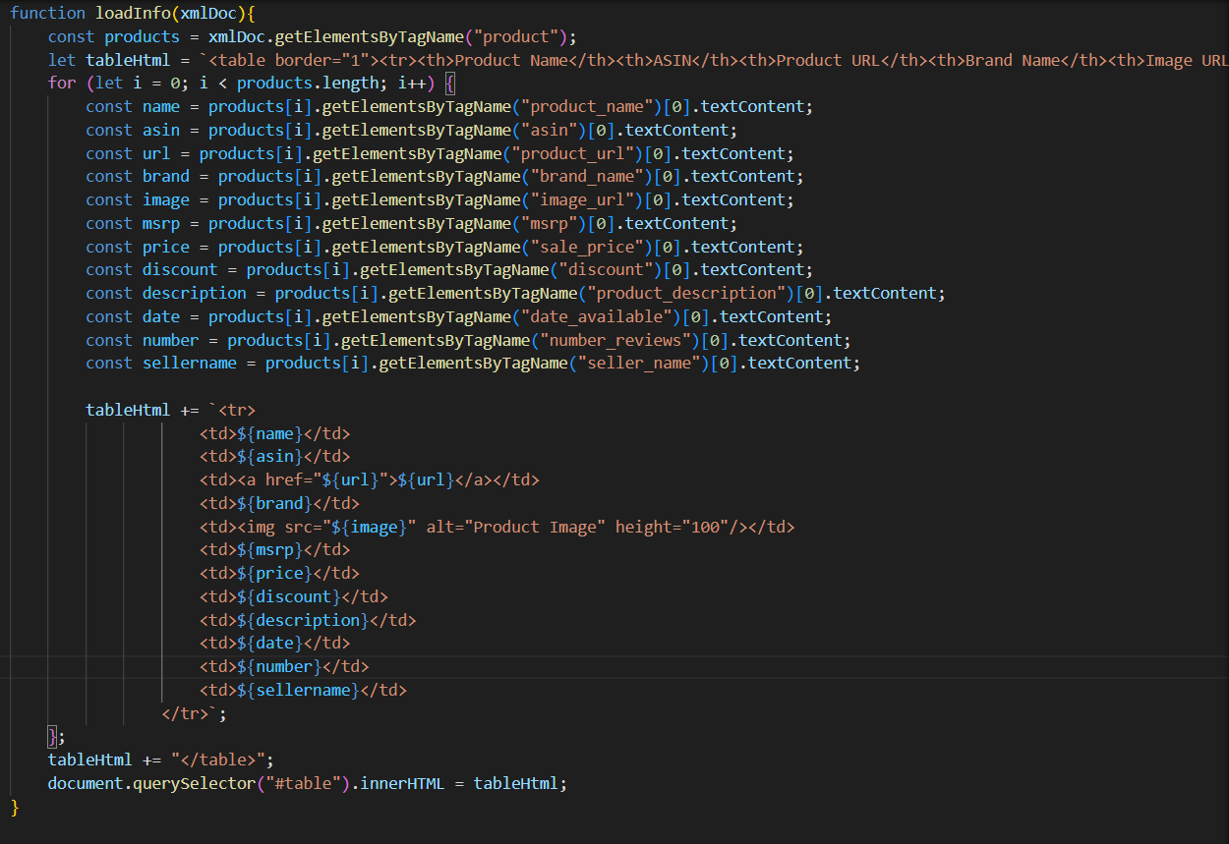

Add this function into listener:

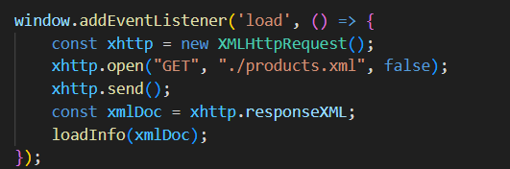

Open with live server:

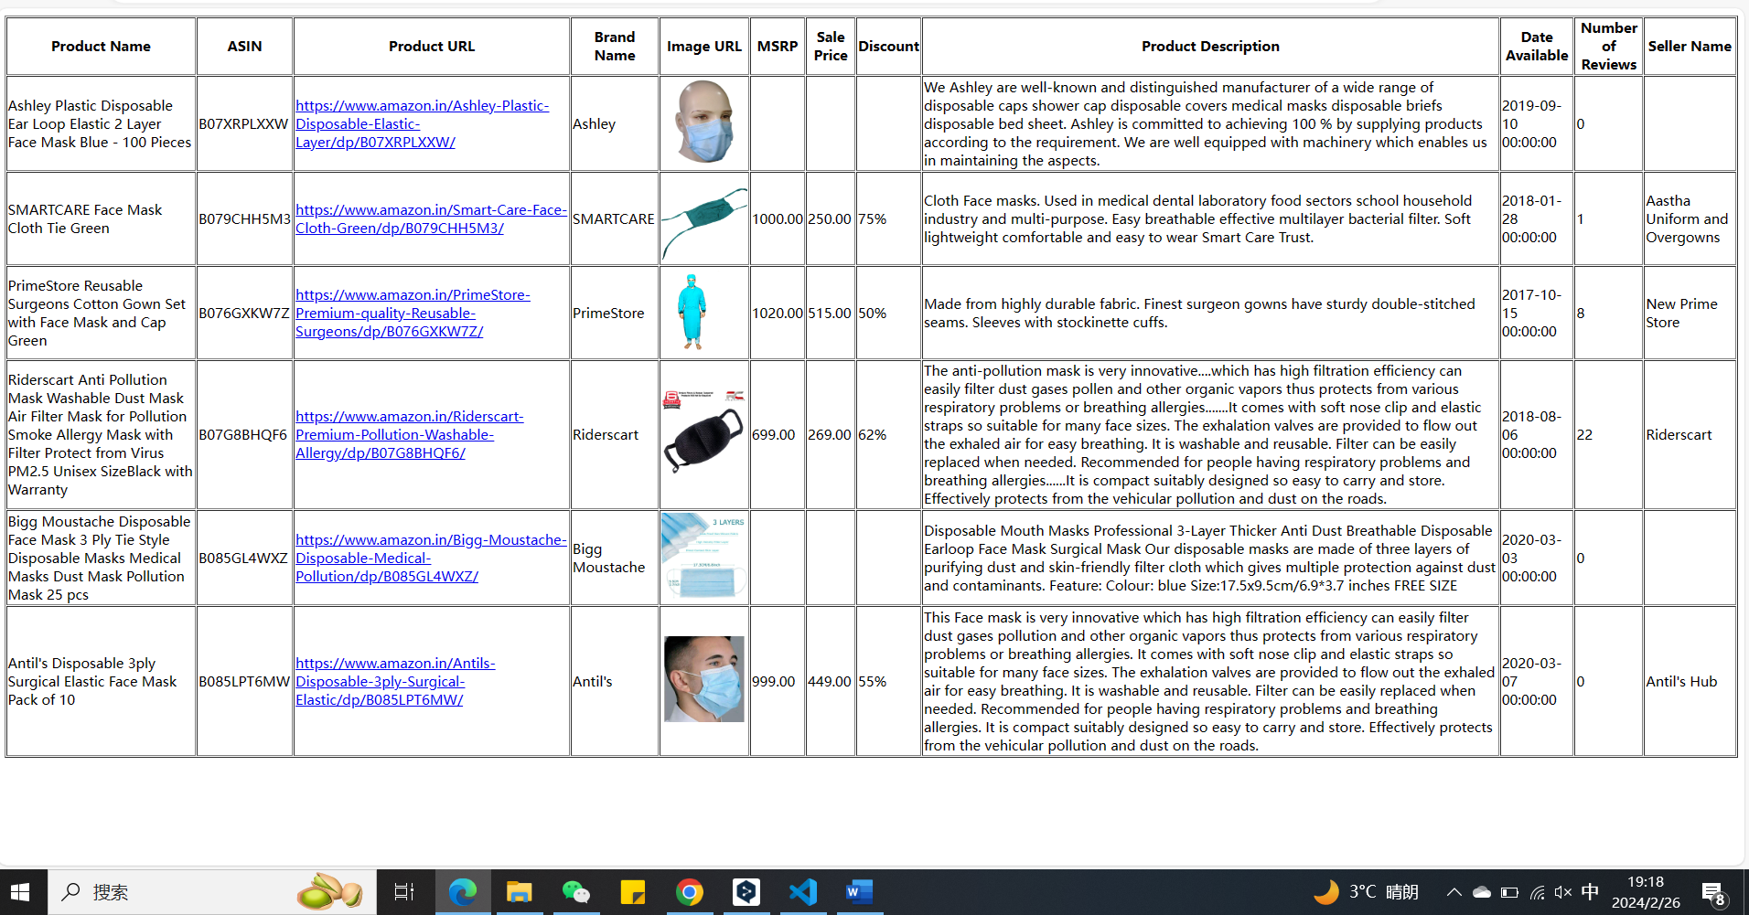

Add 2 suppliers:

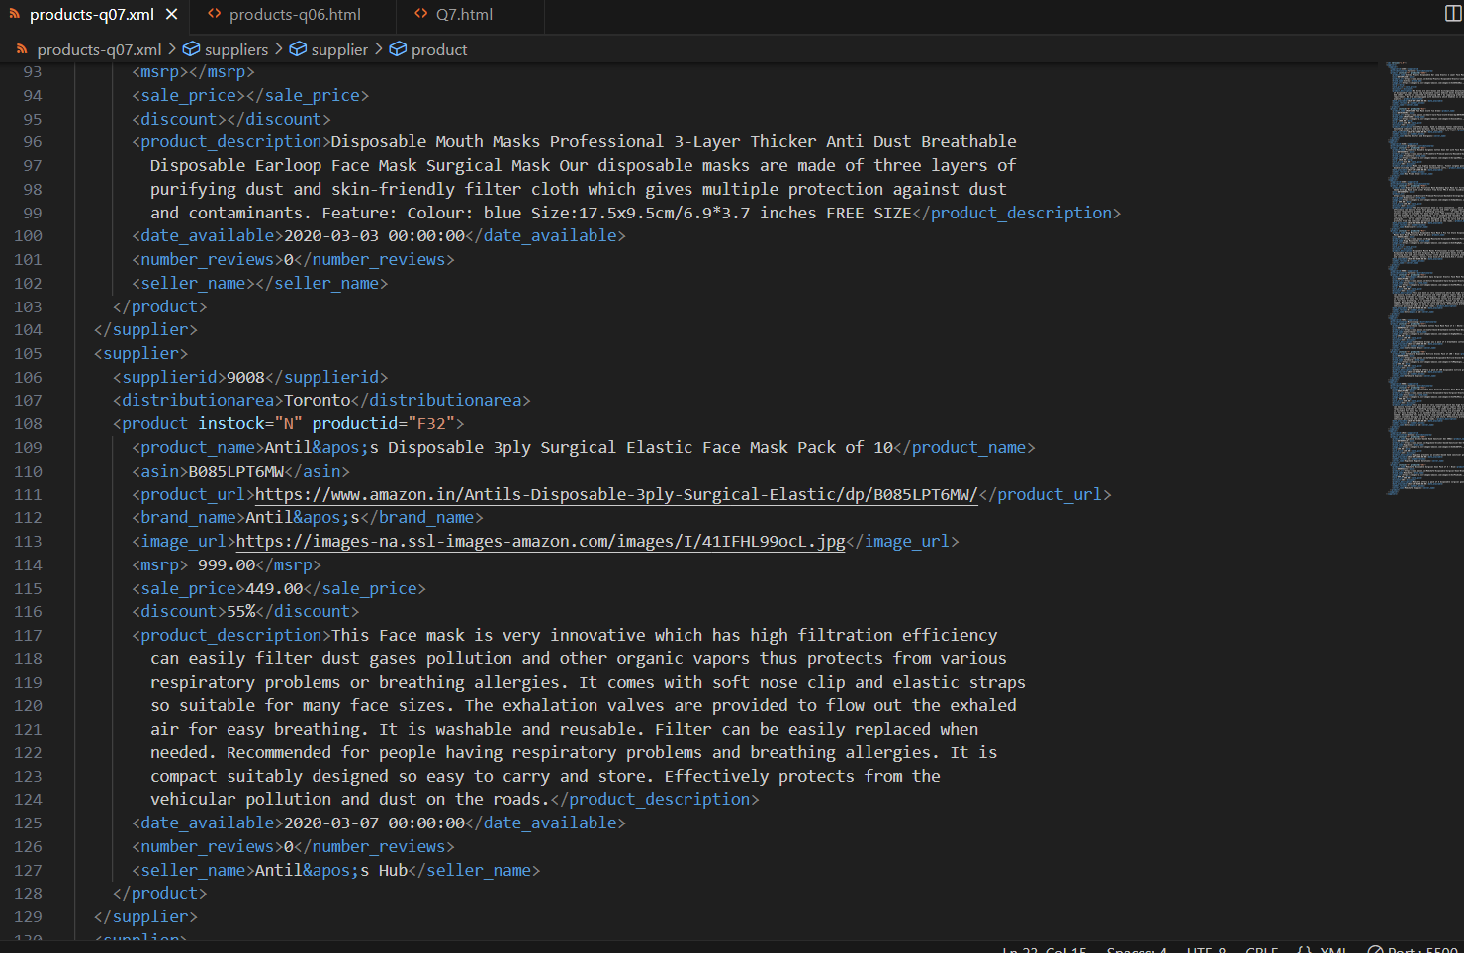

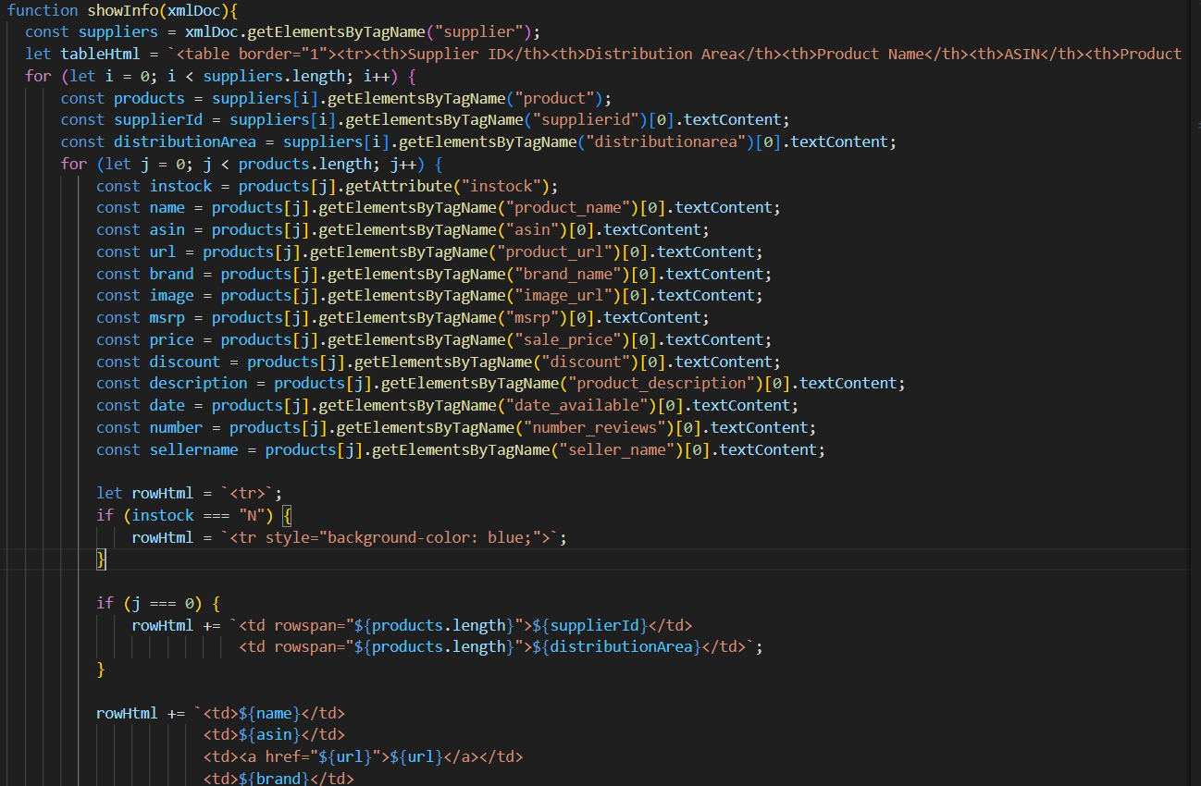

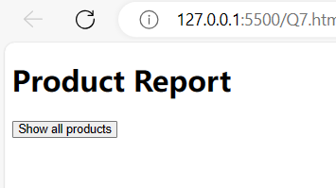

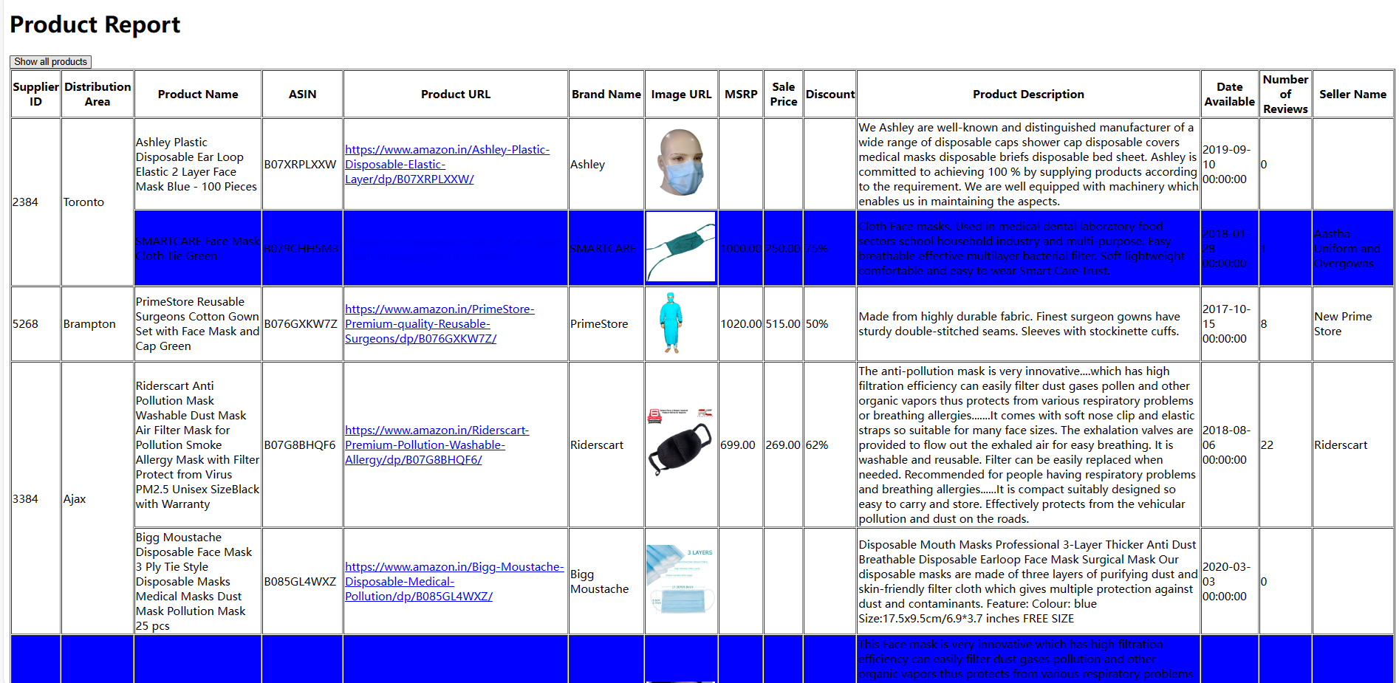

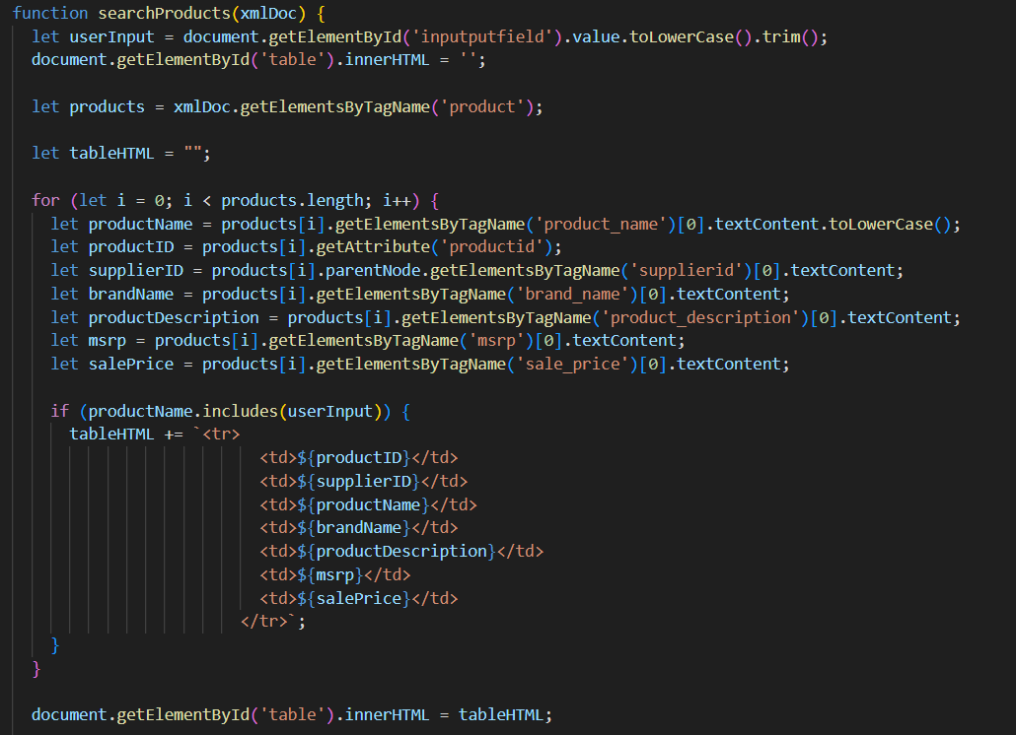

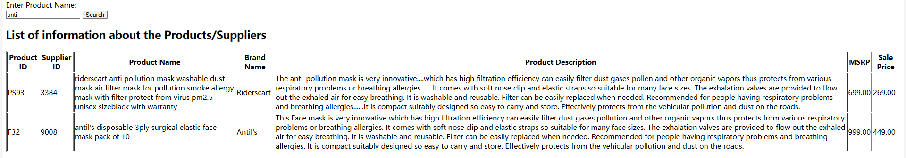

## Answer 9

Describe the major steps for designing the XPath queries and XSLT. How did you test the XPath queries? How did you use XPath in the XSLT?

Add screenshot of the XPath testing and the output of XSLT

Firstly, write XSLT syntax:

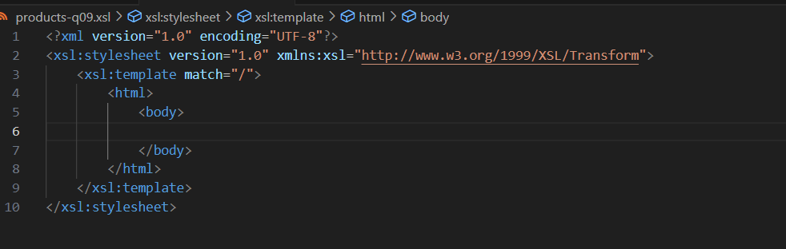

And next write html part

I use some xsl code:

Get every element by giving xpath, which is like foreach in C#.



Get the element.



According to the value of element by giving xpath, sort it.



It’s normal condition syntax.



Get the value of attribute.



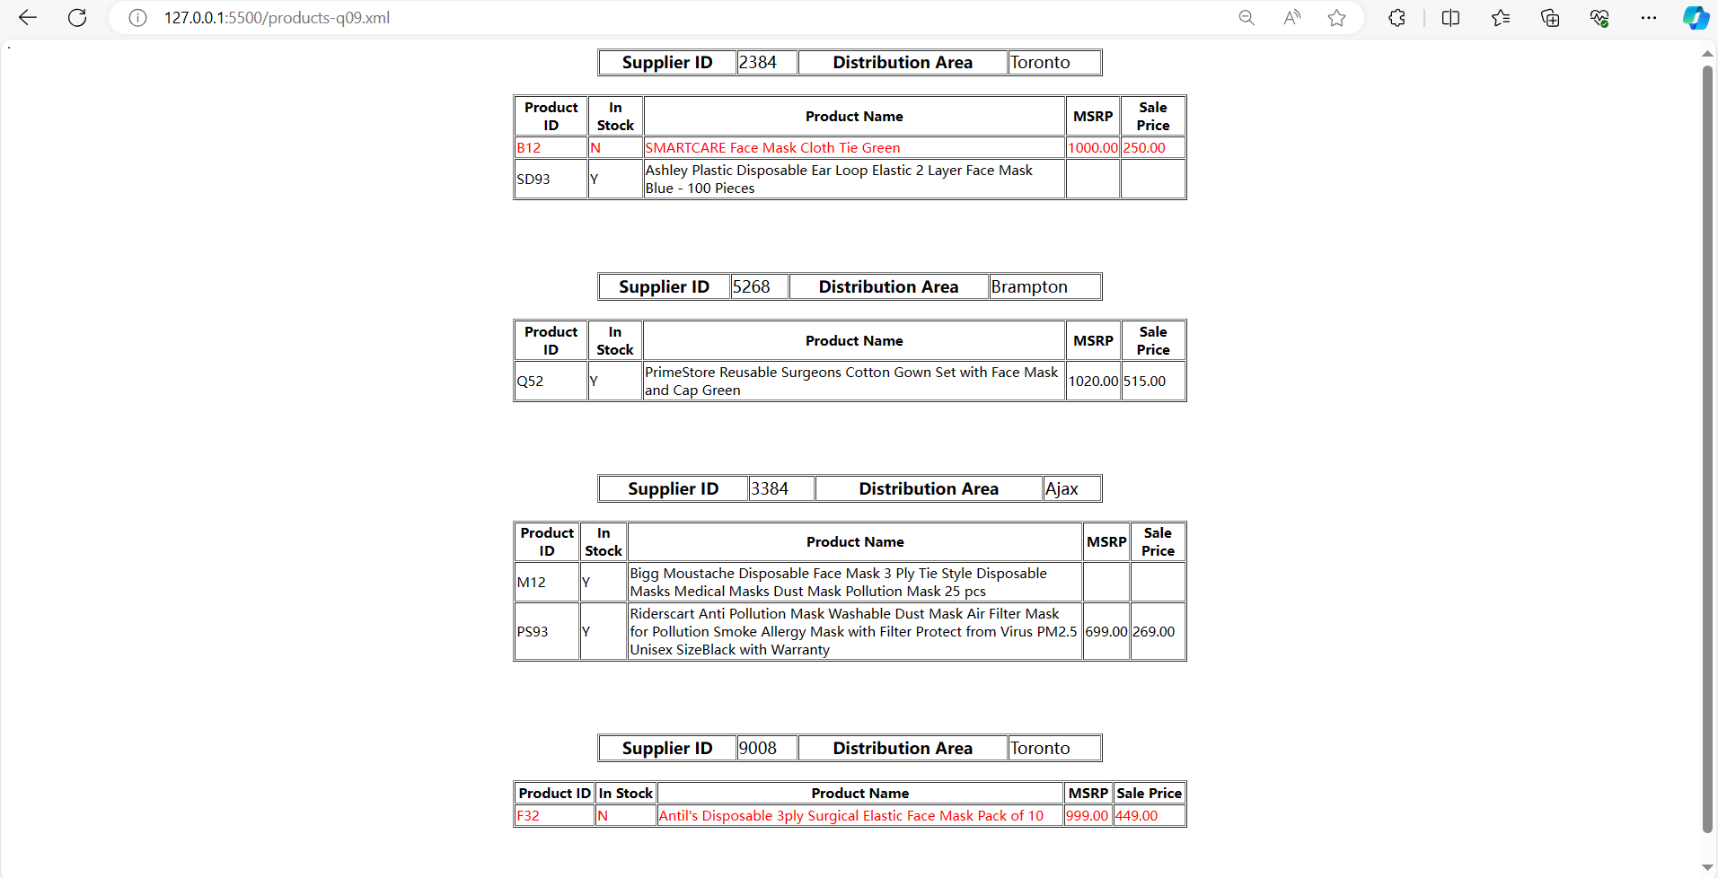

## Answer 10

Answer Question 10 here.

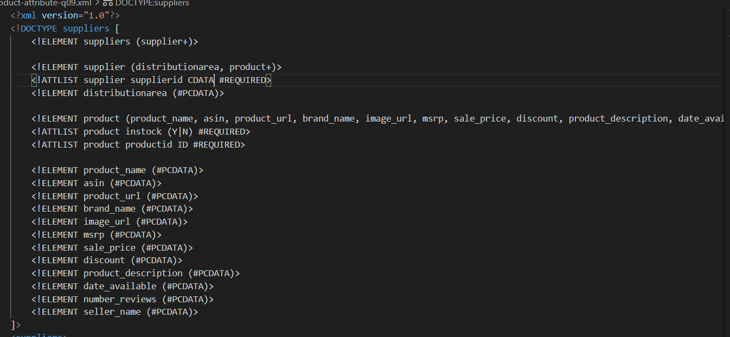

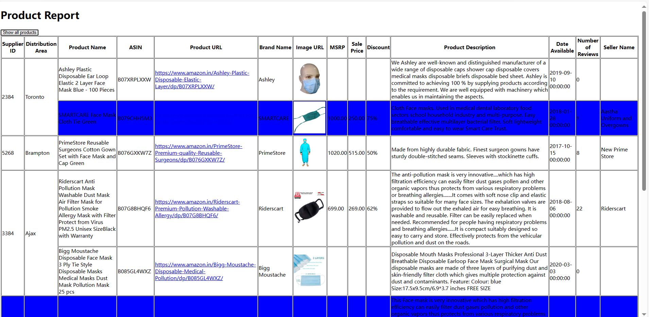 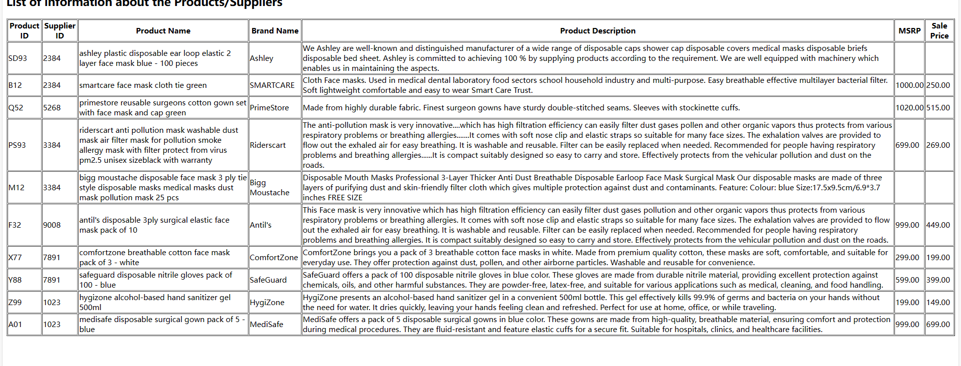

I think the differece is not really tangible. When I’m coding, I just need to use getAttribute to achieve Q9. But in the XML file, if refer ID as attribute, it’s clearer.

## Summary

Summarize your experience while working on this project. Include notes on any challenges you faced and if/how you resolved them.

All the things is covered by previous power point and lab. When I encountered difficult, I check previous lab.

But as for <xsl if>, I think it’s new knowledge, I search it using online tool.

This project is a little taketime, but it’s a good time to review.