## Question1

1. /customers/customer/@custID

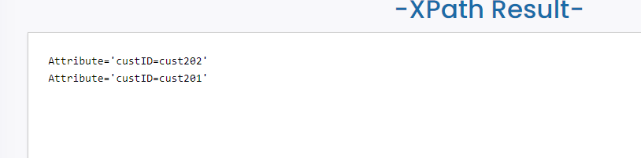

1. /customers/customer/name

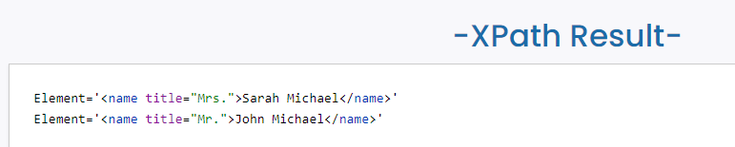

1. /customers/customer/address

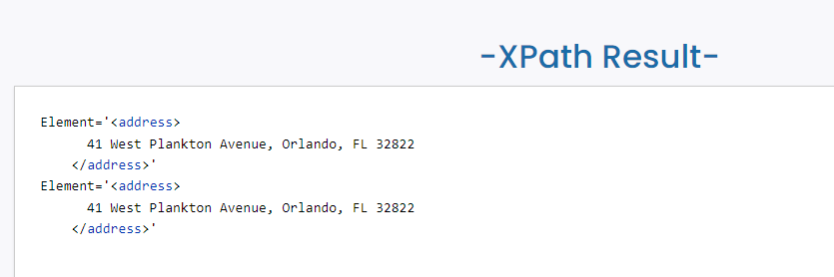

1. /customers/customer/phone

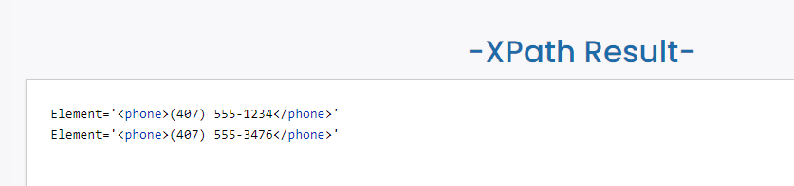

## Question 2

