Activity1

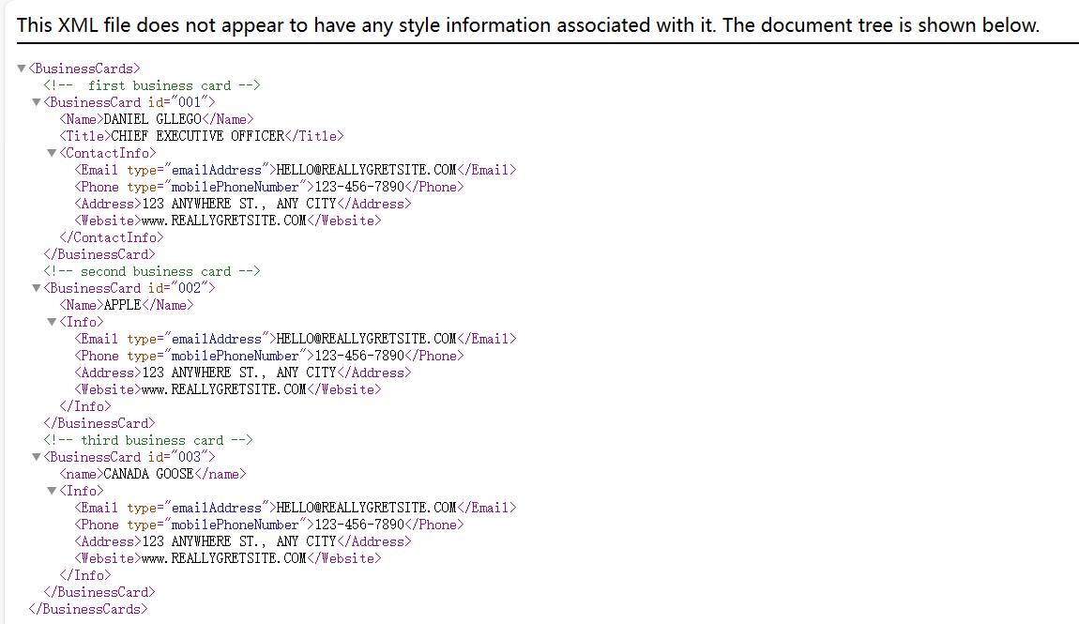

Activity2

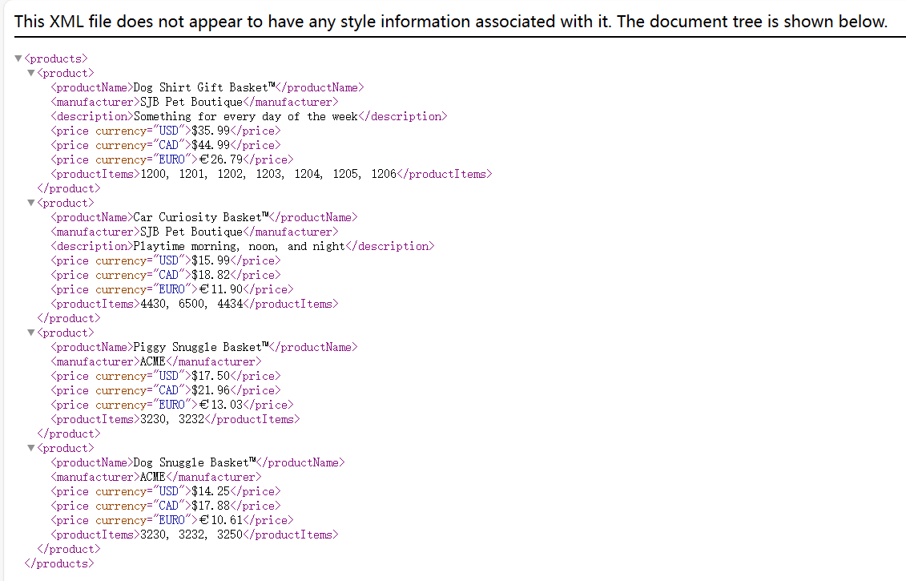

Activity2-3

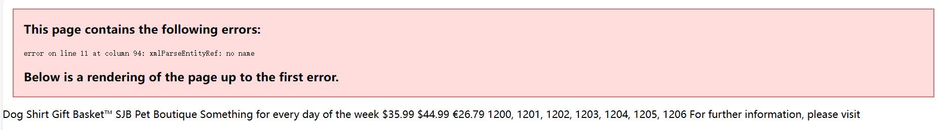

Activity 2-4

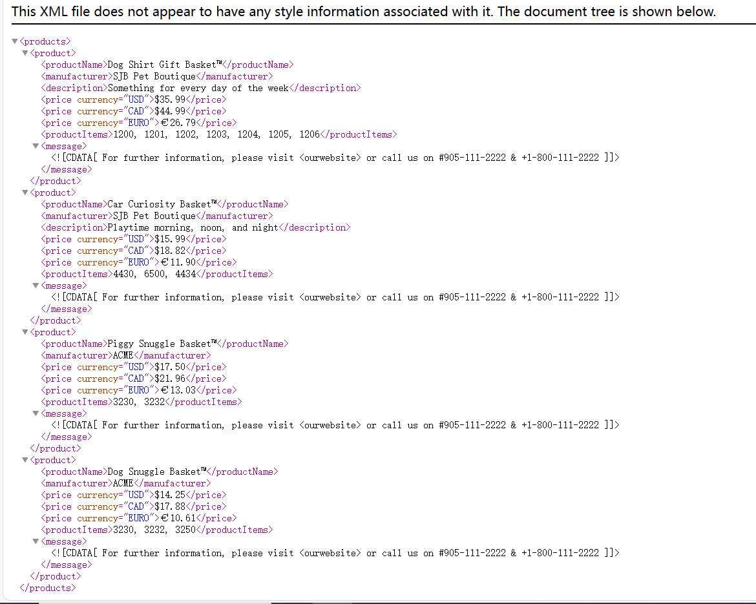

Activity3-1

1. Is product.xml a Well-Formed XML document?

Yes, because there is no XML syntax errors in this file.

1. Is product.xml a Valid XML document?

No, because it hasn’t DTD.

Activity4

