## Activity 1

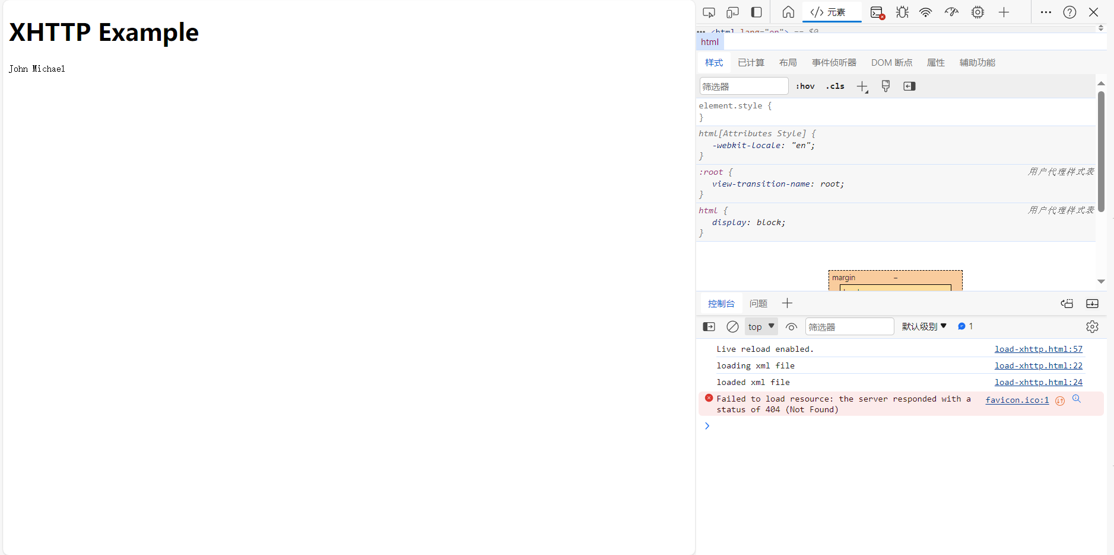

## Activity 2

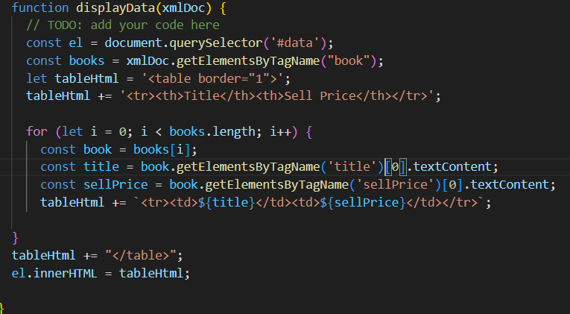

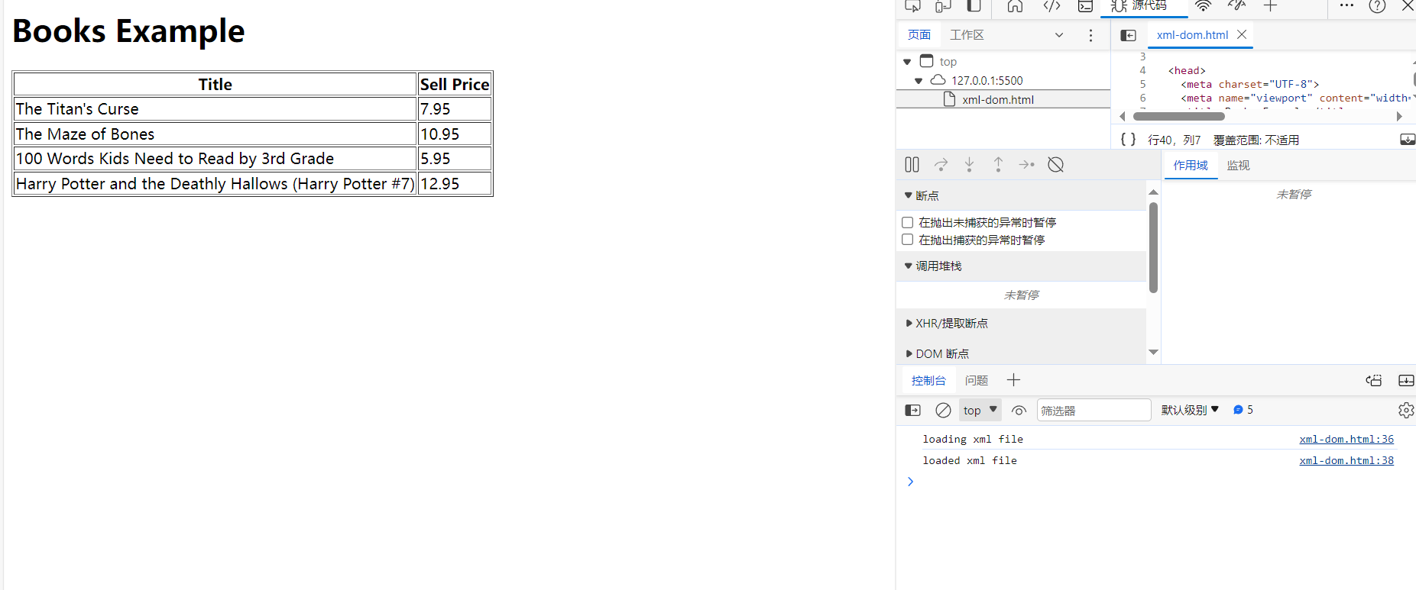

## Activity 2.1

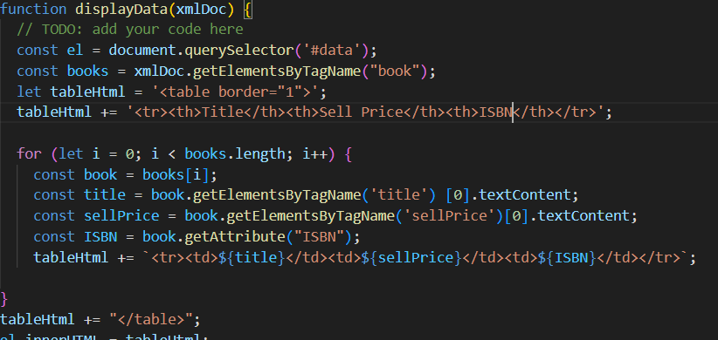

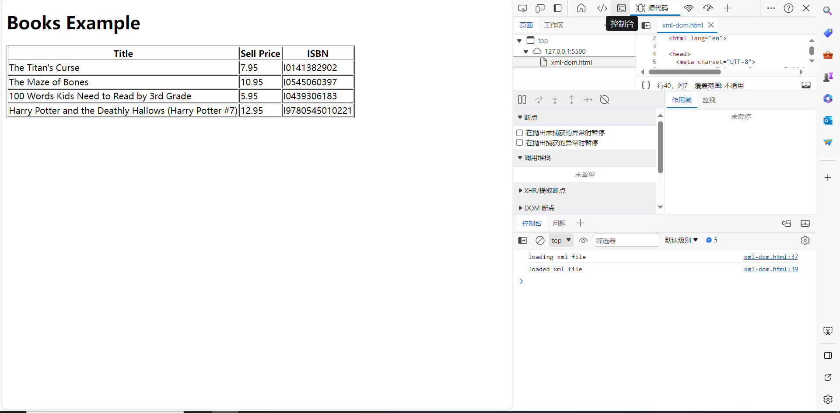

## Activity 3

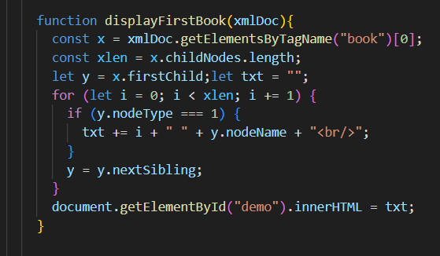

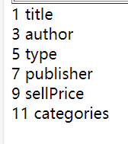

Condition inside an if statement is checking the nodeType is equal to 1, which means if this childnode is text node, it would be presented.

As for the reason, why the output is the nodename of first book, the const y is the node of first book object. And in the loop, use y.nodename.

But if you want to present the information of first book, function textcontent function or firstchild.nodevalue can be used.

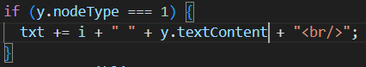

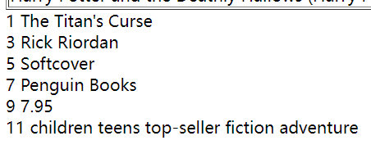

and I can also create:

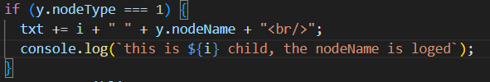

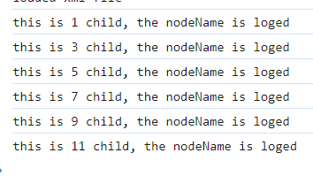

## Activity 4

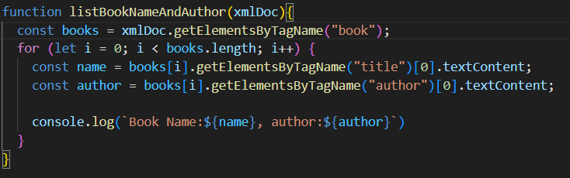

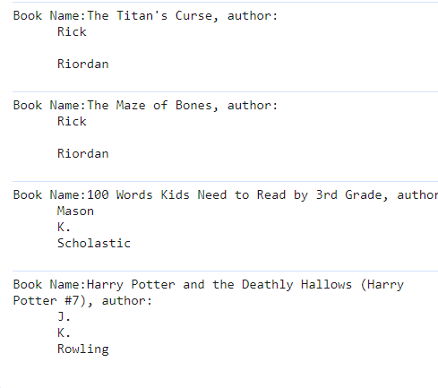

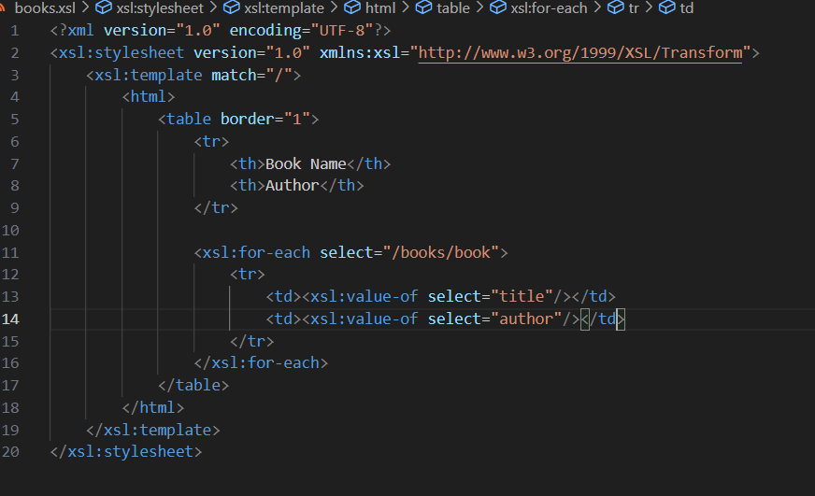

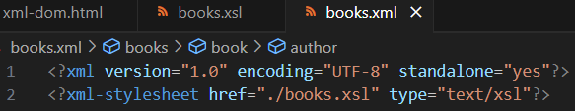

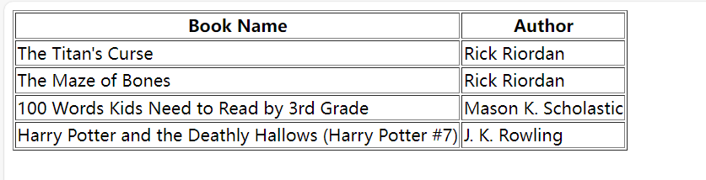

I prefer JavaScript, as the syntax of xslt is more complex.