1a.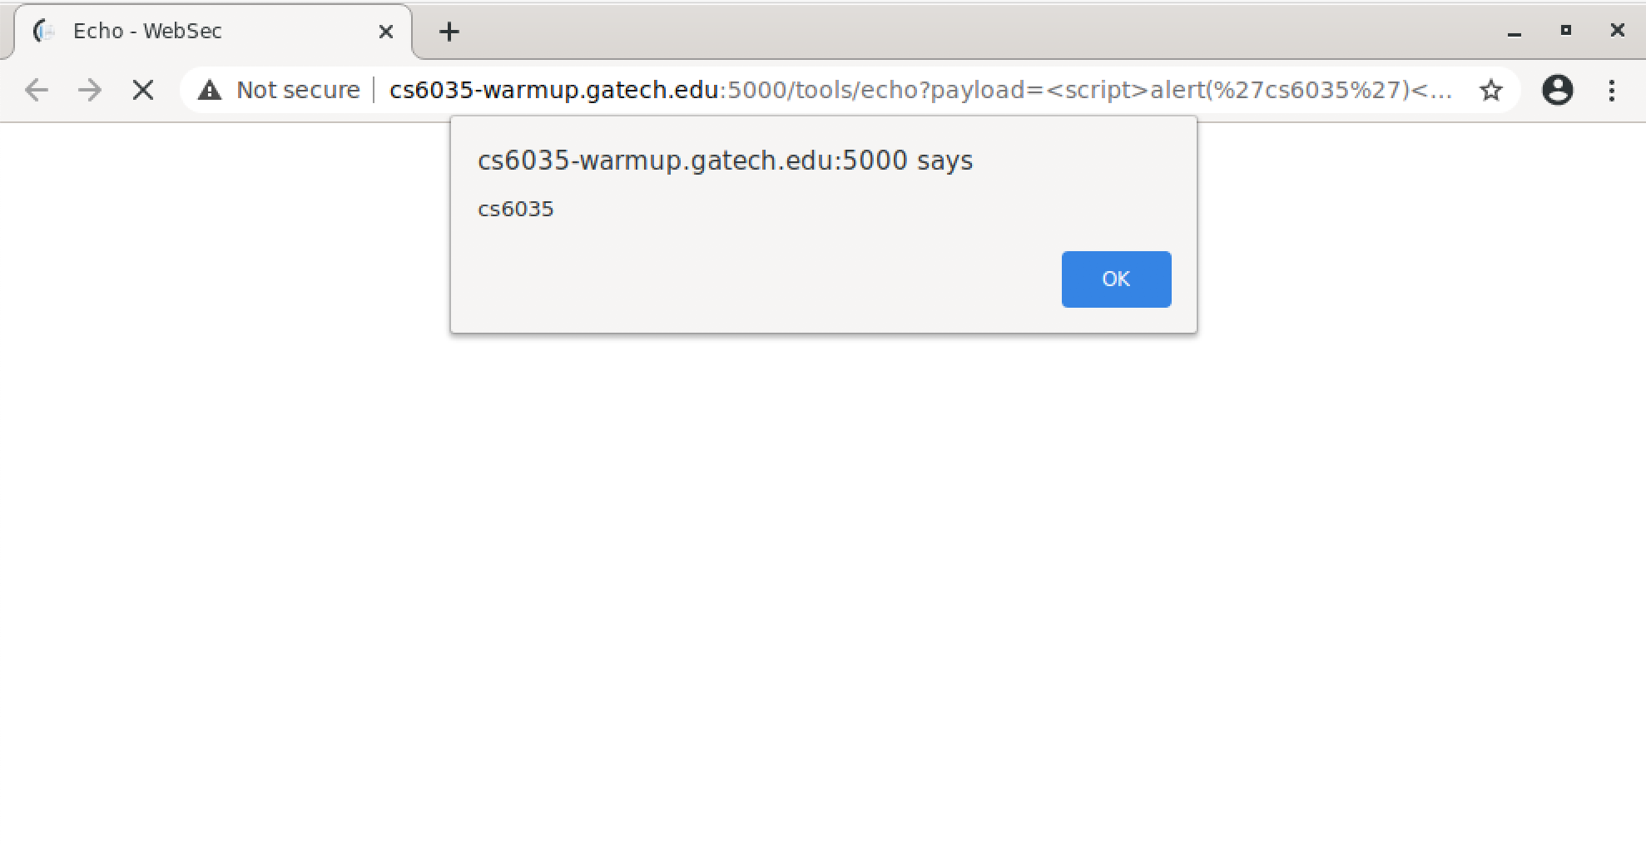

* HTML: Hypertext Markup Language
  + Standard languages for documents to show up on the web browser. It is used to structure and design a website.
* PHP: Hypertext Preprocessor
  + Scripting language that enables commands to be embedded in html. Use the tags <?php ?> to use php mode in html.
  + Php is scripting and html is a markup language. Most of html is static, whereas with php you can enable dynamic content. Php is server side while html is client side.
* <?php ?>
* SQL: structured query language.
  + Querying language used to communicate with databases. Helps manage data held in database
* SQL commands are embedded into the server side of the website, so when it is called it grabs data from the database and uses it in the server to display the data in a user friendly way. Should be done with php
* DOM: Document object model
  + Data representation of the objects that make up the document on the web

1.b

Activity 1:

1. TheCakeIsALie
2. cs6035.js
3. undefined

Activity 2:

1. post
2. 418 I’m a teapot
3. With_Cream

Activity 3:

1. http://cs6035-warmup.gatech.edu:5000/tools/echo?payload=<script>alert(“cs6035”)</script>
2. 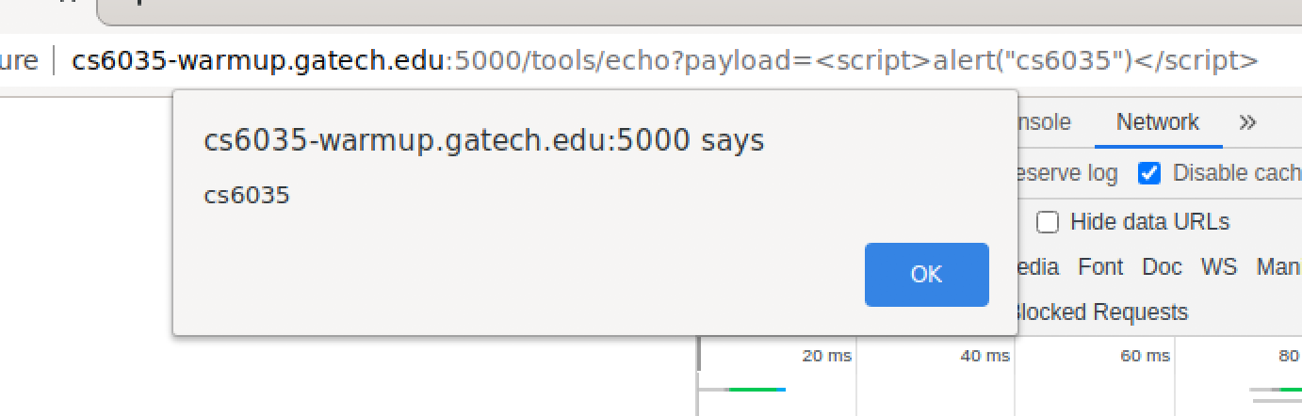

1.c

Activity 4

Congratulations!, you've successfully finished this activity. The answer is Birthday Cake

Acitivity 5