A Short Paper With The Usual Problems

Introduction
This document exists so that docxaudit has something public to run against. It is converted with pandoc, which is enough to reproduce several of the failures the tool looks for.

Method
We considered a set of $n$ observations and estimated $θ$ by minimising the loss L(θ)=i​(yi−f(xi))2 over the training split.
The estimator satisfies
$$\hat{θ}=\text{arg}\underset{θ}{\text{min}}L(θ).$$

Results
Method | Accuracy | Runtime (s)
Baseline | 0.71 | 12.4
Ours | 0.83 | 13.1
Table 1 reports accuracy on the held-out split.
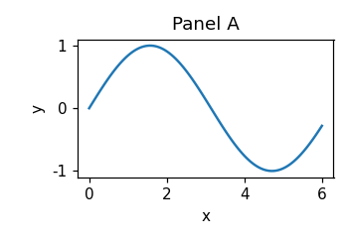
First figure
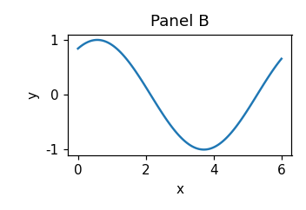
Second figure
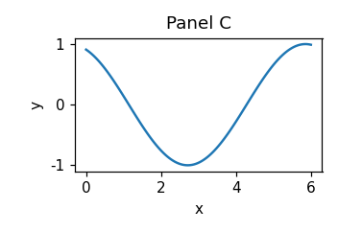
Third figure

Discussion
Nothing here is a real finding.

