Example operations review
  - Capacity results and next cycle actions
Example Analyst
2026-01-15
Example document

Contents

1 Summary
1.1 Outcome measures
2 Method and comparison
2.1 Capacity trend
2.1.1 Calculation example
3 Next actions

1 Summary
The example process completed 96 of 100 planned checks. The next cycle should keep the current staffing level and address the four outstanding checks. This report presents fictional operating data, the comparison method, and the next actions.
Prepared on 2026-01-15 by Example Analyst. The work mix appears in Figure 1, and the outcome measures are in Table 1.

1.1 Outcome measures
Table 1 — Planned and completed checks
Measure | Planned | Completed
Initial review | 40 | 39
Follow up review | 35 | 33
Final review | 25 | 24
Total | 100 | 96
The completion fraction is . The numerical result is a planning indicator, not a claim about any real organization.
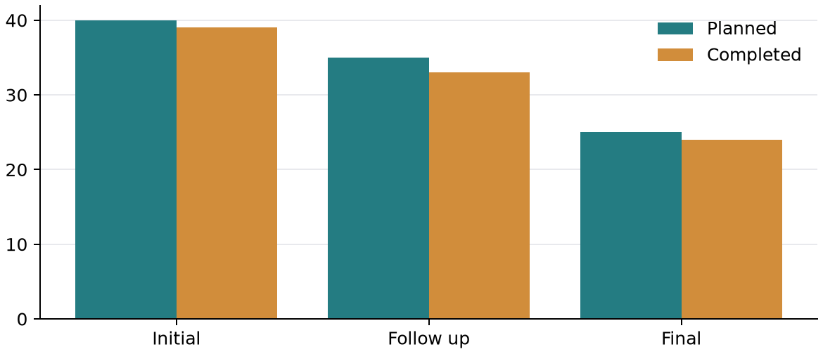
Figure 1 — Planned and completed checks

2 Method and comparison
The same counting rule applies to every group. A check counts as complete only when the example reviewer has recorded its result.

2.1 Capacity trend
Table 2 — Weekly capacity observations
Week | Capacity | Used
One | 100 | 82
Two | 100 | 89
Three | 100 | 96
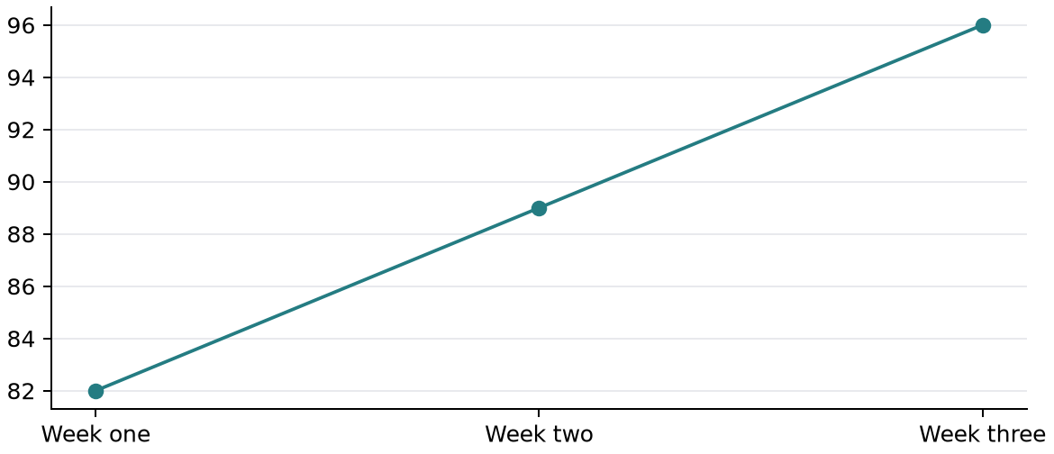
Figure 2 — Completed checks across three weeks
The arithmetic mean is defined by the following expression.
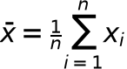

2.1.1 Calculation example
completed = [82, 89, 96]
mean_completed = sum(completed) / len(completed)
assert mean_completed == 89
Use the same observation window when comparing one cycle with another.

3 Next actions
Table 3 — Actions for the next review
Action | Owner | Status
Recheck four open items | Example Reviewer | Planned
Confirm next review date | Example Coordinator | Planned
Archive the completed checks | Example Analyst | Complete
☑ Validate the current sample totals.
☐ Review the four remaining checks.
☐ Compare the next result with Figure 2.
- Review the source table before publishing.
- Rebuild the report after changing any data.
See 1 Summary for the decision and Table 3 for ownership.

Counts are fictional. A completed check has a recorded result; repeated observations count once.

