**E MCM/ICM 2009714**

**Summary Sheet**

**Construction of environmental safety assessment system based on discrete regression model under the bakgrou nd of plastic pollution**

**Summary**

Our team is employed to solve the problem of plastic waste pollution that has become more and more important in recent years. Specifically, we need to create an evaluation model of the degree of environmental pollution caused by plastic waste in order to effectively evaluate the local level of pollution when considering plastic pollution in a country or region. As the problem of plastic pollution has received increasing attention from the international community in recent years, it is urgent to explore the impact of plastic waste on the natural environment and various countries.

Our team started by exploring the process of plastic waste generation, the industrial status of the plastic industry, and the chemical and biological role of plastic waste in the natural environment. We studied the European Plastics Industry Annual Report 2019, the pollution effects of microplastics in the marine environment, and the global database of Oxford University. Based on the data in the above research report, an environmental safety evaluation system was established using discrete regression, P

（y=1/x1,x2,x3）= 1

1+exp [−(β0+β1x1+β2x2+β3x3)]

，and the current upper and lower limits of

environmental quality and safety were 98.0 % and 4.07 %.

Based on the environmental safety assessment system , we also used the analytic hierarchy process to comprehensively evaluate the more typical countries in the world. The three elements of the reference layer C inherit the three variables in the regression model. The proportion of C 1 imports and exports, the utilization rate of C 2 substitutes, and the degree of C 3 policy implementation. And explained the country ranking. We then according to from 1980 to 2015 data (year 36 observations) using the gray model for the future development trend of disposable plastic products it is predicted. It is expected that the output of plastics will drop to a minimum of 0.37622, and it is concluded that the minimum amount of disposable plastic products that can be reached worldwide is 1.6 million tons.

According to the model and results, that in order to reduce global emissions of waste plastics, countries around the world need to work together, hand in hand, with the passage of time, which is bound to cause problems of uneven equity allocation, we carried out by national marginal effect Analyze, determine the optimal distribution amount 𝑄0 , and work out a suitable equity transfer mechanism scheme. And predict the future based on gray model of the plastics industry by 50 years to write a memo.

**Contents**

1. Introduction 3
   1. Plastic and microplastic waste 3
   2. The threat of microplastics 3
   3. Requirements for plastic pollution assessment systems 3
2. restatement 4
   1. Analysis of Problem One 4
   2. Analysis of Problem Two 4
   3. Analysis of Problem Three 5
   4. Analysis of Problem Four 5
   5. Analysis of Problem Five 5
3. Analysis, establishment and solution of the model 6
   1. Symbol definition 6
   2. Assumptions 6
   3. Environmental safety assessment model 6
      1. Establishing an Environmental Safety Evaluation Model with a Discrete Regression Model 6
      2. Analytic hierarchy process 11
   4. Establishing a gray model to predict global waste plastic waste .15 3.5 Sensitivity analysis 16
4. Conclusion 17
   1. Implementation plan for different countries or regions 17
      1. Implement regional management and balance the equity trading market 17
      2. Equity transfer in the region 18

Memorandum on the minimum target level of global waste plastic emissions 20

* 1. Waste plastic emission reduction standards 20
  2. Limitations of forecast timelines and factors that may accelerate or delay target achievement 21

References 23

Appendix 24

# Introduction

## Plastic and microplastic waste

Since the invention of plastic, plastic products have quickly become a part of people's daily life with its irreplaceable portability and low cost. However, by the own chemical structure of the polymer, the plastic article exhibits plastic throughout the natural environment is difficult to degrade the properties. However, people's plastic demand and output are increasing day by day. A steady stream of plastic waste flows into nature and accumulates as "white pollution." Among them, the seriousness of marine plastic garbage is imminent. Due to the role of the natural environment, a large amount of plastic garbage is often broken into plastic particles with a diameter of less than 1 cm after flowing into the seawater. When the diameter is less than 5 mm, it can be defined as microplastics [1] .

## The threat of microplastics

Microplastics are stable in the environment and can exist in the environment for hundreds or even thousands of years. Some microplastic particles, due to their hydrophilic chemical structure, will continuously adsorb toxic chemicals in the seawater environment, forming toxic polymer, which will cause more serious pollution to the environment. In addition, anatomical studies have shown that microplastic residues have been found in plankton and fish, but there is currently no research on the role of microplastics and their by-products along the food chain, and there is no direct evidence in the wild. Microplastics have impacted the ecosystem. Microplastics may cause compound chemical pollution damage to marine life, but its research on human health risks has rarely been confirmed by research [1].

## Requirements for plastic pollution assessment

**systems**

Because microplastics have been widely distributed in various levels of water in marine waters, it is reasonable to worry about the degree of pollution caused by microplastics. The existing scientific research results show that microplastics are distributed from the surface of the ocean to the deep water area of 5000 meters [2]. It is necessary to establish a reasonable evaluation system to assess the threat of plastic waste. We proceed from the current published academic papers, try searching for the plastic

industry plastic micro data and research data around the world to discuss the impact of several factors for the entire evaluation system, and build accordingly established a relevant evaluation model.

# restatement

The plastic manufacturing industry's output value has increased exponentially while bringing various negative impacts to the society. The amount of plastic product waste generated is extremely high, the recycling rate is low, and the environment is seriously polluted. The greatly shortened plastic production time has accelerated plastic consumption, far exceeding the plastic processing rate. To ensure that the environment is in a safe state, research how to reduce or even eliminate the waste of plastic products, change the way plastics are handled, and reduce the environmental pollution of plastic products. This problem is divided into the following five points: the maximum waste of plastic products can be reduced if the environment is not destroyed, and the amount of plastic waste can be reduced when the environment is at a safe level; Forecast the future minimum target level of plastics.

## Analysis of Problem One

Problem one studies the maximum amount of disposable plastic product waste that can be mitigated without causing damage to the environment. This question focuses on whether the environment will be destroyed, that is, when the carrying capacity of the environment will reach the threshold. Therefore, we need to consider the source of disposable plastic waste. In both cases, it is either generated by the country itself or imported from abroad. This has something to do with the import and export volume of disposable plastic waste in various countries. In addition, whether the country has a policy to deal with disposable plastic waste is also very relevant, and whether there are alternatives to disposable plastic waste and advanced technology. So, if we look through the introduction of a one-time import and export volume of plastic waste in different countries and regions worldwide, and government policies and whether there are alternatives to the relevant data, 0-1 treatment, regression equations were environmental safety level metrics, The maximum amount of wasted product is then obtained.

## Analysis of Problem Two

Through the first question to understand the environmental capacity of waste plastics, analyze the social factors that may cause this degree of influence in various regions. Under artificial control, if the amount of waste plastics disposable reduce damage to the environment, by reducing a time of waste plastics waste so as to achieve emission levels of environmental safety. Based on the environmental safety evaluation model established in Question1, and then using the analytic hierarchy process to comprehensively evaluate each country, the influence weight of national social factors is obtained, and the environmental safety level of each country is explained.

## Analysis of Problem Three

Combining issues one and two, we can see a series of relationships between environmental capacity and human behavior in the natural environment. Set a minimum waste volume goal, that is, reduce human waste and improper disposal through artificial control based on environmental capacity. You can infer the trend of the decline in plastics by inferring the level of plastics treatment. Because there are many uncertain and complicated factors, a gray model is used for prediction.

## Analysis of Problem Four

Through question two, it is known that the level of environmental safety under the social influence of each region can be obtained. Equity allocation considers relative fairness rather than absolute fairness. It is necessary to determine the equity allocation plan, carry out a marginal effect analysis on each country, and determine the optimal allocation amount. There is mutual supervision between countries and the purchase of initial equity by itself. Over time, equity distribution will inevitably face mismatches, so appropriate equity transfer mechanisms should be identified.

## Analysis of Problem Five

The lowest target level of disposable plastic waste in the world can be considered when the plastic is not replaced, when the amount of plastic waste and improper disposal of plastic is minimized. From the grey model of question three, the future situation of waste plastic treatment can be derived, and the future trend of the plastics industry can be inferred.

# Analysis, establishment and solution of the model

## Symbol definition

|  |  |
| --- | --- |
| **symbol** | **meaning** |
| **M** | Target layer |
| **C** | Criterion layer |
| **P** | Solution layer |

## Assumptions

* + 1. Assume that the global financial crisis will not have a major impact on the plastics industry in the next few hundred years.
    2. The political situation in the world is stable and there is no turbulent

war.

* + 1. Factors affecting waste of plastic products will maintain their

existing trend. This assumption eliminates the possibility of a major event on these factors. With its help, we can later apply the GM (1,1) model to these factors.

## Environmental safety assessment model

### Establishing an Environmental Safety Evaluation Model with a Discrete Regression Model

Set the security of each country (region) at the level of environmental safety as Y, Y ∈ [ 0,1] . When Y = 0 , the country is considered to have poor security; when Y = 1 , the country is considered to be poor Or regional security.

Under the environmental safety level, without considering the influence of other interference factors, it is considered that the environmental safety level of each country or region is affected by the plastic waste level of that country or region, and the plastic waste level of each country is One of the main metrics.

Analyze the factors that may affect the level of plastic waste in various countries, and select three social human factors specifically, the relative

proportion of waste plastic imports and exports, the strength of policy implementation, and whether there are effective alternatives (the proportion of alternatives used). Defined as independent variables x1，x2， x3.

When x1 = 0, the country is considered to be a completely waste plastic importing country, and only waste plastic is imported, and not exported; When x1 = 1, the country is considered to be a completely waste plastics exporting country, and only exports waste plastic. import. x1∈

[ 0,1] .

When the x2 = 0, it is considered that there were no proper use of plastics processing policy or policy enforcement is zero; when the x2 = 1, it is considered the country about the use of plastic processing policy enforcement to 1. 00 %. x2∈[ 0,1] .

When x3 = 0, it is considered that there was no effective alternative to

plastic or presence of an effective utilization of alternatives but zero; when x3 = 1, it is considered that the country of use plastic substitute rate of 1 00 %. x3∈[ 0,1] .

Build a regression model:

P（y=1/x1,x2,x3）= 1

1+exp [−(β0+β1x1+β2x2+β3x3)]

Among them, P indicates that under the influence of three social human factors, the country's environment can use the future development space.

Let Z=β0  β1x1+β2x2+β3x3。

|  |  |  |  |  |
| --- | --- | --- | --- | --- |
| **x1** | **x2** | **x3** | **Y** | **Frequency** |
| 0 | 0 | 0 | 0 | 92 |
| 0 | 0 | 1 | 0 | 55 |
| 0 | 1 | 0 | 0 | 47 |
| 0 | 1 | 1 | 0 | 14 |
| 1 | 0 | 0 | 0 | 17 |
| 1 | 0 | 1 | 0 | 7 |
| 1 | 1 | 0 | 0 | 5 |
| 1 | 1 | 1 | 0 | 3 |
| 0 | 0 | 0 | 1 | 4 |
| 0 | 0 | 1 | 1 | 11 |
| 0 | 1 | 0 | 1 | 13 |
| 0 | 1 | 1 | 1 | 32 |
| 1 | 0 | 0 | 1 | 23 |
| 1 | 0 | 1 | 1 | 43 |

|  |  |  |  |  |
| --- | --- | --- | --- | --- |
| 1 | 1 | 0 | 1 | 53 |
| 1 | 1 | 1 | 1 | 67 |

Select a number of typical countries and regions around the world to idealize them, and consider that x1，x2，x3 have only two values of 0 and 1 . Perform discrete regression on the above data.

**Variables in the equation**

|  |  |  |  |  |  |  |  |
| --- | --- | --- | --- | --- | --- | --- | --- |
|  | | B | Standar d error | Wald | Degrees of freedo  m | Salienc y | Exp(B) |
| **Step 1a** | trade | 3.343 | .299 | 125.172 | 1 | .000 | 28.297 |
| policy | 2.047 | .284 | 52.059 | 1 | .000 | 7.743 |
| alternative  s | 1.660 | .278 | 35.751 | 1 | .000 | 5.259 |
| constant | -3.158 | .310 | 103.794 | 1 | .000 | .043 |

**a. Variables entered in step 1 : trade, policy, alternatives.**

Z=-3.158+3.343x1+2.047x2+1.660x3

From the analysis of the above table, we can see that the three human factors have passed the significance test, indicating that they have a significant impact on the level of waste plastic in the country.

|  |  |  |
| --- | --- | --- |
| **x1** | **1** | **0** |
| **x2** | 1 | 0 |
| **x3** | 1 | 0 |
| **z** | 3.892 | -3.158 |
| **P** | 0.980004 | 0.040777 |

Now x1，x2，x3 respectively do 0-1 treatment.

When xi（i=1,2,3）are all taken 0，the country is on the edge of the security environment without the prevention and control of human factors,

which means the future development and utilization space of the country is P0=4.08%，waste plastic occupancy rate Q0=1-P0=95.92%.

When xi(i=1,2,3) are all set to 1，hat is, under the strict control of

human factors, the country is at the safest level. At this time, the country's

future development and utilization space is P1=98.0%，Plastic occupation rate Q1=1-P1=2%。

Environmental safety level is assumed that the environment may be a capacity of 100%，and the capacity beyond that is in an unsafe state,. The peak level of unsafe environmental is the threshold value of environmental carrying capacity, and exceeding it means collapse. The warning zone is between the environmental carrying capacity and the environmental safety level, and the warning zone is an unsafe zone.

P1 is the available storage capacity of the environment under the control conditions, that is, regardless of the natural adjustment capacity of the ecological environment, there will be 1-P1=2.00% pollution share of waste plastics. 1-P1 is an irreversible factor, an inevitable result of the influence of natural factors, and cannot reach the optimal state in the model, that is, the source of pollution is always present, and waste plastic will also exist in the natural environment under non-human action, which is consistent with the reality.

It can be known from the above that when xi= 0, the country is at the edge of environmental safety, that is, the largest share of waste plastics, that is, the data required in question one is that the largest share of disposable plastics is 95.92%。

In order to ensure the environmental safety level,，we take artificially

control of the condition of xi=0 to make it close to P1 as much as possible.

at this time the amount of waste that can be artificially reduced is less or equal to P1-P2，P1-P2is In order to ensure the environmental safety level, the amount of waste that can be manipulated manually. Therefore, reducing the disposable waste plastic occupancy rate by up to 93.92% in any country can ensure that the environment is always at a safe level. Different countries need to reduce the different share of disposable plastic waste. The following uses the United States, China, Italy, and Malaysia as examples

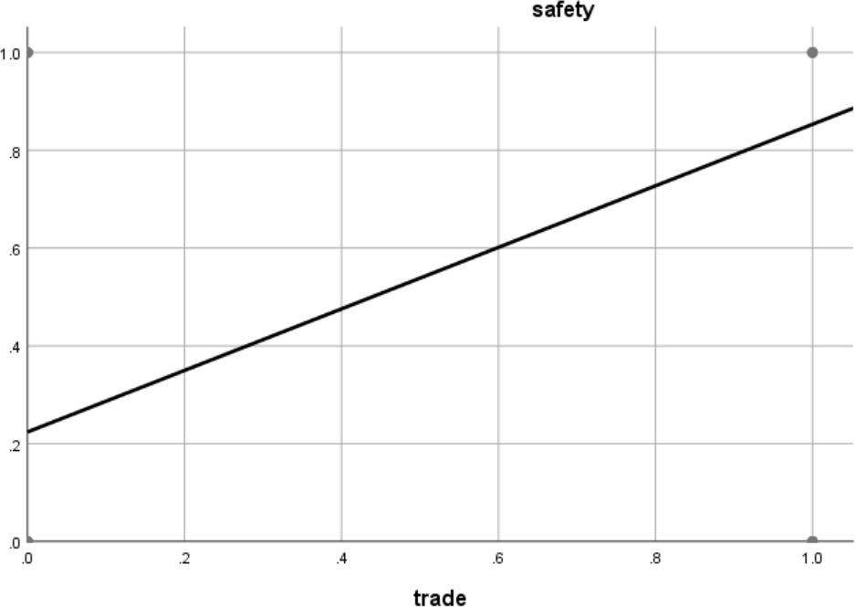

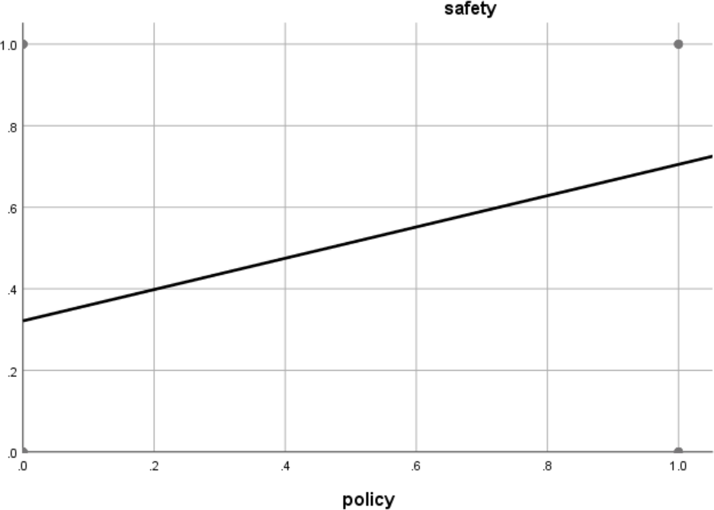

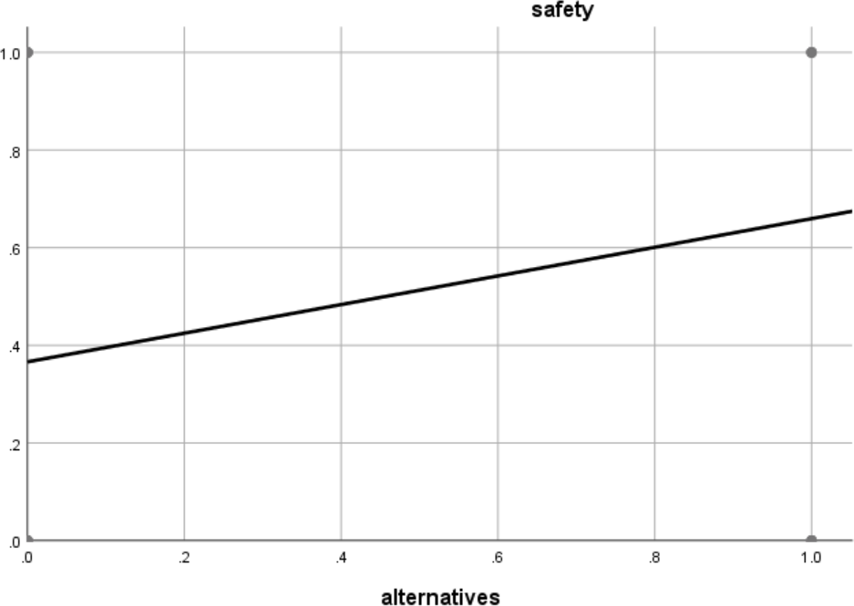

Through SPSS correlation analysis, we can see that among the three factors, the impact of x1 (trade) is the most significant, followed by the impact of x2 (policy), and the third is x3 (alternatives).

So we can use the above three indicators to evaluate the four countries of the United States, China, Italy, and Malaysia.

Among the four countries, the United States and Italy are developed countries, and China and Malaysia are developing countries. They are located in Asia, Europe, and North America. Before 2017, China was the largest importer of disposable waste plastics. After the promulgation of a plastics restriction order in 2017, it no longer imports garbage. Since then, Malaysia has become the largest importer of disposable waste plastics, so these four countries are very typical.

### Analytic hierarchy process

#### Establish a analytic hierarchy process model

The decision problem is decomposed into three levels, the uppermost layer is the target layer M, that is to select the most appropriate evaluation of the degree of environmental safety of key indicators; lowermost layer

for the program, namely Si Ge countries P1, P2, P3, P4; intermediate layer The standard level includes three indicators of import and export volume C1, substitute C2, and policy C3 (as shown in Figure 1):

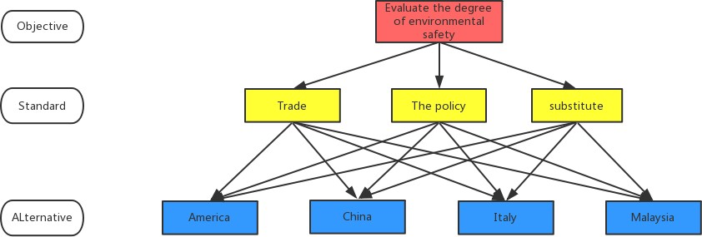

#### Model Solving 2

Figure 1: Analytical display

#### ① Construct the judgment matrix MC: Compare the three elements C1, C2, and C3 in the reference layer C one by one to obtain a pairwise comparison matrix.

|  |  |  |  |
| --- | --- | --- | --- |
| **M** | **C1** | **C2** | **C3** |
| **C1** | 1 | 2 | 2 |
| **C2** | 1/2 | 1 | 1 |
| **C3** | 1/2 | 1 | 1 |

After solving the eigenvalues of M-C，he weight vector ω = (0.5000 , 0.2500 , 0.2500) *T* can be easily obtained. From the formula

*CI*  ** max n

n -1

*CR*  *CI*

,and according to the calculation *RI* ,we can know CR=-

8.54021016 <0.1, which passed the consistency test.

|  |  |  |  |  |  |  |  |  |  |  |
| --- | --- | --- | --- | --- | --- | --- | --- | --- | --- | --- |
| ***n*** | **1** | **2** | **3** | **4** | **5** | **6** | **7** | **8** | **9** | **10** |
| *RI* | 0.00 | 0.00 | 0.52 | 0.89 | 1.12 | 1.26 | 1.36 | 1.41 | 1.46 | 1.49 |

Table 2 Relationship between n and RI

#### ②Construct judgment matrices C1-P、C2-P、C3-P。

|  |  |  |  |  |
| --- | --- | --- | --- | --- |
| **C1** | **P1** | **P2** | **P3** | **P4** |
| **P1** | 1 | 4 | 2 | 7 |
| **P2** | 1/4 | 1 | 1/2 | 2 |
| **P3** | 1/2 | 2 | 1 | 3 |
| **P4** | 1/7 | 1/2 | 1/3 | 1 |

Table 3 C1-P judgment matrix

|  |  |  |  |  |
| --- | --- | --- | --- | --- |
| **C2** | **P1** | **P2** | **P3** | **P4** |
| **P1** | 1 | 2 | 1/2 | 5 |
| **P2** | 1/2 | 1 | 1/3 | 3 |
| **P3** | 2 | 3 | 1 | 7 |
| **P4** | 1/5 | 1/3 | 1/7 | 1 |

Table 4 C2-P judgment matrix

|  |  |  |  |  |
| --- | --- | --- | --- | --- |
| **C3** | **P1** | **P2** | **P3** | **P4** |
| **P1** | 1 | 1/2 | 1/4 | 3 |
| **P2** | 2 | 1 | 1/2 | 5 |
| **P3** | 4 | 2 | 1 | 7 |
| **P4** | 1/3 | 1/5 | 1/7 | 1 |

Table 5 C3-P judgment matrix

Similarly, the consistency check of the judgment matrix is as follows:

|  |  |  |  |
| --- | --- | --- | --- |
| ***judgment matrix*** | **C1-P** | **C2-P** | **C3-P** |
| *CI* | 0.0026 | 0.0064 | 0.0094 |
| *CR* | 0.0029 | 0.0072 | 0.0106 |

Table 6 Consistency ratio table of judgment matrix

As can be seen from the above table, the judgment matrices have all passed the consistency check.

#### ③ Calculate weight

After passing the consistency check, we calculate the weight of the criterion layer C for each country in the P layer. Because the previous papers used the analytic hierarchy process to solve practical problems, they used one of the methods to find the weight, and different calculation methods may cause the results to be biased. In order to ensure the robustness of the results, this article uses three methods to obtain the

weights, and then to obtain the average weight. This avoids the bias generated by a single method, and the conclusions drawn will be more comprehensive and effective.

Import and export volume:

|  |  |  |  |  |
| --- | --- | --- | --- | --- |
|  | **Arithmetic mean** | **Geometric averaging** | **Eigenvalue method** | **Average weight** |
| **United States** | 0.5305 | 0.5310 | 0.5305 | 0.5307 |
| **China** | 0.1374 | 0.1373 | 0.1374 | 0.1374 |
| **Italy** | 0.2556 | 0.2555 | 0.2557 | 0.2556 |
| **Malaysia** | 0.0765 | 0.0763 | 0.0764 | 0.0764 |

Alternatives:

|  |  |  |  |  |
| --- | --- | --- | --- | --- |
|  | **Arithmetic mean** | **Geometric averaging** | **Eigenvalue method** | **Average weight** |
| **United States** | 0.2879 | 0.2879 | 0.2878 | 0.2879 |
| **China** | 0.1623 | 0.1619 | 0.1615 | 0.1619 |
| **Italy** | 0.4894 | 0.4901 | 0.4905 | 0.4900 |
| **Malaysia** | 0.0604 | 0.0601 | 0.0601 | 0.0602 |

Policy:

|  |  |  |  |  |
| --- | --- | --- | --- | --- |
|  | **Arithmetic mean** | **Geometric averaging** | **Eigenvalue method** | **Average weight** |
| **United States** | 0.1478 | 0.1469 | 0.1470 | 0.1469 |
| **China** | 0.2799 | 0.2808 | 0.2793 | 0.2800 |
| **Italy** | 0.5129 | 0.5136 | 0.5148 | 0.5138 |
| **Malaysia** | 0.0594 | 0.0587 | 0.0589 | 0.0590 |

A composite matrix that calculates the weights of the scheme layer and the criterion layer

|  |  |  |  |  |
| --- | --- | --- | --- | --- |
|  | **United States** | **China** | **Italy** | **Malaysia** |
| **import and**  **export** | 0.5307 | 0.1374 | 0.2556 | 0.0764 |
| **alternatives** | 0.2879 | 0.1619 | 0.4900 | 0.0602 |
| **Policy** | 0.1469 | 0.2800 | 0.5138 | 0.0590 |

Calculated in the regression model formula

|  |  |  |  |  |
| --- | --- | --- | --- | --- |
| Country /  region | United  States | China | Italy | Malaysia |
| import and  export | 0.5307 | 0.1374 | 0.2556 | 0.0764 |
| Policy | 0.1469 | 0.28 | 0.5138 | 0.059 |
| alternatives | 0.2878 | 0.1619 | 0.49 | 0.0602 |
| Z value | -0.60542 | -1.85676 | -0.43838 | -  2.68189 |
| **P value** | **0.353105** | **0.135081** | **0.392127** | **0.06405** |

The P value is shown above, Italy> United States > China > Malaysia. According to the environmental safety assessment system established earlier, it is known that the environmental level of the four countries (mainly the level of waste plastics) is the best in Italy, the second in the United States, the second in China, and the worst in Malaysia. It is basically consistent with the actual situation, so it can be considered that the evaluation system established in this question has certain reliability and

can be used for environmental level inspection.

## Establishing a gray model to predict global waste

**plastic waste**

Through the previously established environmental safety assessment model, we can know that the country's policies and the development of the plastic industry have a significant impact on the waste of disposable plastic products. In addition, there are many social uncertainties that will affect the waste of disposable plastic products. Due to the complexity of uncertainties, we use grey prediction models to predict the amount of waste in future plastic products.

If a set of time series data has a clear trend, the gray prediction model in gray system theory can give accurate predictions even when the amount of data is small (at least 5 individuals). Based on Assumption 3 , we apply the GM (1,1) model (the most widely used gray prediction model) to predict the waste of disposable plastic products. Our data from 1980 years to 2015 data[4] , it is sufficient for GM (1,1) model.

The prediction results are shown in the figure. Through the gray model prediction, it is known that the amount of disposable plastic products is expected to reach the lowest in 2316, which will drop to 0.37622 in 1980. According to the data [3], it is known that the global waste of products in

2010 was 27.327 million tons. The lowest amount of disposable plastic products that can be achieved worldwide is 1.6 million tons.

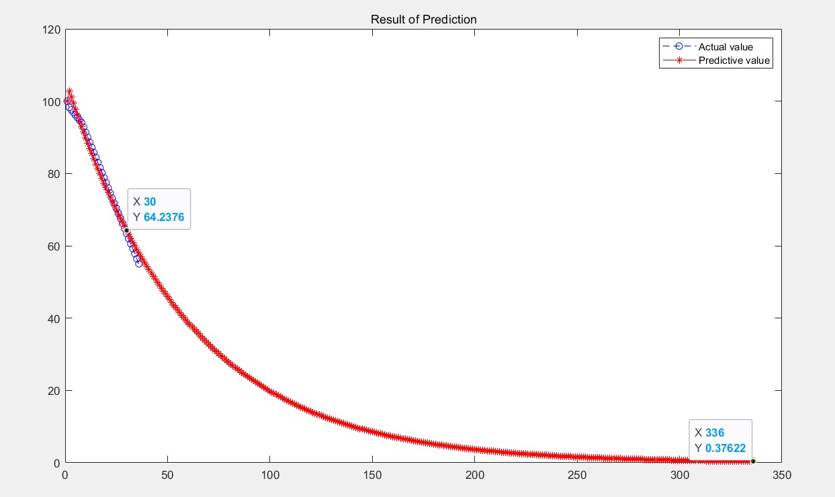

## Sensitivity analysis

Our regression model for all variables 0- 1 analysis, so the results have been absolutely representative, given the level of upper and lower limits in a safe environment under ideal conditions. The model thus established is widely applicable and can give more accurate numerical estimates of the environmental safety of various countries. Through the country's environmental security level, compared with the world, we can very well estimate the future development prospects. Carry out industrial planning, technological innovation, and policy reforms to maximize global benefits. In reality, the data needs to be collected and sorted every year, and the model is time-effective and limits continuity. Global environmental quality estimates need to be performed within a fixed period to ensure that models

reflect the true level of each country's environment.

Because the gray model has great dependence on historical data, the model requires higher data accuracy. The regression model is based on an idealized model, and the level of the environment reflected is more extreme, with a certain deviation.

# Conclusion

## Implementation plan for different countries or regions

From the data we have collected, it is clear that the production, waste disposal, and import and export of the disposable plastics industry are uneven across countries. Therefore, although we have established the above-mentioned environmental safety assessment model, the responsibility weight of each country in this action should be different for the global one-time waste plastic emission reduction treatment . This is also the same conclusion that the distribution of known waste plastic production and treatment varies from country to country. We have noticed that there are differences in the cost and capacity of different countries to invest in waste disposal. For example, although the more developed countries have more advanced plastic waste treatment systems and technologies, their smaller land areas and higher labor costs have led to higher costs for plastic waste treatment in European and American countries. In addition, most European and American countries are the main producers of plastic waste, and their national processing capacity is not capable of such a huge amount of processing capacity; in contrast, some developing countries can effectively handle large amounts of waste due to low construction costs and labor costs plastic. The supply and demand relationship between the two has always been reflected in the volume of waste plastic imports and exports in various countries.

In view of the possible issue of equity distribution, we believe that a system of coexistence of global integration and regional economicization can be implemented. Establish equity management mechanism.

### Implement regional management and balance the

**equity trading market**

According to the environmental safety assessment model, the waste level of each country and region is evaluated, and the countries and regions of the same level are divided into one equity share. Each country in the region enjoys ownership but not control of equity.

The countries in the region make free claims for the first time, followed by paid distribution, and the proportion of paid distribution increases year by year. Reserved shares are reserved in the region.

As shown in the figure, the curve MSC represents the marginal social treatment cost of waste plastic, the marginal social cost decreases, and the curve slopes to the lower right. The curve MEC represents the marginal external cost of waste plastic. The marginal external cost increases, and the curve slopes to the upper right. The two curves intersect at a point（Q0， P0），which represents the optimal level of waste plastic treatment in society and the optimal market price of equity. The regional total control center controls the total amount of the region, that is, the optimal equity quota issued is Q0.

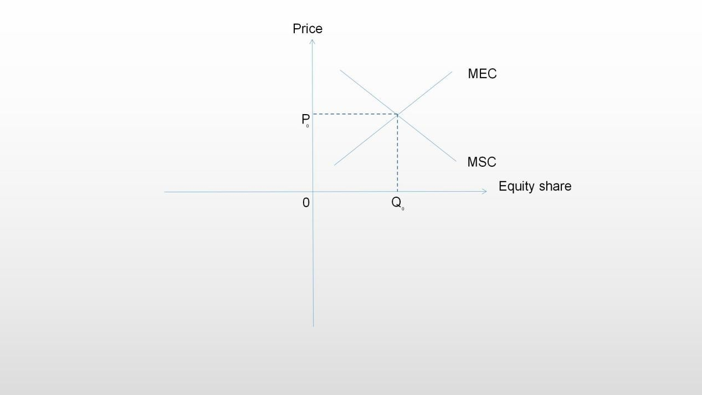

### Equity transfer in the region

Clarify equity transfer agreements and establish equity transfer mechanisms. Ensure that both parties to the contract achieve a zero-sum game.

Countries in the region enjoy equity in their own shares. When the share of a certain country is insufficient, they can conduct equity transfer transactions to other countries in the same region.

Option processing of equity, after the two parties of the contract reach an agreement, the buyer pays a certain shareholding fee to the seller to obtain a right to buy or sell a certain share of equity at a specific price in the future.

The profits and losses of the two parties in the agreement are as follows. L1 represents the buyer and L2 represents the seller.

After paying a certain premium to the seller, the purchaser has the right to buy or sell equity at a price agreed in the contract within a certain

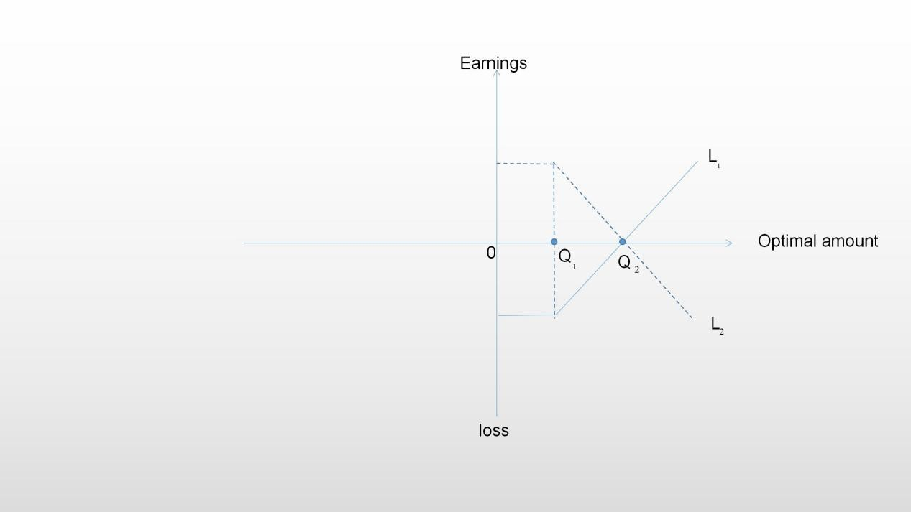period of time in the future. When the buyer's optimal amount Q1 is less than or equal to the present value of the equity amount, it is in a loss state, and the loss amount is the premium. The seller is profitable, and the profit amount is the premium. When the optimal amount gradually increases, the loss and profit decrease year-on-year; when the optimal amount Q2 is greater than the equity amount, the buyer makes a profit and the seller loses . At this time, the buyer can choose to purchase an appropriate amount of shares and sell the remaining amount of shares.

# Memorandum on the minimum target level of global waste plastic emissions

## Waste plastic emission reduction standards

Through the aforementioned grey prediction model, fitting the proportion of improper treatment in the global amount of waste plastics, we obtained a curve that approximates an exponential decay. Our real data is based on the time series as the horizontal axis and is arranged in increasing order from 1980 to 2015. The figure shows the predicted values of the proportion of waste plastics improperly treated after 15 years, 50 years, 100 years, 150 years, and 200 years based on 2015. Our team recommends that ICM use this forecast as a criterion for assessing global emissions of waste plastics. The reasons are as follows:

The current society has made a clear division of the whereabouts of plastic waste: recycling, harmless treatment and improper disposal [4] . Among them, harmless treatment includes: standardized landfill treatment; incineration treatment that complies with standard procedures and pre- treatment compost treatment. These three treatments can ensure that plastic waste does not flow into the natural environment in the form of a pollution source. Therefore, the discharge of this part of plastic waste will not affect the natural environment. Under the premise that the current plastic product manufacturing process cannot make breakthrough progress, we assume that non-degradable disposable plastics still occupy the main position of plastic products. Impact, we only need to reduce the discharge of improperly disposed waste.

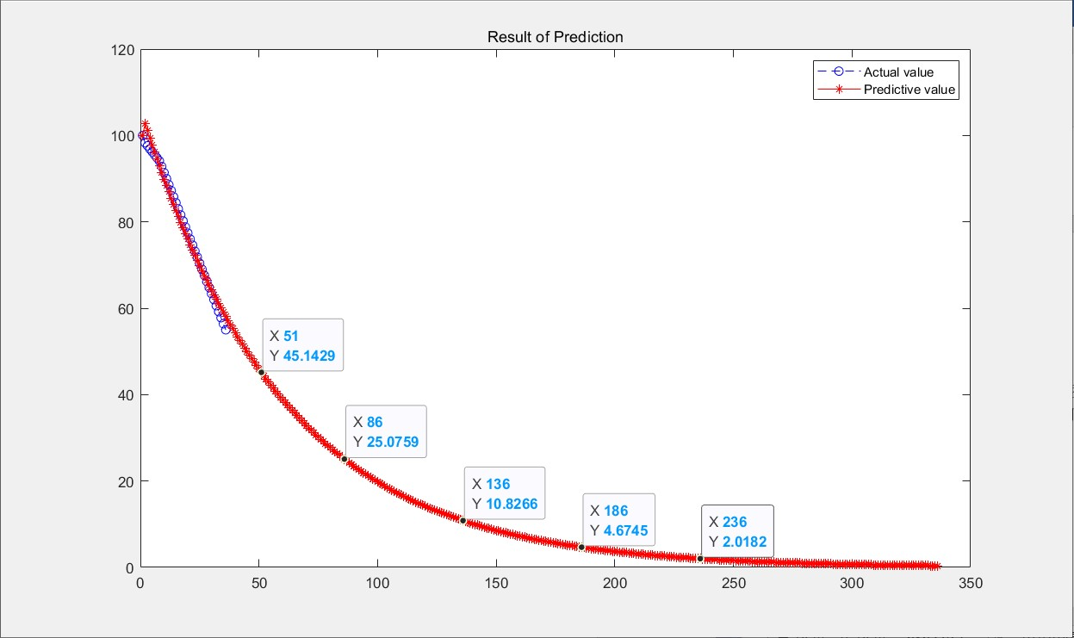

Therefore, we will use the above-mentioned time node as the evaluation standard for the staged emission reductions. By 2030, the proportion of improperly handled waste plastics should be reduced to 45%, before 2065, the proportion should be reduced to 25% etc. The target value is as follows:

|  |  |  |  |  |  |
| --- | --- | --- | --- | --- | --- |
| **Year** | **2030** | **2065** | **2115** | **2165** | **2215** |
| **Data** | 45.1429% | 25.0759% | 10.8266% | 4.6745% | 2.0182% |

## Limitations of forecast timelines and factors that may accelerate or delay target achievement

This timeline was established with a gray prediction model. Grey prediction is a method of predicting a system containing uncertain factors. Grey prediction identifies the degree of disparity in development trends between system factors, that is, performs correlation analysis, and generates and processes the original data to find the rules of system changes, and generates data sequences with strong regularity, thereby making future development trends prediction. The data and forecast data used by our team from 1980 to 2015 passed the correlation test, which has certain reliability at the statistical level.

However, the gray forecast is a fuzzy system, and the assumption we make here is that no breakthrough will occur in the plastic manufacturing process in this forecasting environment. That is to say, the progress and popularity of science and technology will have a more significant impact on the forecast value.

It is foreseeable that when the cost of the degradable plastic manufacturing process is greatly reduced, the hard-to-degradable disposable plastics will be quickly eliminated, so the goal of reducing emissions will also be achieved substantially in advance. Correspondingly, uncontrollable factors such as the turmoil in the world's political situation and the outbreak of war will greatly delay the achievement of goals.

1. Li Daoji, marine micro plastic pollution and its countermeasures recommended . Environmental Science , 2019.32 (02): the first 197-202 pages .
2. OCEANOGRAPHY, etc. , marine pollution and micro-plastic plastic Advances in Microbial Degradation . Application of oceanography Journal , 2019.38 (04): the first 490-501 pages .

[3]. The data of waste plastics worldwide https://ourworldindata.org/plastic- pollution?utm_source=wechat_session&utm_medium=social&utm_oi=10161059245 73896704

[4]. Plastics the facts2019 htt[ps://www.plasti](http://www.plasticseurope.org/en/resources/market-)c[seurope.org/en/resources/market-](http://www.plasticseurope.org/en/resources/market-) data

function GeryExpect(A) syms alph um; c=[alph,um]'; Ago=cumsum(A); n=length(A);

for k=1:(n-1)

Z(k)=(Ago(k)+Ago(k+1))/2;

end

Yn =A;

Yn(1)=[];

Yn=Yn';

E=[-Z;ones(1,n-1)]'; c=(E'*E)\(E'*Yn);

c= c'; alph=c(1); um=c(2); matrixF=[];

matrixF(1)=A(1); for k=2:(n+300)

matrixF(k)=(A(1)-um/alph)/exp(alph*(k-1))+um/alph;

end PredictG=[];

PredictG(1)=A(1); for k=2:(n+300)

PredictG(k)=matrixF(k)-matrixF(k-1);

end t1=1:n;

t2=1:(n+300);

plot(t1,A,'bo--'); hold on;

plot(t2,PredictG,'r*-'); title('Result of Prediction');

legend('Actual value','Predictive value');

%%%%%%%%%%%%%%%%%%%%%%%%%%%%

disp('input matrix A') A=input('A=');

[n,n] = size(A); Sum_A = sum(A);

SUM_A = repmat(Sum_A,n,1); Stand_A = A ./ SUM_A; disp('Arithmetic mean：'); disp(sum(Stand_A,2)./n) Prduct_A = prod(A,2); Prduct_n_A = Prduct_A .^ (1/n); disp('Geometric averaging：');

disp(Prduct_n_A ./ sum(Prduct_n_A)) [V,D] = eig(A);

Max_eig = max(max(D)); [r,c]=find(D == Max_eig , 1); disp('Eigenvalue method：'); disp( V(:,c) ./ sum(V(:,c)) ) CI = (Max_eig - n) / (n-1);

RI=[0 0.0001 0.52 0.89 1.12 1.26 1.36 1.41 1.46 1.49 1.52 1.54 1.56 1.58 1.59]; CR=CI/RI(n);

disp('CI=');disp(CI);

disp('CR=');disp(CR); if CR<0.10

disp('Acceptable');

else end

disp('Unacceptable');