

Liu Xingxing

Associate Professor

China Agricultural University

E-mail: [liuxingxing56285@163.com](mailto:liuxingxing56285@163.com)

Tel: 8615810518672

Reference Letter

Dear Sir/Madam,

As the supervisor of Mr. Qizhi Guo’s project and academic teacher for the course of *Microcontroller Principles & Application*, I am very glad to provide this letter to support Qizhi’s application for your postgraduate programme.

I initially familiarized with him when I instructed his academic project, in which he showcased strong logical thinking and creative spirit as well as experimental ability. In the project, he innovatively combined LED with the left-right scanning program, achieving the goal of cross scanning. Encountering difficulties, he always searched information and conducted proper investigation in order to find appropriate methods to complete the project. Eventually, he finished his paper combined with key points learnt in classes with well-organized and clear statement, which was also published. As to personal character, he was also impressed me by his great optimism and confidence.

When he attended my course, because of the outbreak of COVID-19, I have to develop my teaching online. Unlike some students who were slacked off in study because of lacking supervision, Qizhi still listened to me attentively and took the initiative to answer my questions. For every coursework, he treated very seriously until he could complete it relatively perfect. As a goal-oriented and enterprising man, he clearly knows where his real interest lies in and what he should do next.

Therefore, I am very pleased to support his decision to pursue his master degree in your distinguished university. Due to his devotion to the major and strong ability, I was convinced that he will be better in the future study. I will be grateful if you could give him favorable consideration. If more specific information is needed about him, please feel free to contact me.

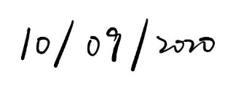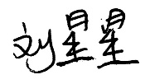Best wishes,

Liu Xingxing

SEP. 29, 2020