本文档主要记录的是关于xgboost的predict函数中部分参数的含义，主要涉及参数output_margin、pred_leaf、pred_contribs。
output_margin：是否输出原始未变换幅度值，如果为True，则分两种情况，对于二分类，该值为样本分到每颗树下叶子节点的权值累加；对于多分类和回归问题，该值为样本分到每颗树下叶子节点的权值累加后再加上偏置0.5得到；
pred_leaf：输出每个样本对应于每颗树下的叶子节点索引，输出形状为(nsample,ntrees)，对于二分类，ntrees=num_boost_round，对于多分类，ntrees=nclass*num_boost_round*num_parallel_tree，num_parallel_tree默认为1；
pred_contribs：在预测阶段，每个特征的贡献(SHAP值)，所有特征贡献总和加上bias即为原始未变换幅度值。输出形状为(nsample,nfeats+1)，对于多分类，输出形状为(nsample, nclass,nfeats+1)，最后一列为bias，最后一维求和后的结果等于参数output_margin为True时的结果
参数含义参考：
1、https://xgboost.readthedocs.io/en/latest/prediction.html中Prediction Options
2、https://xgboost.readthedocs.io/en/latest/python/python_api.html中predict函数参数描述
3、shap值解释参考https://zhuanlan.zhihu.com/p/79556002?from_voters_page=true

1、首先，xgboost的叶子节点值是什么东西？
从原理看，xgboost由于梯度采用的是泰勒二阶展开近似，叶子节点输出值wj(即叶子结点的权重)是wj= -Gj/(Hj+λ) ，其中Gj是所有落到这个叶子结点的一阶导，Hj是所有落到这个叶子结点的二阶导，λ是叶子节点的正则系数。

二分类下输出解释：
代码：
import xgboost as xgb

from sklearn.datasets import load_breast_cancer
from sklearn.model_selection import train_test_split

data = load_breast_cancer()
x_data = data.data
y_data = data.target

x_train, x_test, y_train, y_test = train_test_split(x_data, y_data, test_size=0.2)
dtrain = xgb.DMatrix(x_train, y_train)
dtest = xgb.DMatrix(x_test[0:10], y_test[0:10]) # 只取10个样本测试，方便输出展示

# reg:logistic
params = {'objective': 'reg:logistic', 'booster': 'gbtree', 'max_depth': 3, 'silent':1}
watch_list = [(dtrain, 'train'), (dtest, 'eval')]
model = xgb.train(params=params, dtrain=dtrain, num_boost_round=5, evals=watch_list)

# 打印模型结构
model.dump_model('reg_logistic_model.txt')

# 预测：
# 模型转换后的输出值
ypred = model.predict(dtest)

# 模型原始的输出值（logistic输出前），叶子节点的权重值累加
ypred_margin = model.predict(dtest, output_margin=True)

# 原始输出值所在的叶子节点下标，将叶子节点的下标对应的值相加即为output_margin=True时的结果
ypred_leaf = model.predict(dtest, pred_leaf=True)

print('='*20, 'prob', '='*20)
print(ypred)
print('='*20, 'margin', '='*20)
print(ypred_margin)
print('='*20, 'leaf', '='*20)
print(ypred_leaf)
输出结果
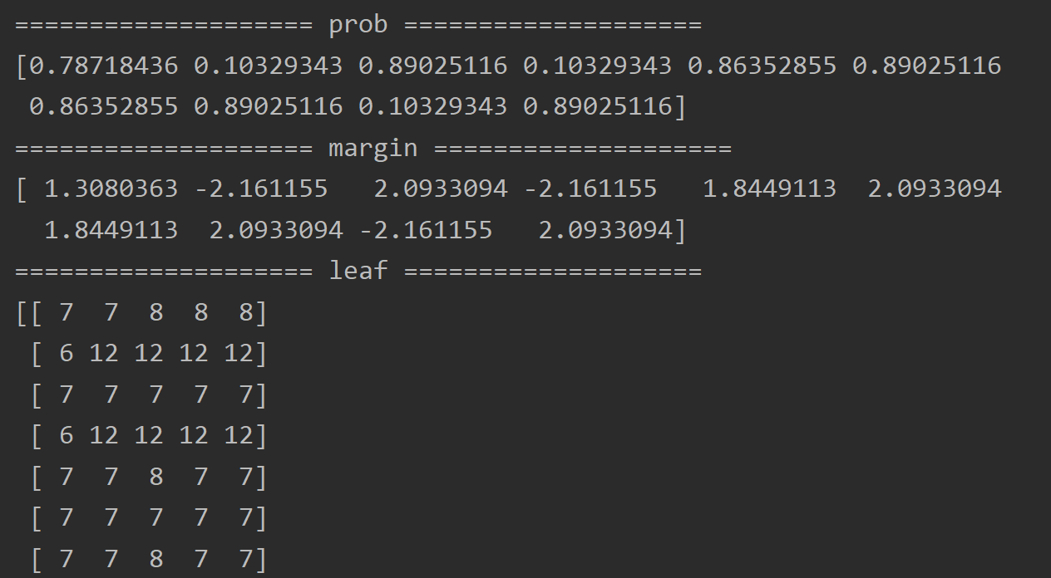
模型文件内容为
booster[0]:
0:[f23<884.549988] yes=1,no=2,missing=1
1:[f27<0.160299987] yes=3,no=4,missing=3
3:[f27<0.135800004] yes=7,no=8,missing=7
7:leaf=0.569230795
8:leaf=0.214285731
4:leaf=-0.436363667
2:[f6<0.0721400008] yes=5,no=6,missing=5
5:[f1<19.5449982] yes=9,no=10,missing=9
9:leaf=0.300000012
10:leaf=-0.41538465
6:leaf=-0.581679404
booster[1]:
0:[f23<868.199951] yes=1,no=2,missing=1
1:[f27<0.160299987] yes=3,no=4,missing=3
3:[f23<754.099976] yes=7,no=8,missing=7
7:leaf=0.450171679
8:leaf=0.192792848
4:leaf=-0.336826414
2:[f26<0.218050003] yes=5,no=6,missing=5
5:[f1<18.875] yes=9,no=10,missing=9
9:leaf=0.298233718
10:leaf=-0.158671305
6:[f1<14.9899998] yes=11,no=12,missing=11
11:leaf=-0.0726150647
12:leaf=-0.458602399
booster[2]:
0:[f27<0.145449996] yes=1,no=2,missing=1
1:[f23<929.800049] yes=3,no=4,missing=3
3:[f13<33.0049973] yes=7,no=8,missing=7
7:leaf=0.383512139
8:leaf=0.135114074
4:[f1<18.4950008] yes=9,no=10,missing=9
9:leaf=0.0905119255
10:leaf=-0.297559291
2:[f23<710.200012] yes=5,no=6,missing=5
5:leaf=0.144234151
6:[f6<0.0858850032] yes=11,no=12,missing=11
11:leaf=-0.0753959566
12:leaf=-0.405040115
booster[3]:
0:[f22<101.649994] yes=1,no=2,missing=1
1:[f5<0.168049991] yes=3,no=4,missing=3
3:[f12<4.04699993] yes=7,no=8,missing=7
7:leaf=0.361708939
8:leaf=0.0662958845
4:leaf=-0.0481978804
2:[f7<0.0488649979] yes=5,no=6,missing=5
5:[f21<29.4900017] yes=9,no=10,missing=9
9:leaf=0.288874358
10:leaf=-0.228386462
6:[f21<20.6450005] yes=11,no=12,missing=11
11:leaf=0.0788586214
12:leaf=-0.374647439
booster[4]:
0:[f23<874.849976] yes=1,no=2,missing=1
1:[f27<0.135800004] yes=3,no=4,missing=3
3:[f13<38.3499985] yes=7,no=8,missing=7
7:leaf=0.32868576
8:leaf=0.0872238874
4:[f1<20.3699989] yes=9,no=10,missing=9
9:leaf=0.135029867
10:leaf=-0.352343351
2:[f26<0.218050003] yes=5,no=6,missing=5
5:leaf=0.0720539168
6:[f10<0.245949998] yes=11,no=12,missing=11
11:leaf=-0.0377697162
12:leaf=-0.34118548
分析：
举例：对于第一个样本，
概率输出：prob值，经logistic函数变换后，概率值为0.78718436；
原始输出：margin结果，未经logistic函数变换，值为1.3080363，经logistic函数变换后的值为1/(1+exp(-1.3080363))=0.78718437(与prob值相同)；
叶子节点：leaf结果，值为[7,7,8,8,8]，索引的含义为第k个booster，在模型文件中找到其对应的权重值为[0.569230795,0.450171679,0.135114074,0.0662958845,0.0872238874]，累加后的值为1.3080363199(与margin值相同)。

问题：
1、树的个数是否与num_boost_round一致？
答：一致

2、如何根据样本所在的叶子节点索引计算其未经logistic函数变换的值?
答：将叶子节点索引对应的权值累加，与xgboost原理一致。
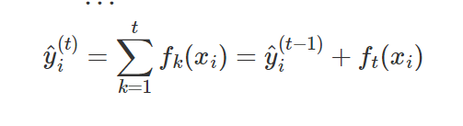

多分类输出解释：如下为四分类
代码：
import pandas as pd
import numpy as np
import xgboost as xgb

from sklearn.datasets import load_breast_cancer
from sklearn.model_selection import train_test_split

np.random.seed(1994)

kRows = 100
kCols = 10
kClasses = 4 # number of classes
kRounds = 10 # number of boosting rounds.

# Generate some random data for demo.
x_data = np.random.randn(kRows, kCols)
y_data = np.random.randint(0, 4, size=kRows)

x_train, x_test, y_train, y_test = train_test_split(x_data, y_data, test_size=0.2, random_state=1)
print(x_train.shape, x_test.shape, y_train.shape, y_test.shape)

dtrain = xgb.DMatrix(x_train, y_train)
dtest = xgb.DMatrix(x_test, y_test)

params = {'objective': 'multi:softprob', 'num_class': 4, 'booster': 'gbtree', 'max_depth': 3, 'silent':1}
watch_list = [(dtrain, 'train'), (dtest, 'eval')]

# total number of built trees is num_parallel_tree * num_classes * num_boost_round
model1 = xgb.train(params=params, dtrain=dtrain, num_boost_round=3, evals=watch_list)

model1.dump_model('multi_softmax_model.txt')

ypred = model1.predict(dtest)

ypred_margin = model1.predict(dtest, output_margin=True) # shape=[20,4]，输出是叶子节点权重和加上偏置(0.5)，也是每个特征贡献值加上偏置
ypred_leaf = model1.predict(dtest, pred_leaf=True) # shape=[20,4*3]，num_class*num_boost_round，相当于在迭代过程中，有4路在并行训练，对应每个类别，每个类别对应有3棵树

# 输出为[nSamples, nClass, nFeature+bias_term]，最后一列为bias，剩余列表示每个特征的贡献值(shap值)
ypred_contribs = model1.predict(dtest, pred_contribs=True) # shape=[20, 4, 11]，最后一维求和后的结果等于参数output_margin的结果

print('='*20, 'prob', '='*20)
print(ypred)
print('='*20, 'margin', '='*20)
print(ypred_margin)
print('='*20, 'leaf', '='*20)
print(ypred_leaf)
print('='*20, 'pred_contribs', "="*20)
print(ypred_contribs)

输出结果：
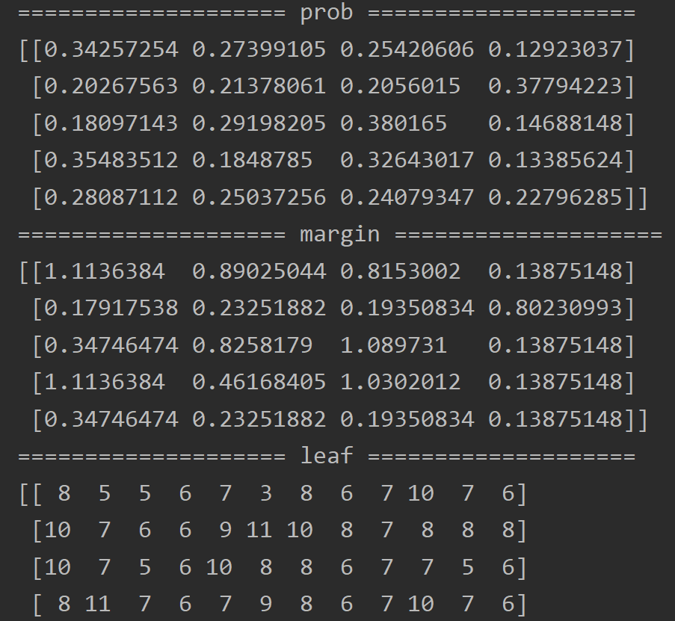
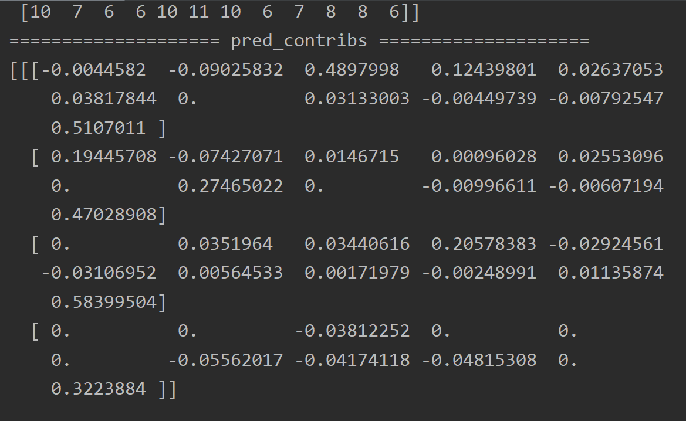
模型文件内容：
booster[0]:
0:[f2<-0.791140079] yes=1,no=2,missing=1
1:[f3<0.660657644] yes=3,no=4,missing=3
3:[f5<-0.871800065] yes=7,no=8,missing=7
7:leaf=0.0352941193
8:leaf=0.381818205
4:leaf=-0.120000005
2:[f2<1.66550362] yes=5,no=6,missing=5
5:[f1<-1.4158119] yes=9,no=10,missing=9
9:leaf=0.120000005
10:leaf=-0.103664927
6:[f0<0.0866146982] yes=11,no=12,missing=11
11:leaf=0.0352941193
12:leaf=0.317647099
booster[1]:
0:[f6<0.583156586] yes=1,no=2,missing=1
1:[f3<0.788653195] yes=3,no=4,missing=3
3:[f3<0.0443455987] yes=7,no=8,missing=7
7:leaf=-0.0206896551
8:leaf=-0.179220781
4:[f1<0.0623376034] yes=9,no=10,missing=9
9:leaf=0.268965542
10:leaf=-0.105882362
2:[f0<-0.378903568] yes=5,no=6,missing=5
5:leaf=0.323076963
6:[f4<0.532522619] yes=11,no=12,missing=11
11:leaf=-0.154285729
12:leaf=0.131707326
booster[2]:
0:[f2<1.50204134] yes=1,no=2,missing=1
1:[f5<0.817743659] yes=3,no=4,missing=3
3:[f3<-0.446667314] yes=5,no=6,missing=5
5:leaf=0.132467538
6:leaf=-0.0227848105
4:[f8<1.24406362] yes=7,no=8,missing=7
7:leaf=0.347368419
8:leaf=-0.105882362
2:leaf=-0.154285729
booster[3]:
0:[f7<2.34574294] yes=1,no=2,missing=1
1:[f8<2.03366232] yes=3,no=4,missing=3
3:[f6<-1.53523707] yes=5,no=6,missing=5
5:leaf=0.138461545
6:leaf=-0.11811024
4:leaf=0.24000001
2:leaf=0.317647099
booster[4]:
0:[f2<-0.791140079] yes=1,no=2,missing=1
1:[f3<0.660657644] yes=3,no=4,missing=3
3:[f7<0.918429732] yes=7,no=8,missing=7
7:leaf=0.292870551
8:leaf=0.00904013123
4:leaf=-0.114780806
2:[f2<1.50204134] yes=5,no=6,missing=5
5:[f4<0.0457562432] yes=9,no=10,missing=9
9:leaf=-0.156109437
10:leaf=0.0121799093
6:[f8<-0.44182837] yes=11,no=12,missing=11
11:leaf=0.286880881
12:leaf=0.0263169128
booster[5]:
0:[f0<0.147903055] yes=1,no=2,missing=1
1:[f1<-1.10636878] yes=3,no=4,missing=3
3:leaf=-0.154797792
4:[f2<-1.03505778] yes=7,no=8,missing=7
7:leaf=-0.0910554305
8:leaf=0.135622993
2:[f8<-0.940396607] yes=5,no=6,missing=5
5:[f3<-0.635360718] yes=9,no=10,missing=9
9:leaf=-0.106001474
10:leaf=0.268644661
6:[f6<1.06208122] yes=11,no=12,missing=11
11:leaf=-0.177855849
12:leaf=0.0246539675
booster[6]:
0:[f3<0.463181496] yes=1,no=2,missing=1
1:[f3<-0.446667314] yes=3,no=4,missing=3
3:[f1<-1.36869311] yes=7,no=8,missing=7
7:leaf=-0.141530231
8:leaf=0.149023652
4:[f1<-1.36121619] yes=9,no=10,missing=9
9:leaf=0.0958179235
10:leaf=-0.136948273
2:[f8<0.35002625] yes=5,no=6,missing=5
5:[f2<0.223202571] yes=11,no=12,missing=11
11:leaf=0.132633492
12:leaf=-0.138908371
6:[f1<-0.326279193] yes=13,no=14,missing=13
13:leaf=0.334007233
14:leaf=0.100445218
booster[7]:
0:[f7<2.34574294] yes=1,no=2,missing=1
1:[f8<0.925064325] yes=3,no=4,missing=3
3:[f6<-1.53523707] yes=5,no=6,missing=5
5:leaf=0.1189849
6:leaf=-0.12763384
4:[f2<-0.167484552] yes=7,no=8,missing=7
7:leaf=-0.12824896
8:leaf=0.235856593
2:leaf=0.262775302
booster[8]:
0:[f3<0.900968611] yes=1,no=2,missing=1
1:[f1<-1.4158119] yes=3,no=4,missing=3
3:[f9<-0.324194491] yes=5,no=6,missing=5
5:leaf=0.0760476664
6:leaf=0.316641122
4:[f1<0.381498933] yes=7,no=8,missing=7
7:leaf=-0.0610502437
8:leaf=0.143157393
2:leaf=-0.161269009
booster[9]:
0:[f1<0.338270307] yes=1,no=2,missing=1
1:[f6<0.769280314] yes=3,no=4,missing=3
3:[f0<-1.14976358] yes=7,no=8,missing=7
7:leaf=0.210884556
8:leaf=-0.06893567
4:[f1<-1.49328279] yes=9,no=10,missing=9
9:leaf=-0.102474302
10:leaf=0.221971259
2:[f9<0.696660817] yes=5,no=6,missing=5
5:[f8<0.718744993] yes=11,no=12,missing=11
11:leaf=-0.173176825
12:leaf=0.0439673588
6:leaf=0.0884747133
booster[10]:
0:[f4<1.32345176] yes=1,no=2,missing=1
1:[f3<0.250791281] yes=3,no=4,missing=3
3:[f3<-0.406885445] yes=7,no=8,missing=7
7:leaf=0.0338090733
8:leaf=-0.146758601
4:[f6<-1.21899986] yes=9,no=10,missing=9
9:leaf=-0.115767993
10:leaf=0.12837033
2:[f9<0.225976914] yes=5,no=6,missing=5
5:leaf=0.308239788
6:[f7<0.545265317] yes=11,no=12,missing=11
11:leaf=0.0706969947
12:leaf=-0.102807619
booster[11]:
0:[f7<2.34574294] yes=1,no=2,missing=1
1:[f8<0.925064325] yes=3,no=4,missing=3
3:[f6<-1.53523707] yes=5,no=6,missing=5
5:leaf=0.0957215726
6:leaf=-0.115504451
4:[f2<-0.167484552] yes=7,no=8,missing=7
7:leaf=-0.121165149
8:leaf=0.184563592
2:leaf=0.233139247

分析：
举例：对于第一个样本，
概率输出：prob值，经softmax函数变换后，概率值为[0.34257254, 0.27399105, 0.25420606, 0.12923037]，对应每一类的概率；
原始输出：margin结果，未经softmax函数变换，值为[1.1136384, 0.89025044, 0.8153002, 0.13875148]，第一个经softmax变换后，其结果与prob相同
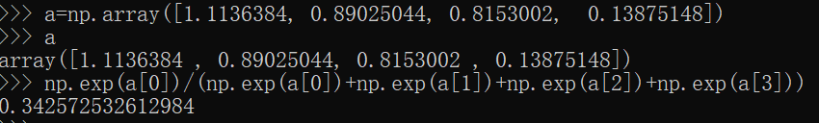
叶子节点：leaf结果，值为[ 8, 5, 5, 6, 7, 3, 8, 6, 7, 10, 7, 6]，索引的含义为第k个booster，在模型文件中找到其对应的权重值为[0.381818205,0.323076963,0.132467538,-0.11811024,0.292870551,-0.154797792,0.149023652,-0.12763384,-0.0610502437,0.221971259,0.0338090733,-0.115504451]。由于是num_boost_round=3和四分类问题，将其shape转换为[3,4]后为
叶子节点：
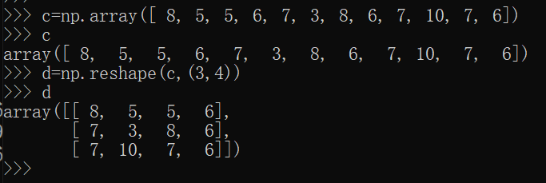
叶子节点对应的权值：
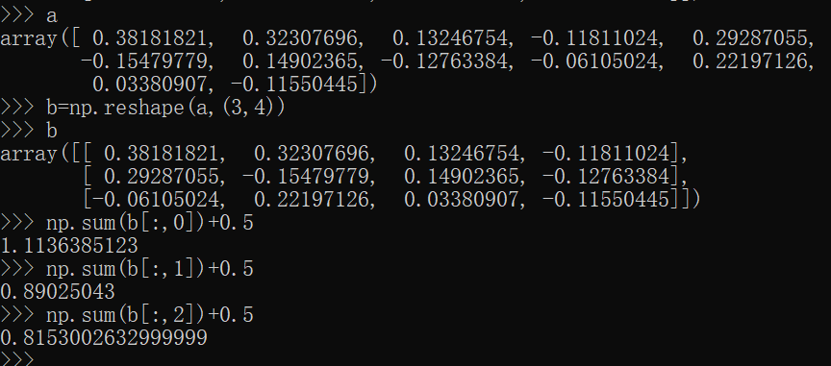
从上图可以看出，转换后每列累加再加上偏置0.5（与二分类有所区别）后，与margin结果一致。（相当于给4类分别训练了3棵树）
特征贡献度：其输出shape为(样本数，类别数，特征数+1)，取第一个样本第一种类别为[-0.0044582, -0.09025832, 0.4897998, 0.12439801, 0.02637053, 0.03817844, 0., 0.03133003, -0.00449739, -0.00792547, 0.5107011]，累加后的结果与margin值非常接近。

问题：
1、树的个数是否与num_boost_round一致？
答：不一致，树的个数等于nclass*num_boost_round*num_parallel_tree，num_parallel_tree默认为1，只支持增强型随机森林。

- 由于生成nclass*num_boost_round棵树，那margin结果还是将所有叶子节点的权值累加吗？
答：不是，与二分类不同，由于是nclass分类问题，叶子节点的索引向量不再是num_boost_round长度，而是nclass*num_boost_round长度，每个样本在每个类别都有对应的叶子节点输出，具体见上述分析。

- 为什么叶子节点权值累加后还要加上偏置0.5才是未softmax前的结果？
答：从xgboost源码和参数介绍里发现存在base_score参数，该值默认为0.5。那为什么二分类中不需要加偏置0.5?
base_score参数参考：https://github.com/dmlc/xgboost/blob/master/src/predictor/cpu_predictor.cc
https://github.com/dmlc/xgboost/blob/master/include/xgboost/learner.h
https://xgboost.readthedocs.io/en/latest/parameter.html
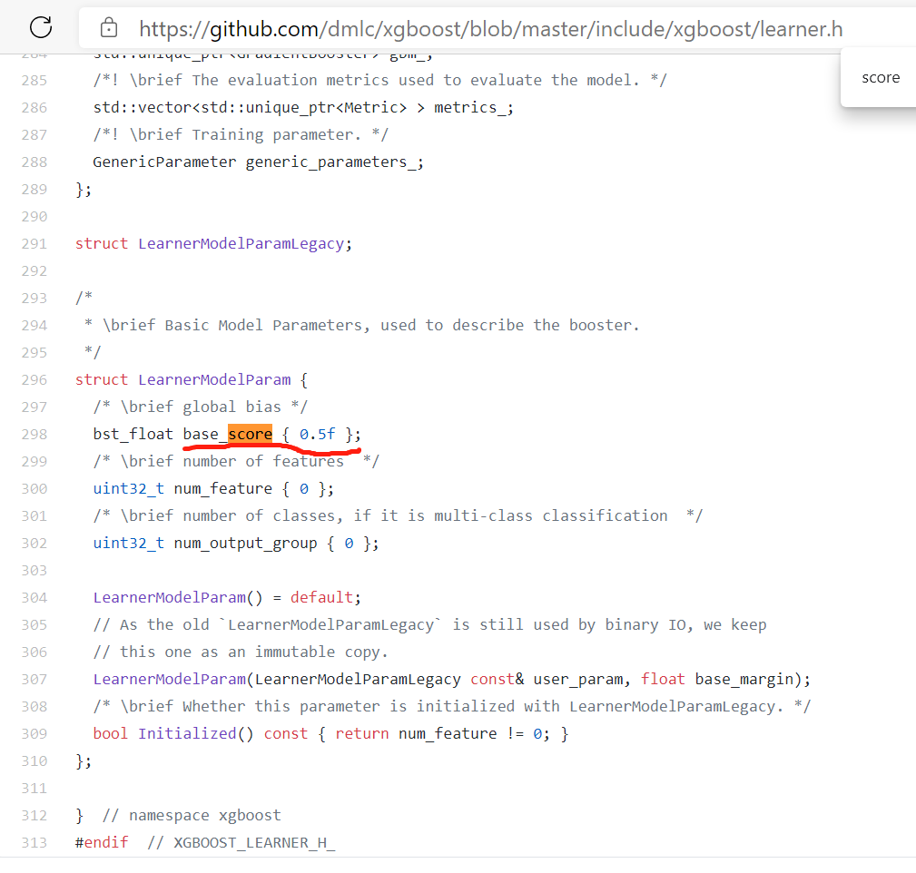

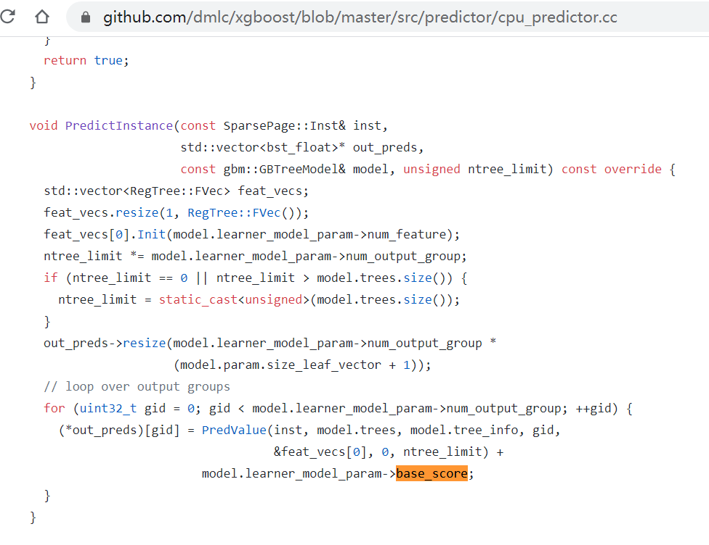
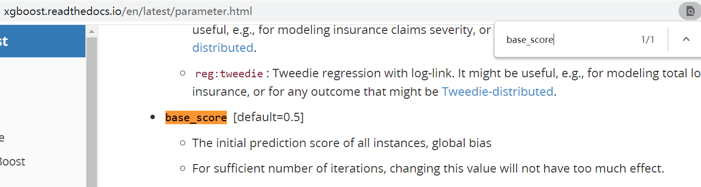

回归问题
代码：
import pandas as pd
import numpy as np
import xgboost as xgb

from sklearn.datasets import load_boston
from sklearn.model_selection import train_test_split

np.random.seed(1994)
data = load_boston()
x_data = data.data
y_data = data.target

x_train, x_test, y_train, y_test = train_test_split(x_data, y_data, test_size=0.2)
dtrain = xgb.DMatrix(x_train, y_train)
dtest = xgb.DMatrix(x_test[0:10], y_test[0:10])

params = {'objective': 'reg:squarederror', 'booster': 'gbtree', 'max_depth': 3, 'silent':1}
watch_list = [(dtrain, 'train'), (dtest, 'eval')]

model = xgb.train(params=params, dtrain=dtrain, num_boost_round=5, evals=watch_list)

model.dump_model('reg_squarederror_model.txt')

ypred = model.predict(dtest)
ypred_margin = model.predict(dtest, output_margin=True) # 输出是叶子节点权重和加上偏置(0.5)
ypred_leaf = model.predict(dtest, pred_leaf=True)

print('='*20, 'prob', '='*20)
print(ypred)
print('='*20, 'margin', '='*20)
print(ypred_margin)
print('='*20, 'leaf', '='*20)
print(ypred_leaf)
输出结果：
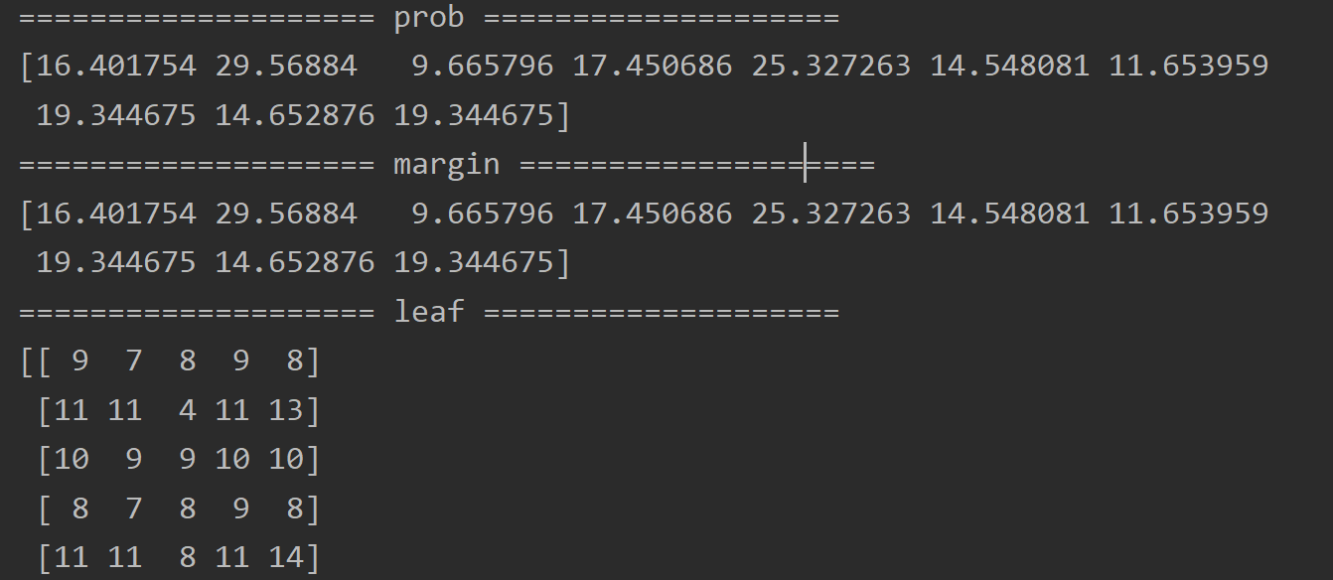
模型文件内容：
booster[0]:
0:[f5<6.8375001] yes=1,no=2,missing=1
1:[f12<14.3950005] yes=3,no=4,missing=3
3:[f12<9.71500015] yes=7,no=8,missing=7
7:leaf=7.26108122
8:leaf=6.02400017
4:[f0<5.78189993] yes=9,no=10,missing=9
9:leaf=4.97506857
10:leaf=3.22619057
2:[f5<7.43700027] yes=5,no=6,missing=5
5:[f0<7.39342499] yes=11,no=12,missing=11
11:leaf=9.3697834
12:leaf=3.12749982
6:leaf=13.0575008
booster[1]:
0:[f5<6.94099998] yes=1,no=2,missing=1
1:[f12<15] yes=3,no=4,missing=3
3:[f5<6.54449987] yes=7,no=8,missing=7
7:leaf=4.43739939
8:leaf=5.67651415
4:[f7<2.00119996] yes=9,no=10,missing=9
9:leaf=2.25827312
10:leaf=3.52858019
2:[f0<7.39342499] yes=5,no=6,missing=5
5:[f5<7.43700027] yes=11,no=12,missing=11
11:leaf=6.87476587
12:leaf=9.3034687
6:leaf=2.42381263
booster[2]:
0:[f12<5.43999958] yes=1,no=2,missing=1
1:[f5<6.90849972] yes=3,no=4,missing=3
3:leaf=4.31929874
4:leaf=6.2788682
2:[f12<16.3199997] yes=5,no=6,missing=5
5:[f7<1.22714996] yes=7,no=8,missing=7
7:leaf=7.56030416
8:leaf=3.22052431
6:[f0<9.82036495] yes=9,no=10,missing=9
9:leaf=2.27566981
10:leaf=1.22571003
booster[3]:
0:[f5<7.01049995] yes=1,no=2,missing=1
1:[f12<10.1399994] yes=3,no=4,missing=3
3:[f0<6.98771477] yes=7,no=8,missing=7
7:leaf=2.54797316
8:leaf=6.04824352
4:[f4<0.669499993] yes=9,no=10,missing=9
9:leaf=1.89106596
10:leaf=1.07127368
2:[f5<7.43700027] yes=5,no=6,missing=5
5:[f0<13.9285946] yes=11,no=12,missing=11
11:leaf=3.65395808
12:leaf=0.859224439
6:leaf=4.93823528
booster[4]:
0:[f5<6.54699993] yes=1,no=2,missing=1
1:[f12<19.6450005] yes=3,no=4,missing=3
3:[f7<1.39789999] yes=7,no=8,missing=7
7:leaf=4.51597166
8:leaf=1.37769735
4:[f4<0.603000045] yes=9,no=10,missing=9
9:leaf=1.35300207
10:leaf=0.334388763
2:[f12<4.69499969] yes=5,no=6,missing=5
5:[f7<3.20744991] yes=11,no=12,missing=11
11:leaf=4.32014227
12:leaf=2.83221936
6:[f9<267.5] yes=13,no=14,missing=13
13:leaf=2.89146686
14:leaf=1.70823276

分析：
举例：对于第一个样本，
回归输出：prob值，回归值为16.401754；
原始输出：margin结果，值为16.401754，与prob值相同；
叶子节点：leaf结果，值为[9,7,8,9,8]，索引的含义为第k个booster，在模型文件中找到其对应的权重值为[4.97506857，4.43739939，3.22052431，1.89106596，1.37769735]，累加后的结果加上偏置0.5后与margin结果一致。
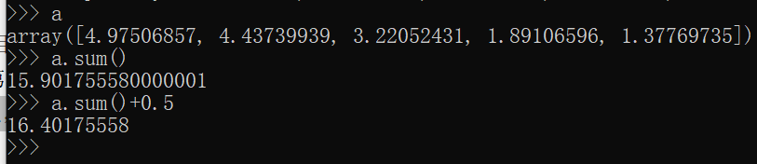

问题：
1、树的个数是否与num_boost_round一致？
答：一致

参考：
1、https://zhuanlan.zhihu.com/p/139123617

