目录

UC1 1

UC2.1 2

UC3 3

UC4.1 4

UC4.2 5

UC5.1 6

UC5.2 7

UC5.3 8

UC5.4 9

UC6.1 10

UC6.2 11

UC6.3 12

UC7 13

UC8 14

UC9.1 15

UC9.2 16

UC10 17

UC11 18

UC12 19

UC13 20

UC14 21

UC15.1 22

UC15.2 24

UC16 25

UC17.1 26

UC17.2 27

UC18 28

# UC1

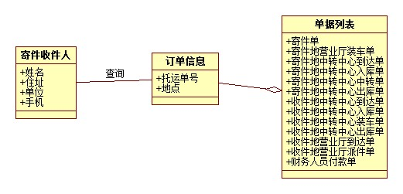

# UC2.1

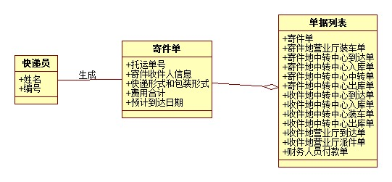

# UC3

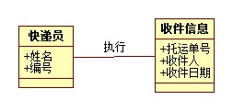

# UC4.1

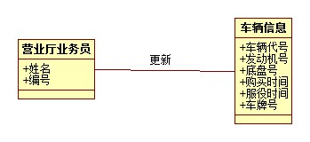

# UC4.2

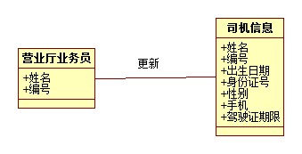

# UC5.1

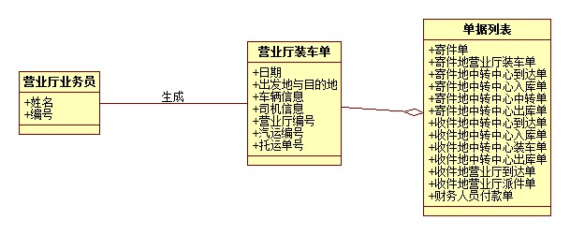

# UC5.2

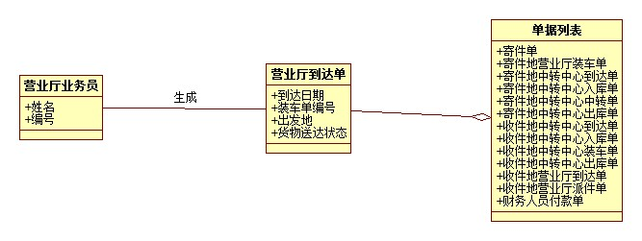

# UC5.3

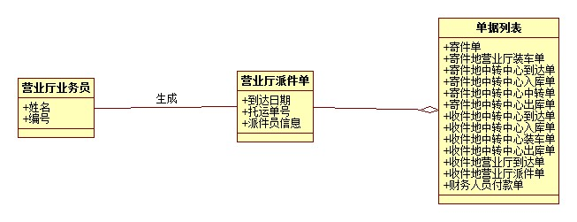

# UC5.4

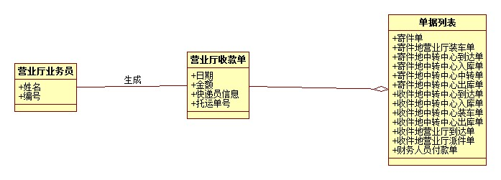

# UC6.1

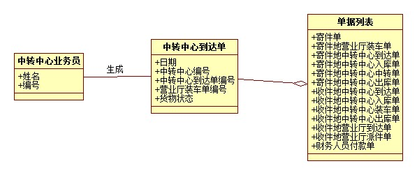

# UC6.2

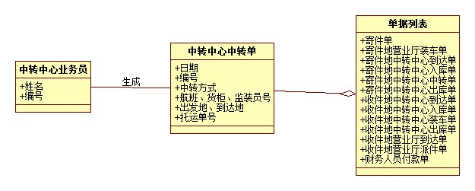

# UC6.3

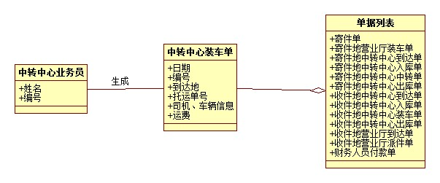

# UC7

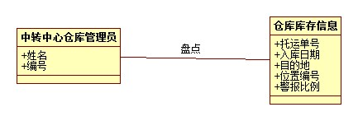

# UC8

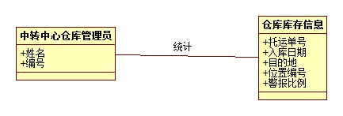

# UC9.1

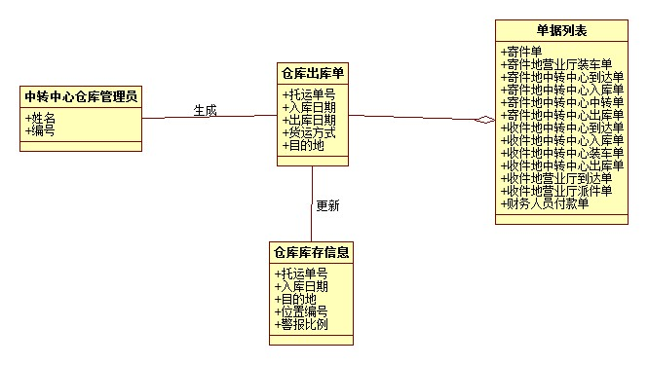

# UC9.2

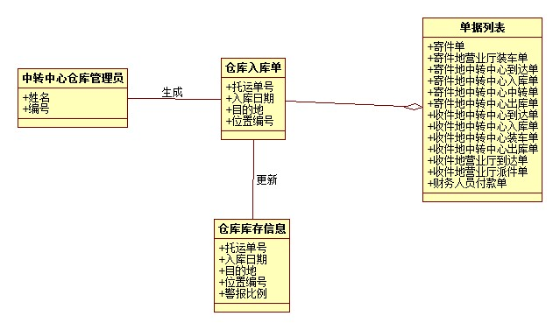

# UC10

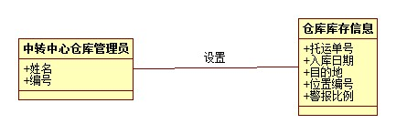

# UC11

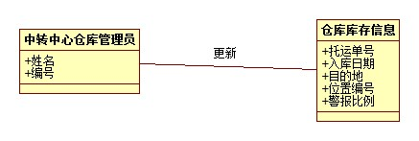

# UC12

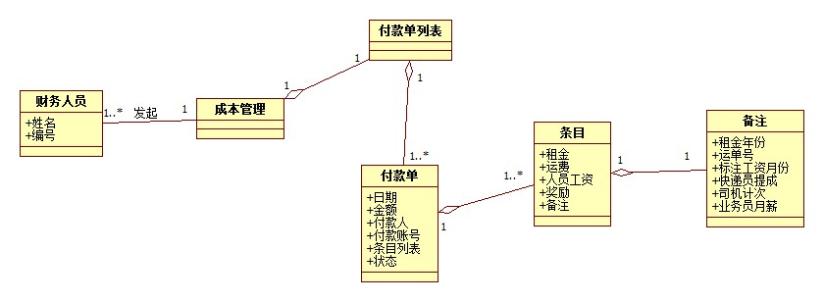

# UC13

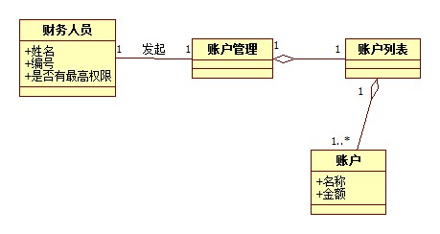

# UC14

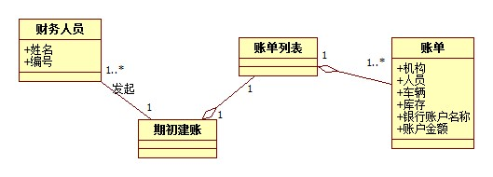

# UC15.1

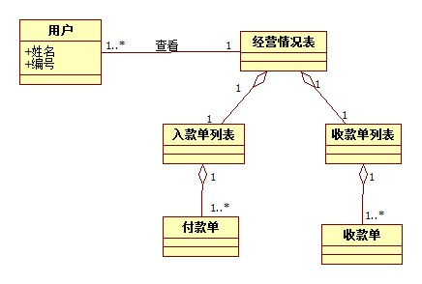

# UC15.2

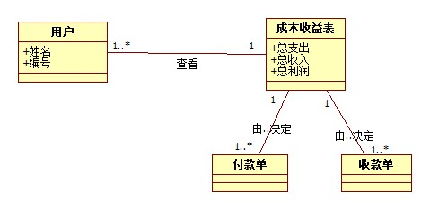

# UC16

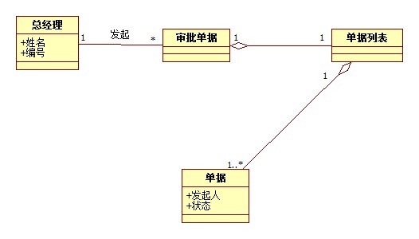

# UC17.1

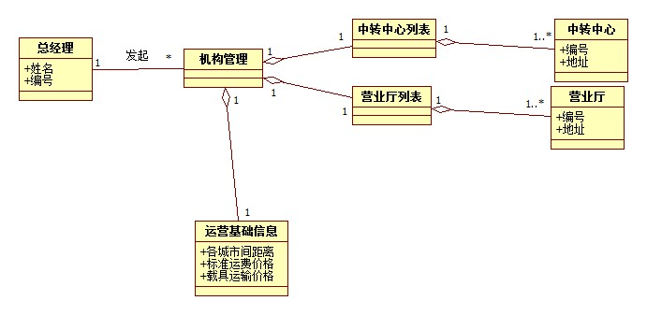

# UC17.2

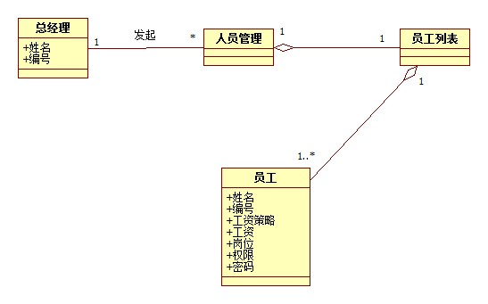

# UC18

