目录

UC1 1

UC2.1 1

UC3 2

UC4.1 2

UC4.2 3

UC5.1 3

UC5.2 4

UC5.3 5

UC5.4 5

UC6.1 6

UC6.2 6

UC6.3 7

UC7 7

UC8 8

UC9.1 8

UC9.2 9

UC10 9

UC11 10

UC12 11

UC13 12

UC14 13

UC15.1 14

UC15.2 15

UC16 16

UC17.1 17

UC17.2 18

UC18 19

# UC1

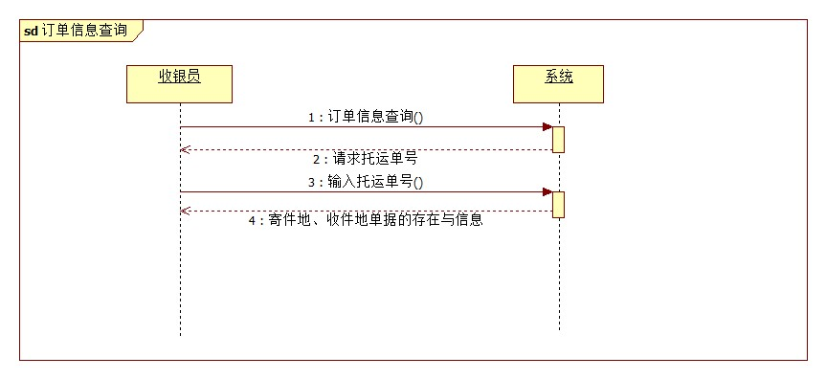

# UC2.1

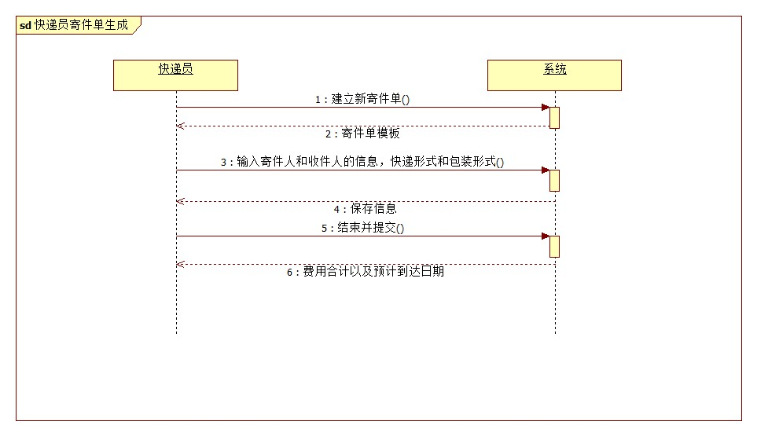

# UC3

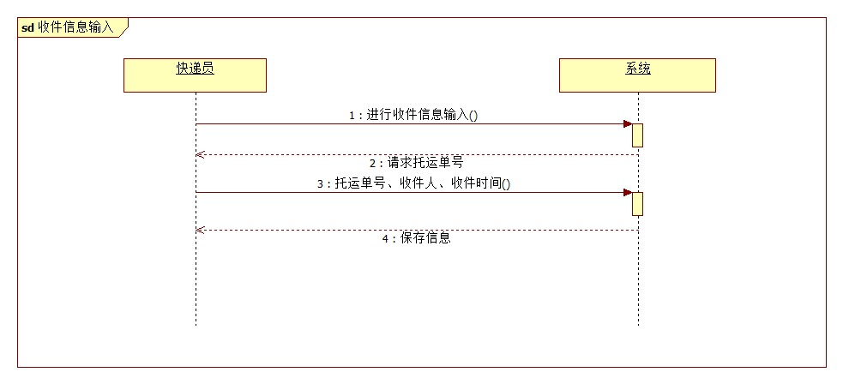

UC4.1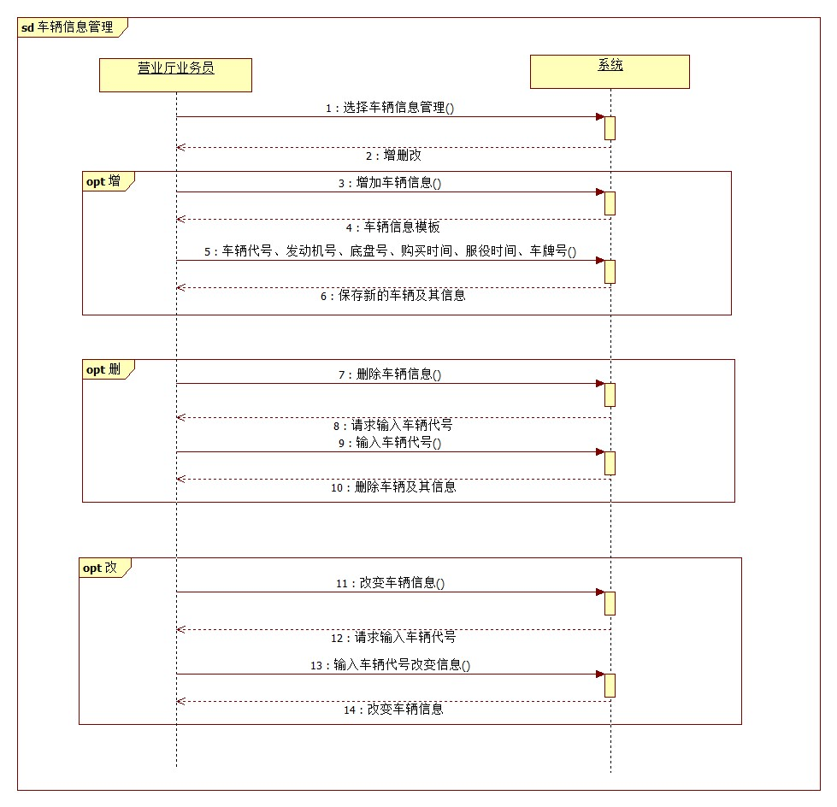

# UC4.2

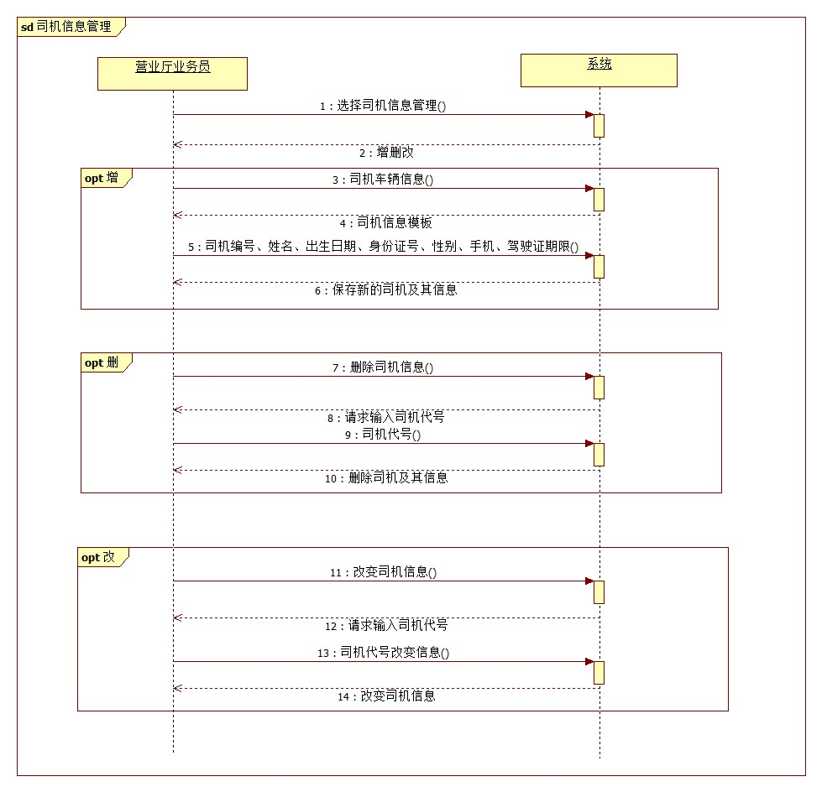

UC5.1

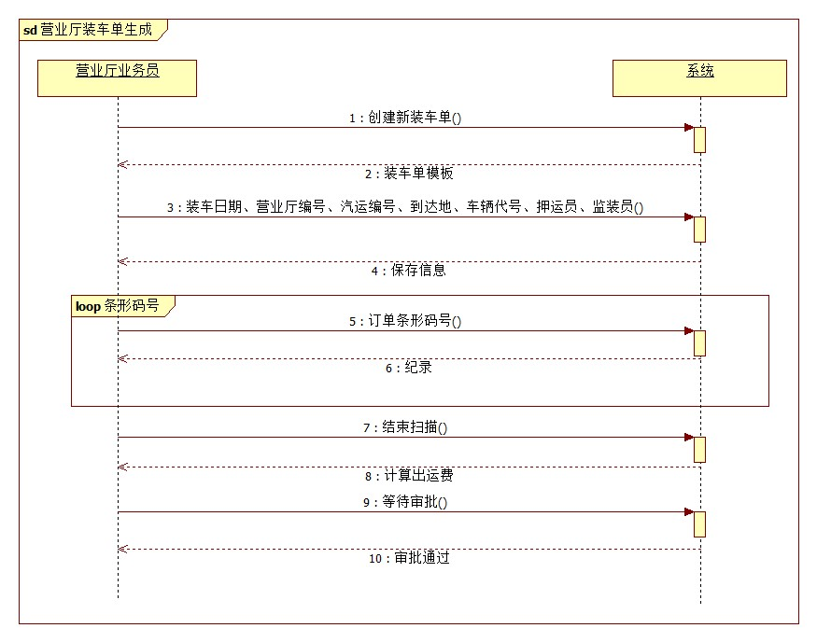

# UC5.2

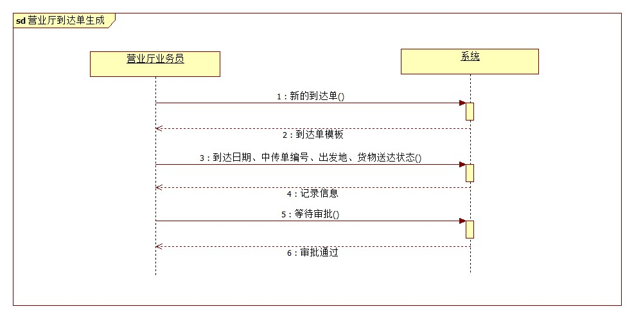

# UC5.3

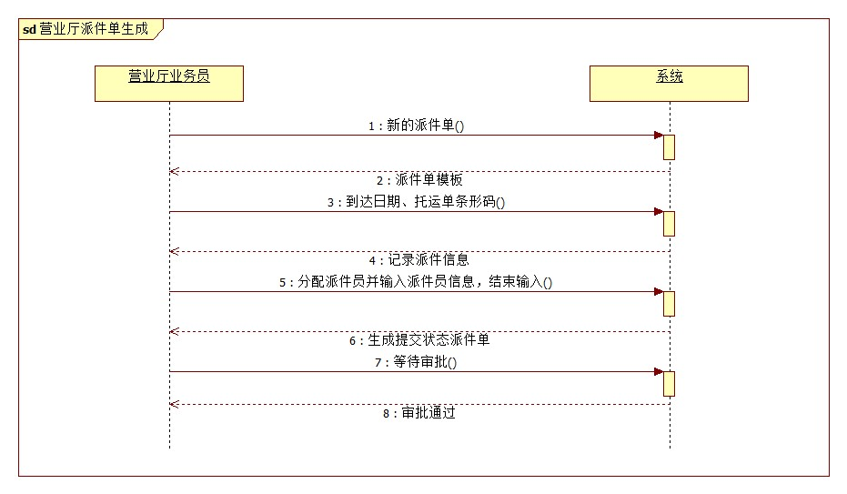

# UC5.4

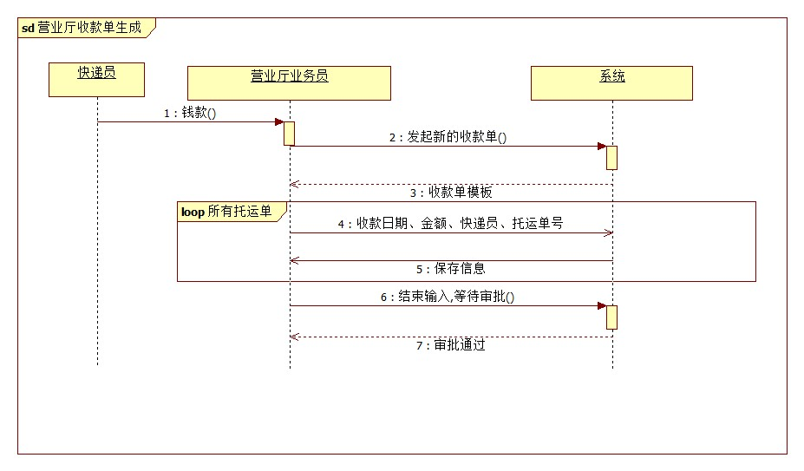

# UC6.1

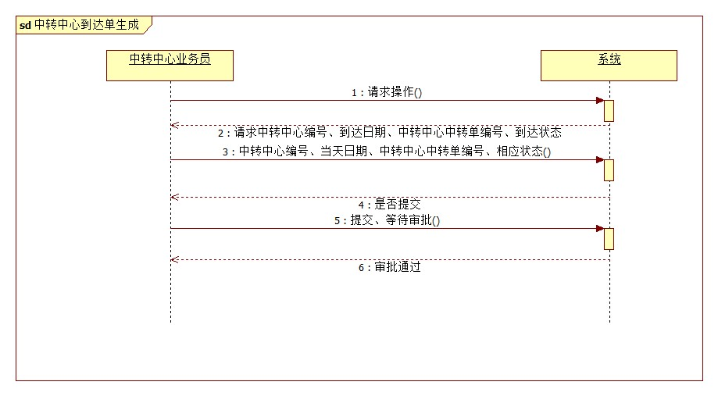

# UC6.2

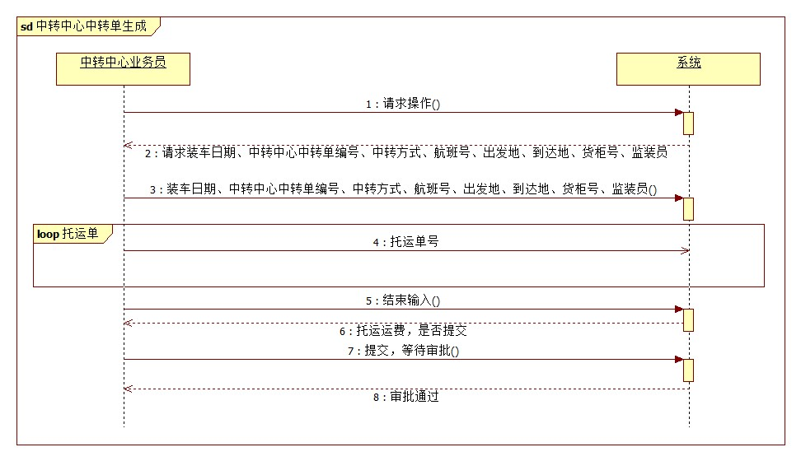

# UC6.3

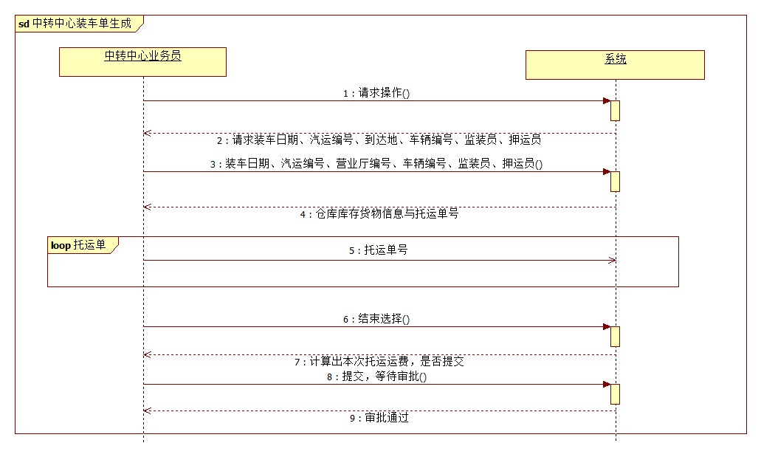

# UC7

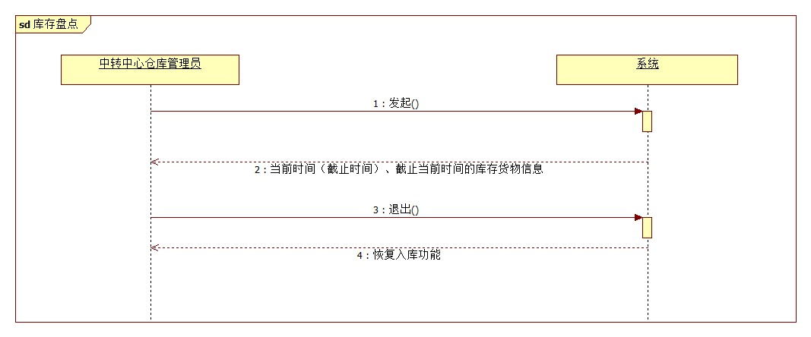

# UC8

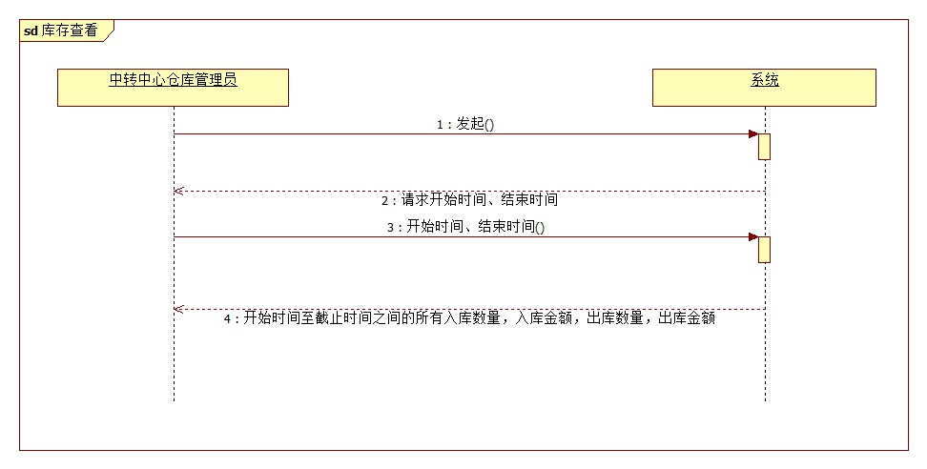

# UC9.1

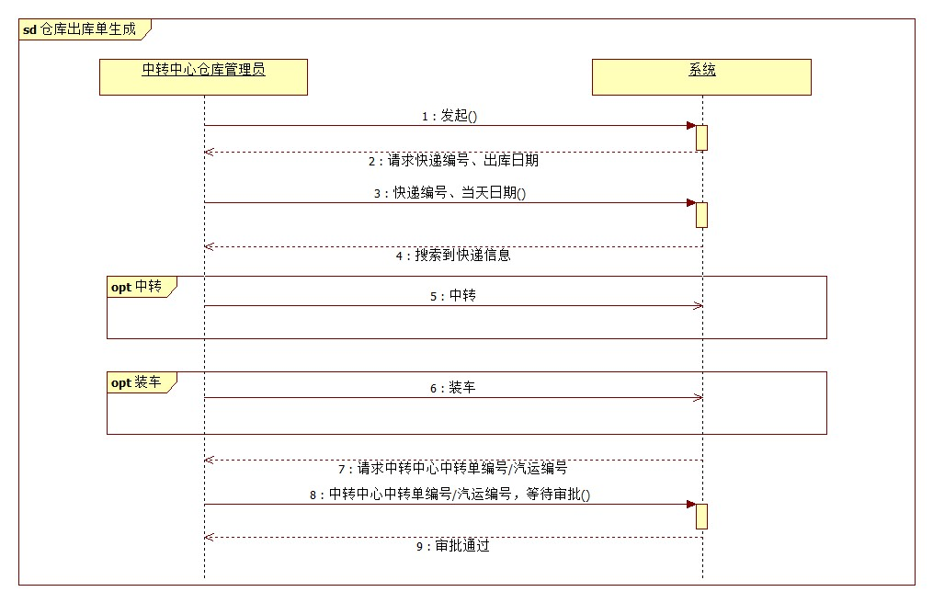

# UC9.2

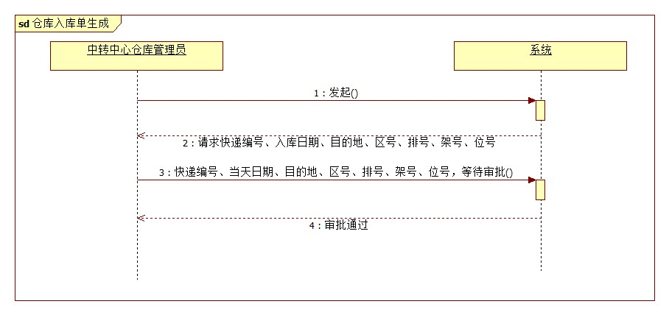

# UC10

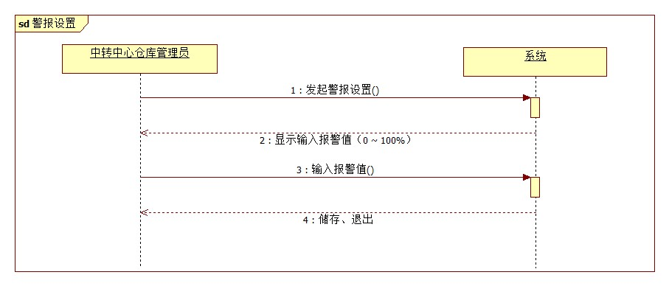

# UC11

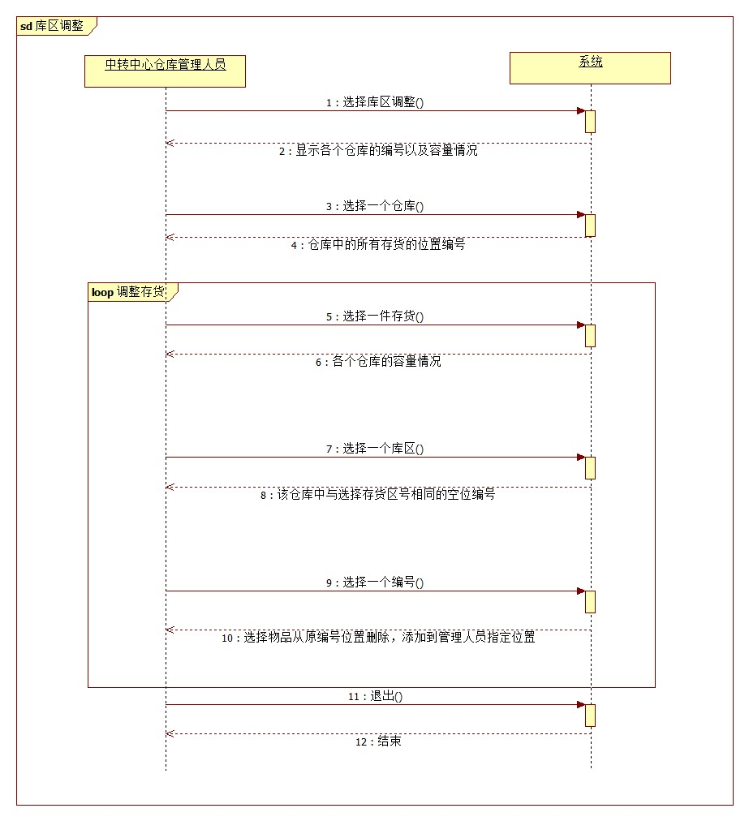

# UC12

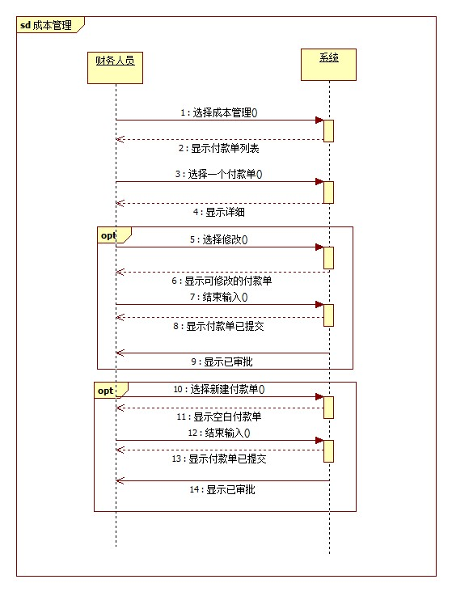

# UC13

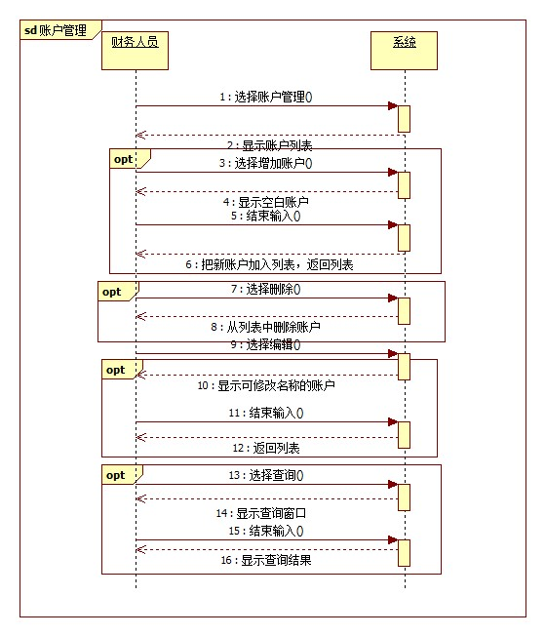

# UC14

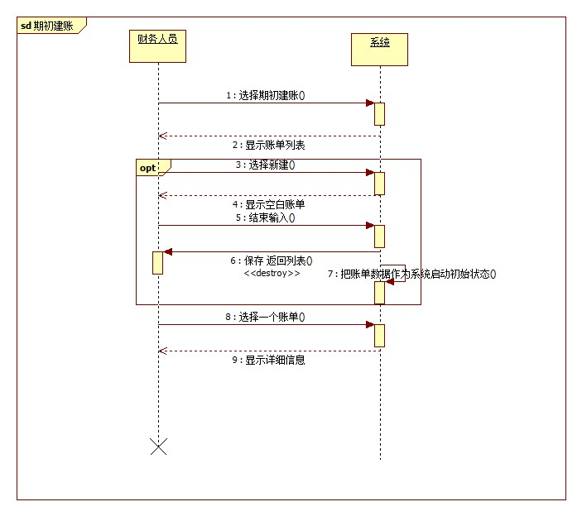

# UC15.1

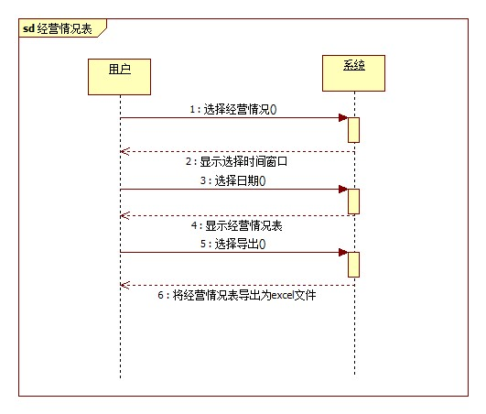

# UC15.2

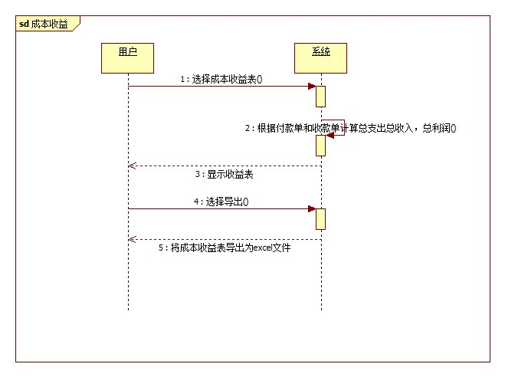

# UC16

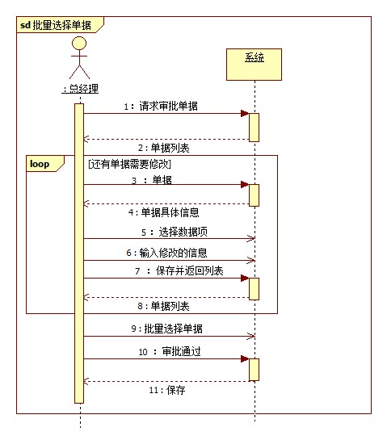

# UC17.1

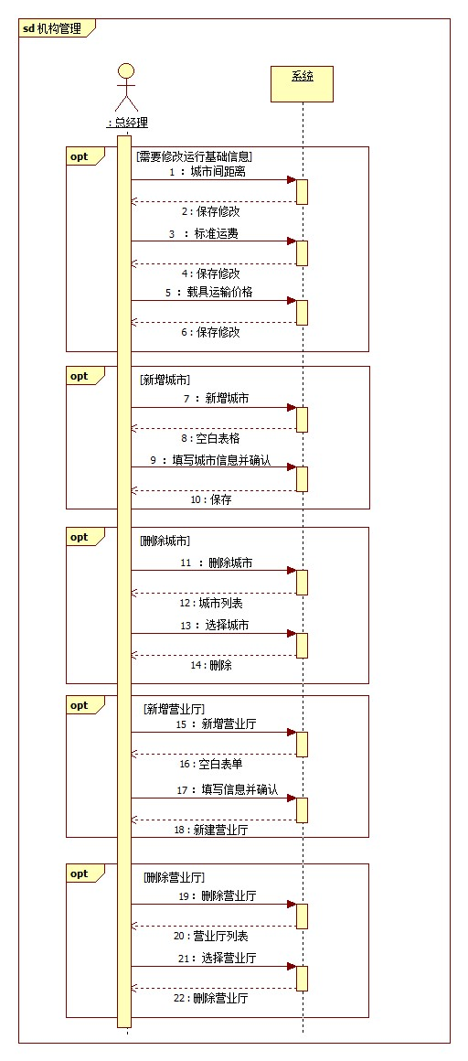

# UC17.2

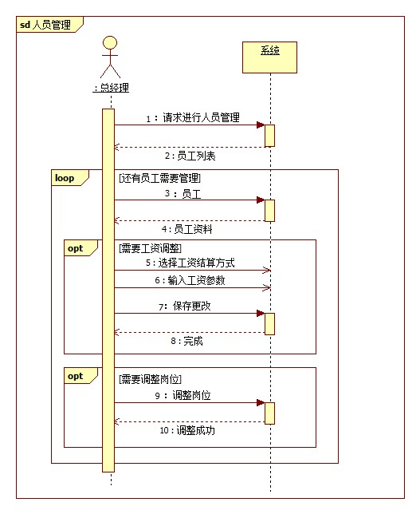

# UC18

