Does Financial News Sentiment Move the S&P 500?

1. Problem Statement
Financial markets are supposed to react quickly to public information, but investors still spend a lot of money on news feeds, terminals, and text-based trading signals. That tension motivated our project. We wanted to test whether daily financial headlines contain enough information to help explain or predict next-day S&P 500 movement. More specifically, we frame the main prediction task as a binary direction problem: whether the S&P 500 will close higher or lower on the next trading day.
We were not trying to prove that news never matters. Large news events clearly affect how investors think about risk. Our question is narrower: after headlines are aggregated at the daily level, do sentiment features add useful signal beyond a simple market baseline? We also wanted to see whether that signal changes across very different market periods, including the 2008-2009 financial crisis, the 2020 COVID shock, and the 2022-2023 rate-hike cycle.
The short answer is mixed and mostly cautious. Some finance-specific sentiment features look promising in selected backtests, but the overall predictive signal is weak. Classification accuracy stays close to chance, return models barely improve on a historical mean benchmark, and the strategy results are sensitive to regime, threshold choice, and trading assumptions.

2. Data Description
Our main dataset is the Kaggle file "S&P 500 with Financial News Headlines (2008-2024)" by dyutidasmahaptra. The raw file has 19,127 rows with headline text, date, and S&P 500 close price, covering January 2, 2008 through March 4, 2024. Because there are often multiple headlines on the same trading day, the raw data is headline-level rather than one row per market day.
Item | Value
Raw rows | 19,127
Clean headline rows | 18,153
Exact duplicate rows removed | 974
Prepared daily rows | 3,506
Mean headlines per trading day | 5.17
Median headlines per trading day | 4
Maximum headlines on one date | 55
Next-day up-day rate | 54.3%
We kept the cleaning process conservative. We removed exact duplicate rows, checked that each date mapped to one closing price, and found no missing values in the raw headline, date, or close fields. After cleaning, we aggregated headlines to the daily level and created next-day return and next-day direction targets. The prepared daily dataset contains 3,506 rows, with an average of 5.17 headlines per trading day.
To give the models market context, we added FRED macro variables such as the VIX, Treasury rates, the 10Y-2Y spread, the federal funds rate, CPI inflation, unemployment, and a recession indicator. These variables are not meant to make the project a macro forecasting exercise; they help separate headline sentiment from the market environment in which the headlines appeared.
The data also has important limits. The original news source is not fully documented, some headlines are only loosely connected to the S&P 500, and daily close prices cannot capture intraday reactions. Headline volume also rises over time, which means the 2008 part of the sample is not directly comparable to the 2023-2024 part. We treat that drift as part of the analysis rather than something we can fully remove.

3. Methods
The workflow starts with daily aggregation and data checks, then builds from simple sentiment measures to more flexible models. The first sentiment layer is a dictionary baseline with both general and finance-specific word lists. From that we calculate average daily sentiment, positive and negative headline shares, extreme sentiment counts, and headline volume.
We then compare that baseline with VADER, FinBERT, and LDA topic modeling. VADER gives a general short-text sentiment score, while FinBERT is designed for financial language and returns positive, neutral, and negative probabilities. LDA topics help us check whether different kinds of headlines, such as policy, earnings, inflation, or banking stress, behave differently.
The classification target is next-day market direction, coded as 1 when the next close-to-close return is positive and 0 otherwise. For prediction, we use time-aware splits instead of random splits: training before 2020, validation during 2020-2021, and testing from 2022 through March 2024. Logistic regression serves as an interpretable benchmark, while XGBoost tests whether nonlinear interactions improve performance. Probability thresholds are selected on the validation set, not the test set.
We also evaluate whether model signals would have any economic value. The backtest uses a simple long/flat rule: the strategy is long when the predicted probability of an up day is above the selected threshold and flat otherwise. We apply a 1 basis point transaction cost whenever the position changes, then review performance by regime, threshold, cost level, and failure cases.

4. Findings

4.1 Simple sentiment relationships are weak
The first clear finding is that simple sentiment variables do not line up strongly with next-day market movement. Average finance sentiment has a correlation of -0.012 with next-day return and 0.022 with next-day direction. General sentiment and headline count are also close to zero. In plain terms, a more positive headline day does not reliably translate into a stronger market day tomorrow.
Feature | Corr. next-day return | Corr. next-day direction
avg_finance_sentiment | -0.012 | 0.022
avg_general_sentiment | -0.008 | 0.007
negative_headline_share | 0.000 | -0.032
headline_count | 0.022 | -0.009
The tercile comparison tells a similar story. Low finance sentiment days average a 0.033% next-day return and a 52.6% up-day rate. Middle sentiment days average 0.054% and a 56.2% up-day rate, while high sentiment days average 0.049% and a 54.1% up-day rate. The middle group performs best, not the highest-sentiment group, so the relationship is not a clean positive slope.
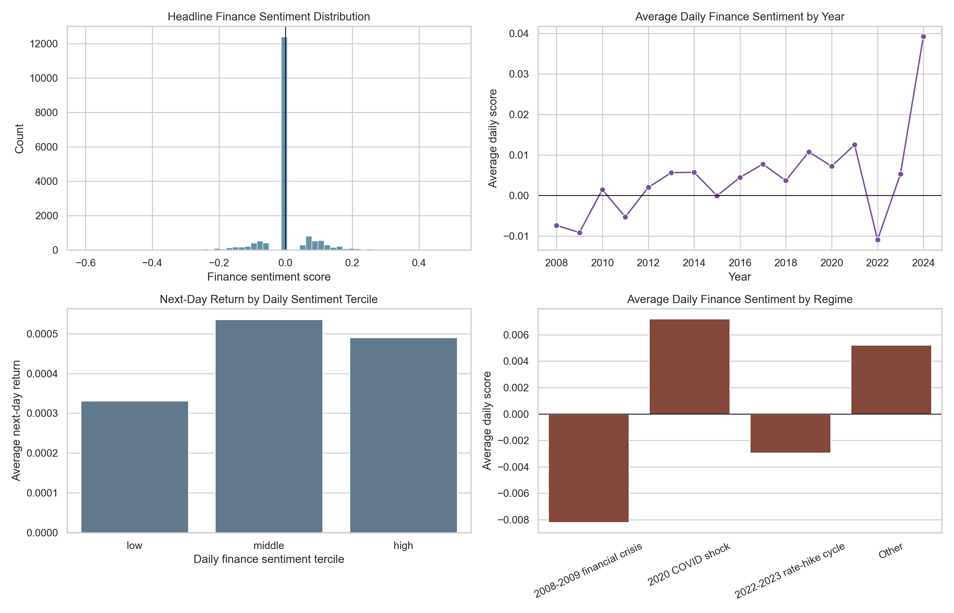
Figure 1. Daily sentiment summaries from the dictionary baseline.

4.2 Direction models stay close to baseline
The held-out test models also stay close to baseline. The majority-class benchmark has 49.5% accuracy and 50.0% balanced accuracy. Most logistic regression and XGBoost versions land near that range. The best balanced accuracy in the comparison is XGB with VADER features at 51.4%, which is an improvement, but still too small to call a reliable direction signal by itself.
Model | Feature set | Accuracy | Balanced acc. | AUC | Threshold
Majority baseline | - | 0.495 | 0.500 | 0.500 | 0.50
Logit | all | 0.493 | 0.498 | 0.509 | 0.54
XGB | all | 0.495 | 0.500 | 0.522 | 0.50
XGB | vader | 0.510 | 0.514 | 0.507 | 0.54
Logit | finbert | 0.497 | 0.499 | 0.522 | 0.55
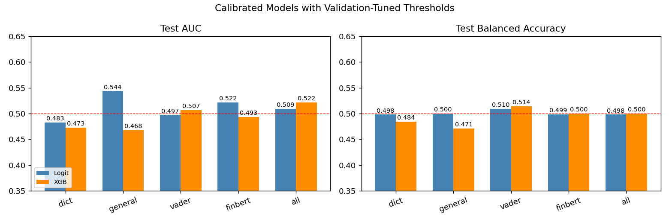
Figure 2. Test-set comparison across sentiment feature sets.
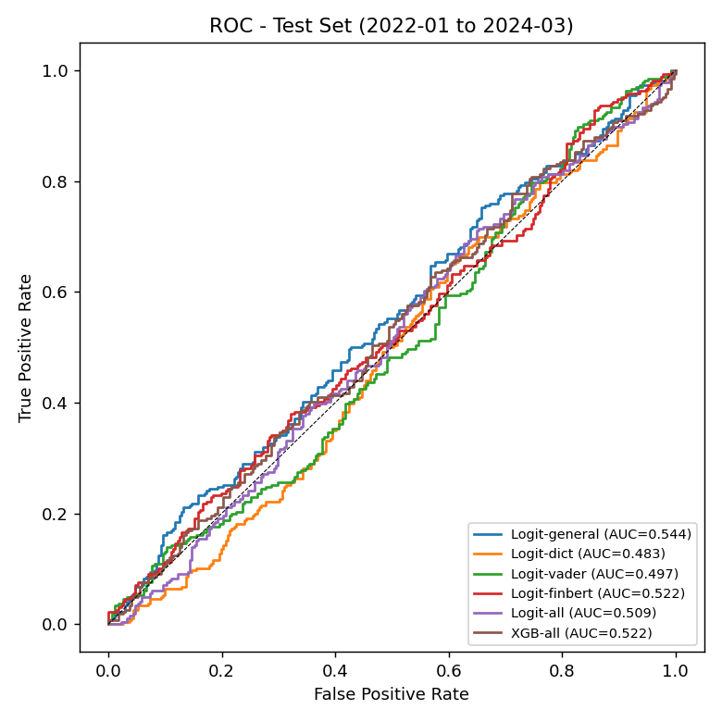
Figure 3. ROC curves on the held-out test set; most curves remain close to the 0.50 baseline.

4.3 Finance-specific signals help some backtests, but the edge is fragile
Backtesting gives a more complicated picture than classification accuracy alone. The all-feature Logit and XGB strategies are almost identical to buy-and-hold in the test period because they are long nearly all the time. Logit with FinBERT, however, produces a 13.1% cumulative test return versus 7.0% for buy-and-hold, with a smaller maximum drawdown. XGB with VADER also improves on buy-and-hold. These results are interesting, but they should be treated carefully because they depend on feature set and threshold choice.
Model | Features | Strategy return | Buy-hold | Sharpe | Max drawdown | Exposure | Trades
Logit | all | 7.15% | 6.97% | 0.266 | -25.24% | 99.4% | 7
XGB | all | 6.96% | 6.97% | 0.261 | -25.38% | 100.0% | 1
Logit | finbert | 13.12% | 6.97% | 0.453 | -15.20% | 64.8% | 134
XGB | vader | 9.13% | 6.97% | 0.320 | -22.34% | 90.3% | 87
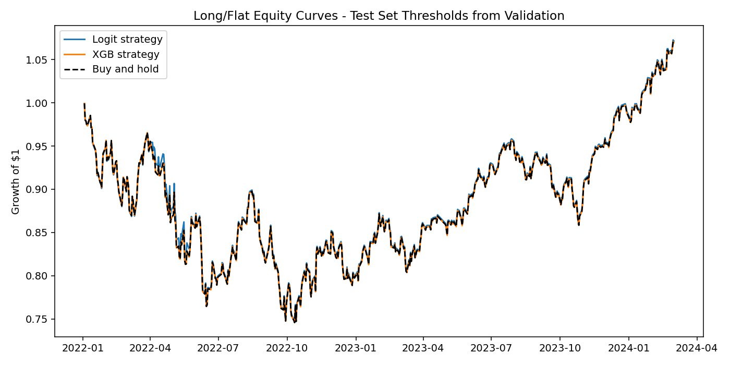
Figure 4. Test-set long/flat equity curves for the all-feature models; the table also reports selected sentiment-only variants.

4.4 Regime analysis shows instability
Performance is not stable across regimes. On the held-out test set, the 2022-2023 rate-hike cycle is the dominant regime, and all-feature models are basically at baseline. Logit all has 48.5% accuracy, 49.8% balanced accuracy, and a 0.499 AUC. XGB all is similar, with 48.7% accuracy, 50.0% balanced accuracy, and a 0.513 AUC. The small 'Other' slice has only 42 days, so we do not treat it as strong evidence.
The expanding-window backtest suggests that text signals may work better in some stress periods than in calm or highly policy-driven periods. During 2008-2009, the all-feature Logit and XGB strategies beat buy-and-hold in cumulative return. During 2020 and 2022-2023, the same approach is much less convincing. That instability is one of the most important findings from the evaluation section.
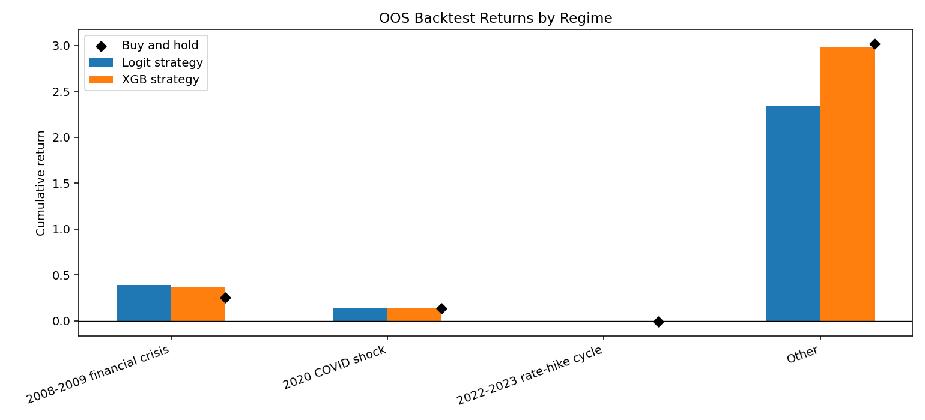
Figure 5. Regime-level backtest returns from the expanding-window evaluation.

4.5 Robustness and return models keep the conclusion cautious
Threshold robustness matters because several strategies look like buy-and-hold at low thresholds. Around 0.40 to 0.50, exposure is often close to 100%; at 0.60, some models barely trade. The backtest edge therefore depends not only on model quality, but also on how the probability signal is turned into positions.
Continuous return prediction is also weak. The historical mean baseline has a test RMSE of about 0.01197 and nearly zero R-squared. The best XGBRegressor variant improves RMSE only slightly, to about 0.01193, which is too small to support a strong return-forecasting claim.
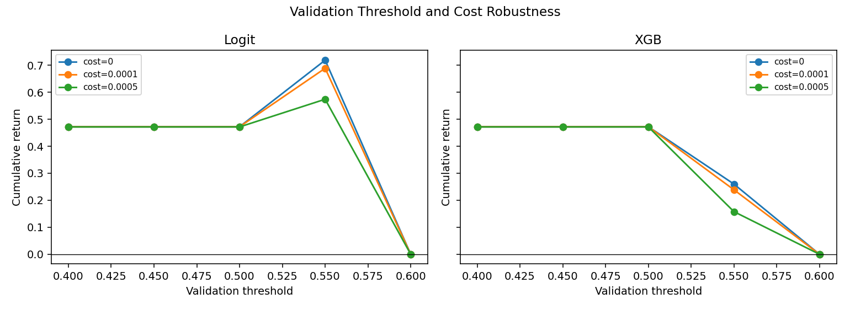
Figure 6. Threshold and transaction-cost robustness checks used to test whether the trading results survive reasonable assumptions.
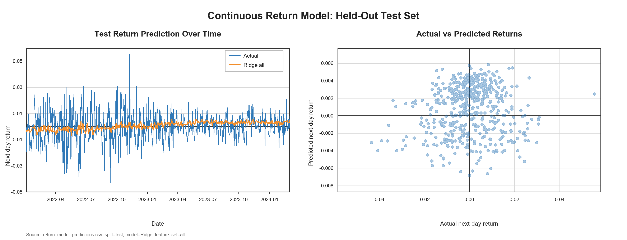
Figure 7. Continuous return model predictions, showing only limited improvement over a simple historical-mean baseline.

5. Conclusions
Overall, we do not find strong evidence that daily financial headline sentiment reliably predicts next-day S&P 500 movement. The strongest pattern is actually the weakness of the relationship: correlations are small, direction models stay near chance, and continuous return models add very little beyond a simple baseline.
At the same time, the project was not a failure. Finance-specific tools such as FinBERT look more useful than very simple dictionary sentiment in some economic tests, and the regime analysis shows why one overall accuracy number can hide important differences across market environments. The evaluation step made the results more honest: some apparent strategy gains disappear once we look at thresholds, exposure, costs, and regimes.
Future work should use timestamped news with intraday returns, include source and outlet metadata, filter off-topic headlines more carefully, and test event-specific models for Fed policy, inflation, earnings, geopolitics, and banking stress. A stronger design would also use walk-forward threshold selection and more realistic trading assumptions before making any claim about a tradable edge.

6. Reflection
Data Preparation Lead
What surprised me most was how unevenly the headlines were spread over time — 2008 had only a handful per day while 2023 routinely had over fifty — and that imbalance shaped almost every later regime decision the team made together. The 974 duplicates I removed weren't random either; many were near-duplicates with subtle rewording, and our group calls were where we agreed how strict to be. Next time I would build a fuzzy-duplicate layer using sentence embeddings and document the FRED merge earlier. Every cleaning rule was reviewed by at least one teammate before it landed.
NLP Lead
The biggest surprise was how little FinBERT actually beat the dictionary baseline at the daily level. I assumed a finance-trained transformer would clearly win, but its correlation with next-day returns was just as small as VADER's. We debated this for hours and the team concluded the bottleneck was really the data — short, often off-topic headlines. Next time I would aggressively filter off-topic headlines, score at the headline level with confidence weights, and try fine-tuning rather than using FinBERT off-the-shelf. The five-way comparison was a group call.
Modeling Lead
What surprised me most was how stubborn the 50% line turned out to be. Even after balanced logistic regression, calibrated probabilities, and a tuned XGBoost grid, the best balanced accuracy was only 51.4%. I rebuilt the pipeline twice with the team before I trusted the numbers weren't a leakage bug. Next time I would use a proper time-aware cross-validation scheme instead of one fixed split, since the 2020–2021 validation window was unusually noisy. Split boundaries and which metric to call primary were all team decisions; I just implemented what we agreed on.
Evaluation Lead
My biggest surprise was how the story shifted between classification and backtesting. The direction models looked weak, yet FinBERT logistic produced a 13.1% test return versus 7.0% for buy-and-hold. I almost called it a clean win — the team rightly pushed back. Once I swept thresholds from 0.40 to 0.60 and split by regime, that edge turned out to be fragile and unstable. Next time I would use walk-forward threshold selection, a more realistic cost model, and bake the regime split into validation from day one. Calibrating my own enthusiasm against the team's skepticism was the most useful part.
Writing and Presentation Lead
The hardest part was telling a "we did not find a strong signal" story without making it sound like a failed project. My first instinct was to lead with the best backtest number, but the team convinced me that being upfront about the weak correlations would make the report more credible. The figures had to be redrawn three times to stay in sync with the latest pipeline outputs. Next time I would lock figure captions earlier, set up a shared glossary, and rehearse the video together instead of recording solo. The narrative is genuinely a five-person product.

References
Dyutidas Mahaptra. (2024). S&P 500 with financial news headlines (2008–2024) [Dataset]. Kaggle. https://www.kaggle.com/datasets/dyutidasmahaptra/sp-500-with-financial-news-headlines-20082024
Federal Reserve Bank of St. Louis. (n.d.). FRED macroeconomic series: VIXCLS, DGS10, DGS2, FEDFUNDS, CPIAUCSL, UNRATE, USREC. Federal Reserve Economic Data. https://fred.stlouisfed.org
Hutto, C. J., & Gilbert, E. (2014). VADER: A parsimonious rule-based model for sentiment analysis of social media text. Proceedings of the International AAAI Conference on Web and Social Media. https://ojs.aaai.org/index.php/ICWSM/article/view/14550
Araci, D. (2019). FinBERT: Financial sentiment analysis with pre-trained language models [arXiv preprint arXiv:1908.10063]. https://arxiv.org/abs/1908.10063
ProsusAI. (2019). FinBERT model documentation [Documentation]. https://huggingface.co/ProsusAI/finbert
Pedregosa, F., Varoquaux, G., Gramfort, A., Michel, V., Thirion, B., Grisel, O., … Duchesnay, É. (2011). Scikit-learn: Machine learning in Python. Journal of Machine Learning Research, 12, 2825–2830. http://www.jmlr.org/papers/v12/pedregosa11a.html
Chen, T., & Guestrin, C. (2016). XGBoost: A scalable tree boosting system. Proceedings of the 22nd ACM SIGKDD International Conference on Knowledge Discovery and Data Mining (pp. 785–794). ACM. https://doi.org/10.1145/2939672.2939785

