

Dynamic Data Assimilation in Agent-based Models

Alice Tapper, Dr Jonathan Ward, Dr Nicolas Malleson and Dr Andrew Evans

University of Leeds

**Project background (100 words)**

Agent-based models (ABMs) play a useful role in the social sciences, helping us to understand emergent patterns in social and environmental systems while retaining detail of the individuals. However, their predictive potential is limited, as calibration is often restricted to a one-shot approach. Dynamic Data Assimilation (DDA) of ABMs is an as-yet unexplored area that would allow the models to be calibrated on the fly, resulting in continuous error constraint. The purpose of this project was to apply DDA to a very basic ABM and to identify any ABM-specific problems with data assimilation.

**Data and Methods (130 words)**

The ABM was designed using python to simulate agents moving along a street, from point A to point B. Footfall cameras were placed at points A and B, counting how many agents passed. Halfway along the street some agents would leave the system, at a certain constant rate termed the bleed-out rate. The inspiration for this model came from publicly available footfall data sourced from cameras in Leeds city centre.

We assumed (unrealistic) knowledge of the number of agents leaving point A and used DDA with simulated data to estimate the number of agents at point B.

The DDA method used was the Ensemble Kalman Filter (EnKF). The algorithm combines noisy observations with a model that has knowledge of the underlying system, to produce estimates of the true system state.

**Key findings (200 words)**

Figure one shows the results obtained when running the ensemble Kalman filter for five days. The camera counts at point B predicted solely by the model are shown in blue, the observations in cyan, and the analysis (the DDA predictions produced by combining the noisy observations with the model predictions) in green.

In predicting the number of agents at point B, the DDA method also performs parameter estimation of the bleed-out rate, shown in figure 1.b). After a period of initial fluctuation the rate settles to a roughly constant value, varying slowly from 0.427 – 0.435. Given that the true bleed-out rate is 0.433, this is fairly successful.

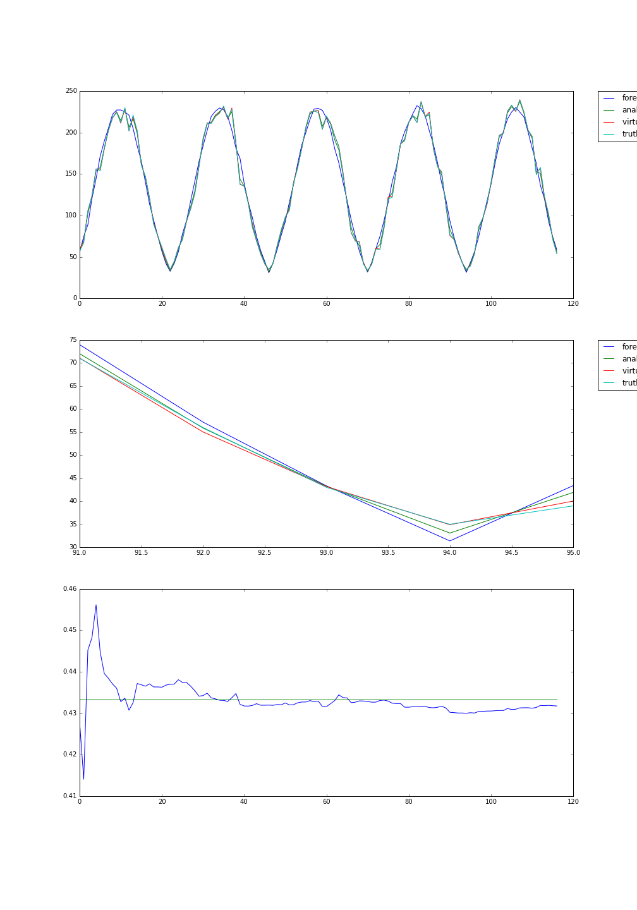



*Figure 1.a) The camera B counts for 5 days (colours explained in text).  
1.b) Parameter estimation of the bleed-out rate. The ground truth is shown in green, estimation in blue.*

**Value of the research (100 words)**

Successful application of the EnKF has shown how DDA can perform reliable parameter estimation. A more detailed explanation of the EnKF can also act as a how-to guide, to help the ABM community apply DDA methods to their own research.

The mathematics involved in applying the EnKF highlighted certain ABM-related issues, for example, we needed to know the maximum number of active agents in the system’s future. Also, in this case the EnKF analysis was less accurate than the observations. Further work should be carried out into these issues, to identify for which ABMs the EnKF is most appropriate.