**Ve270 Introduction to Logic Design Homework 10**

**Assigned: November 29, 2018**

**Due: December 6, 2018, 4:00pm.**

**The homework should be submitted in hard copies.**

1. Problem 5.19 (30 points)

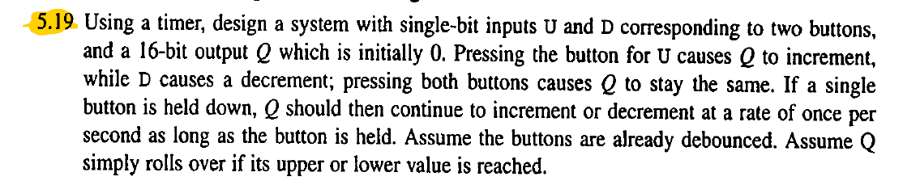

1. Problem 5.27 (20 points)

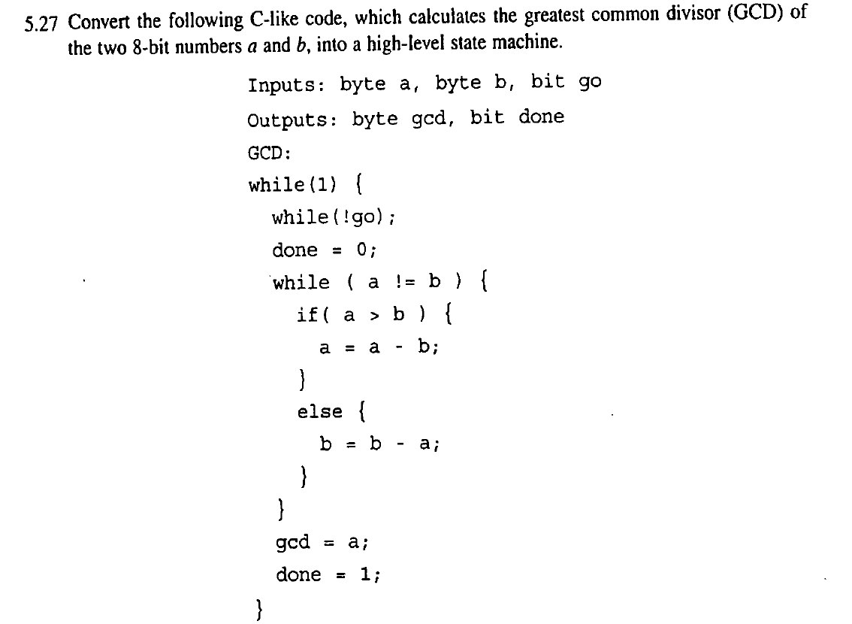

1. Problem 5.28 (20 points)

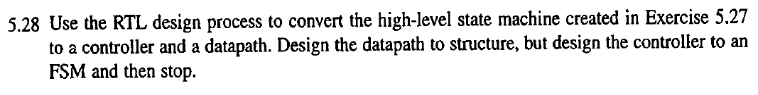

1. Problem 6.27 (10 points)

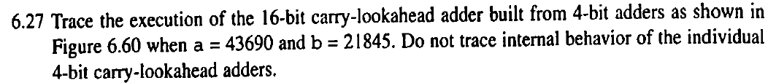

1. Problem 6.28 (10+5+5 points)

