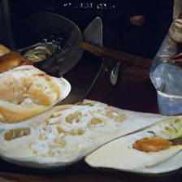

A half eaten meal sitting on a plate

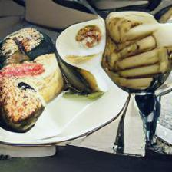

A plate of finger foods next to a blue and raspberry topped cake

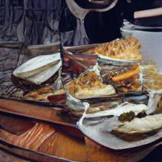

A plate on a wooden table full of bread

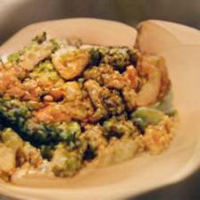

A bean and corn mixture, rice, and broccoli on a plate

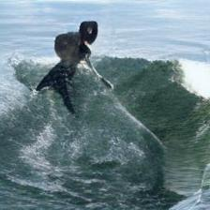

A surfer is riding on a small wave

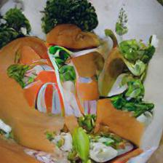

a plate that has some cut up vegetables on it Carrots and small green beans on a white plate

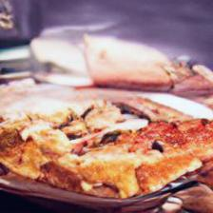

a close up of a slice of pizza on a plate

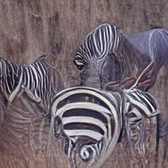

A group of zebras walking away from trees

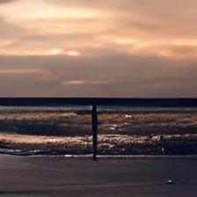

A man standing at the beach shoreline and watching the sunset

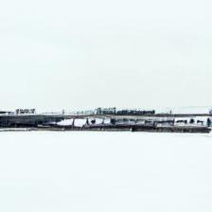

The white bridge stretches out over the horizon as the transport train travels below it

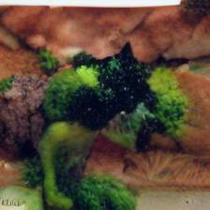

Cooked broccoli sitting on a plate with salmon

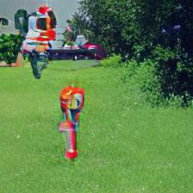

The fire hydrant in the green grass is red