Documentation for Extra Credit 1

1. Libraries to use:
2. How to compile and run:

* Step 1: change line #XXX in XX.lsp to the location of the graph (include screenshot and comment in the code)
* Step 2: launch LISP interpreter and do (load “XXX”)
* Step 3: call function (XX ), see below for examples

1. Test examples:

* The topology specified in the file “graph” is shown below (“usc” instead of “<http://www.usc.edu>” for simplicity):

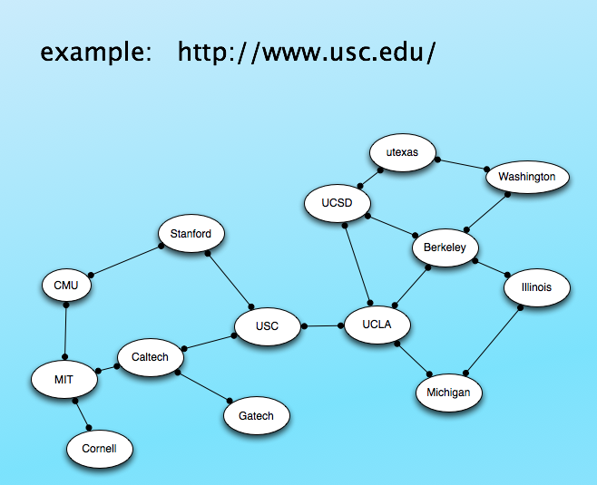

* Test cases:
* 1. Same start and goal:
* (find-URL-path "http://www.cmu.edu/" "http://www.cmu.edu/")
* ("http://www.cmu.edu/")
* 2. Start not in graph:

(find-URL-path "http://www.uofphoenix.edu/" "http://www.washington.edu/")

(PLEASE CHECK THE START PAGE)

3. Goal not in graph:

(find-URL-path "http://www.usc.edu/" "http://www.oxford.edu/")

(PLEASE CHECK THE GOAL PAGE)

4. Normal test case (1)

(find-URL-path "http://www.cornell.edu/" "http://www.washington.edu/")

(("http://www.cornell.edu/" "http://www.mit.edu/") ("http://www.mit.edu/" "http://www.caltech.edu/") ("http://www.caltech.edu/" "http://www.usc.edu/") ("http://www.usc.edu/" "http://www.ucla.edu/") ("http://www.ucla.edu/" "http://www.berkeley.edu/") ("http://www.berkeley.edu/" "http://www.washington.edu/"))

5. Normal test case (2)

(find-URL-path "http://www.usc.edu/" "http://www.mit.edu/")

(("http://www.usc.edu/" "http://www.caltech.edu/") ("http://www.caltech.edu/" "http://www.mit.edu/"))

6. Normal test case (3)

(find-URL-path "http://www.utexas.edu/" "http://www.michigan.edu/")

(("http://www.utexas.edu/" "http://www.ucsd.edu/") ("http://www.ucsd.edu/" "http://www.ucla.edu/") ("http://www.ucla.edu/" "http://www.michigan.edu/"))