

**University of Siegen**

**Computer Vision Group**

**Master Thesis**

**Non-Rigid Puzzles without Template**

by

**Amit Kumar Gupta**

**Matr.-nr.: 1537224**

Master’s Committee:

1st Examiner : Dr. Zorah Lähner

2nd Examiner : Prof. Dr. Michael Möller

**Declaration**

I hereby declare that this thesis entitled Non-Rigid Puzzles without Template, is the result of my fine tuning the original work done for Non-Rigid Puzzles with template and it has not been submitted for any other degree or other purposes. Further, I have faithfully and accurately cited all sources that assisted me throughout my Master's thesis work, including other researchers‘ work published or unpublished.

I am aware of the consequences of not recognizing any sources used in the respective work and it is considered as fraud and plagiarism.

…………………………………………………..

**1 Abstract**

Non-Rigid Puzzles or finding shape correspondences have a wide variety of applications in the fields such as Medical imaging, autonomous driving, Robotics and many more. Here the focus was on to find the correspondences of the Non-Rigid deformations of the shapes without any template. It is already a challenging task to get the correspondences when there is no control on the variation of the shapes. The shapes could be anything from a complete shape to a complete noise and form completely overlapping to not overlapping at all. This work is based on Non-Rigid Puzzles[1], the original work is challenging and removing the template from the scope makes it even more challenging. So fewer modifications have been done to achieve the output. In the original work[1] only the SHOT[2] descriptor was used. In this work additional 4 descriptors are used named as HKS[3], Gaussian Curvature[4], Geodesic Distance[5] and EigenValues. The most fascinating part was how adding the Eigen Values and HKS made a huge difference qualitatively. With addition of the extra above-mentioned descriptors the MSE loss for ICP got reduced from ____ to ____ . The results or the final matching correspondences for the given parts are good but not ideal. Majority of the parts did match to the overlapping part but not completely. It is possible to get the matching of the left half of the human body part to the right half of the human body part e.g left arm of a human body could be matched to any arm of the human body.

**2 Introduction**

The ever changing fields of study like Robotics Vision, Archaeology, Texture Mapping and Medical Imaging deals with the usage of 3D Computer Vision. Eg, in Archaeology the deformed remains of Dinosaurs makes it difficult for Archaeologists to study it and come to a conclusion. In Medical Imaging, after the body scans of a human, if some body parts are not scanned properly then it is really difficult to make any decision as making decisions in Medical field is very critical. For a self-driving car to map the path correctly it is of utmost importance to scan the environment correctly using the LIDAR scans.

In all of the above use cases there is a common problem of missing parts of the object which is being scanned. This is one of the most common problems in computer vision which is currently in study and we are learning new things. To solve the above problem we are using different methods of point cloud matching but the common approach in each of the solutions is to find the correspondences with or without the template. The problem setup has significant variance. From having template to missing template, from finding full shape correspondences to finding partial correspondences, from matching one shape to matching multiple shapes, with and without noise and Rigid deformation to Non-Rigid Deformation or combination of one another.

In this thesis paper the problem setup is to find the correspondences of the missing shapes of a human body scans among them without a template. There could be many shapes with missing parts as well. So this problem falls into the category of finding Non-Rigid Deformed Multiple partial shapes correspondences. Based on Non-Rigid Puzzles[6] and Learning Spectral Unions of Partial Deformable 3D Shapes[7] I tried to solve this problem with some success.

I have used the code base for Non-Rigid Puzzles[8] for my reference which is written in MATLAB. However, in the original code the problem setup was with template so some changes were needed which were done and managed to find considerable correspondences among the shapes. Firstly, the template was replaced by one of the shapes given and iteratively correspondences were found for all other shapes. Secondly, in the original code only one descriptor of 352 dimension was used which was added with other 3 descriptors. Tried many combinations with the number of eigen values to be used and number of iterations to converge to an optimal solution.

**3 Background**

**3.1** ICP and SVD Optimization

In this thesis 3D Point Clouds are used. Point Clouds are a set of points in 2D or 3D. ICP stands for Iterative Closest Point, it is a method to find the closest point to an original point cloud to its approximate. There are varieties of ICP such as Linear and Nonlinear. NonLinear ICP uses the SVD approach. SVD stands for Singular Value Decomposition, SVD is the factorization of a matrix into 3 components.

$M = UΛV'$

In the above equation M is a $m×n$ matrix, $Λ$ is a $n×n$ matrix and $V'$ is a $n×m$ matrix. We are using the Root Mean Squared Error (RMSE) Method to Optimize the transformation matrix we get from SVD. The Transformation matrix R is obtained by dot product of $U and V'$ and this R is multiplied with the approximate point cloud to get the approximation of the original point cloud.

$R = U.V'$

$e = 1/k * \sqrt{Σ(X - R.Y)²}$

In the above equation $e$ is the RMSE, $X$ is the original point cloud, $Y$ is the point cloud to match and $k$ is the total number of points in the point cloud to match. The above mentioned keeps on until $e$ is less than a threshold value.

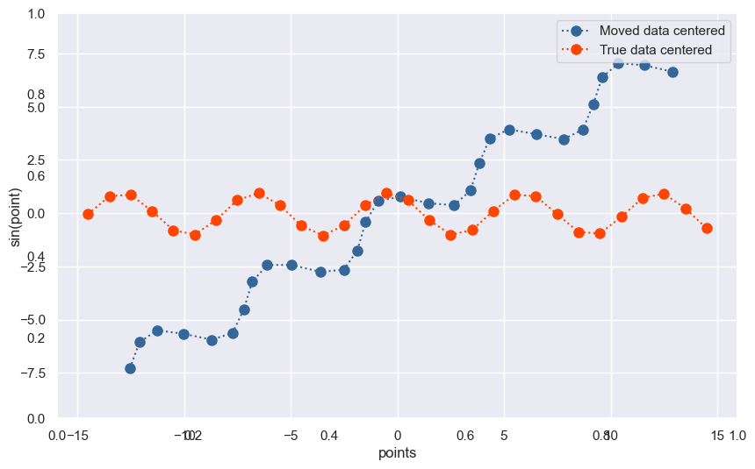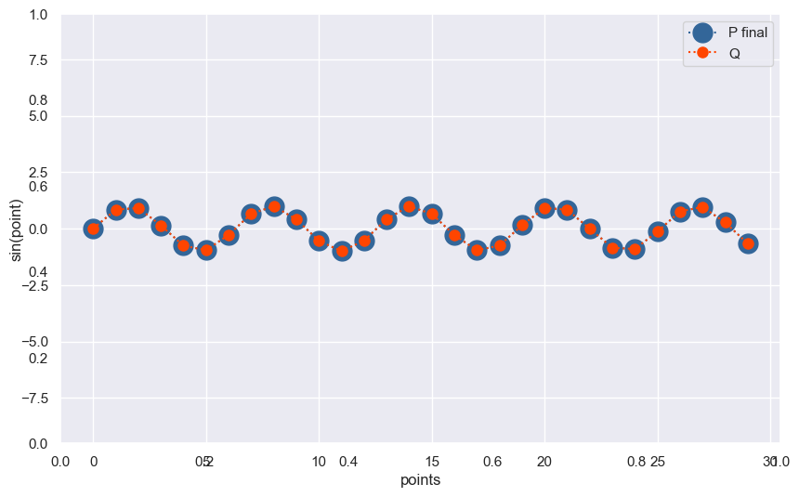

Fig1 : Point Clouds before ICP Fig2 : Point Clouds after ICP

**3.2** Eigen Decomposition

Eigen Decomposition is a method of representing a matrix into it’s eigen values and eigen vectors. The only condition is that the matrix should be a diagonalizable matrix.

$AΦ = λΦ (1)$

Where A is the matrix and $Φ$ is the eigen vectors and $λ$ is the eigen values. All the eigen vectors are orthogonal and linearly independent in nature.

**3.3** Laplace Beltrami Operator[9]

Laplacian on an euclidean surface is defined as divergence demoted as $∇$ of the gradient devoted as $∇f$ of the scalar function defined on the euclidean surface. Laplace Beltrami Operator denoted as $Δm$ is the generalization of the Laplace Operator to functions defined on Manifolds of an Euclidean space.

$∇f =\frac{∂f}{∂x}i + \frac{∂f}{∂x}j +\frac{∂f}{∂x}k (2)$

$Δm =∇.∇f = \frac{∂²f}{∂x} + \frac{∂²f}{∂x} +\frac{∂²f}{∂x} (3)$

The Laplacian used here is the cotangent laplacian which is represented as

$L = cot(α)+cot(β), i= j, (α,β) opposite angles (4)$

$L = -cot(γ), i ≠j , γ : opposite angle to i and j (5)$

$i,j,k ϵ I$

From equation 1 we get,

$LΦⱼ = λΦⱼ (6)$

**3.4** Manifolds

The Manifolds could be defined as the open subset space of the closed 3D Euclidean space. The manifolds are equipped with properties like Gradient and Laplace-Beltrami Operators which carry the hierarchical properties from Euclidean space to manifolds. An eigen decomposition could be done on the manifolds using Laplacian calculated from Laplace Beltrami Operator. The eigen decomposition helps in the representation of each point in the manifold with a linear combination of eigen vectors much like the Fourier Transform.

**3.5** Functional Correspondence[FNC]

Since ICP is the classical algorithm, the recent breakthrough in the shape matching is Functional Correspondence[10] given by Ovsjanikov et al. The correspondences $Cij$ is computed as the result of this method. Let us assume a model $M$ and part $N$ to be matched. $Φi$ and $Ψj$ are the eigenfunctions we got on $M$ and $N$ respectively. The eigenfunctions $Φi$ and $Ψj$ $∀ i≥j$, are matched with a Linear Operator $T$ defined as

$T : L²(M)→L²(N)$

Mapping function on $M$ to functions on $N$. Since eigenfunctions of the Laplacian form a basis, let $f ϵ L²(M)$ be any function defined on $M$ which is described as the linear combination of the eigenfunctions.

$f(x) = ∑\left(f,Φi\right)ₘ$ $Φ(x)$ $, ∀ i≥ 1$

Here in the above equation $\left(f,Φi\right)$ is the dot product between $f and Φi$. Now the function $f$ on $M$ can be mapped $N$ by Linear Transformations denoted by $T$.

$Tf$ = $T∑\left(f,Φi\right)ₘΦi$ = $∑\left(f,Φi\right)ₘTΦi$ = $∑\left(f,Φi\right)ₘ(TΦi,Ψj)ₙΨj$

$Cij$ = $(TΦi,Ψj)ₙ$

**4 Related Work**

There are many successful attempts in this direction to solve the problem of shape matching which could be referenced from this survey[11].

4.1 Rigid Multipart shape Matching [12]

In Computational Archaeology, it often happens that researchers used to get the several pieces of remains and to combine them to make sense shape matching could be used. In this setup the pieces are assumed to be rigidly transformed and using the ICP algorithm for both rotation and translation the shapes can be matched to the reference model. However, there is a challenge, there is a high possibility that along with the genuine pieces some noise is also found so to reduce the effect of noise regularizer is used in this approach by O. Litany, A.M. Bronstein, and M.M. Bronstein. The matching and segmentation of the shapes are done simultaneously.

In this setting, there are two approaches discussed. In the first approach the author is trying to do the shape registration using the L2 distance based loss as shown below.

$D(X,Y) = Σ||x-y*(x)||² + Σ||x(y)*-y||²$ (10)

This formulation solved by means of alternating optimization, in first, for a fixed transformation T, the closest correspondences are found denoted as x∗, y∗. In second, the correspondences x∗, y∗ are fixed and then the transformation T is found by minimizing $D(X,T.Y)$.

The reference shape X is given and other multiparts denoted by $Yi$. The matching regions on X is denoted by $Xi$ such that $∪_{i=1}^{n}{}Xi = X$ and $∩_{i=1}^{n}{}Xi = Φ$. It is also taken as assumption that the shapes $Yi$ are non overlapping. In the loss function to counter the noise a regularizer is added in equation 10 as shown below.

$\sum_{i=1}^{n}{}D(Xi,T.Yi) + λ \sum_{i=1}^{n}{}R(Xi)$, minimized for T (11)

Where the first aggregate focus on the alignment part of the shapes with reference by minimizing the distance between $Xi and T.Yi.$ Each segment $Xi$ which is a disjoint subset of points from the other segments on the reference is matched to $Yi$. The second aggregate focuses on the producing of the smooth boundary of the segments without any fragments and irregularities by giving a penalty as $R(Xi) = L(∂Xi)$ where $L(∂Xi)$ is the distance of the boundary of the $Xi$ segment.

The final results look quite promising and we can clearly see in the fig 3 that the broken pieces of the Dragon in the left part are well segmented to the reference of the Dragon. The figure below is taken from the original paper written by O. Litany, A.M. Bronstein, and M.M. Bronstein [12].

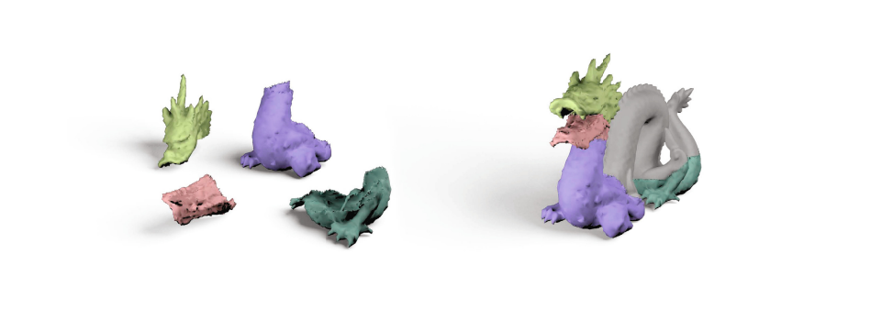

Fig.4 : Multipart Rigid shape matching

Our problem setup is a little bit different than this. In our setting, we do not have a reference model and instead of Rigid transformation the shapes we have are going through Non-Rigid Transformations. This makes the solution much more challenging. To address this challenge the Non-Rigid Puzzles [1] on which my work is based has updated the loss function with addition of regularization terms. Instead of regularizing reference the parts and prior correspondences are also regularized.

4.2 Partial Matching of Deformable Shapes[12]

In the previous setting, the reference model or template was full and shapes were going rigid transformations. However in this setup the template is full but the shapes to match are not full. The shapes to be matched are with cuts and holes. In addition to the non-full shapes the shapes are also undergoing non-rigid transformations.

The author has used the Geodesic Distance* to measure the quality of matching. Let's assume that used matching method produces a matching for $x ∈ M$ on $y ∈ N$ where $M$ is the shape to be matched and $N$ is the template. There is a ground truth for $x is y*$ so the evaluation metric looks like below.

$ε(x) = \frac{dₙ(y,y*)}{\sqrt{area(N)}}$ (12)

$dₙ$ is the geodesic distance of between the $y and y*$ on the template for $x$ on $M$. The error $ε(x)$ is averaged over all the matching pairs of $(M,N)$.

The author has evaluated 5 different methods namely partial functional correspondence [FNC], the isometric embedding method of [ISO], game-theoretic matching [RBA], elastic net matching [RTH], and a learning technique based on random forests [RRBW]. All the solutions obtained from these methods are point-to-point matchings. Out of all these methods only two methods are used in this thesis work. The first one is functional Correspondence and isometric embedding methods. The functional correspondence is discussed in detail on page 5. Let's discuss the isometric embedding method for shape matching.

Geodesic Distance is used as the isometric property for calculating the distortion for a mapping.

$Diso ∝ d¡ₛₒ(Si, Pj)$ (*)

$d¡ₛₒ(Si, Pj) = Σ\left|ρ(Si,Pj;Sa,Pb)−ρ(Si,Pj;Sc.Pd)\right|$ (13)

$ρ(Si,Pj;Sk,Pl)=max(\frac{g(Si,Sk)}{g(Pj,Pl)}, \frac{g(Pj,Pl)}{g(Si,Sk)}))$ (14)

In the equation 14 the $g(Si,Sk)$ is the geodesic distance between the points $(Si,Sk)$ as shown in the fig.5. This figure is taken from the original paper Partial Matching of Deformable Shapes[12].

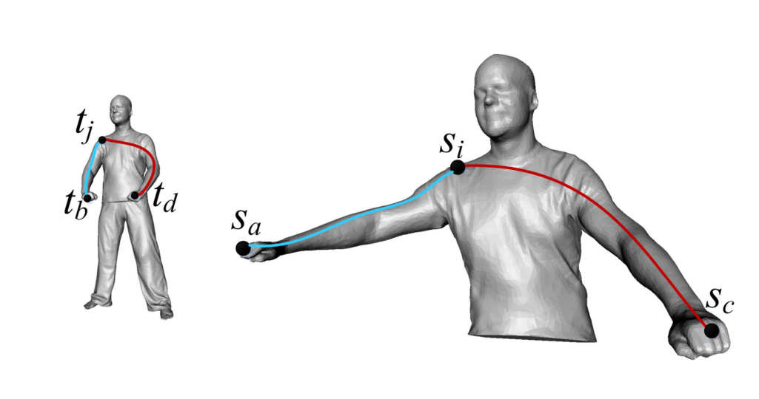

Fig.5 : In the left human body which is the template, the geodesic distance between the points tb ,tj and td should be similar to the geodesic distance on the partial shape on the right of the points Sa ,Si and Sc.

The results from this paper clearly shows that in the case of computing partial shape correspondences in Non-Rigid deformation setup function map correspondences and using Geodesic Distances as mapping between template and shape works the best.

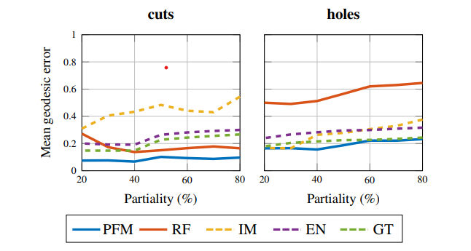

Fig.6 : Mean error for point-point matching for different matching methods.[12]

4.3 Learning Spectral Unions of Partial Deformable 3D Shapes [LSUPD3]

This work deals with the Non-RIgid partial deformations of the shapes. In this setup no full model or template is given. This approach utilizes the parameters learning method to predict the Eigenvalues of the unions of the partial shapes using the Neural Network. Given two manifolds $M and N$ have laplacian decomposed into eigenvalues and eigenfunctions but unlike other in this case author completely disregards the use of eigenfunctions instead author uses the eigenvalues i and j of $M$ and $N$ respectively to get the output as eigenvalues of $M ∪ N$ after some transformation .

$λ(M ∪ N) = U$ $Θ$ ( $λ(M),λ(N))$ (15)

$U$ $Θ$ is the learnable parameters.

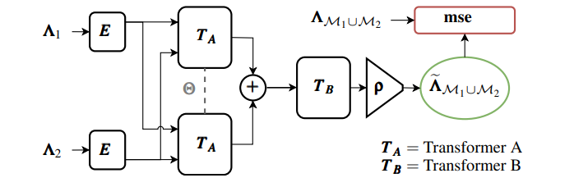

Fig.7 : Neural Network Architecture

1 and 2 are the eigenvalues of the shapes $M and N$ respectively. $E$ is embedding the input eigenvalues into higher dimensions. A is a transformer which is broadcasting the embedded eigenvalues into latent representations and summing them together to form the latent representation eigenvalues of the union. B and $ρ$ are the decoders which translate back the latent representation of the eigenvalue of union to predicted eigenvalues.

From this piece of work it was found out that eigenvalues could also be used as a descriptor for calculating the correspondences. Instead of using a Neural Network as proposed in this paper[LSUPD3], only adding the diagonalized matrix of eigenvalues as one of the descriptors was decided. Interestingly, adding eigenvalues as descriptors improves the performance on matching the partial shapes without template.

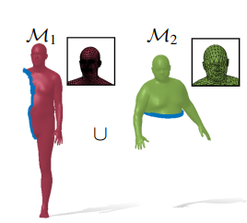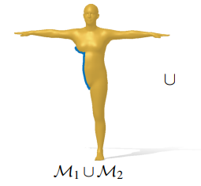

Fig.8 : Given the input Laplacian of M1 and M2 the algorithm predicts the Laplacian of M1  M2.