Proposal Report

[MR02] IOT-based Radio Tomographic Imaging System

Authors:

* GUPTA, Pranav - 20682816, pguptaaf@connect.ust.hk
* LEE, Kwun Yin - 20704470, kyleeax@connect.ust.hk

Key Objectives:

* To set up the Wi-Fi nodes for measuring Received Signal Strength Indication
* To build a wireless network of nodes with a server
* To implement the Radio Tomographic Imaging algorithm
* To experiment with hardware and software methods to speed up imaging
* To experiment with different hardware optimizations and machine learning algorithms to improve imaging accuracy.

**TABLE OF CONTENTS**

**SECTION 1 - INTRODUCTION**

1.1 Background and Engineering Problem 1

1.2 Objectives 1

1.3 Literature Review of Existing Solutions 2

**SECTION 2 - Methodology**

2.1.1 System Description 3

2.1.2 Block Diagram 4

2.1.3 Component List 4

2.1.4 ECE Knowledge 4

2.2.1 Setting Up WiFi nodes for computing Received Signal Strength indication (RSSI) 5

2.2.2 Network server on Terminal 5

2.2.3 Implement RTI Algorithm 6

2.2.4 Explore ways to speed up the imaging system 6

2.2.5 Machine Learning Algorithms to improve imaging accuracy 6

**SECTION 3 - PROJECT PLANNING**

3.1 Project Schedule 7

3.2 Project Budget 10

**REFERENCES**

Reference List 11

**APPENDICES**

A Meeting Minutes 11

**Section 1 - Introduction**

**1.1 Background and Engineering Problem**

In Radio Tomographic Imaging (RTI), wireless signal transceivers are arranged as individual wireless nodes that are part of a wireless network. As illustrated in Figure 1, links are formed between every possible pair of nodes in the network, in which one node momentarily receives a signal from the other node. The signal attenuation due to physical obstruction in every link in the network is measured to generate an image of the object. [1]

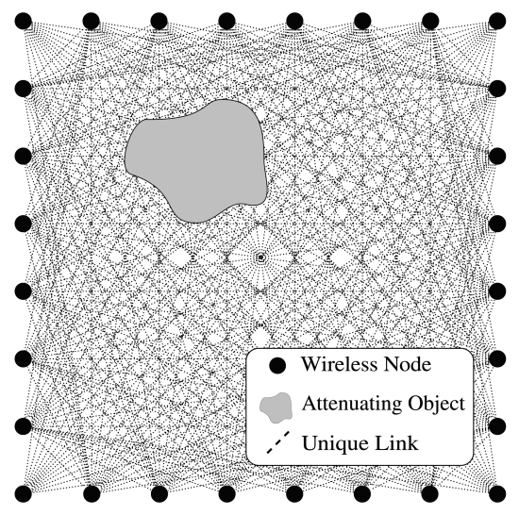

Figure 1: Example of Links between Nodes in a Wireless Network [1]

There is considerable research on this imaging modality to demonstrate its potential in various scenarios such as in general through-the-wall surveillance, rescue operations, and in Internet-of-Things applications. However, one major drawback of using RTI systems is that the real-time images generated are often not of high resolution. This is mainly due to the different contributing factors of signal attenuation, including the distance between nodes, constructive and destructive interference between signals, and environmental factors.

Therefore, this project aims to explore different methods to improve the imaging quality, and ultimately, build an IOT-based RTI system that truly meets the industrial standards for its applications.

**1.2 Objective**

This project aims to implement an IOT-based Radio Tomographic Imaging System that can be used for different commercial applications such as surveillance and IoT applications. Furthermore, the project aims to optimize the Signal-to-Noise ratio and Spatial Resolution of the imaging system by experimenting with different Hardware-level Optimizations, Signal Processing techniques, and Machine Learning algorithms.

**1.2.1 Objective Statements**

Objective 1: To set up the Wi-Fi nodes for measuring Received Signal Strength Indication (RSSI)

Objective 2: To build the networked system with a server

Objective 3: To implement the RTI algorithm

Objective 4: To experiment with hardware and software methods to speed up the imaging system

Objective 5: To experiment with different hardware optimizations and machine learning algorithms to improve imaging accuracy.

**1.3 Literature Review of Existing Solutions**

Radio Tomographic Imaging has several practical applications in surveillance systems and Internet-of-Things applications. In the RTI systems, wireless nodes that are part of a wireless network are aligned such that they surround the targeted location to be inspected. There are various alternatives and existing solutions that are already being implemented for such applications, such as Video Cameras, GPS Tracking, and RFID Tags.

Video Cameras are currently being used in both surveillance and IoT applications. Different Deep Neural Networks can be deployed to extract real-time insights from video footage. For instance, video footage can be used to perform gesture recognition to control different IoT devices. Moreover, several applications use ensemble learning - in which the audio is used alongside the video for better inference. However, such models require quality video footage that may not be available in foggy or dark environments. Some applications also include thermal imaging to counter such environments. While these systems can produce accurate images using InfraRed waves, these waves can easily be blocked by glass panels and concrete walls. Since RTI systems use Radio Frequency signals that can penetrate such physical and non-physical barriers, these systems are potentially a more effective solution in such applications.

Radio Frequency Identification (RFID) tracking systems are also widely deployed for tracking applications. RFID tags are smart labels that are carried by the object to be tracked. An RFID system transmits radio frequency waves to search, identify, and track the location of such tags. While these systems can accurately locate objects, they can neither be used to monitor an object’s behaviour nor to identify the physical objects that are not tagged. Moreover, there are several environmental constraints when using such systems - for instance, RFID tags need to maintain a specified minimum distance between each other to minimize interference and ensure proper functioning. Our proposed RTI system does not require any physical tags on the objects being imaged and hence, is a more comprehensive solution when compared to RFID tags.

Location Fingerprinting with Bluetooth is a popular technique used in indoor tracking applications. Similar to the RTI method, this localization method uses Received Signal Strength (RSS) to measure the distance between the Bluetooth beacons and any physical obstruction. [2] Both systems require initial calibration to record the RSS values to determine if there are any physical obstructions. Using Bluetooth Low Energy (BLE) significantly reduces power consumption, and the imaging accuracy is comparable to that of RTI systems using Wi-Fi. However, Bluetooth beacons have a relatively smaller coverage compared to Wi-Fi and hence, a higher density of beacons is required to maintain a high degree of imaging accuracy. [3] A BLE system can be implemented in the future to evaluate the accuracy of our IoT-based RTI system.

There has been significant research to develop RTI systems with considerable accuracy. For instance, one paper investigates the benefits of using Electronically-Switched Directional Antennae for the wireless nodes instead of a fixed antenna per node. This method has shown significant improvements in imaging quality mainly because it reduces the impact of signal attenuation due to environmental factors by using directional antennae. [4] Similar papers include one that involves the use of compressive sensing to reduce the system latency and spatial diversity to improve imaging performance. By using multiple antennae on each wireless node, the paper claims to have achieved a significant reduction in the localization error. [5] We will consider experimenting with various hardware-level and software-level optimization techniques to improve imaging quality and reduce system latency.

**Section 2 - Methodology**

**2.1.1: System Description**

The project aims to build an IoT-based Radio Tomographic Imaging System. In essence, the system is a network of wireless nodes that transmit signals to each other, and the attenuation in signal strength due to physical obstruction is recorded for imaging that object.

Key hardware components and software modules

ESP32 - this module is the wireless transceiver module that functions as a node in the wireless network. This module is currently one of the most common IoT modules and hence, there is extensive software support for it - there are existing libraries to measure the RSSI values. Moreover, there are a lot of settings that can be customized on the module, such as the signal transmitting power (max: 20.5 dBm), the antenna diversity (it comes with an external RF switch that can reduce the effects of channel fading), and the internet protocols (e.g., 802.11 b/g/n). Lastly, alternative wireless modules and communication protocols can be experimented with.

Sensor Network and Terminal - a personal computer (PC) will be used as the terminal where all the RSSI values per image will be collected from all the wireless nodes.

After successfully implementing the RTI system, we will consider replacing the terminal with an independent microcontroller (e.g., STM32, Arduino) to speed up the imaging system.

RTI Algorithm - This algorithm controls the RSSI data collection from every link in the network. Moreover, the code will also include an image reconstruction algorithm to convert the RSSI values into a real-time image. We aim to develop the algorithm in Python or C depending on the Network settings mentioned above.

Machine Learning Algorithms - After successfully implementing the Radio Tomographic Imaging System, different Machine Learning algorithms will be experimented with to optimize the imaging accuracy (e.g., Mean Squared Error).

**2.1.2: Block Diagram**

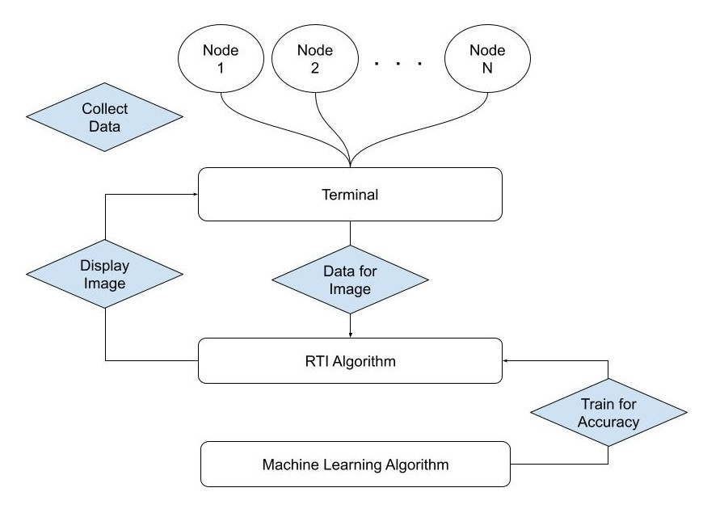

Figure 2: Block diagram for the proposed IOT-based Radio Tomographic Imaging system

**2.1.3: Component List**

|  |  |
| --- | --- |
| **Component** | **Specification** |
| Wireless Transceivers | ESP32 (e.g. Sparkfun Dev-13907) |
| Computing Unit with Display | Personal Computer,  MCU (STM32 or ATMega) in future |

**2.1.4: ECE Knowledge**

ELEC3100 Signal Processing and Communications

This course first introduces fundamental signal processing techniques, and models for wireless channels and noise. These concepts are essential to build the network of wireless nodes and accurately model the attenuation of signals due to physical obstruction.

ELEC3300 Introduction to Embedded Systems

This course is an introduction to both the hardware and software components of embedded systems engineering. Through this course, we will learn to integrate different hardware components and control them via a microprocessor. This knowledge will be essential in acquiring the RSSI values from all wireless nodes in the network. Moreover, the skills learned in class will be useful in debugging our system and reducing its latency.

ELEC4820 Medical Imaging

This course introduces the working principles behind several common medical imaging modalities, including Magnetic Resonance Imaging, Ultrasound Imaging, and Computed Tomography. Several concepts will be taught in this course that may be relevant to the image reconstruction algorithm, such as the Fourier Slice Theorem and the Radon Transform.

**2.2: Objective Statements Execution**

**2.2.1 Setting Up Wi-Fi nodes for computing Received Signal Strength indication (RSSI)**

The objective of this task is to prepare each Wi-Fi module to be a node of the wireless network. These nodes will later be used to transmit and receive signals from each other to compute the RSSI values for imaging.

ESP32 is a low-power microcontroller with an integrated module with which we can conveniently compute the RSSI values and send them to our server directly. The RSSI values will be computed by each wireless node for every link, after which the values will be sent to the terminal for imaging. We will start with 16 wireless nodes to first develop a prototype and then investigate adding more nodes for higher imaging accuracy.

Task 1: Completing the ESP32 module circuit and test signal transmission and reception function

Member in Charge: Lee Kwun Yin

Description: Complete the circuit for each wireless node. This mainly includes powering each module with 3.7V and connecting any external peripherals, if any.

Task 2: Write code for the ESP32 module to transmit and receive signals with each other

Member in Charge: Lee Kwun Yin

Description: Write the program in either Arduino or MicroPython to successfully establish communication with other ESP32 modules. Write the method for computing the RSSI values from the received signals.

2.2.2 Network server on Terminal

The objective is to build a server system to receive and organize RSSI data from all the wireless nodes

Objective: To build a server to receive data from the Wi-Fi nodes system

The objective is to create a local file server to receive RSSI data from each ESP32 module. This terminal will collect the data and organize it for the RTI algorithm.

Task 1: Setup a local server

Member in charge: Lee Kwun Yin

Description: Create a file server to allow ESP32 modules to consistently transfer data back to the terminal

Task 2: Build a data pipeline for all data to be received and organized

Member in Charge: Lee Kwun Yin

Description: Set one ESP32 node as the terminal node that communicates directly with the PC. Build a pipeline to convert the raw RSSI data into a dictionary for further processing.

2.2.3 Implement RTI Algorithm

The objective is to write a program that would receive a dictionary of all the RSSI values from every link between the wireless nodes and produce an image of any physical obstructions between the links.

Task 1: Write RTI Algorithm to receive RSSI values from all nodes

Member in charge: Pranav Gupta

Description: Record RSSI values from every node for every link in the wireless network. This program needs to set the link(s) that be active during a given period for computing the RSSI values accurately (i.e., with minimal interference and natural signal attenuation)

Task 2: Write Image Reconstruction Algorithm

Member in Charge: Pranav Gupta

Description: Write a program to convert the RSSI values into images that are color-coded (like heatmaps, where warmer colours would indicate signal attenuation).

2.2.4: Explore ways to speed up the imaging system

The objective is to explore methods to improve the hardware and software to improve the imaging speed

Task 1: Speed Up Program

Member in Charge: Pranav Gupta

Description: Explore ways to speed up the RTI algorithm (e.g., by replacing iterative methods with matrix multiplication if possible, or by implementing own methods instead of using large libraries to improve execution speed, or shifting to C++ from Python, etc.)

Task 2: Research Hardware Improvements

Member in Charge: Lee Kwun Yin, Pranav Gupta

Description: Explore possible improvements to the hardware - such as connecting an external antenna to each ESP32, implementing the terminal in embedded systems (e.g., STM32), etc.

2.2.5: Machine Learning Algorithms to improve imaging accuracy

The objective is to explore different machine learning algorithms to train the imaging model to accurately generate images of any physical obstructions.

Task 1: Implement Machine Learning models into the RTI system

Member in Charge: Pranav Gupta

Description: Implement different machine learning models and train them with different configurations and loss functions (e.g., Mean-Squared Error, Hinge Loss, Boundary Loss). Compare the results and choose the configuration that best suits the application needs of the RTI system.

**Section 3 - Project Planning**

**3.1 Progress Table**

|  |  |  |  |  |  |  |  |  |  |  |  |  |  |  |  |  |  |  |  |
| --- | --- | --- | --- | --- | --- | --- | --- | --- | --- | --- | --- | --- | --- | --- | --- | --- | --- | --- | --- |
| **Objective Statements** | **Task** | **Group Member in charge** | **WK1 Date** | **WK2 Date** | **WK3 Date** | **WK4 Date** | **WK5 Date** | **WK6 Date** | **WK7 Date** | **WK8 Date** | **WK9 Date** | **WK10 Date** | **WK11 Date** | **WK12 Date** | **Wk 13 Date** | **Wk 14 Date** | **Wk 15 Date** | **WK16 Date** | **WK17 Date** |
| **Setting up WiFi nodes for Computing RSSI** |  | Lee Kwun Yin |  |  |  |  |  |  |  |  |  |  |  |  |  |  |  |  |  |
|  | **Complete ESP32 module circuit** | Lee Kwun YIn |  |  |  |  |  |  |  |  |  |  |  |  |  |  |  |  |  |
|  | **Write code for ESP32 to transmit and receive signal** | Lee Kwun YIn |  |  |  |  |  |  |  |  |  |  |  |  |  |  |  |  |  |
| **Network Server on PC/terminal** |  | Lee Kwun Yin |  |  |  |  |  |  |  |  |  |  |  |  |  |  |  |  |  |
|  | **Setup server on terminal** | Lee Kwun YIn |  |  |  |  |  |  |  |  |  |  |  |  |  |  |  |  |  |
|  | **Build a data pipeline for all data to be received and organised** | Lee Kwun YIn |  |  |  |  |  |  |  |  |  |  |  |  |  |  |  |  |  |
| **Implement RTI algorithm** |  | GUPTAPranav |  |  |  |  |  |  |  |  |  |  |  |  |  |  |  |  |  |
|  | **Write RTI algorithm to receive RSSI from all nodes** | GUPTAPranav |  |  |  |  |  |  |  |  |  |  |  |  |  |  |  |  |  |
|  | **RTI Image algorithm** | GUPTAPranav |  |  |  |  |  |  |  |  |  |  |  |  |  |  |  |  |  |
| **Explore ways to speed up the imaging system** |  | Lee Kwun Yin, GUPTA Pranav |  |  |  |  |  |  |  |  |  |  |  |  |  |  |  |  |  |
|  | **Speed up Program** | GUPTAPranav |  |  |  |  |  |  |  |  |  |  |  |  |  |  |  |  |  |
|  | **Research Hardware Improvement** | Lee Kwun Yin |  |  |  |  |  |  |  |  |  |  |  |  |  |  |  |  |  |
| **Machine learning algorithm to improve imaging accuracy** |  | GUPTAPranav |  |  |  |  |  |  |  |  |  |  |  |  |  |  |  |  |  |
|  | **Implement the machine learning model into the RTI system** | GUPTAPranav |  |  |  |  |  |  |  |  |  |  |  |  |  |  |  |  |  |

**3.2 Budget Table**

|  |  |
| --- | --- |
| **Items** | **Estimated Cost (HKD)** |
| ESP32 Modules - Sparkfun Dev-13907 *16 | HKD$190 *16 = HKD$3040 |
| **Total** | **HKD$3040** |

**\*\* There may be additional procurements made subject to our project plan and the availability of different items.**

**References**

[1] J. Wilson and N. Patwari, "Radio Tomographic Imaging with Wireless Networks," in *IEEE Transactions on Mobile Computing*, vol. 9, no. 5, pp. 621-632, May 2010, DOI: 10.1109/TMC.2009.174.

[2] R. Faragher and R. Harle, "Location Fingerprinting With Bluetooth Low Energy Beacons," in IEEE Journal on Selected Areas in Communications, vol. 33, no. 11, pp. 2418-2428, Nov. 2015, DOI: 10.1109/JSAC.2015.2430281.

[3] A. Lindemann, B. Schnor, J. Sohre, and P. Vogel, “Indoor Positioning: A Comparison of WiFi and Bluetooth Low Energy for Region Monitoring,” Proceedings of the 9th International Joint Conference on Biomedical Engineering Systems and Technologies, 2016, DOI: 10.5220/0005704603140321.

[4] B. Wei, A. Varshney, N. Patwari, W. Hu, T. Voigt, and C. T. Chou, “dRTI: Directional Radio Tomographic Imaging,” *Proceedings of the 14th International Conference on Information Processing in Sensor Networks*, Feb. 2014, DOI: 10.1145/2737095.2737118

[5] S. Xu, H. Liu, F. Gao, and Z. Wang, “Compressive sensing based radio tomographic imaging with spatial diversity,” *Sensors*, vol. 19, no. 3, p. 439, Feb. 2019, DOI: 10.3390/s19030439.

**Appendix**

**A - Meeting Minutes**

Date: 05/09/2022

Time: 3 PM

Location: HKUST, Room 2517

Attendances: LEE Kwun Yin, GUPTA Pranav, Prof. Ross Murch, Amartansh DUBEY, QIAN Jun

Absent: None

Minutes taken by: LEE Kwun Yin

* Prof. Murch introduced the background and key objectives for the project
* Lee Kwun Yin will be responsible mainly for the hardware side of the project while Gupta Pranav will be responsible for the software side
* Group decided that ESP32 module will be used for the project
* The students will check for existing ESP32 modules in the ECE store room, and purchase more if needed
* The main task is to try and generate RSSI data from 2-3 ESP32 modules in 1-2 weeks
* Prof. Murch and Amartansh recommended to read the research paper titled: “Radio Tomographic Imaging with Wireless Networks” for reference
* Prof. Murch reminded to keep all receipts for purchases relevant to this project

|  |  |  |
| --- | --- | --- |
| **Action Item to be completed** | **By when** | **By whom** |
| Check ECE Store Room for ESP32 modules available. | Sep 16th | Lee Kwun Yin |
| Purchase ESP32 Modules and other peripherals if needed | Sep 17th | Lee Kwun Yin |
| Complete Proposal Report | Sep 14th | GUPTA Pranav |
| Read relevant research papers (including the paper mentioned above) | Sep 19th | All |
| Research on ESP32 basic development | Sep 18th | Lee Kwun Yin |
| Research for image reconstruction algorithms | Sep 19th | GUPTA Pranav |

Table 1. Action Items for Next Meeting

Next Scheduled Meeting: Sep 19, 15:30-16:30, Room 2517