Build, Release, and Deployment Runbook
Client Engineering Guide for Horizon Relevance AI DevSecOps Platform
Evidence Date: May 20, 2026
Example Client/Application: Acme Fintech / acme-fintech-angular-main
Document Type: Client engineer runbook and audit evidence guide
This runbook explains how client engineers build an application, publish immutable release metadata, promote the same image digest across environments, and validate runtime evidence using the Horizon Relevance AI DevSecOps platform.

Table of Contents
- Purpose and Audience
- End-to-End Process Summary
- Architecture and Artifact Flow
- Prerequisites
- Build & Deploy Pipeline
- Validate Pipeline
- Release Promotion Pipeline
- Evidence and Audit Artifacts
- Validation Checklist
- Troubleshooting
- Appendix: Captured Evidence

1. Purpose and Audience
This document is intended for client developers, QA engineers, release managers, platform administrators, and auditors. It describes how the platform moves a build from source code to a deployable container image, then promotes and deploys that image through QA and STAGE without rebuilding the source.

2. End-to-End Process Summary
- Build & Deploy Pipeline builds source code, creates a Docker image, pushes it to ECR, writes metadata to S3, and deploys to the selected environment.
- Validate Pipeline tests the running application after deployment without creating a new image.
- Release Promotion Pipeline reads the original S3 metadata and promotes the same immutable image digest from DEV to QA, QA to STAGE, and later STAGE to PROD.
- QA, STAGE, and PROD should deploy the digest created by the original DEV build. They should not rebuild source code.

Recommended Release Lifecycle
Step | Product Capability | Outcome
1 | Developer Git push | Application source is available in the configured repository and branch.
2 | Build & Deploy Pipeline to DEV | One image tag and immutable digest are created, metadata is stored in S3, and DEV is deployed.
3 | Validate Pipeline against DEV | Basic runtime, UI, API, performance, code, and security checks can run against DEV.
4 | Release Promotion DEV to QA | The same digest is tagged for QA and deployed to the QA namespace.
5 | Validate Pipeline against QA | QA validates the promoted digest in the QA environment.
6 | Release Promotion QA to STAGE | The same digest is tagged for STAGE and deployed to the STAGE namespace.
7 | Release Promotion STAGE to PROD | After approval, the same digest is tagged for PROD and deployed to production.

3. Architecture and Artifact Flow
Step | Component | Responsibility
1 | Developer pushes code | GitHub repo and branch are selected in the frontend.
2 | Build & Deploy | Jenkins builds the image, pushes to ECR, and deploys to DEV.
3 | Artifact publish | S3 receives image.json and templateconfiguration.json at the base artifact prefix.
4 | Release promotion | QA and STAGE read the same base artifact prefix and deploy the promoted image digest.
5 | Evidence publish | approval.json and deployment.json are written under environment evidence folders.

4. Prerequisites
Setting | Value
AWS Region | us-east-1
Artifact Bucket | acme-fintech-devsecops
ECR Repository | 426946630837.dkr.ecr.us-east-1.amazonaws.com/acme-fintech
Project | acme-fintech-angular-main
Source Repo | https://github.com/ankur1825/horizon-demo-angular.git
Branch | main
Build Image Tag | 5153d121c12
Base Artifact Prefix | devops-pipeline/acme-fintech-angular-main/5153d121c12

5. Build & Deploy Pipeline
The engineer selects Build & Deploy Pipeline and provides the project information. Infrastructure details are resolved server-side from the Environment Catalog.
Frontend Field | Example Value
Project Name | acme-fintech-angular-main
Project Type | Angular
Repository Type | GitHub
Repository URL | https://github.com/ankur1825/horizon-demo-angular.git
Branch | main
Target Environment | DEV

Build Output
The pipeline generated the following immutable metadata at the base S3 artifact prefix:
s3://acme-fintech-devsecops/devops-pipeline/acme-fintech-angular-main/5153d121c12/image.json
s3://acme-fintech-devsecops/devops-pipeline/acme-fintech-angular-main/5153d121c12/templateconfiguration.json

6. Validate Pipeline
The Validate Pipeline is used after the application is deployed. It does not build a new image and does not promote an image. It validates the running application, source repository metadata, deployed image URI, and selected quality or security gates.
Validation Gate | Purpose | Typical Environment
UI End-to-End Test | Validates browser-level user workflows. | DEV, QA, STAGE
API Regression Test | Validates API endpoint behavior with collection-based tests. | DEV, QA, STAGE
Performance Test | Validates response time, throughput, and error rate. | QA, STAGE
Code Quality Scan | Validates maintainability, bugs, code smells, and coverage signals. | DEV, QA
Static Security Scan | Validates source-level security weaknesses and risky patterns. | DEV, QA
Container / IaC Vulnerability Scan | Validates image packages and infrastructure misconfiguration. | DEV, QA, STAGE
Policy Validation | Validates enterprise deployment guardrails. | DEV, QA, STAGE

For client demos, run validation once after the DEV deployment, then again after QA promotion. This proves that the promoted image digest works in the target runtime environment.

7. Release Promotion Pipeline
The Release Promotion Pipeline should be used after the initial DEV build. It promotes the image metadata and deploys the same release artifact to QA, STAGE, and eventually PROD.
Promotion | Project Name | Artifact Prefix / Build ID | Source | Target | Target Tag
DEV to QA | acme-fintech-angular-qa | devops-pipeline/acme-fintech-angular-main/5153d121c12 | DEV | QA | qa-5153d121c12
QA to STAGE | acme-fintech-angular | devops-pipeline/acme-fintech-angular-main/5153d121c12 | QA | STAGE | stage-5153d121c12
STAGE to PROD | acme-fintech-angular | devops-pipeline/acme-fintech-angular-main/5153d121c12 | STAGE | PROD | prod-5153d121c12

Important: Do not use devops-pipeline/acme-fintech-angular-main/5153d121c12/qa or devops-pipeline/acme-fintech-angular-main/5153d121c12/stage as the Artifact Prefix / Build ID. Those folders contain environment evidence. Use the base prefix: devops-pipeline/acme-fintech-angular-main/5153d121c12.
For production, use an immutable production tag such as prod-<source-tag> for auditability. A mutable prod alias can be added only as a convenience pointer when the client release policy allows it.

8. Evidence and Audit Artifacts
Artifact | S3 Location | Purpose
image.json | s3://acme-fintech-devsecops/devops-pipeline/acme-fintech-angular-main/5153d121c12/image.json | Immutable image URI, repository, tag, and digest.
templateconfiguration.json | s3://acme-fintech-devsecops/devops-pipeline/acme-fintech-angular-main/5153d121c12/templateconfiguration.json | Deployment parameters consumed by release automation.
QA approval.json | s3://acme-fintech-devsecops/devops-pipeline/acme-fintech-angular-main/5153d121c12/qa/approval.json | Approval metadata for QA promotion.
QA deployment.json | s3://acme-fintech-devsecops/devops-pipeline/acme-fintech-angular-main/5153d121c12/qa/deployment.json | QA deployment audit record.
STAGE approval.json | s3://acme-fintech-devsecops/devops-pipeline/acme-fintech-angular-main/5153d121c12/stage/approval.json | Approval metadata for STAGE promotion.
STAGE deployment.json | s3://acme-fintech-devsecops/devops-pipeline/acme-fintech-angular-main/5153d121c12/stage/deployment.json | STAGE deployment audit record.

image.json
{
"ImageURI": "426946630837.dkr.ecr.us-east-1.amazonaws.com/acme-fintech@sha256:ef76917d6020f8ce39c1db1f667d0716496136bd7a4ea30dca5789284db315c1",
"ImageSHA": "sha256:ef76917d6020f8ce39c1db1f667d0716496136bd7a4ea30dca5789284db315c1",
"ImageRepo": "426946630837.dkr.ecr.us-east-1.amazonaws.com/acme-fintech",
"ImageTag": "5153d121c12"
}

templateconfiguration.json
{
"Parameters": {
"ProjectType": "Angular",
"ImageName": "acme-fintech",
"ImageURI": "426946630837.dkr.ecr.us-east-1.amazonaws.com/acme-fintech@sha256:ef76917d6020f8ce39c1db1f667d0716496136bd7a4ea30dca5789284db315c1",
"ImageRepo": "426946630837.dkr.ecr.us-east-1.amazonaws.com/acme-fintech",
"ImageTag": "5153d121c12",
"TargetEnv": "DEV"
}
}

QA deployment.json
{
"application": "acme-fintech-angular-qa",
"sourceEnv": "DEV",
"targetEnv": "QA",
"imageUri": "426946630837.dkr.ecr.us-east-1.amazonaws.com/acme-fintech@sha256:1ef7dcb6c14ccf26b00b2c206c088c7fcf6642687d83aba8b20464bdf07c343d",
"imageDigest": "sha256:1ef7dcb6c14ccf26b00b2c206c088c7fcf6642687d83aba8b20464bdf07c343d",
"sourceImageDigest": "sha256:ef76917d6020f8ce39c1db1f667d0716496136bd7a4ea30dca5789284db315c1",
"targetTags": "qa-5153d121c12",
"jenkinsJob": "acme-fintech-angular-qa-qa-release",
"buildNumber": "5",
"buildUrl": "https://horizonrelevance.com/jenkins/job/acme-fintech-angular-qa-qa-release/5/",
"deployedAt": "2026-05-19T19:33:13Z"
}

STAGE deployment.json
{
"application": "acme-fintech-angular",
"sourceEnv": "QA",
"targetEnv": "STAGE",
"imageUri": "426946630837.dkr.ecr.us-east-1.amazonaws.com/acme-fintech@sha256:1ef7dcb6c14ccf26b00b2c206c088c7fcf6642687d83aba8b20464bdf07c343d",
"imageDigest": "sha256:1ef7dcb6c14ccf26b00b2c206c088c7fcf6642687d83aba8b20464bdf07c343d",
"sourceImageDigest": "sha256:ef76917d6020f8ce39c1db1f667d0716496136bd7a4ea30dca5789284db315c1",
"targetTags": "stage-5153d121c12",
"jenkinsJob": "acme-fintech-angular-stage-release",
"buildNumber": "1",
"buildUrl": "https://horizonrelevance.com/jenkins/job/acme-fintech-angular-stage-release/1/",
"deployedAt": "2026-05-20T00:35:51Z"
}

9. Validation Checklist
Check | Expected Result | Evidence
Build pipeline | Jenkins build succeeds | Build log ends with Finished: SUCCESS
S3 base artifacts | image.json and templateconfiguration.json exist | S3 artifact listing
ECR image | Commit tag and latest tag exist | ECR image metadata
DEV validation | Selected validation gates pass against DEV | Validation job logs and reports
QA promotion | QA release job succeeds | QA Jenkins log and QA deployment.json
QA runtime | QA pod is Running | kubectl pod output
QA validation | Selected validation gates pass against QA | Validation job logs and reports
STAGE promotion | STAGE release job succeeds | STAGE Jenkins log and STAGE deployment.json
STAGE runtime | STAGE pod is Running | kubectl pod output
PROD promotion | Approval is captured and same digest is deployed | Production deployment evidence

10. Troubleshooting
Symptom | Likely Cause | Resolution
Release job cannot find image.json | Artifact prefix includes /qa or /stage | Use the base artifact prefix only.
QA rebuilds image | Build & Deploy used for QA | Use Release Promotion after the DEV build.
EKS access denied | Deploy role lacks access entry or namespace RBAC | Run installer preflight and repair the Environment Catalog mapping.
ECR image not found | Wrong repository, tag, or account | Validate Environment Catalog and ECR repository.
Notification failure | SMTP provider not configured | Configure client SMTP settings and requester email.

11. Appendix: Captured Evidence
The following evidence was captured directly from the running platform using frontend screenshots, AWS CLI, Kubernetes, and Jenkins pod filesystem access.

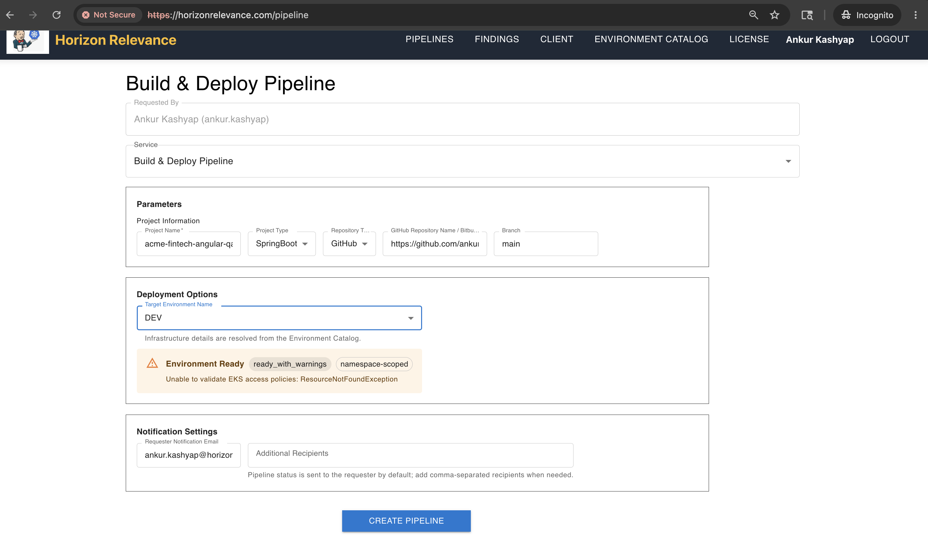
Frontend Build & Deploy Pipeline form. Resolve environment readiness warnings before submitting a client run.

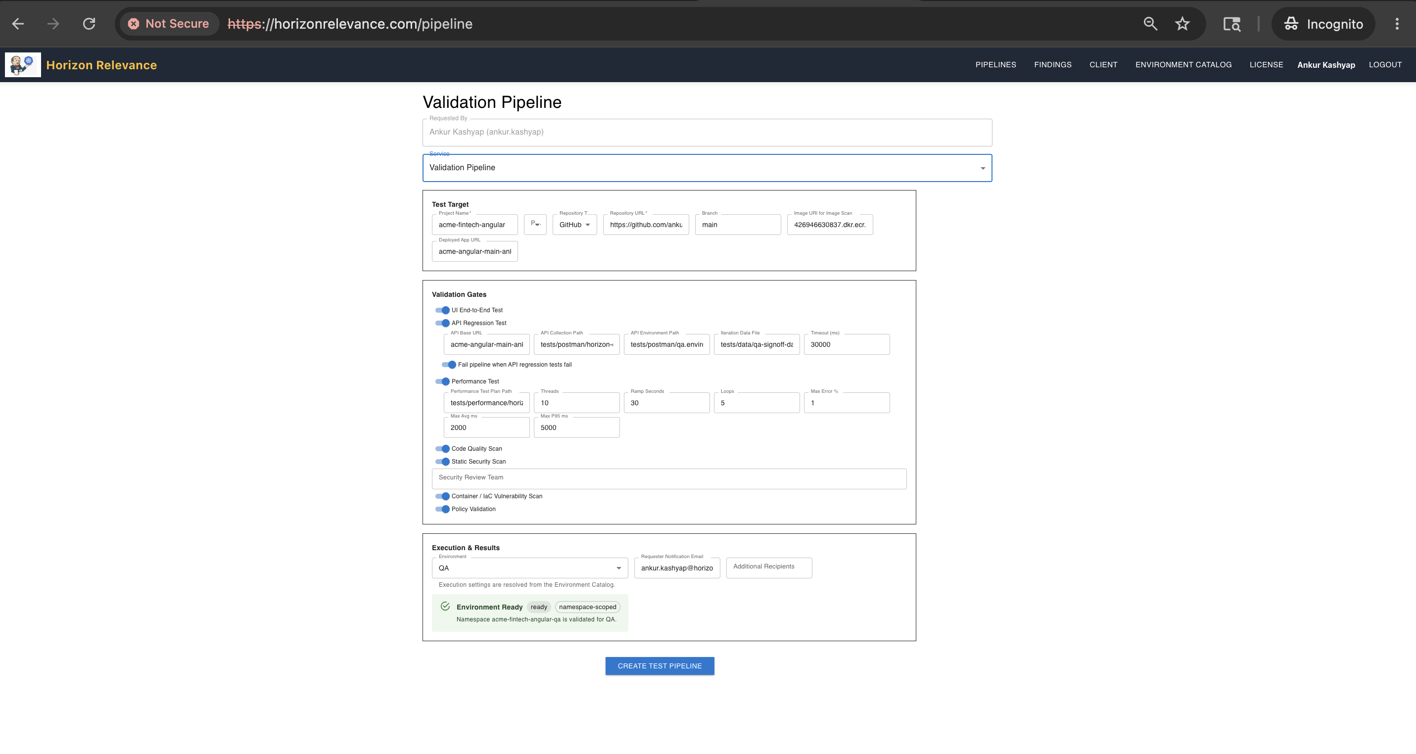
Frontend Validation Pipeline form showing UI, API, performance, code, security, container/IaC, and policy validation gates.

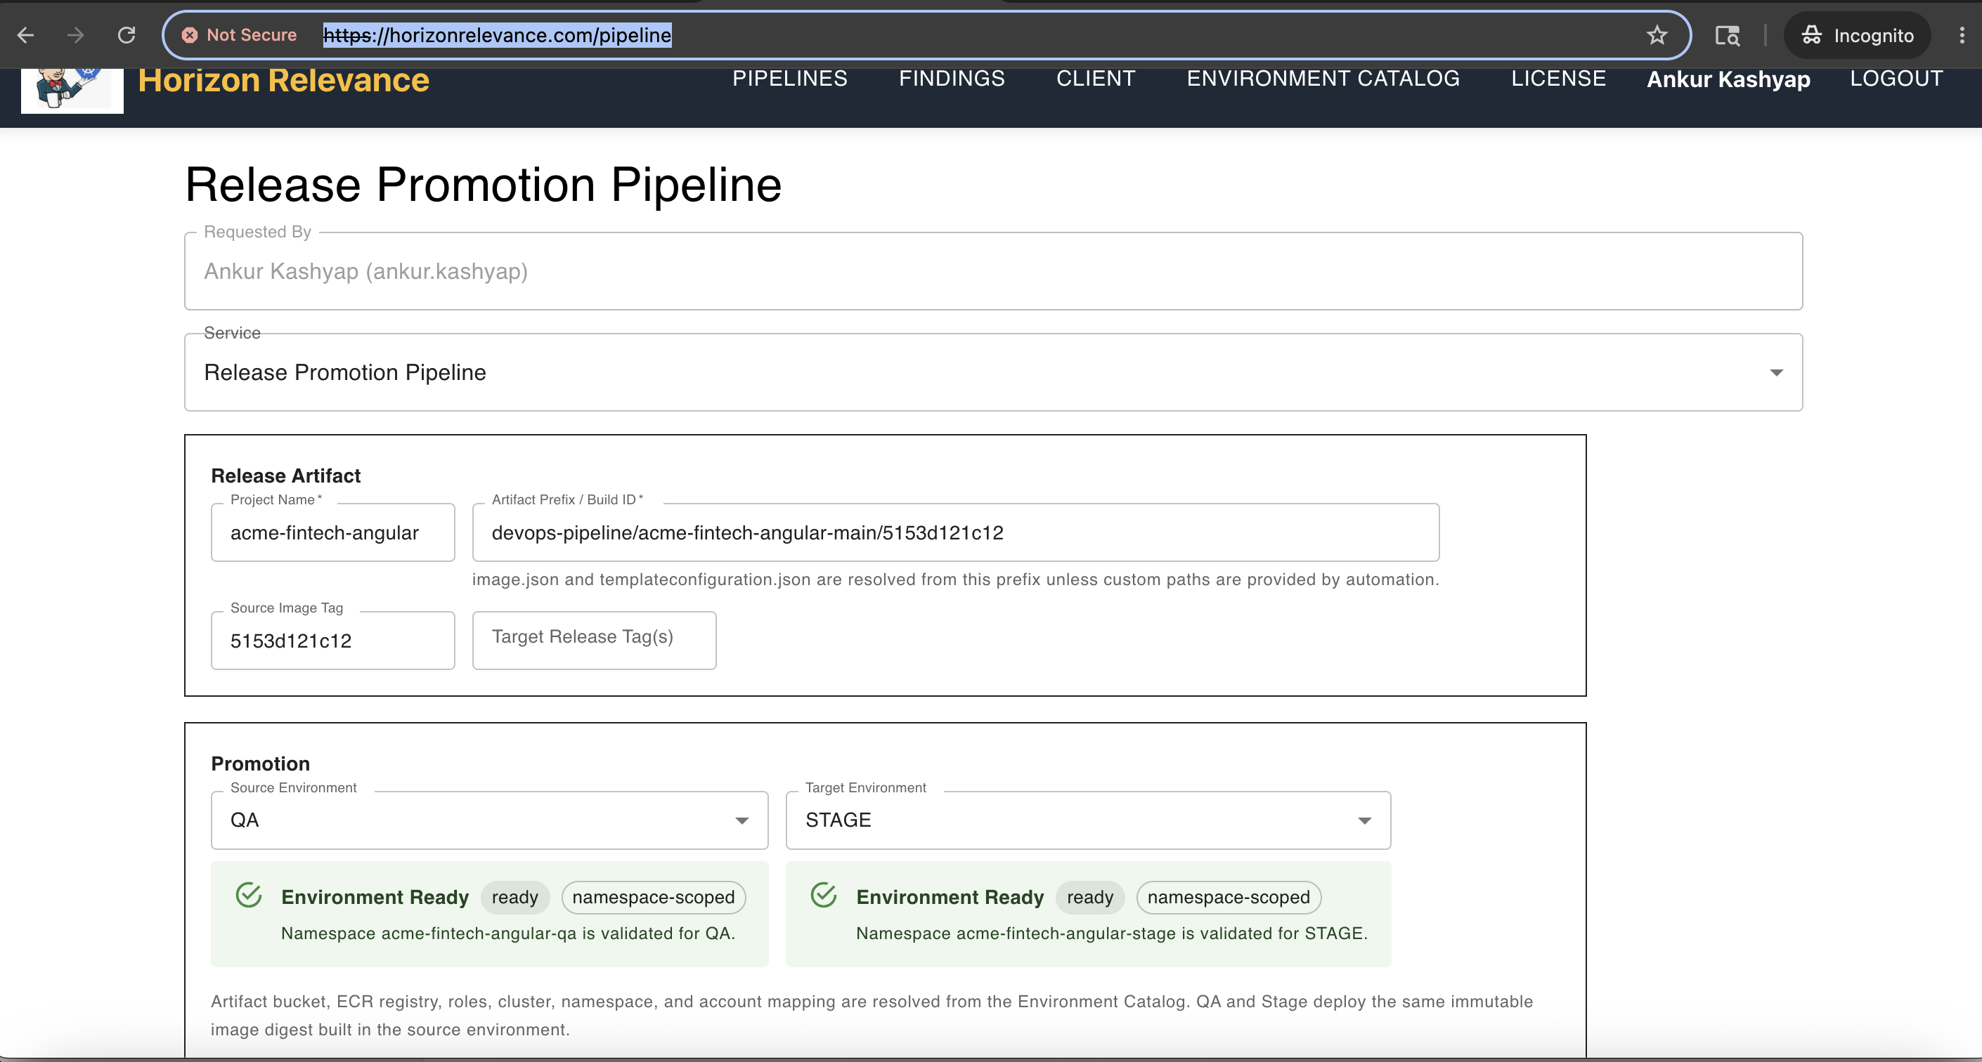
Frontend Release Promotion Pipeline form showing QA to STAGE promotion with both environments ready and namespace-scoped.

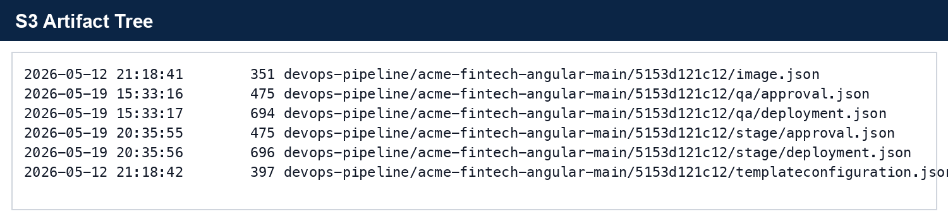
S3 artifact tree showing base metadata and QA/STAGE evidence folders.

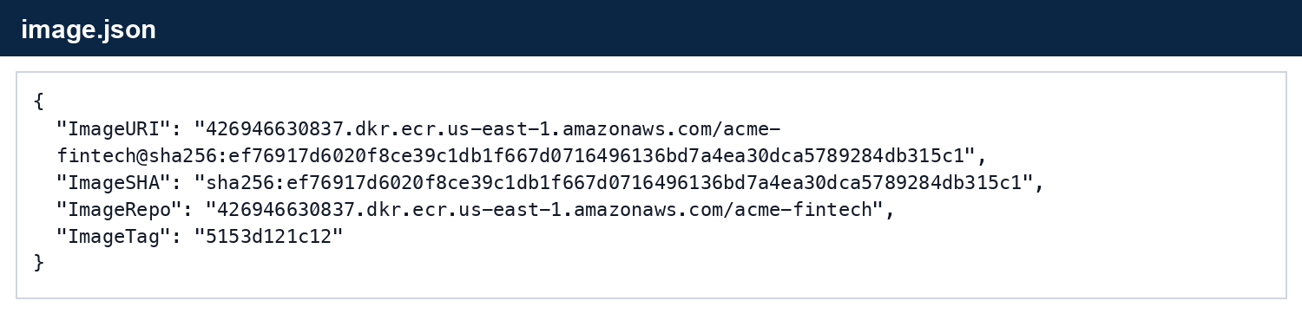
Generated image.json captured from S3.

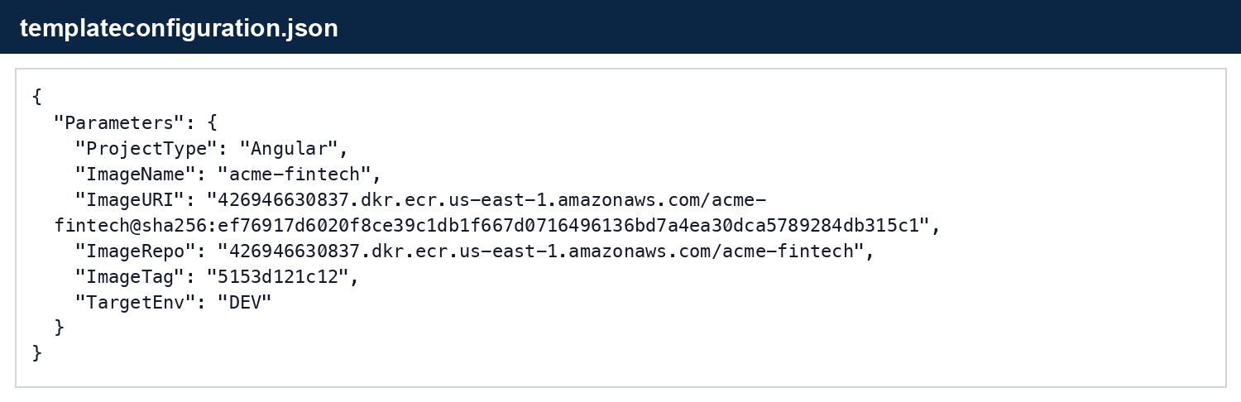
Generated templateconfiguration.json captured from S3.

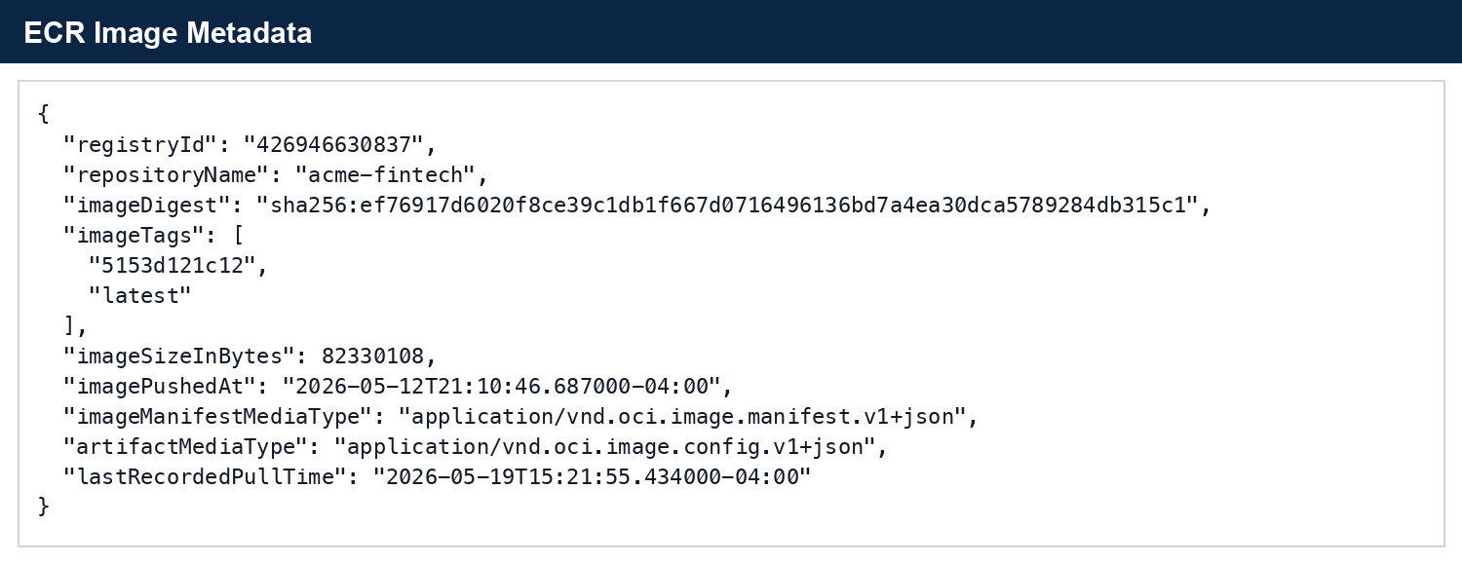
ECR metadata for image tag 5153d121c12.

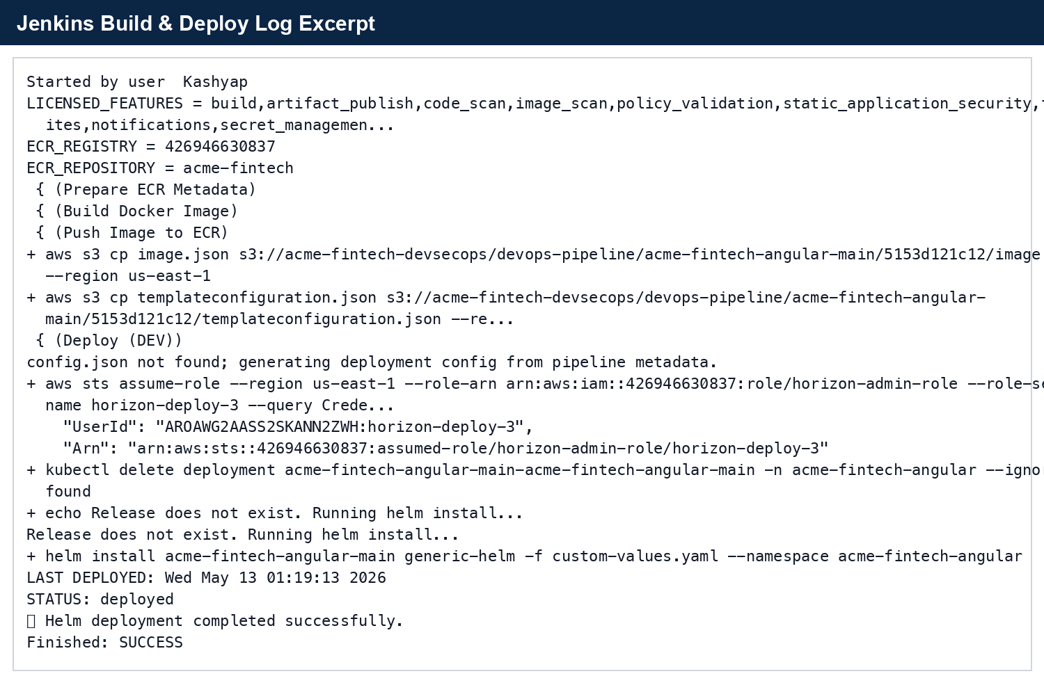
Jenkins Build & Deploy log excerpt.

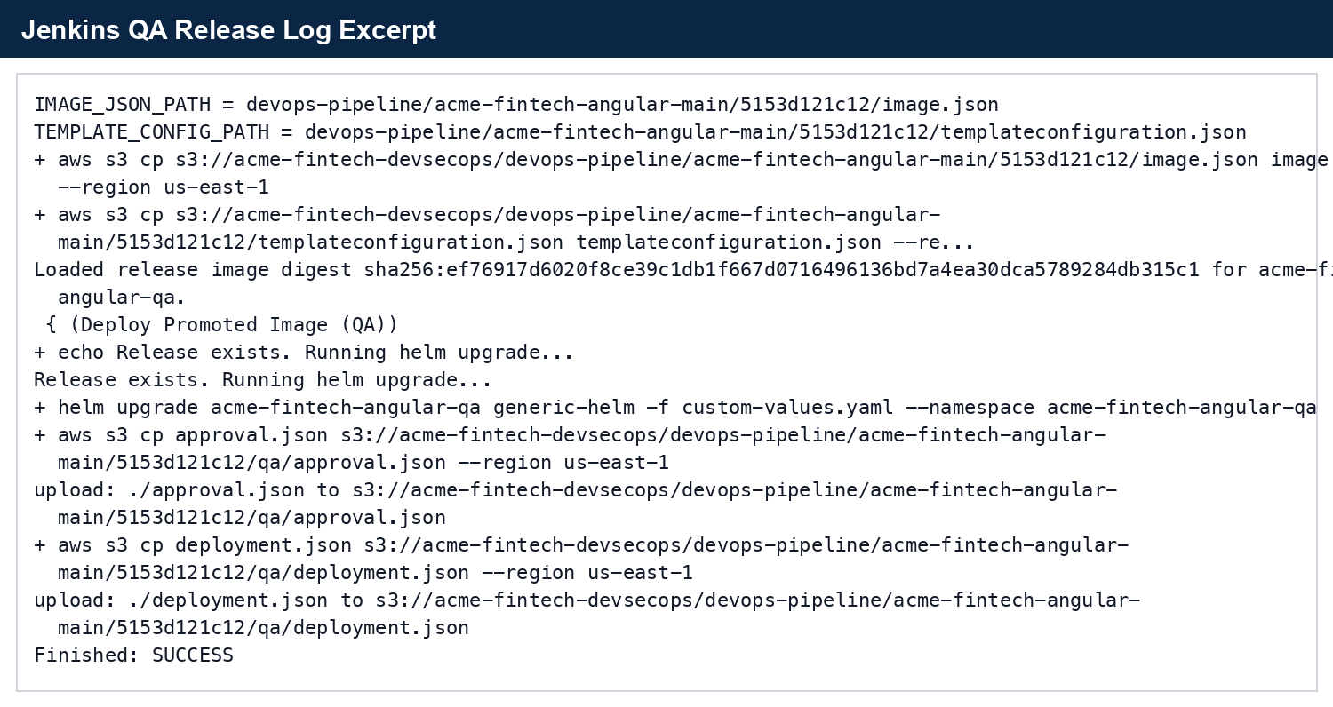
Jenkins DEV to QA Release Promotion log excerpt.

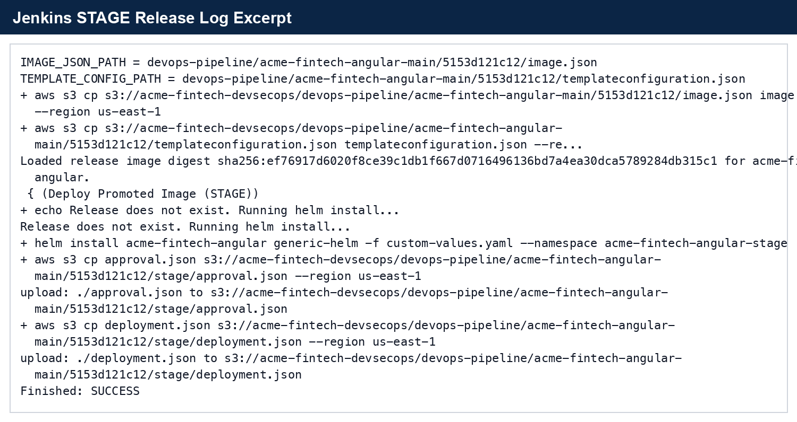
Jenkins QA to STAGE Release Promotion log excerpt.

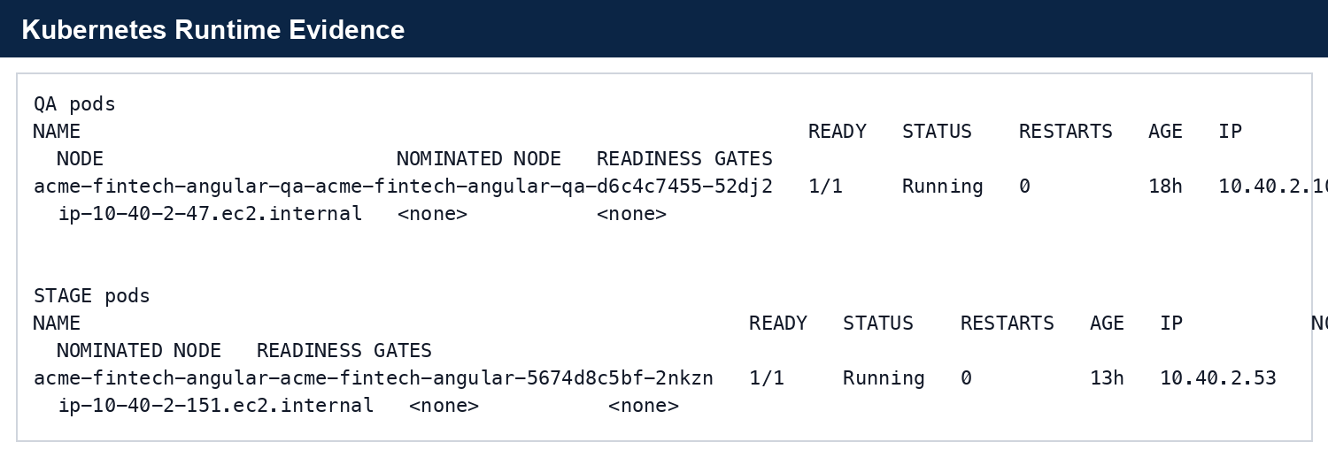
QA and STAGE runtime pod evidence.
End of document.

