1. ETCD yaml file - /etc/kubernetes/manifests/api-server.yaml

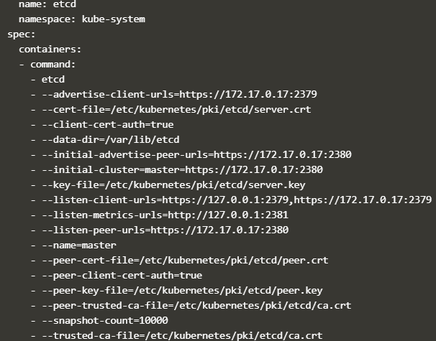

1. Etcd yaml file

