BugClassiNet Next

Frozen Hierarchical Routing Evaluation
Oracle and predicted routing with complete Stage 1 to Stage 3 cascade results
Document Complete routing and retention report
Evaluation cohort 806 reconstructed reports with known BUG subtype labels
Status Final frozen evaluation
Date 27 September 2026
The primary frozen cascade correctly classifies 548 of 806 known BUG reports. Its accuracy is 0.6799 and its Macro F1 is 0.6126. Stage 2 routing remains the largest source of error, while Stage 1 rejection adds 47 errors beyond the frozen Stage 2 to Stage 3 baseline.

1 Executive Summary
This report completes the routing evaluation for the three-stage BugClassiNet hierarchy. Stage 1 identifies BUG reports, Stage 2 separates Bohrbugs from Mandelbugs, and Stage 3 separates Non-Aging Mandelbugs from Aging-Related Bugs. The routing study measures how errors propagate when each frozen stage makes its own prediction.
The primary end-to-end result is evaluated on 806 reports already known to be BUGs and annotated as BOH, NAM, or ARB. With the predeclared collapsed-argmax Stage 1 gate, 752 reports proceed to Stage 2 and 54 are rejected. The complete cascade produces 548 correct subtype predictions and 258 errors, for 0.6799 accuracy, 0.6126 Macro F1, 0.7106 weighted F1, and 0.6072 balanced accuracy.
Evaluation mode | Correct | Accuracy | Macro F1 | Balanced accuracy | MCC
Oracle Stage 2 routing with frozen Stage 3 | 764 of 806 | 0.9479 | 0.8215 | 0.8078 | 0.8899
Predicted Stage 2 to Stage 3 routing | 595 of 806 | 0.7382 | 0.6271 | 0.6370 | 0.4827
Full Stage 1 to Stage 3 argmax cascade | 548 of 806 | 0.6799 | 0.6126 | 0.6072 | Not reported

Table 1. Headline routing results on the 806-report known-BUG cohort.
The main findings are:
- Stage 2 routing is the dominant bottleneck. Replacing oracle Stage 2 routing with frozen predicted routing lowers accuracy by 0.2097 and Macro F1 by 0.1943.
- Stage 1 retains 752 of 806 known BUG reports under the primary argmax gate. Of the 54 rejected reports, 47 would have been correct downstream and seven were already incorrect in the Stage 2 to Stage 3 baseline.
- The full primary cascade contains 54 Stage 1 rejections, 169 retained Stage 2 routing errors, and 35 retained Stage 3 errors. These categories account for all 258 final errors.
- Stage 1 retention varies sharply by project. AXIS and HTTPD account for 50 of the 54 rejections, whereas Linux and MySQL account for most downstream routing errors.
- The validation-derived Stage 1 probability threshold retains one additional report but produces the same number of correct final predictions as argmax and a slightly lower Macro F1. The primary result therefore remains the predeclared argmax gate.
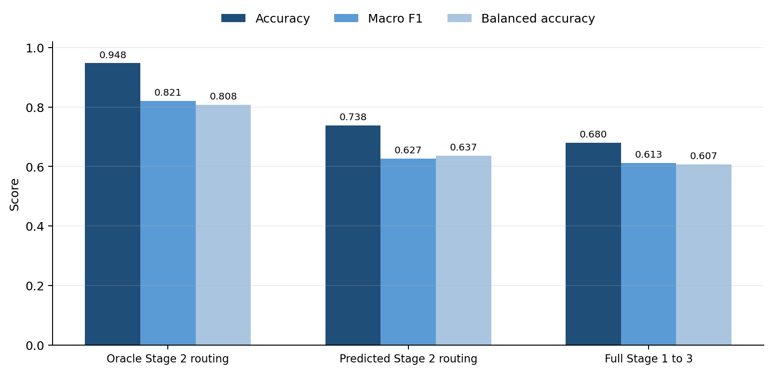
Figure 1. Performance decreases as oracle routing is replaced by predicted Stage 2 routing and then by the complete Stage 1 to Stage 3 cascade.

2 Research Questions and Scope
- RQ1 What performance ceiling does the frozen Stage 3 model achieve when Stage 2 routing is correct by construction
- RQ2 How much performance is lost when frozen Stage 2 predictions determine which reports reach Stage 3
- RQ3 How many known BUG reports survive the frozen Stage 1 gate and how does retention vary by project and subtype
- RQ4 What is the final subtype performance when all three frozen stages are combined
- RQ5 Which stage and project account for the remaining errors
Evaluation boundary. The 806-report routing cohort contains only known BUG reports with BOH, NAM, or ARB labels. The full-cascade scores in this report therefore measure subtype recovery and routing loss among known BUGs. They do not measure false positives on DOCUMENTATION, ENHANCEMENT, or QUESTION reports and must not be presented as global six-class production accuracy.

3 Hierarchical Classification System
Stage | Decision | Possible outcome | Routing action
Stage 1 | Semantic issue type | BUG | Continue to Stage 2
Stage 1 | Semantic issue type | DOCUMENTATION ENHANCEMENT QUESTION | Stop outside the bug hierarchy
Stage 2 | Bug manifestation | BOH | Stop with BOH
Stage 2 | Bug manifestation | MAN | Continue to Stage 3
Stage 3 | Mandelbug subtype | NAM or ARB | Return final subtype

Table 2. Frozen routing logic used in the evaluation.
A correct final prediction requires every upstream gate on its path to be correct. BOH reports must pass Stage 1 and stop at Stage 2. NAM and ARB reports must pass Stage 1, be routed to MAN by Stage 2, and then receive the correct Stage 3 subtype. A rejection or early stop prevents later stages from recovering the report.

4 Frozen Data Models and Artifacts

Evaluation Dataset
The routing dataset contains 806 unique issues from AXIS, HTTPD, Linux, and MySQL. Its final labels are 544 BOH, 207 NAM, and 55 ARB. Stage 2 collapses NAM and ARB into 262 MAN reports. The frozen dataset SHA 256 is 15d1d06426feecf50061d1eb57a67359f7b5cd9b5b78e7629c6b6453a4aa1acb.
Project | BOH | NAM | ARB | Total
AXIS | 183 | 7 | 8 | 198
HTTPD | 116 | 15 | 10 | 141
Linux | 122 | 121 | 24 | 267
MySQL | 123 | 64 | 13 | 200
Total | 544 | 207 | 55 | 806

Table 3. Frozen routing cohort by project and final subtype.

Frozen Stage Configurations
Component | Frozen configuration | Selection basis
Stage 1 | DeBERTa v3 small at 256 tokens with alpha 0.25 class weighting and two training epochs | Final Stage 1 official-test model
Stage 2 | SBERT all mpnet base v2 initial evidence at 512 tokens with logistic regression and nested project-aware thresholds | Four-project outer LOPO with inner project selection
Stage 3 | SBERT all mpnet base v2 initial evidence at 512 tokens with nested class weight and ARB threshold selection | Four-project outer LOPO with inner project selection

Table 4. Frozen model configurations used in routing.
All thresholds and class-weight choices were selected before the final routing evaluation. No threshold was tuned on the pooled 806 routing labels. For the Stage 2 to Stage 3 reconstruction, each held-out project was scored by a Stage 3 model trained only on gold MAN reports from the other three projects.

5 Routing Evaluation Protocol

Oracle Stage 2 Routing
The oracle run sends all known BUG reports through Stage 1 and uses the true BOH or MAN class to control Stage 2 routing. All 544 BOH reports stop correctly. The 262 true MAN reports enter the frozen out-of-fold Stage 3 model. This isolates the best achievable cascade performance when upstream routing is perfect.

Predicted Stage 2 Routing
The predicted routing run uses the frozen Stage 2 nested binary predictions. Stage 2 predicts BOH for 490 reports and MAN for 316. The 316 routed reports comprise 201 true MAN reports and 115 true BOH reports. Stage 3 then assigns NAM or ARB to every routed report using held-out-project scoring.

Stage 1 Retention
The frozen Stage 1 model scores the exact 806 initial-evidence texts. Three predeclared gates are evaluated: collapsed argmax, BUG probability at least 0.5, and the validation-selected BUG threshold of 0.4434446096420288. Collapsed argmax is the primary gate.

Full Cascade
Each Stage 1 gate is joined to the frozen Stage 2 to Stage 3 prediction by issue key. A Stage 1 rejection receives the explicit output REJECTED_STAGE1. All 806 reports remain in the denominator. Macro F1 is the unweighted mean over BOH, NAM, and ARB; a Stage 1 rejection contributes a false negative for its true subtype. Balanced accuracy is the mean recall over the same three target labels.

6 Frozen Stage Results
Model evaluation | Rows | Accuracy | Macro F1 | Balanced accuracy | MCC
Stage 1 official four-class test | 142320 | 0.8848 | 0.7934 | Not reported | 0.8016
Stage 2 BOH versus MAN | 806 | 0.7816 | 0.7626 | 0.7779 | 0.5332
Stage 3 NAM versus ARB | 262 | 0.8397 | 0.7322 | 0.7116 | 0.4745

Table 5. Frozen standalone results. Stage 1 uses a separate official-test cohort and is not directly comparable to the 806 routing scores.

Stage 2 Confusion Matrix
True label | Predicted BOH | Predicted MAN | Support
BOH | 429 | 115 | 544
MAN | 61 | 201 | 262

Table 6. Frozen Stage 2 nested-threshold confusion matrix.
Stage 2 creates 176 routing errors: 115 true BOH reports are sent to Stage 3 and 61 true MAN reports stop early as BOH. These errors dominate the loss from oracle to predicted routing.

Stage 3 Confusion Matrix
True label | Predicted NAM | Predicted ARB | Support
NAM | 193 | 14 | 207
ARB | 28 | 27 | 55

Table 7. Frozen Stage 3 nested-selection confusion matrix on 262 gold MAN reports.
The Stage 3 reconstruction reproduced all 262 frozen labels exactly. The maximum absolute probability difference was 2.35e-7 and the mean difference was 2.80e-8, confirming that the routing implementation restored the frozen Stage 3 decision rule.

7 Oracle and Predicted Routing Results

Oracle Routing Ceiling
Oracle Stage 2 routing yields 764 correct final predictions and 42 errors. Every error is a Stage 3 subtype error: 28 ARB reports become NAM and 14 NAM reports become ARB. The resulting accuracy is 0.9479 and Macro F1 is 0.8215.
True label | BOH | NAM | ARB
BOH | 544 | 0 | 0
NAM | 0 | 193 | 14
ARB | 0 | 28 | 27

Table 8. Oracle routing confusion matrix in BOH NAM ARB order.

Predicted Stage 2 to Stage 3 Routing
With predicted Stage 2 routing, 490 reports stop as BOH and 316 enter Stage 3. The final output contains 490 BOH, 264 NAM, and 52 ARB predictions. The cascade correctly classifies 595 reports and makes 211 errors.
True label | BOH | NAM | ARB | Support
BOH | 429 | 100 | 15 | 544
NAM | 52 | 142 | 13 | 207
ARB | 9 | 22 | 24 | 55

Table 9. Predicted Stage 2 to Stage 3 routing confusion matrix.
Error source | Reports | Share of 211 errors
Stage 2 BOH to MAN routing error | 115 | 54.5%
Stage 2 MAN to BOH routing error | 61 | 28.9%
Stage 3 ARB to NAM | 22 | 10.4%
Stage 3 NAM to ARB | 13 | 6.2%

Table 10. Error attribution before Stage 1 is introduced.
Stage 2 contributes 176 of the 211 errors, or 83.4 percent. Stage 3 contributes 35 visible errors rather than its standalone total of 42 because seven Stage 3 errors are already masked by incorrect Stage 2 routing.

Routing Penalty Relative to Oracle
Metric | Oracle routing | Predicted routing | Absolute loss
Accuracy | 0.9479 | 0.7382 | 0.2097
Macro F1 | 0.8215 | 0.6271 | 0.1943
Balanced accuracy | 0.8078 | 0.6370 | 0.1708
MCC | 0.8899 | 0.4827 | 0.4072

Table 11. Loss caused by predicted Stage 2 routing.

8 Stage 1 BUG Retention
Gate | Retained | Rejected | Retention | Loss rate
Collapsed argmax primary | 752 | 54 | 0.9330 | 0.0670
BUG probability at least 0.5 | 740 | 66 | 0.9181 | 0.0819
Validation threshold 0.4434446 | 753 | 53 | 0.9342 | 0.0658

Table 12. Stage 1 retention on the 806 known-BUG reports.
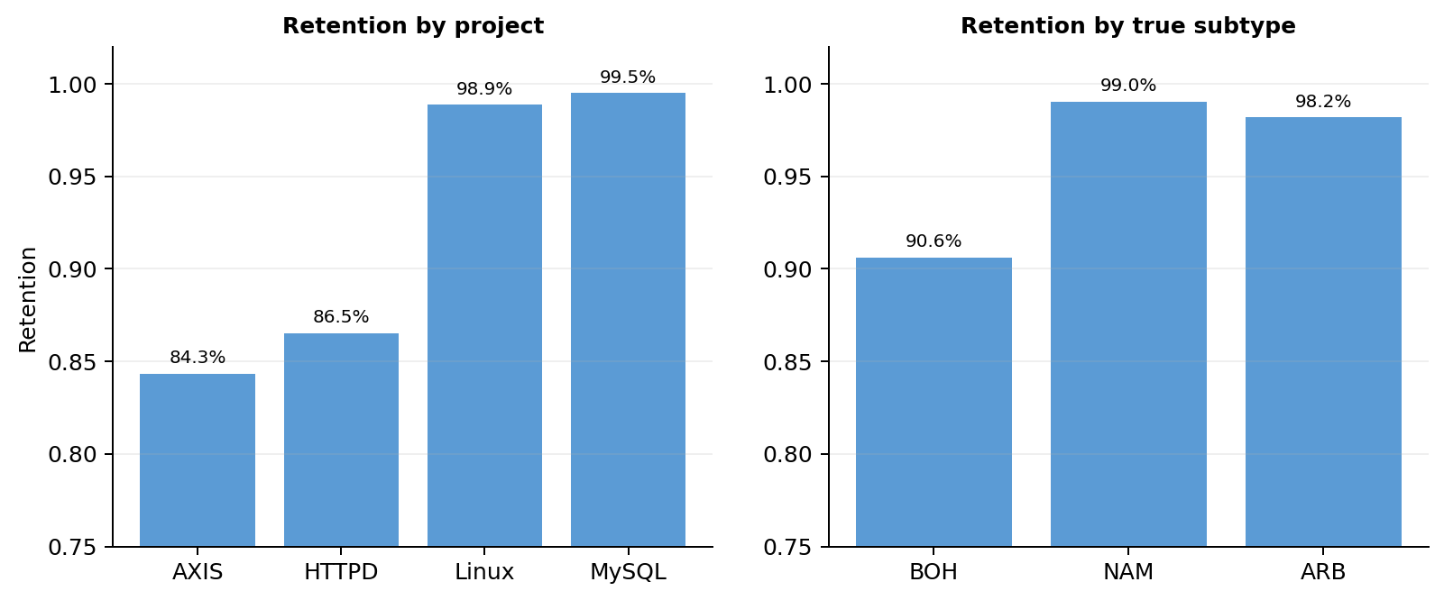
Figure 2. Primary argmax retention by project and true subtype.
The primary gate loses 31 AXIS reports and 19 HTTPD reports, compared with three Linux reports and one MySQL report. By subtype, 51 of the 54 rejected reports are BOH, two are NAM, and one is ARB. Thus 259 of 262 MAN reports reach Stage 2, a retention rate of 98.85 percent.
Project | Total | Retained | Rejected | Retention
AXIS | 198 | 167 | 31 | 0.8434
HTTPD | 141 | 122 | 19 | 0.8652
Linux | 267 | 264 | 3 | 0.9888
MySQL | 200 | 199 | 1 | 0.9950

Table 13. Primary Stage 1 retention by project.

9 Complete Stage 1 to Stage 3 Cascade

Gate Comparison
Stage 1 gate | Correct | Errors | Accuracy | Macro F1 | Weighted F1 | Balanced accuracy
Stage 2 to Stage 3 baseline | 595 | 211 | 0.7382 | 0.6271 | 0.7455 | 0.6370
Collapsed argmax primary | 548 | 258 | 0.6799 | 0.6126 | 0.7106 | 0.6072
BUG probability at least 0.5 | 537 | 269 | 0.6663 | 0.6095 | 0.7016 | 0.6004
Validation threshold | 548 | 258 | 0.6799 | 0.6122 | 0.7103 | 0.6072

Table 14. Full-cascade performance under the three frozen Stage 1 gates.
The primary argmax gate reduces accuracy by 0.0583 and Macro F1 by 0.0145 relative to the Stage 2 to Stage 3 baseline. The validation threshold retains one additional report in total, but it does not add a correct final prediction. Its Macro F1 is slightly lower. The 0.5 probability gate is consistently worse because it rejects 66 known BUG reports.

Primary Full Cascade Confusion Matrix
True label | BOH | NAM | ARB | Rejected at Stage 1 | Support
BOH | 383 | 97 | 13 | 51 | 544
NAM | 51 | 141 | 13 | 2 | 207
ARB | 8 | 22 | 24 | 1 | 55

Table 15. Primary full-cascade confusion matrix. Stage 1 rejections remain explicit.

Per Class Results
Class | Precision | Recall | F1 | Support
BOH | 0.8665 | 0.7040 | 0.7769 | 544
NAM | 0.5423 | 0.6812 | 0.6039 | 207
ARB | 0.4800 | 0.4364 | 0.4571 | 55

Table 16. Per-class performance for the primary full cascade.

10 Final Error Attribution
The first-failure analysis assigns each report to the earliest stage that prevents a correct final prediction. The 54 Stage 1 rejections include 47 reports that were correct in the downstream baseline and seven that were already wrong. This is why Stage 1 adds 47 errors rather than 54.
Outcome or first failure | Reports | Share of all reports | Share of 258 errors
Correct | 548 | 68.0% | Not applicable
Stage 2 BOH to MAN | 110 | 13.6% | 42.6%
Stage 2 MAN to BOH | 59 | 7.3% | 22.9%
Stage 1 BUG rejected | 54 | 6.7% | 20.9%
Stage 3 ARB to NAM | 22 | 2.7% | 8.5%
Stage 3 NAM to ARB | 13 | 1.6% | 5.0%

Table 17. First-failure attribution for the primary full cascade.
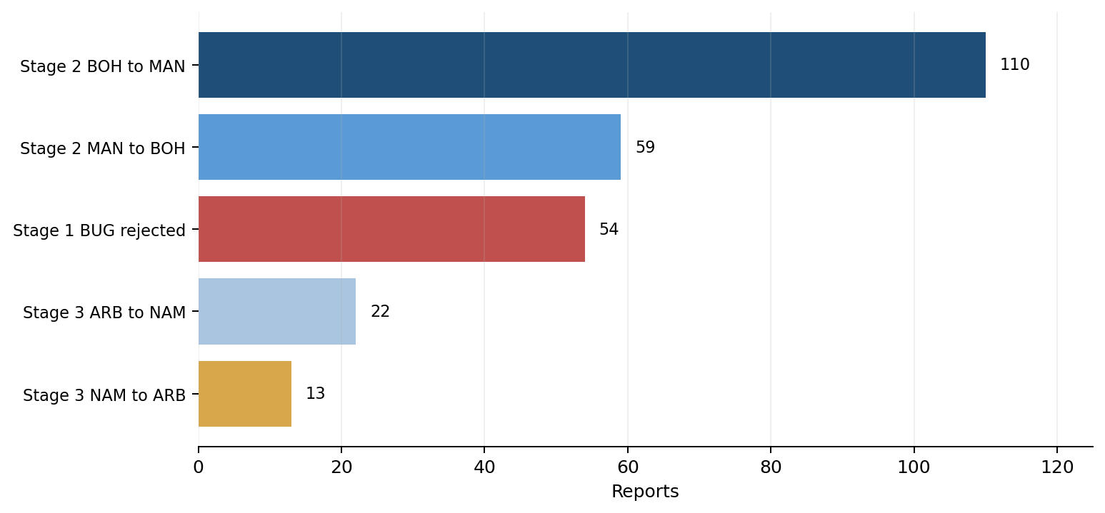
Figure 3. Final error counts by first failure source.
After Stage 1 is introduced, retained Stage 2 routing still contributes 169 errors, or 65.5 percent of all final errors. Stage 1 contributes 20.9 percent and Stage 3 contributes 13.6 percent. The error priorities therefore remain unchanged: Stage 2 routing offers the largest potential gain, followed by Stage 1 BUG retention and then Stage 3 subtype discrimination.

11 Project Level Results
Project | Stage 1 rejected | New Stage 1 errors | Baseline accuracy | Full accuracy | Full Macro F1 | Full balanced accuracy
AXIS | 31 | 28 | 0.9394 | 0.7980 | 0.6822 | 0.5846
HTTPD | 19 | 16 | 0.8014 | 0.6879 | 0.5986 | 0.6274
Linux | 3 | 2 | 0.6180 | 0.6105 | 0.5124 | 0.4921
MySQL | 1 | 1 | 0.6550 | 0.6500 | 0.5925 | 0.6536

Table 18. Stage 1 impact and final performance by project.
AXIS and HTTPD are primarily affected by Stage 1 retention. They account for 44 of the 47 newly introduced errors. Linux and MySQL have near-perfect Stage 1 retention, but their downstream cross-project routing remains difficult. In the Stage 2 to Stage 3 baseline, Linux contributes 102 errors and MySQL contributes 69, compared with 12 for AXIS and 28 for HTTPD.
AXIS illustrates why Macro F1 must be read with accuracy. Its full-cascade Macro F1 rises slightly from 0.6797 to 0.6822 even though 28 additional correct predictions are lost. Rejecting some incorrectly classified reports removes false positives for other classes, which can improve their precision while overall accuracy falls.

12 Interpretation and Research Implications

Routing Quality Limits the Hierarchy
The standalone Stage 3 model is not the main constraint on end-to-end performance. Under oracle Stage 2 routing, the hierarchy reaches 0.9479 accuracy. Predicted Stage 2 routing lowers this to 0.7382 because false MAN routes force BOH reports into a NAM or ARB decision and false BOH routes prevent true MAN reports from reaching Stage 3.

Stage 1 Loss Is Concentrated
Stage 1 retains 93.30 percent of the known BUG cohort, but the aggregate rate hides a project effect. AXIS and HTTPD retention is 84.34 and 86.52 percent, whereas Linux and MySQL exceed 98 percent. The Stage 1 model was trained for broad semantic issue classification rather than project-specific BUG retention, so this variation should be investigated before deployment claims are made.

MAN Retention Is High but Stage 2 Recall Is Lower
Stage 1 retains 259 of 262 true MAN reports. The larger loss occurs at Stage 2, where only 201 of 262 MAN reports are routed forward. Improving Stage 2 MAN recall without sharply increasing BOH false routes is therefore the most direct route to better NAM and ARB recovery.

Gate Selection Remains Frozen
The routing results do not justify changing the primary Stage 1 gate after evaluation. Argmax and the validation-selected threshold produce the same 548 correct predictions, while argmax has slightly higher Macro F1. The 0.5 threshold is worse on every headline metric. The reported primary configuration remains collapsed argmax, with the other gates retained as sensitivity analyses.

13 Validity Limits
- The routing cohort contains only known BUG reports. Non-BUG precision and false-positive routing are outside this evaluation.
- The Stage 1 official-test result and the 806-report cascade result use different cohorts and label spaces. Their scores cannot be multiplied or combined into a single global accuracy estimate.
- Potential overlap between the 806 routing reports and the Stage 1 training corpus has not been audited. The Stage 1 retention result should be described as a transfer audit on this cohort rather than an independently established external test.
- Only four projects are represented. Project-level estimates, especially for AXIS NAM and ARB support, are based on small counts.
- The study reports deterministic point estimates. It does not provide confidence intervals or hypothesis tests for differences between gates.
- A true global end-to-end evaluation requires a single held-out dataset containing non-BUG labels and BOH NAM ARB subtype labels for BUG reports.

14 Reproducibility Record
Artifact | Purpose or verified property
stage2.parquet | 806-row frozen routing cohort with SHA 256 identity check
nested_outer_predictions.parquet | Frozen Stage 2 project-held-out predictions using pred_nested_binary
Stage 3 predictions.parquet | Frozen 262-report Stage 3 predictions and probability targets
stage3_all_806_oof_scores.parquet | Held-out-project Stage 3 scores for all 806 reports including false Stage 2 routes
stage1_retention_predictions.parquet | Stage 1 labels probabilities and three frozen gate decisions
predicted_routed_predictions.parquet | Frozen Stage 2 to Stage 3 cascade with error attribution
primary_full_cascade_predictions.parquet | Canonical primary Stage 1 to Stage 3 prediction table
run_manifest.json and final_summary.json | Paths hashes thresholds metric definitions and evaluation scope

Table 19. Core artifacts required to reproduce or audit the routing report.
Stage 3 restoration was verified against the frozen 262-report output before it was used for routing. Dataset keys were unique, the Stage 1 and Stage 2 to Stage 3 issue sets matched exactly, and the frozen Stage 2 confusion matrix was reproduced before the full join. The final output directory also records SHA 256 checksums for each saved artifact.

15 Final Result
The frozen three-stage hierarchy correctly assigns BOH, NAM, or ARB to 548 of 806 known BUG reports under the primary Stage 1 argmax gate. The final accuracy is 0.6799 and Macro F1 is 0.6126. The oracle-routing ceiling of 0.9479 accuracy confirms that routing errors, especially at Stage 2, account for most of the gap. Stage 1 retains 93.30 percent of known BUG reports but adds 47 errors, concentrated in AXIS and HTTPD. These findings complete the known-BUG routing study and establish a clear order for future work: improve Stage 2 routing, audit and improve Stage 1 retention by project, and then revisit residual Stage 3 subtype errors.

Appendix A Detailed Primary Retention
Project | Subtype | Total | Retained | Rejected | Retention
AXIS | ARB | 8 | 7 | 1 | 0.8750
AXIS | BOH | 183 | 153 | 30 | 0.8361
AXIS | NAM | 7 | 7 | 0 | 1.0000
HTTPD | ARB | 10 | 10 | 0 | 1.0000
HTTPD | BOH | 116 | 98 | 18 | 0.8448
HTTPD | NAM | 15 | 14 | 1 | 0.9333
Linux | ARB | 24 | 24 | 0 | 1.0000
Linux | BOH | 122 | 120 | 2 | 0.9836
Linux | NAM | 121 | 120 | 1 | 0.9917
MySQL | ARB | 13 | 13 | 0 | 1.0000
MySQL | BOH | 123 | 122 | 1 | 0.9919
MySQL | NAM | 64 | 64 | 0 | 1.0000

Table A1. Primary collapsed-argmax Stage 1 retention by project and true subtype.

Appendix B Frozen Stage 2 Thresholds
Held-out project | Selected MAN threshold
AXIS | 0.530121
HTTPD | 0.638022
Linux | 0.514885
MySQL | 0.485653

Table B1. Frozen Stage 2 thresholds selected using only the outer-training projects.

Appendix C Frozen Stage 3 Selection
Held-out project | Selected class weight | Selected ARB threshold
AXIS | None | 0.305
HTTPD | Balanced | 0.600
Linux | Balanced | 0.550
MySQL | Balanced | 0.560

Table C1. Frozen project-specific Stage 3 decisions selected inside the training projects.

