BugClassiNet-Next
A Reproducible, Imbalance-Aware Transformer Pipeline
for Multi-Class Semantic Issue Classification
Complete Technical Context, Experimental Record, Results, Contributions,
and Research-Paper Framing
0.7934  Final Test Macro-F1 | 0.8848  Final Test Micro-F1 | 0.8016  Final Test MCC
1,089,694  Training Data | 142,320  Official Test | DeBERTa-v3-small  Final Model

Prepared for discussion with research supervisor / professor
Status: Stage 1 completed and frozen; hierarchical Stage 2/3 extensions planned

1. Executive Summary
Final outcome. The completed Stage-1 system classifies GitHub issues into BUG, DOCUMENTATION, ENHANCEMENT, and QUESTION. The final DeBERTa-v3-small model, trained on 1,089,694 cleaned reports for two epochs with mild power-balanced class weighting (alpha = 0.25), achieved 0.7934 Macro-F1 and 0.8848 Micro-F1 on the untouched official test set of 142,320 issues.

Research progression. The work began with a reproducible NLBSE 2023 preprocessing pipeline, established a large-vocabulary TF-IDF baseline, identified memory and data-leakage risks, conducted controlled transformer ablations over data scale, class weighting, context length, and epoch count, and finished with a stable validation-to-test result. The final model is substantially stronger than the optimized classical baseline on Macro-F1, MCC, and balanced accuracy.
- Data integrity: deterministic preprocessing, deduplication, explicit official-test overlap removal, stable source hashes, and frozen train/validation/test artifacts.
- Classical baseline: word-only TF-IDF scaled from 200K to 2M features; Macro-F1 rose from 0.7402 to 0.7643 before diminishing returns.
- Transformer diagnosis: inverse-frequency class weighting over-corrected minority classes, producing high minority recall but poor precision.
- Imbalance contribution: a controlled weighting continuum (unweighted, alpha=0.25, sqrt-balanced, inverse-balanced) showed alpha=0.25 gave the best Macro-F1 trade-off.
- Context audit: 32.5% of reports exceed 256 tokens, but increasing max length from 256 to 384 did not improve Macro-F1 enough to justify the compute penalty.
- Scale and training duration: two epochs were clearly better than one; scaling the selected configuration from 200K to 500K to full data consistently improved Macro-F1.
- Engineering contribution: the transformer pipeline was redesigned from ~30 GiB host-RAM pressure to a disk-backed Arrow + dynamic-padding path, enabling full-corpus training on Kaggle.
- Cloud robustness: cross-session checkpoint/resume was implemented with stable SHA-256 source identity, optimizer/scheduler restoration, strict model-state verification, and legacy LayerNorm remapping.
- Generalization: validation Macro-F1 0.7927 and official-test Macro-F1 0.7934 are nearly identical, indicating a stable final model rather than validation-only gains.
Item | Final / key value
Dataset | NLBSE 2023 issue classification
Classes | BUG, DOCUMENTATION, ENHANCEMENT, QUESTION
Final training rows | 1,089,694
Validation rows | 121,078
Official test rows | 142,320
Final model | microsoft/deberta-v3-small
Max length | 256 tokens
Epochs | 2
Class weighting | power-balanced, alpha = 0.25
Validation Macro-F1 | 0.792682
Official test Macro-F1 | 0.793414
Official test Micro-F1 | 0.884830
Official test MCC | 0.801625

2. Research Problem, Scope, and Final Stage-1 Objective
Problem. Issue trackers contain heterogeneous reports: true bugs, enhancement requests, documentation tasks, and questions. Automated semantic issue classification can reduce triage effort, improve routing, support analytics, and provide a structured entry point for deeper defect taxonomies.
Completed Stage-1 objective. Given an issue title/body, predict one of four canonical labels: BUG, DOCUMENTATION, ENHANCEMENT, or QUESTION. This stage is designed to become the front gate of a hierarchical BugClassiNet-Next pipeline.
GitHub issue
|
v
Stage 1: semantic issue type
+-- BUG ----------------------> Stage 2: BOHR vs MANDELBUG (planned)
+-- DOCUMENTATION
+-- ENHANCEMENT
+-- QUESTION
If Stage 2 = MANDELBUG:
v
Stage 3: ARB vs NAM (planned)
Scope boundary. This document reports Stage-1 work as completed. BOHR/MANDELBUG and ARB/NAM classification, ModernBERT, DAPT, and hierarchical end-to-end evaluation are future extensions and are not presented as completed results.

3. Dataset and Data-Integrity Pipeline

3.1 NLBSE 2023 source schema
Field discovered in archive | Role in pipeline
id | source issue identifier
labels | original issue label
title | issue title
body | issue body / description
author_association | metadata retained in source but not required for core text classifier

Repository metadata limitation. The prepared NLBSE archive did not expose repository identifiers in the detected schema. Therefore, the development split is stratified by class rather than repository-aware. This should be stated explicitly as a limitation in a research paper.

3.2 Final prepared splits
Split | Rows | BUG | DOCUMENTATION | ENHANCEMENT | QUESTION
train_benchmark | 1,096,948 | 583,226 | 48,956 | 397,685 | 67,081
validation (benchmark) | 121,884 | 64,803 | 5,440 | 44,187 | 7,454
train_clean | 1,089,694 | 579,398 | 48,664 | 394,835 | 66,797
validation_clean | 121,078 | 64,378 | 5,407 | 43,871 | 7,422
official test | 142,320 | 74,781 | 6,252 | 52,797 | 8,490

Data-integrity events recorded by preprocessing. 57,048 deduplicated training rows were reported removed; 5,662 non-unique source issue IDs were disambiguated using normalized-text hashes; 10,011 official-test overlap rows were detected before cleaning and the reported post-cleaning overlap is zero. These pipeline statistics should be retained in the artifact manifest and reported with the paper.

Integrity statistic | Recorded value
deduplicated_train_rows_removed | 57,048
source_issue_id_rows_disambiguated | 5,662
official_test_overlap_rows_before_cleaning | 10,011
rows_removed_for_official_test_overlap | 10,011
official_test_overlap_rows_after_cleaning | 0
test duplicate_hashes (within test artifact) | 2,314
split strategy | stratified_no_repository_metadata

Stable source identity. For cross-session reproducibility, the final pipeline verifies persisted Parquet sources using SHA-256 rather than volatile Hugging Face / Arrow fingerprints.
train_clean.parquet
SHA-256: 1ab09ae2489946053b3299ee139bff900280a800e192e99f04a1b5377d5a4503
validation_clean.parquet
SHA-256: 74530b1b39e25729dbf70edfeb57632e9434dc28655a6875009a5385723eba5f

4. Reproducible Training Architecture and Engineering Contributions

4.1 Final data/training flow
NLBSE CSV archives
|
v
Schema inspection + label canonicalization
|
v
Normalized text hash / deduplication
|
v
Official-test overlap removal
|
v
train_clean.parquet / validation_clean.parquet / test.parquet
|
+-------------------------------+
| |
v v
TF-IDF classical baseline Hugging Face Arrow dataset
|
v
batched tokenization (512 rows)
|
v
dynamic batch padding
|
v
DeBERTa-v3-small training
|
v
validation / official test

4.2 The 30 GiB memory failure and fix
Original failure mode. The 500K transformer run initially reached approximately the full 30 GiB host-RAM limit before training because the old path simultaneously retained multiple large representations.
- A Pandas DataFrame containing all 12 columns and the full 1,089,694 rows.
- A copied 500K-row sample.
- Python text lists.
- Globally padded input_ids and attention masks (500,000 x 256).
- A second in-memory Arrow table created from Python dictionaries.
- Duplicated validation DataFrame/tokenization.
Memory-safe redesign. The final implementation projects only required Parquet columns into disk-backed Arrow, performs deterministic sampling, tokenizes in bounded batches with padding disabled, uses DataCollatorWithPadding for dynamic batch padding, reuses the same validation dataset, and keeps DataLoader workers conservative.
Observed effect. Host RAM fell from ~30/30 GiB at startup to approximately 2-5 GiB around data preparation and roughly 4-9 GiB during active training in observed Kaggle sessions. This enabled full-corpus training without changing the scientific input, labels, max length, learning rate, or objective.

4.3 Cross-session checkpoint/resume
- Full-state checkpoints store model, optimizer, LR scheduler, trainer state, RNG state, and global step.
- Resume compatibility uses stable source SHA-256, row/class counts, schema, label mapping, preprocessing version, seed, model revision, training configuration, and expected optimizer-step horizon.
- Volatile Hugging Face Dataset fingerprints are diagnostic only and no longer authoritative across Kaggle sessions.
- A legacy LayerNorm gamma/beta to weight/bias remap was added for the earlier checkpoint format; strict restoration later reported missing=0 and unexpected=0.
- Optimizer and LR scheduler restoration was explicitly verified at checkpoint global step 18,000 during the full one-epoch segmented run.
- Evaluation-only integrity was later verified with training_invoked=false and a model parameter SHA-256 before official test evaluation.
Evaluation-only integrity SHA-256: 01c7c40b73c6b08e70fc7cf9dc28fecadbfb181dd1c75ac3b065cc81146bcfb4

5. Classical Baseline: TF-IDF + Linear Classifier
Purpose. Before expensive transformer training, a strong lexical baseline was built and deliberately scaled. This established a realistic target and revealed that software issue text contains a very large useful word/bigram vocabulary.
Max word features | Macro-F1 | Micro-F1 | Weighted-F1 | MCC | Balanced Acc.
200K | 0.740231 | 0.849304 | 0.850978 | 0.742528 | 0.752176
500K | 0.750106 | 0.855639 | 0.855763 | 0.751346 | 0.750186
750K | 0.755399 | 0.858546 | 0.858187 | 0.755734 | 0.751161
1.0M | 0.759167 | 0.860908 | 0.860275 | 0.759455 | 0.751962
1.5M | 0.762179 | 0.863303 | 0.862259 | 0.763074 | 0.751115
2.0M | 0.764284 | 0.864715 | 0.863406 | 0.765196 | 0.750676

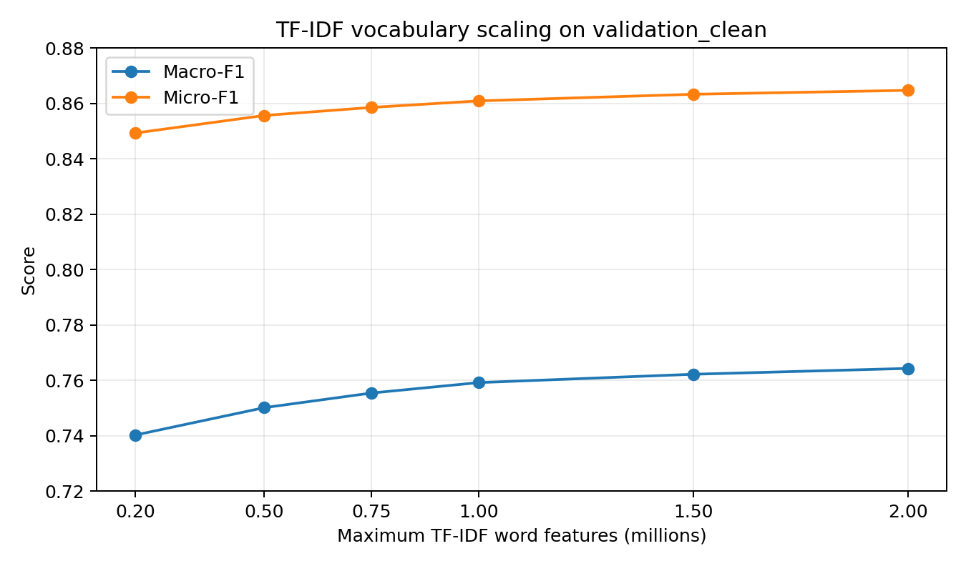
Figure 1. TF-IDF vocabulary scaling shows consistent but diminishing gains.
Class | F1 @ 200K | F1 @ 2M | Absolute gain
BUG | 0.8990 | 0.9081 | +0.0091
DOCUMENTATION | 0.6386 | 0.6827 | +0.0441
ENHANCEMENT | 0.8544 | 0.8643 | +0.0099
QUESTION | 0.5689 | 0.6021 | +0.0331

TF-IDF finding. Vocabulary growth particularly helped the minority DOCUMENTATION and QUESTION classes, but balanced accuracy remained around 0.75. The lexical model became more precise without materially improving minority recall, motivating a contextual transformer.

5.1 Word + character ablations
Experiment | Train rows | Feature space / note | Macro-F1 | Micro-F1 | MCC | Balanced Acc.
word+char early | 200K | ~350K features | 0.726991 | 0.845661 | 0.731309 | 0.709797
word+char scaling | 500K | ~350K features | 0.735278 | 0.847594 | 0.736377 | 0.727833
word+char large | 500K | reported 2.075M total features | 0.751822 | 0.859520 | 0.755286 | 0.731508

Interpretation. Character features did contain useful signal, but their sparse density created a much worse memory/performance trade-off than word-only TF-IDF under the 30 GiB environment. The main paper can report this as an efficiency ablation rather than a claim that character n-grams are universally inferior.

6. Transformer Input-Length Audit
Why it mattered. GitHub issues can be long. A token audit was run before deciding whether 256 tokens materially truncated the dataset and whether longer contexts justified their compute cost.
Group | Rows | Mean | Median | P75 | P90 | P95 | P99 | Max | >128 | >256 | >384 | >512
ALL | 1,089,694 | 401.86 | 155 | 329 | 710 | 1,246 | 4,318 | 123,516 | 56.52% | 32.50% | 20.89% | 14.87%
BUG | 579,398 | 569.17 | 225 | 460 | 1,029 | 1,817 | 6,337 | 123,516 | 70.15% | 44.74% | 30.22% | 22.22%
DOCUMENTATION | 48,664 | 190.27 | 99 | 189 | 371 | 569 | 1,472 | 37,993 | 40.22% | 16.65% | 9.49% | 5.99%
ENHANCEMENT | 394,835 | 178.00 | 94 | 184 | 338 | 497 | 1,272 | 91,618 | 37.50% | 15.70% | 7.95% | 4.70%
QUESTION | 66,797 | 428.02 | 180 | 382 | 814 | 1,341 | 4,081 | 91,553 | 62.68% | 37.21% | 24.79% | 17.78%

Max length | Fully preserved | Truncated
64 | 22.19% | 77.81%
128 | 43.48% | 56.52%
192 | 57.64% | 42.36%
256 | 67.50% | 32.50%
320 | 74.30% | 25.70%
384 | 79.11% | 20.89%
512 | 85.13% | 14.87%

Controlled 256 vs 384 experiment. At 200K rows, one epoch, unweighted loss, increasing max_length from 256 to 384 slightly improved accuracy/MCC but reduced Macro-F1 and increased evaluation runtime by roughly 49%. Therefore 256 tokens was frozen as the efficient default.
Setting | Accuracy | Macro-F1 | MCC | Balanced Acc. | Eval runtime
256, unweighted, 1 ep | 0.874015 | 0.759053 | 0.779879 | 0.734028 | ~1085 s
384, unweighted, 1 ep | 0.874585 | 0.758144 | 0.780791 | 0.732591 | ~1620 s

7. Class-Imbalance Study

7.1 Why the original weighting was problematic
Original loss. The first transformer used inverse-frequency balanced cross-entropy: w_c = N / (K * n_c). On the full clean training set this makes the minority classes much more expensive than BUG.
Class | Training rows | Balanced weight | Relative to BUG | sqrt-balanced | Unweighted
BUG | 579,398 | 0.470184 | 1.00x | 0.685699 | 1.0
DOCUMENTATION | 48,664 | 5.598050 | 11.91x | 2.366020 | 1.0
ENHANCEMENT | 394,835 | 0.689968 | 1.47x | 0.830643 | 1.0
QUESTION | 66,797 | 4.078379 | 8.67x | 2.019500 | 1.0

Observed symptom. Full-data inverse weighting produced very high minority recall but low minority precision. QUESTION, for example, reached recall 0.7447 but precision 0.4707, which strongly inflated QUESTION predictions.
Full-data inverse weighted, 1 epoch | Precision | Recall | F1
BUG | 0.9316 | 0.8741 | 0.9020
DOCUMENTATION | 0.6079 | 0.7692 | 0.6791
ENHANCEMENT | 0.8967 | 0.8602 | 0.8781
QUESTION | 0.4707 | 0.7447 | 0.5768

7.2 Weighting continuum at 200K, 1 epoch, 256 tokens
Weighting | Accuracy | Macro-F1 | MCC | Balanced Acc. | Key behavior
Unweighted | 0.874015 | 0.759053 | 0.779879 | 0.734028 | highest precision / accuracy
alpha = 0.25 | 0.869440 | 0.761141 | 0.774408 | 0.756980 | best Macro-F1 balance
sqrt-balanced | 0.861792 | 0.755337 | 0.764890 | 0.773075 | more minority recall
inverse-balanced | 0.836453 | 0.728761 | 0.732525 | not captured | over-corrected minorities

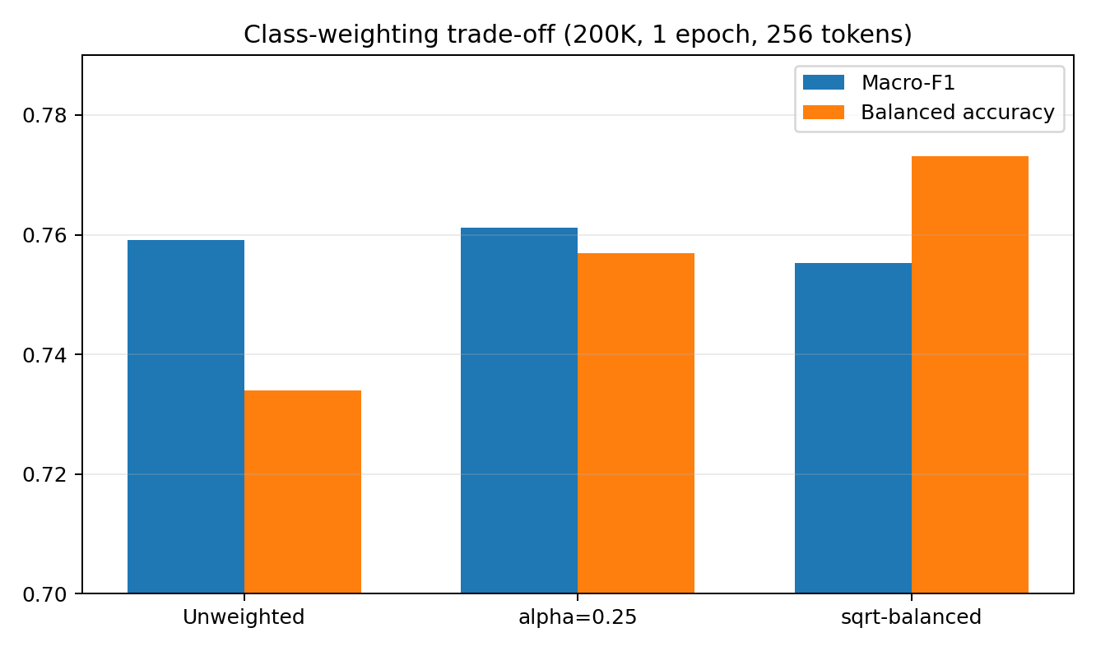
Figure 2. Mild weighting trades a small amount of accuracy for much better class balance.
Main imbalance contribution. The experiments show that full inverse-frequency weighting is too aggressive for this dataset. A power-balanced formulation with alpha = 0.25 gives a better compromise between minority recall and precision and ultimately becomes the final Stage-1 weighting strategy.

8. Transformer Experimental Progression
Model family. microsoft/deberta-v3-small was selected for Stage 1 as a compute-efficient contextual transformer suitable for million-scale text classification on Kaggle T4 GPUs.
Experiment | Rows | Length | Weighting | Epochs | Macro-F1 | Micro-F1 | MCC | Balanced Acc. | Eval loss
D1 | 200K | 256 | inverse | 1 | 0.728761 | 0.836453 | 0.732525 | - | 0.599434
D2 | 500K | 256 | inverse | 1 | 0.743104 | 0.846413 | 0.748258 | - | 0.555507
D3 | Full | 256 | inverse | 1 | 0.758979 | 0.856473 | 0.763001 | 0.812055 | 0.537569
D4 | 200K | 256 | sqrt-balanced | 1 | 0.755337 | 0.861792 | 0.764890 | 0.773075 | 0.501923
D5 | 200K | 256 | unweighted | 1 | 0.759053 | 0.874015 | 0.779879 | 0.734028 | 0.383379
D6 | 200K | 384 | unweighted | 1 | 0.758144 | 0.874585 | 0.780791 | 0.732591 | 0.382516
D7 | 200K | 256 | alpha=.25 | 1 | 0.761141 | 0.869440 | 0.774408 | 0.756980 | 0.442808
D8 | 200K | 256 | alpha=.25 | 2 | 0.770550 | 0.872867 | 0.781073 | 0.772072 | 0.432416
D9 | 200K | 256 | unweighted | 2 | 0.769509 | 0.877740 | 0.786649 | 0.747429 | 0.374879
D10 | 500K | 256 | alpha=.25 | 2 | 0.781914 | 0.879524 | 0.792263 | 0.783830 | 0.409351
D11 FINAL VAL | Full | 256 | alpha=.25 | 2 | 0.792682 | 0.884570 | 0.800832 | 0.792424 | 0.393527
D12 FINAL TEST | 142,320 test | 256 | alpha=.25 | 2 | 0.793414 | 0.884830 | 0.801625 | 0.794172 | -

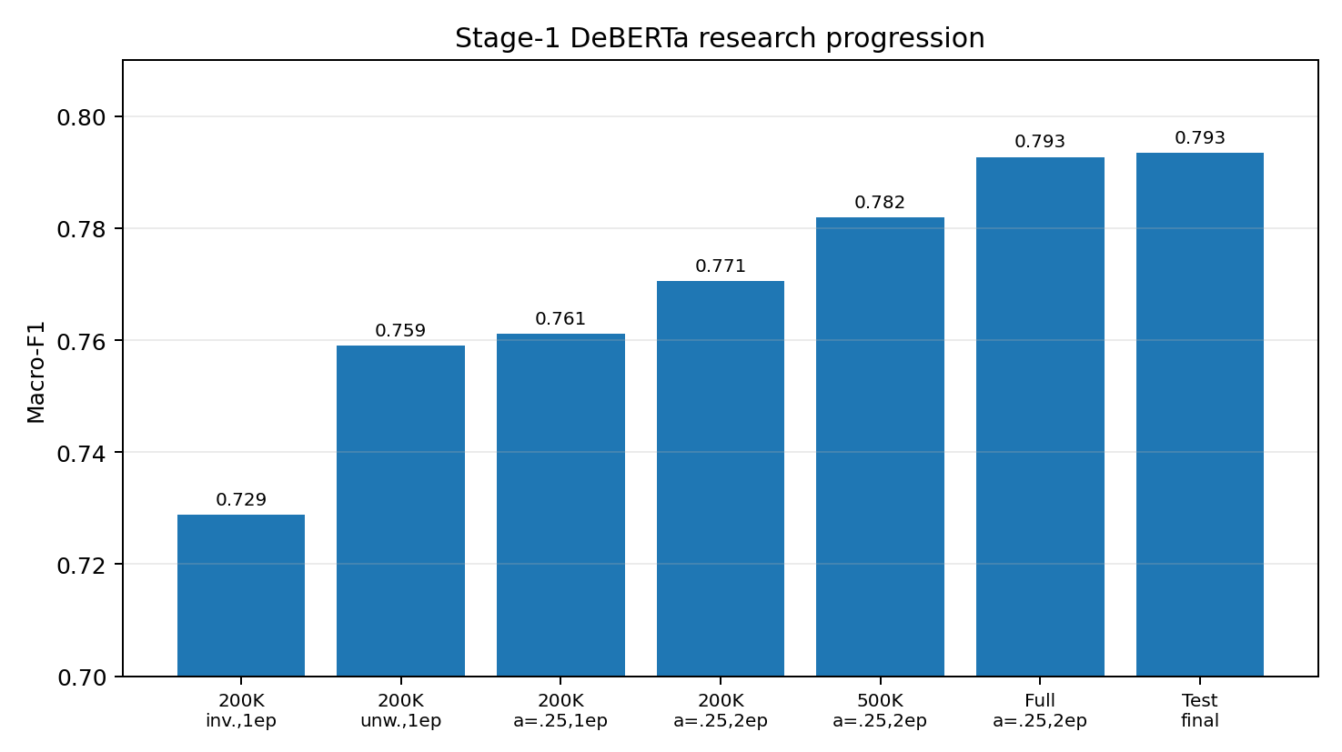
Figure 3. Key DeBERTa progression: correcting weighting and training longer mattered more than simply scaling the original configuration.
200K comparison | Macro-F1 1 ep | Macro-F1 2 ep | Gain
alpha = 0.25 | 0.761141 | 0.770550 | +0.009409
unweighted | 0.759053 | 0.769509 | +0.010456

Key causal finding. The original full-data one-epoch inverse-weighted DeBERTa (Macro-F1 0.7590) was outperformed by a 200K-row alpha=0.25 two-epoch model (0.7706). This demonstrates that loss design and training duration were more important than raw data scale under the original configuration.

9. Final Frozen Stage-1 Model
Configuration item | Final value
Model | microsoft/deberta-v3-small
Training split | train_clean.parquet
Training rows | 1,089,694
Validation rows | 121,078
Max sequence length | 256
Epochs | 2
Learning rate | 2e-5
Per-device batch size | 8
Gradient accumulation | 2
Observed effective batch size | 32 with 2 T4 GPUs
Class weighting | power-balanced, alpha = 0.25
Seed | 42

9.1 Final validation results
Metric | Score
Accuracy | 0.884570
Micro-F1 | 0.884570
Macro-F1 | 0.792682
Weighted-F1 | 0.884478
MCC | 0.800832
Balanced Accuracy | 0.792424
Eval loss | 0.393527

Class | Precision | Recall | F1 | Support
BUG | 0.919055 | 0.926807 | 0.922915 | 64,378
DOCUMENTATION | 0.719169 | 0.723692 | 0.721423 | 5,407
ENHANCEMENT | 0.895673 | 0.884730 | 0.890168 | 43,871
QUESTION | 0.637989 | 0.634465 | 0.636222 | 7,422

True \ Pred | BUG | DOCUMENTATION | ENHANCEMENT | QUESTION
BUG | 59,666 | 453 | 2,872 | 1,387
DOCUMENTATION | 482 | 3,913 | 790 | 222
ENHANCEMENT | 3,060 | 934 | 38,814 | 1,063
QUESTION | 1,713 | 141 | 859 | 4,709

9.2 Official test results
Official test result. The frozen final model was evaluated on 142,320 official test examples with evaluation-only integrity verification and no training invocation. Test Macro-F1 (0.7934) slightly exceeded validation Macro-F1 (0.7927), indicating stable generalization.

Metric | Score
Accuracy | 0.884830
Micro-F1 | 0.884830
Macro-F1 | 0.793414
Weighted-F1 | 0.884868
MCC | 0.801625
Balanced Accuracy | 0.794172

Class | Precision | Recall | F1 | Support
BUG | 0.918287 | 0.924660 | 0.921462 | 74,781
DOCUMENTATION | 0.712242 | 0.716571 | 0.714400 | 6,252
ENHANCEMENT | 0.897048 | 0.886225 | 0.891603 | 52,797
QUESTION | 0.643174 | 0.649234 | 0.646190 | 8,490

True \ Pred | BUG | DOCUMENTATION | ENHANCEMENT | QUESTION
BUG | 69,147 | 565 | 3,431 | 1,638
DOCUMENTATION | 584 | 4,480 | 923 | 265
ENHANCEMENT | 3,739 | 1,113 | 46,790 | 1,155
QUESTION | 1,830 | 132 | 1,016 | 5,512

Class | True count | Predicted count | Difference
BUG | 74,781 | 75,300 | +519
DOCUMENTATION | 6,252 | 6,290 | +38
ENHANCEMENT | 52,797 | 52,160 | -637
QUESTION | 8,490 | 8,570 | +80

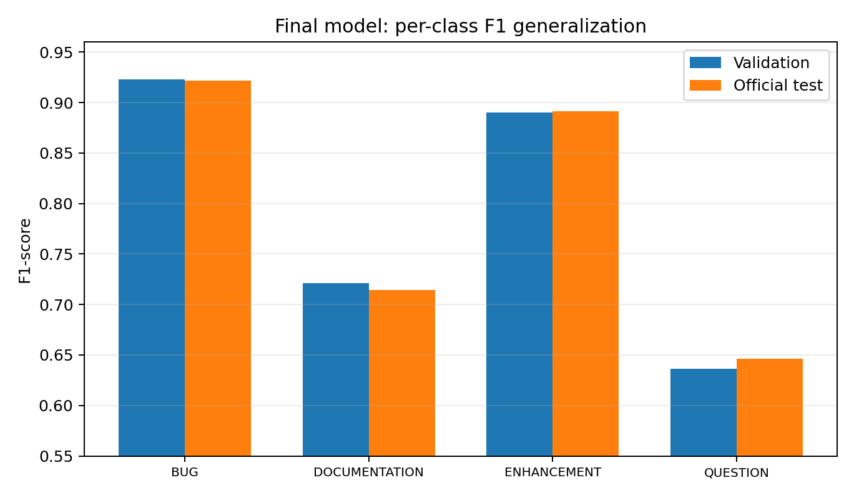
Figure 4. Final per-class F1 is highly consistent between validation and official test.

10. What the Results Demonstrate
Comparison | Macro-F1 | Micro-F1 | MCC | Interpretation
TF-IDF 2M validation | 0.764284 | 0.864715 | 0.765196 | strong optimized lexical baseline
DeBERTa 200K alpha=.25, 2 ep | 0.770550 | 0.872867 | 0.781073 | beats TF-IDF with ~18% of train rows
DeBERTa 500K alpha=.25, 2 ep | 0.781914 | 0.879524 | 0.792263 | clear scale gain
Final full validation | 0.792682 | 0.884570 | 0.800832 | best validation model
Final official test | 0.793414 | 0.884830 | 0.801625 | stable generalization

Final improvement over TF-IDF baseline (validation-level comparison). Macro-F1 improves by approximately +0.0284 (2.84 percentage points), Micro-F1 by +0.0199, and MCC by +0.0364 from the 2M-vocabulary TF-IDF baseline to the final full-data DeBERTa validation model.
Important benchmark caution. Earlier project notes referenced published NLBSE results such as an SGD Micro-F1 around 0.8523 and a RoBERTa Micro-F1 around 0.8906. These values should be re-verified against the original paper and exact benchmark protocol before being used in a publication claim. The current final official-test Micro-F1 is 0.8848.

11. Research and Engineering Contributions
C1. Leakage-aware dataset preparation - Built a deterministic NLBSE preprocessing path with schema inference, canonical labels, normalized-text hashing, deduplication, source-ID disambiguation, and explicit official-test overlap removal.
C2. Large-vocabulary classical baseline - Showed that software issue classification continues to benefit from vocabulary scaling up to 2M word features, with diminishing returns quantified across six controlled runs.
C3. Minority-class analysis - Demonstrated that full inverse-frequency cross-entropy substantially over-corrects DOCUMENTATION and QUESTION, creating a high-recall / low-precision regime.
C4. Power-balanced loss study - Introduced and evaluated a mild power-balanced weighting continuum, with alpha=0.25 becoming the best Macro-F1 compromise.
C5. Training-duration ablation - Showed that a second epoch yields roughly +0.94 to +1.05 Macro-F1 points at 200K, validating that one epoch undertrained the transformer.
C6. Context-length audit - Measured token-length distributions on all 1.089M clean reports and showed that 384 tokens does not justify its additional compute over 256 despite reducing truncation.
C7. Scalable memory architecture - Reduced host-memory pressure from approximately 30 GiB to a practical single-digit-GiB range through Arrow-backed loading, batched tokenization, dynamic padding, column projection, and validation reuse.
C8. Robust cloud checkpointing - Implemented stable cross-session source identity, full optimizer/scheduler/RNG restoration, strict state validation, and checkpoint continuation suitable for Kaggle session limits.
C9. Scale study - Demonstrated consistent improvement from 200K to 500K to 1.089M using the frozen alpha=0.25 / two-epoch configuration.
C10. Strong held-out generalization - Final validation and official-test metrics are essentially identical, strengthening the evidence that gains are not validation-specific.

12. Research Questions Supported by the Experiments
RQ | Question | Evidence / answer
RQ1 | How strong can a classical lexical baseline become on NLBSE 2023? | 2M word TF-IDF reached 0.7643 Macro-F1; gains diminished after 1M+ features.
RQ2 | Does more transformer training data help? | Yes. Under a fixed configuration, 200K -> 500K -> full data increased Macro-F1.
RQ3 | Does inverse-frequency balancing solve minority performance? | No. It over-predicts minorities; high recall is purchased with severe precision loss.
RQ4 | Can milder class weighting improve the trade-off? | Yes. alpha=0.25 gives the strongest Macro-F1 balance and scales well.
RQ5 | Is one epoch sufficient? | No. Two epochs clearly improve Macro-F1 for both unweighted and alpha=0.25 models.
RQ6 | Does increasing context 256 -> 384 help? | Not materially. Macro-F1 slightly decreased while evaluation cost rose substantially.
RQ7 | Does the final model generalize to the untouched official test? | Yes. 0.7927 validation Macro-F1 vs 0.7934 test Macro-F1.

13. Error Analysis of the Final Official-Test Model
Largest confusions. The final confusion matrix shows that the dominant semantic boundaries remain BUG vs ENHANCEMENT and BUG vs QUESTION. These are plausible ambiguity regions because issue descriptions often mix observed failures, questions, desired behavior, and requests for change.
Error direction | Count
BUG -> ENHANCEMENT | 3,431
ENHANCEMENT -> BUG | 3,739
QUESTION -> BUG | 1,830
BUG -> QUESTION | 1,638
ENHANCEMENT -> QUESTION | 1,155
QUESTION -> ENHANCEMENT | 1,016
ENHANCEMENT -> DOCUMENTATION | 1,113

- Perform a qualitative audit of approximately 50-100 examples from the largest confusion pairs.
- Check for label ambiguity, issue templates, code-heavy bodies, truncation, questions describing real defects, and enhancement requests phrased as failures.
- For publication, consider bootstrap confidence intervals or repeated-seed evaluation for the final model if compute permits.

14. Limitations and Threats to Validity
- No repository metadata in detected schema: the clean development split is stratified rather than project-aware, so cross-project generalization is not directly measured.
- Class imbalance: BUG and ENHANCEMENT dominate the dataset; minority performance remains materially lower, especially QUESTION.
- Potential label noise: issue labels in repository-derived datasets can be ambiguous or inconsistent; no full manual relabeling campaign was performed.
- Single primary seed: most development runs use seed 42. Repeated seeds would strengthen claims about statistical stability.
- Context truncation: 32.5% of reports exceed 256 tokens. Although 384 did not help in one controlled experiment, alternative head+tail or hierarchical long-context strategies remain untested.
- Benchmark comparability: published-paper comparisons must be made only after confirming exact split, cleaning, label mapping, and metric protocol.
- Hierarchical taxonomy not yet complete: BOHR/MANDELBUG and ARB/NAM stages are planned extensions, not completed contributions in the current evidence.

15. Proposed Research-Paper Framing

15.1 Candidate title
BugClassiNet-Next: Imbalance-Aware and Reproducible Transformer-Based Semantic Issue Classification at Scale

15.2 Paper-ready contribution statement
- A leakage-aware, reproducible preprocessing and evaluation pipeline for million-scale NLBSE issue classification.
- A controlled comparison of lexical vocabulary scaling and transformer scaling.
- An empirical class-weighting study showing that conventional inverse-frequency balancing can over-correct minority classes in semantic issue classification.
- A mild power-balanced weighting strategy (alpha=0.25) that produces a stronger Macro-F1 precision/recall balance.
- A context-length and epoch ablation demonstrating that training duration matters more than a 256->384 context increase in this setup.
- A final DeBERTa-v3-small model with 0.7934 Macro-F1, 0.8848 Micro-F1, and 0.8016 MCC on the untouched official test split.

15.3 Draft abstract scaffold
Background: Automated issue classification supports software triage but must handle large, imbalanced, semantically overlapping classes. Method: We construct a leakage-aware NLBSE 2023 pipeline, establish a large-vocabulary TF-IDF baseline, and evaluate DeBERTa-v3-small under controlled data-scale, class-weighting, context-length, and epoch ablations. Key finding: Conventional inverse-frequency balancing over-corrects minority classes, while mild power-balanced weighting (alpha=0.25) provides a better precision/recall trade-off. Result: The final full-data two-epoch model obtains 0.7934 Macro-F1, 0.8848 Micro-F1, and 0.8016 MCC on the official test set, with nearly identical validation and test performance. Extension: The Stage-1 classifier is designed as the entry point to a hierarchical BOHR/MANDELBUG and ARB/NAM bug-taxonomy pipeline.

16. Immediate Next Work: Hierarchical Bug Taxonomy
Do not continue Stage-1 tuning. Stage 1 is now frozen. The highest-value next work is to prepare and audit the BOHR/MANDELBUG dataset, build Stage 2, then build ARB/NAM Stage 3. DAPT should be evaluated only after a no-DAPT ModernBERT baseline exists.

Stage 1 (COMPLETED)
GitHub issue -> DeBERTa-v3-small -> BUG / DOC / ENHANCEMENT / QUESTION
If BUG:
Stage 2 (NEXT)
-> BOHR vs MANDELBUG
suggested first baseline: TF-IDF + LinearSVC
suggested neural model: ModernBERT (no-DAPT first)
If MANDELBUG:
Stage 3 (NEXT)
-> ARB vs NAM
baseline + ModernBERT
Optional research extension after baselines:
DAPT on unlabeled bug-report corpora -> fine-tuning -> controlled comparison
- Freeze and archive all Stage-1 artifacts, configs, hashes, predictions, and result tables.
- Audit BOHR/MANDELBUG data: source, label provenance, row counts, project IDs, duplicates, missing text, class imbalance.
- Create leakage-safe train/validation/test splits; prefer project-aware splitting if project metadata exists.
- Train one classical TF-IDF baseline and one ModernBERT supervised baseline for Stage 2.
- Repeat for ARB/NAM Stage 3.
- Wire hierarchical inference and evaluate end-to-end routing errors.
- Only after the no-DAPT baselines are stable, test DAPT as an explicit ablation.

17. Points to Discuss with the Professor
- Is the Stage-1 contribution sufficient as a standalone paper section, or should publication wait for the full hierarchical taxonomy?
- Should Macro-F1 remain the primary model-selection metric given the class imbalance?
- Should the final Stage-1 result be rerun across 3 seeds for confidence intervals before submission?
- Which BOHR/MANDELBUG dataset and label provenance should be considered authoritative?
- Should Stage 2/3 use project-aware splitting to emphasize cross-project generalization?
- Would a paper contribution around imbalance-aware weighting + reproducible large-scale training be more publishable than simply changing transformer architecture?
- Should DAPT be included now, or reserved as an additional ablation after supervised ModernBERT baselines?
- Which venue and benchmark protocol should define the literature-comparison table?

Appendix A. Final Validation and Test Confusion Matrices
Validation matrix (rows=true, columns=predicted):
BUG DOCUMENTATION ENHANCEMENT QUESTION
BUG 59666 453 2872 1387
DOCUMENTATION 482 3913 790 222
ENHANCEMENT 3060 934 38814 1063
QUESTION 1713 141 859 4709
Official test matrix (rows=true, columns=predicted):
BUG DOCUMENTATION ENHANCEMENT QUESTION
BUG 69147 565 3431 1638
DOCUMENTATION 584 4480 923 265
ENHANCEMENT 3739 1113 46790 1155
QUESTION 1830 132 1016 5512

Appendix B. Chronological Milestones
Milestone | Outcome
Repository scaffold / smoke tests | Reusable CLI, Kaggle notebooks, TF-IDF and transformer paths verified locally.
NLBSE preparation | Clean train/validation/test Parquet artifacts created with leakage checks.
TF-IDF scaling | 200K -> 2M features; final Macro-F1 0.7643.
Initial DeBERTa scaling | 200K -> 500K -> full data, inverse-balanced, 1 epoch; full Macro-F1 0.7590.
Memory redesign | ~30 GiB startup pressure reduced to practical single-digit GiB.
Checkpoint engineering | Cross-Kaggle segmented training and stable resume implemented.
Token audit | 32.5% >256 tokens; 384-token ablation did not improve Macro-F1.
Weighting study | Unweighted / alpha=.25 / sqrt / inverse compared; alpha=.25 selected.
Epoch study | 2 epochs clearly better than 1.
Final scale study | alpha=.25, 2 epochs: 200K 0.7706 -> 500K 0.7819 -> full 0.7927 Macro-F1.
Official test | 0.7934 Macro-F1, 0.8848 Micro-F1, 0.8016 MCC.

End of research progress report
All completed metrics in this document are drawn from the experimental logs and results shared during the BugClassiNet-Next development process. Planned Stage 2/3 items are explicitly marked as future work.

