BugClassiNet-Next
Stage 2 Research Report
Cross-project classification of Bohrbugs vs Mandelbugs from software issue evidence
Research review document | 20 September 2026
Stage 2 status: finalized — model comparison, multi-seed verification, targeted error analysis, and leakage-free nested threshold calibration completed
Prepared from completed Kaggle experiment outputs, frozen Stage 2 data, token-audit artifacts, and final calibration/error-analysis runs.

1. Executive Summary
Objective. Stage 2 evaluates whether software issues can be classified as deterministic Bohrbugs (BOH) or Mandelbugs using issue-report evidence while generalizing to an unseen project. The final supervised dataset contains 806 unique issues across AXIS, HTTPD, Linux, and MySQL. The final evaluation preserves four-project outer LOPO and adds leakage-free inner project-level threshold selection for the best SBERT condition.
Main finding
The final Stage 2 decision rule is SBERT (all-mpnet-base-v2 embeddings + logistic regression) using initial evidence at 512 tokens with nested project-aware threshold calibration. It reaches Macro-F1 = 0.7626, accuracy = 0.7816, balanced accuracy = 0.7779, MCC = 0.5332, and MANDELBUG PR-AUC = 0.6852 under outer leave-one-project-out evaluation. The same model at the default 0.5 threshold scores Macro-F1 = 0.7468.
- The final best result is SBERT initial @512 with nested project-aware threshold calibration: Macro-F1 0.7626, accuracy 0.7816, balanced accuracy 0.7779, and MCC 0.5332.
- Calibration improves Macro-F1 by +0.0158 over the same SBERT model at threshold 0.5 (0.7468 → 0.7626) and reduces total errors from 192 to 176.
- The calibrated confusion matrix reduces BOH→MANDELBUG false positives from 139 to 115, while MANDELBUG→BOH false negatives increase from 53 to 61; this improves overall class balance and MCC.
- ModernBERT remains below SBERT: initial @512 reaches 0.6136 ± 0.0110 Macro-F1 and full @512 reaches 0.6308 ± 0.0291. Freezing eight lower layers further reduces seed-42 Macro-F1 to 0.5935.
- Initial evidence remains the deployment-facing condition. Full comments are retrospective and are not uniformly beneficial; SBERT full @512 is lower at 0.7356 Macro-F1.

2. Research Questions and Scope
- RQ1 — Cross-project generalization: Can BOH vs MANDELBUG be predicted for a project that is completely held out during training?
- RQ2 — Evidence depth: Does adding issue-thread comments improve classification relative to title + initial description + environment only?
- RQ3 — Context truncation: Are model differences primarily explained by limited token context, and does a 512-token ablation materially change results?
- RQ4 — Representation choice: How do sparse lexical features, sentence embeddings, and end-to-end transformer fine-tuning compare under the same LOPO protocol?
- RQ5 — Decision calibration: Can thresholds selected only from training projects reduce cross-project class bias without outer-test leakage?
Stage boundary. Stage 2 collapses NAM and ARB annotations into a single MANDELBUG class. Stage 3 will separate NAM from ARB after the binary BOH/MANDELBUG stage is stabilized.

3. Dataset Reconstruction and Label Design
The source Mandelbugs collection contained 852 raw annotations. Stage 2 required issue reconstruction, deduplication, retrieval of missing issue content where possible, conflict handling, and exclusion of unknown labels before cross-project training.
Raw label | Count | Stage 2 treatment
BOH | 547 | BOH
NAM | 210 | MANDELBUG
ARB | 59 | MANDELBUG
UNK | 36 | Excluded from supervised Stage 2
Final supervised set: 806 unique issues — 544 BOH (67.5%) and 262 MANDELBUG (32.5%).
Project | Total | BOH | MANDELBUG | MANDELBUG share
AXIS | 198 | 183 | 15 | 7.6%
HTTPD | 141 | 116 | 25 | 17.7%
Linux | 267 | 122 | 145 | 54.3%
MySQL | 200 | 123 | 77 | 38.5%
Total | 806 | 544 | 262 | 32.5%
Reconstruction notes. MySQL reached 200 usable classified issues (123 BOH, 77 MANDELBUG) with approximately 98.6% retrieval coverage; two otherwise eligible issues remained unavailable, and conflicting issue 48993 was quarantined rather than forced into a label. Duplicate/conflicting records were handled conservatively.

4. Experimental Protocol
Evaluation uses four-project leave-one-project-out (LOPO) validation. Each project is held out once as the external test fold while the remaining three projects are used for training/model selection. For the final SBERT calibration experiment, each outer fold additionally performs three-project inner LOPO on the training projects only; the resulting threshold is then applied to the untouched outer-project probabilities. This preserves project separation and avoids threshold tuning on outer-test labels.
Component | Choice
Primary metric | Macro-F1
Secondary metrics | Accuracy, balanced accuracy, MCC, MANDELBUG PR-AUC, mean project Macro-F1
Initial evidence | Title + initial description + environment
Full evidence | Initial evidence + issue comments
Cross-project protocol | 4-fold LOPO: AXIS, HTTPD, Linux, MySQL held out in turn
TF-IDF baseline | TF-IDF + linear SVM
SBERT baseline | sentence-transformers/all-mpnet-base-v2 embeddings + logistic regression (C=1.0, max_iter=5000); repeated seeds 13/42/97 reproduce identical outputs under the current deterministic pipeline
ModernBERT | answerdotai/ModernBERT-base, no domain-adaptive pretraining; seeds 13/42/97; additional seed-42 freeze-8 regularization screen
Context ablation | SBERT 384 → 512; ModernBERT 256 → 512 (with token audit up to 1024 for ModernBERT)
Final decision calibration | Nested project-aware threshold selection: inner LOPO on the three training projects, optimized for Macro-F1, then applied once to the untouched outer project
Seed / calibration interpretation
SBERT @512 was repeated with seeds 13, 42, and 97 and produced identical predictions and metrics under the current implementation, so its near-zero reported seed variance reflects deterministic behavior rather than independent stochastic variability. ModernBERT retains three-seed mean ± standard deviation reporting. Final threshold calibration is nested inside the outer LOPO protocol; no outer-project labels are used to choose that project’s threshold.

5. Context-Length and Truncation Audit
A token-level audit was run before interpreting full-evidence results. The audit showed that a large fraction of issues are truncated at default context lengths, especially when comments are included. This motivated the paired 512-token ablation rather than assuming that default context captured the same evidence for all models.
Model / context | Evidence | Truncated | Any comments visible | All comments visible | Median comment fraction
ModernBERT @256 | full | 83.13% | 36.23% | 17.25% | 0.0%
ModernBERT @512 | full | 65.26% | 61.66% | 34.86% | 12.73%
ModernBERT @1024 | full | 48.76% | 81.14% | 51.24% | 100%
SBERT @384 | full | 71.96% | 52.61% | 28.04% | ~1.99%
SBERT @512 | full | 64.76% | 61.91% | 35.24% | 14.53%
Initial-evidence truncation was also substantial: ModernBERT dropped from about 63.0% truncated at 256 tokens to 38.1% at 512; SBERT dropped from about 47.0% at 384 to 38.0% at 512.
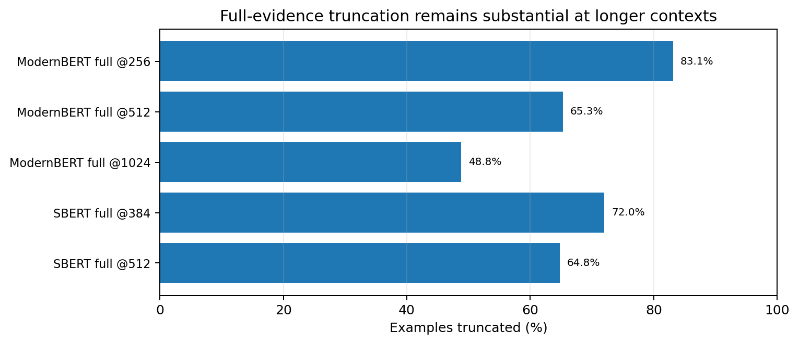
Figure 1. Full-evidence truncation rate by model/context length.

6. Stage 2 Results

6.1 Default-context baselines
Model | Evidence | Context | Macro-F1 | Accuracy | Bal. Acc. | MCC | MAN PR-AUC | Mean project F1
TF-IDF | initial | n/a | 0.5529 | 0.6948 | 0.5671 | 0.1997 | 0.4923 | —
TF-IDF | full | n/a | 0.5956 | 0.7134 | 0.5977 | 0.2678 | 0.5676 | 0.5946
SBERT | initial | 384 | 0.7379 | 0.7519 | 0.7647 | 0.4991 | 0.6794 | 0.6930
SBERT | full | 384 | 0.7397 | 0.7519 | 0.7707 | 0.5088 | 0.6833 | 0.6996
ModernBERT | initial | 256 | 0.6110 ± 0.0447 | 0.6485 ± 0.0425 | 0.6179 ± 0.0473 | 0.2304 ± 0.0924 | 0.4605 ± 0.0380 | 0.5725 ± 0.0378
ModernBERT | full | 256 | 0.6199 ± 0.0288 | 0.6543 ± 0.0329 | 0.6281 ± 0.0333 | 0.2496 ± 0.0630 | 0.5076 ± 0.0290 | 0.5311 ± 0.0482
At default context, SBERT clearly leads the pooled LOPO results. TF-IDF gains strongly from full comments (+0.0427 Macro-F1), whereas SBERT changes only slightly (+0.0018). ModernBERT also improves modestly in pooled Macro-F1 with full evidence, but its mean project Macro-F1 falls, indicating project-specific heterogeneity.

6.2 512-token ablation
Model | Evidence | Macro-F1 | Accuracy | Bal. Acc. | MCC | MAN PR-AUC | Mean project F1
SBERT | initial | 0.7468 | 0.7618 | 0.7711 | 0.5127 | 0.6852 | 0.6984
SBERT | full | 0.7356 | 0.7494 | 0.7629 | 0.4954 | 0.6947 | 0.6980
ModernBERT | initial | 0.6136 ± 0.0110 | 0.6609 ± 0.0242 | 0.6198 ± 0.0239 | 0.2418 ± 0.0316 | 0.4837 ± 0.0363 | 0.5728 ± 0.0239
ModernBERT | full | 0.6308 ± 0.0291 | 0.6518 ± 0.0417 | 0.6507 ± 0.0224 | 0.2880 ± 0.0465 | 0.5360 ± 0.0245 | 0.5548 ± 0.0403
Comparison | Δ Macro-F1 | Interpretation
SBERT initial: 384 → 512 | +0.0089 | Longer context helps initial-evidence SBERT.
SBERT full: 384 → 512 | −0.0041 | No gain from longer full context.
ModernBERT initial: 256 → 512 | +0.0026 | Minimal pooled improvement.
ModernBERT full: 256 → 512 | +0.0109 | Small but clearer gain.
SBERT @512: initial → full | −0.0112 | Comments reduce Macro-F1, despite a small PR-AUC gain.
ModernBERT @512: initial → full | +0.0172 | Comments help pooled Macro-F1 and MANDELBUG ranking.
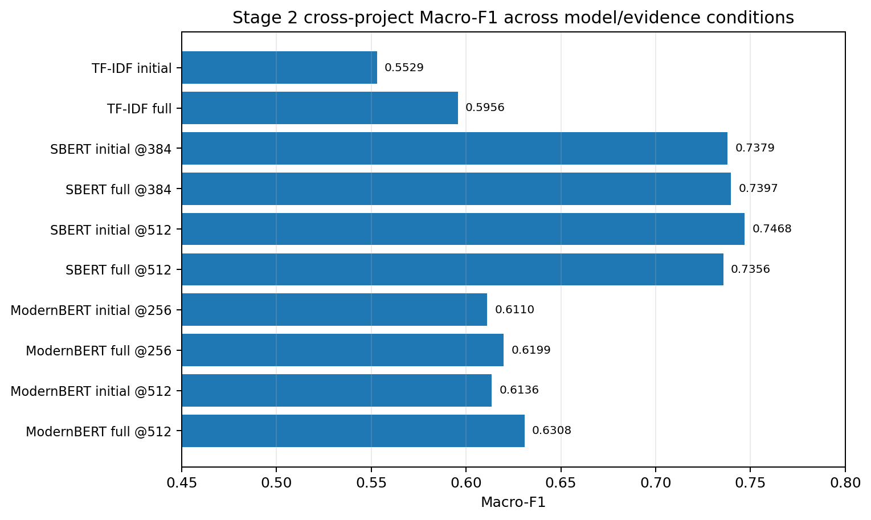
Figure 2. Uncalibrated Macro-F1 across Stage 2 model, evidence, and context-length conditions.

6.3 Uncalibrated and calibrated SBERT error profile
At the default 0.5 threshold, SBERT initial @512 favors MANDELBUG recall but produces many BOH→MANDELBUG false positives. Nested project-aware threshold calibration directly targets this decision imbalance while keeping the encoder and logistic-regression model unchanged.
Condition | BOH→BOH | BOH→MAN | MAN→BOH | MAN→MAN | MAN precision | MAN recall | MAN F1
SBERT initial @512 | 405 | 139 | 53 | 209 | 0.6006 | 0.7977 | 0.6852
SBERT full @512 | 394 | 150 | 52 | 210 | 0.5833 | 0.8015 | 0.6752
SBERT initial @512 + nested threshold | 429 | 115 | 61 | 201 | 0.6361 | 0.7672 | 0.6955

6.4 Final nested threshold calibration
The final improvement experiment retains the strongest SBERT initial-evidence @512 model and changes only its hard decision threshold. For each outer project, the threshold is selected from out-of-fold predictions produced by inner LOPO over the other three projects. The selected threshold is therefore estimated without observing labels from the outer project.
Condition | Macro-F1 | Accuracy | Bal. Acc. | MCC | MAN PR-AUC | Pred. MAN
SBERT initial @512, threshold 0.5 | 0.7468 | 0.7618 | 0.7711 | 0.5127 | 0.6852 | 348
SBERT initial @512, nested calibrated | 0.7626 | 0.7816 | 0.7779 | 0.5332 | 0.6852 | 316
Absolute change | +0.0158 | +0.0199 | +0.0068 | +0.0205 | 0.0000 | −32
Calibration changes only the class decision boundary, so probability ranking and PR-AUC remain unchanged. The calibrated rule reduces BOH→MANDELBUG false positives from 139 to 115 while increasing MANDELBUG→BOH false negatives from 53 to 61; total errors fall from 192 to 176.
Outer project | Selected threshold | Inner Macro-F1 @0.5 | Inner best Macro-F1 | Inner Δ
AXIS | 0.5301 | 0.7030 | 0.7273 | +0.0243
HTTPD | 0.6380 | 0.7401 | 0.7521 | +0.0120
Linux | 0.5149 | 0.7318 | 0.7396 | +0.0078
MySQL | 0.4857 | 0.7229 | 0.7325 | +0.0096

6.5 Project-level calibration effects
Project | Threshold | Default Macro-F1 | Calibrated Macro-F1 | Δ Macro-F1 | Default MCC | Calibrated MCC
AXIS | 0.5301 | 0.7416 | 0.7530 | +0.0114 | 0.4872 | 0.5138
HTTPD | 0.6380 | 0.6609 | 0.7321 | +0.0712 | 0.4344 | 0.4763
Linux | 0.5149 | 0.6704 | 0.6778 | +0.0075 | 0.3645 | 0.3705
MySQL | 0.4857 | 0.7206 | 0.7159 | −0.0047 | 0.4578 | 0.4498
Mean | — | 0.6984 | 0.7197 | +0.0213 | — | —
Calibration improves Macro-F1 on three of four held-out projects. The largest gain occurs on HTTPD (+0.0712), where the higher threshold sharply reduces over-prediction of MANDELBUG. MySQL shows a small −0.0047 decrease, so the gain is not universal; reporting the per-project effect remains necessary.

6.6 Targeted error analysis of the best uncalibrated SBERT model
Project | Rows | BOH→MAN | MAN→BOH | Total errors | Error rate | BOH recall | MAN recall
AXIS | 198 | 5 | 8 | 13 | 6.6% | 0.9727 | 0.4667
HTTPD | 141 | 37 | 3 | 40 | 28.4% | 0.6810 | 0.8800
Linux | 267 | 59 | 25 | 84 | 31.5% | 0.5164 | 0.8276
MySQL | 200 | 38 | 17 | 55 | 27.5% | 0.6911 | 0.7792
Total | 806 | 139 | 53 | 192 | 23.8% | — | 0.7977
The dominant failure mode before calibration is BOH→MANDELBUG over-prediction (139 cases versus 53 MANDELBUG→BOH misses). Linux is the hardest project by error rate (31.5%) and has a 48.4% BOH false-positive rate. AXIS appears easy overall because BOH dominates, but MANDELBUG recall is only 46.7% (7/15).
Qualitative review shows two recurring ambiguity patterns. Some true MANDELBUGs look like ordinary deterministic dependency or environment failures from the initial report (for example missing servlet.jar, JUnit configuration, or JSSE implementation requirements). Conversely, some BOH issues contain performance/load/timing language (for example response time increasing with load or operations taking hours) that resembles nondeterministic behavior and drives confident false positives. Incorrect predictions still have mean confidence 0.6288 versus 0.7245 for correct predictions, indicating systematic domain-semantic errors rather than only near-boundary uncertainty.

6.7 ModernBERT regularization screen
Condition | Seed | Macro-F1 | Accuracy | Bal. Acc. | MCC | MAN PR-AUC
ModernBERT initial @512 baseline | 42 | 0.6263 | 0.6439 | 0.6472 | 0.2767 | 0.5253
ModernBERT initial @512, freeze 8 lower layers | 42 | 0.5935 | 0.6241 | 0.6018 | 0.1946 | 0.5174
Change | — | −0.0328 | −0.0199 | −0.0454 | −0.0821 | −0.0079
Freezing eight lower ModernBERT layers does not improve cross-project robustness; every reported metric declines at seed 42. This negative ablation, together with the modest 256→512 gains, suggests that simple context extension or lower-layer freezing is insufficient to close the representation gap on this small heterogeneous dataset.

7. Interpretation and Research Takeaways
- The final Stage 2 reference is SBERT initial @512 with nested project-aware threshold calibration. Macro-F1 increases from 0.7468 at the default threshold to 0.7626, while MCC rises from 0.5127 to 0.5332.
- The truncation hypothesis is only partially supported. Moving to 512 tokens materially reduces truncation, but ModernBERT gains only +0.0026 Macro-F1 for initial evidence and +0.0109 for full evidence; context length alone cannot explain the model gap.
- Full comments encode useful signal for some models but also introduce noise and project-specific language. TF-IDF benefits strongly; ModernBERT benefits modestly; SBERT initial evidence remains stronger than full evidence at 512 tokens.
- Initial evidence remains the primary deployment-facing condition because it corresponds to triage-time information. The final calibrated result therefore improves the deployable condition rather than relying on retrospective comments.
- Project-level reporting is essential. Calibration improves AXIS, HTTPD, and Linux but slightly reduces MySQL Macro-F1; ModernBERT also shows substantial project and seed variability. Pooled metrics alone can hide these differences.
Final Stage 2 conclusion
Cross-project BOH vs MANDELBUG classification is feasible from triage-time issue text. Sentence-level semantic embeddings generalize substantially better than end-to-end ModernBERT fine-tuning on this 806-issue, four-project dataset. The final leakage-free nested calibration further improves the strongest SBERT decision rule to Macro-F1 0.7626 and MCC 0.5332 by reducing cross-project BOH→MANDELBUG over-prediction. Stage 2 model development is therefore frozen and ready to feed Stage 3 subtype analysis.

8. Reproducibility and Artifact Status
The Stage 2 pipeline is implemented as reproducible CLI-driven experiments with frozen dataset preparation, outer LOPO evaluation, saved manifests, predictions, per-fold metrics, classification reports, confusion matrices, aggregate metrics, error-analysis tables, and final nested-calibration artifacts. The 512-token ModernBERT experiments were executed across separate Kaggle runs because of runtime/storage constraints. For nested threshold calibration, the working-copy protocol was temporarily relaxed to permit three-project inner LOPO; the classifier, features, labels, and outer evaluation data were unchanged, and the outer project was excluded from threshold selection.
Artifact | Status / use
Prepared Stage 2 dataset | 806 unique supervised issues; frozen for current experiments
Token audit | Persisted summaries and per-issue audit; used to justify 512-token ablation
SBERT initial/full @512 | Completed, saved, and repeated with seeds 13/42/97; outputs are identical under the current deterministic pipeline
ModernBERT initial @512 | Completed and saved
ModernBERT full @512 | Completed in separate Kaggle artifact and saved
Final combined summary | Completed: combined 512 summary, per-project tables, initial-vs-full comparison, and final headline result artifacts
Targeted error analysis | Completed: 192 uncalibrated errors characterized by project; representative high-confidence and near-boundary cases sampled
Nested threshold calibration | Completed with leakage-free inner project-level LOPO; final Macro-F1 0.7626, MCC 0.5332
ModernBERT freeze-8 screen | Completed at seed 42; negative result (Macro-F1 0.5935 vs 0.6263 baseline)
Recommended final research artifact contents: aggregate_metrics.json, summary.json, run_manifest.json, per_fold_metrics.csv, per_project_seed_summary.csv, classification_report.csv, confusion_matrix.csv, and predictions.parquet for each experiment. Large model checkpoints can remain in their original Kaggle datasets to avoid unnecessary duplication.

9. Current Limitations
- Dataset size is modest (806 issues) and the class distribution is imbalanced (67.5% BOH vs 32.5% MANDELBUG).
- Project label distributions differ substantially; Linux contains a much higher MANDELBUG share than AXIS/HTTPD, so project identity and label prevalence are entangled.
- SBERT @512 repeats under seeds 13/42/97 are identical under the current deterministic embedding + logistic-regression implementation; these repeats do not provide stochastic uncertainty comparable to ModernBERT’s three-seed variation.
- Full comments can contain post-diagnosis information, so full-evidence performance should not be presented as pure early-triage performance.
- Long-context evidence is still truncated at 512 tokens for a large fraction of full issue threads.
- Nested thresholds vary materially by training-project composition (0.4857–0.6380), so calibration should be re-estimated from training projects when transferring to a new project; no fifth external project is available for an additional independent calibration validation.
- The nested-calibration run required a calibration-only working-copy change to allow three-project inner LOPO. This changes the fold iterator only; it does not alter model architecture, labels, feature construction, or outer predictions.
- Stage 2 merges NAM and ARB into MANDELBUG; subtype discrimination remains unresolved until Stage 3.

10. Recommended Next Steps
1. Freeze and archive Stage 2
Preserve the final calibrated predictions, selected inner thresholds, project-level effects, SBERT multi-seed outputs, ModernBERT runs, token audit, and error-analysis files. Treat Macro-F1 0.7626 as the final Stage 2 headline result and 0.7468 as the uncalibrated reference.
2. Begin Stage 3: NAM vs ARB
Train only on MANDELBUG-labelled issues and retain project-aware evaluation. Because ARB is the smaller subtype, report Macro-F1, per-class recall/F1, MCC, PR-AUC where appropriate, and fold support counts.
3. Design Stage 3 around low-data constraints
Start with lightweight semantic baselines before end-to-end fine-tuning. Use nested model selection or training-only calibration if thresholds are tuned; avoid selecting hyperparameters directly on outer-project folds.
4. Carry forward error taxonomy
Track whether environment/dependency, timing/concurrency, load/performance, and insufficient initial evidence also drive NAM-vs-ARB errors. This links Stage 3 interpretation to the Stage 2 failure modes.
5. Prepare professor/paper package
Use the finalized dataset table, protocol, token audit, model comparison, calibrated final result, project-level effects, error analysis, negative ModernBERT ablation, limitations, and artifact/reproducibility notes from this report.
6. Optional external validation
If another labelled project becomes available, evaluate the frozen SBERT representation and training-only calibration procedure without re-tuning on that project. This would directly test whether the Stage 2 calibration gain transfers beyond the four-project benchmark.

Appendix A. Key Numeric Results for Reference
Condition | Macro-F1 | MCC | MANDELBUG PR-AUC
TF-IDF initial | 0.5529 | 0.1997 | 0.4923
TF-IDF full | 0.5956 | 0.2678 | 0.5676
SBERT initial @384 | 0.7379 | 0.4991 | 0.6794
SBERT full @384 | 0.7397 | 0.5088 | 0.6833
ModernBERT initial @256 | 0.6110 ± 0.0447 | 0.2304 ± 0.0924 | 0.4605 ± 0.0380
ModernBERT full @256 | 0.6199 ± 0.0288 | 0.2496 ± 0.0630 | 0.5076 ± 0.0290
SBERT initial @512 | 0.7468 | 0.5127 | 0.6852
SBERT full @512 | 0.7356 | 0.4954 | 0.6947
ModernBERT initial @512 | 0.6136 ± 0.0110 | 0.2418 ± 0.0316 | 0.4837 ± 0.0363
ModernBERT full @512 | 0.6308 ± 0.0291 | 0.2880 ± 0.0465 | 0.5360 ± 0.0245
SBERT initial @512 + nested threshold | 0.7626 | 0.5332 | 0.6852
ModernBERT initial @512, freeze-8 (seed 42) | 0.5935 | 0.1946 | 0.5174
Final Stage 2 Macro-F1: 0.7626 (SBERT, initial evidence, 512-token embedding context, nested project-aware threshold calibration). Uncalibrated reference: 0.7468.

