BugClassiNet-Next
Stage 3 Research Report
Cross-project classification of Non-Aging Mandelbugs (NAM) vs Aging-Related Bugs (ARB) from software issue evidence
Research review document | 27 September 2026
Stage 3 status: finalized - dataset audit, baseline comparison, evidence-depth study, leakage-free nested selection, targeted error analysis, and ModernBERT screening completed
Routing evaluation is intentionally excluded from this report and will be documented separately after the full hierarchy evaluation is complete.

1. Executive Summary
Objective. Stage 3 separates the MANDELBUG class produced by Stage 2 into Non-Aging Mandelbugs (NAM) and Aging-Related Bugs (ARB). The experiment asks whether this distinction can generalize to a completely unseen software project under a small, imbalanced, cross-project dataset.
Main finding
The selected Stage 3 decision rule is SBERT (sentence-transformers/all-mpnet-base-v2) using initial issue evidence at a 512-token context, followed by logistic regression with nested project-aware selection of class weighting and the ARB probability threshold. Under four-project outer leave-one-project-out evaluation it reaches Macro-F1 = 0.7322, accuracy = 0.8397, balanced accuracy = 0.7116, MCC = 0.4745, NAM F1 = 0.9019, and ARB F1 = 0.5625. The final confusion matrix is [[193, 14], [28, 27]] for [NAM, ARB].
- The frozen supervised Stage 3 dataset contains 262 unique MANDELBUG issues: 207 NAM (79.0%) and 55 ARB (21.0%).
- A classical TF-IDF + LinearSVC baseline reaches only 0.5606 Macro-F1, establishing that sparse lexical features are insufficient for robust cross-project NAM/ARB transfer.
- SBERT initial @512 at the default 0.5 threshold reaches 0.6149 Macro-F1. Leakage-free nested selection raises this to 0.7322, mainly by improving ARB recall from 0.2000 to 0.4909 and ARB F1 from 0.3284 to 0.5625.
- Full discussion evidence does not improve the selected model: nested full-evidence Macro-F1 is 0.6778, 0.0544 below initial evidence, with MCC lower by 0.1188.
- The remaining 42 errors are strongly project-structured: Linux contributes 20 of the 28 ARB→NAM misses, while MySQL contributes 10 of the 14 NAM→ARB false positives.
- A controlled seed-42 ModernBERT-base @512 screen performs near chance relative to the selected SBERT model (0.4996 tuned Macro-F1, MCC 0.0484); it was therefore not expanded to a three-seed study.

2. Research Questions and Scope
- RQ1 - Cross-project generalization: Can NAM vs ARB be predicted for a project that is completely held out from training?
- RQ2 - Representation choice: How do TF-IDF lexical features, fixed sentence embeddings, and end-to-end ModernBERT fine-tuning compare in this low-data setting?
- RQ3 - Evidence depth: Does adding issue-thread discussion improve generalization relative to title + initial description + environment evidence?
- RQ4 - Imbalance-aware decision selection: Can class weighting and an ARB threshold chosen only from training projects improve the minority-class trade-off without outer-test leakage?
- RQ5 - Project sensitivity and error structure: Which projects dominate residual ARB/NAM errors, and are the remaining failure modes symmetric?
Stage boundary. Stage 3 is trained and evaluated only on issues whose reconstructed gold annotation is NAM or ARB. BOH reports are excluded from standalone Stage 3 model selection. Stage 1, Stage 2 routing, and end-to-end hierarchy behavior are outside this report and will be analyzed in a separate routing report.

3. Dataset Construction and Label Design
Stage 3 is derived directly from the frozen Stage 2 supervised dataset. The Stage 2 artifact contains 806 unique issues; filtering to rows with gold Stage 3 labels NAM or ARB yields 262 unique Stage 3 examples with no duplicate issue_key values.
Label | Count | Share | Interpretation
NAM | 207 | 79.0% | Non-aging Mandelbug
ARB | 55 | 21.0% | Aging-related bug
Total | 262 | 100% | Stage 3 supervised set
The resulting class ratio is approximately 3.76 NAM examples for every ARB example. ARB is therefore treated as the positive/minority class for probability reporting, PR-AUC, threshold selection, and error analysis.

3.1 Project distribution
Project | NAM | ARB | Total | ARB share
AXIS | 7 | 8 | 15 | 53.3%
HTTPD | 15 | 10 | 25 | 40.0%
Linux | 121 | 24 | 145 | 16.6%
MySQL | 64 | 13 | 77 | 16.9%
Total | 207 | 55 | 262 | 21.0%
The project distribution is highly heterogeneous. AXIS is nearly balanced, whereas Linux and MySQL are strongly NAM-dominant. Random train/test splitting would therefore mix project-specific distributions and overstate generalization; all headline results use project-held-out evaluation.

3.2 LOPO support audit
Held-out project | Train rows | Train NAM | Train ARB | Test rows | Test NAM | Test ARB
AXIS | 247 | 200 | 47 | 15 | 7 | 8
HTTPD | 237 | 192 | 45 | 25 | 15 | 10
Linux | 117 | 86 | 31 | 145 | 121 | 24
MySQL | 185 | 143 | 42 | 77 | 64 | 13
Every outer training split and every held-out project contains both NAM and ARB, so four-project LOPO is viable without inventing synthetic test support.
Frozen source identity. Stage 2 source SHA-256: 15d1d06426feecf50061d1eb57a67359f7b5cd9b5b78e7629c6b6453a4aa1acb. Frozen Stage 3 parquet SHA-256: ba8ed6f1d564d087223a9fdc5d143928753306f354da24c04910c3b5d8a44ebd.

4. Experimental Protocol
Primary evaluation. Each of AXIS, HTTPD, Linux, and MySQL is held out once as the outer test project. The other three projects supply training data. Headline metrics are pooled over the 262 outer-held-out predictions, with per-project results reported separately.
Primary metric. Macro-F1 is the model-selection headline because of the 79/21 class imbalance. Accuracy, balanced accuracy, MCC, NAM/ARB precision-recall-F1, and ARB PR-AUC are reported as supporting metrics.
Evidence conditions. Initial evidence uses triage-time issue text (title + initial description and available environment/reproduction content). Full evidence additionally includes later comments/discussion and is treated as a retrospective ablation because it can contain post-diagnosis information.
Outer held-out project
|
+-- test only (never used for selection)
Other three projects
|
+-- inner project-aware LOPO
|
+-- compare class_weight = None vs balanced
+-- select ARB threshold maximizing inner Macro-F1
|
+-- refit on all outer-training rows
+-- apply once to held-out project
Nested selection tie-breaking is deterministic: maximize inner Macro-F1, then prefer the threshold closest to 0.5, then prefer the unweighted model on an exact tie. The threshold grid spans 0.05 to 0.95 in 0.005 increments.

4.1 Model configurations
Model | Representation / input | Classifier / training | Role
TF-IDF initial | Word 1-2 grams; initial evidence | LinearSVC, C=1.0, class_weight=balanced | Classical baseline
SBERT initial/full | all-mpnet-base-v2; max_seq_length=512 | LogisticRegression, C=1.0, max_iter=5000 | Primary semantic model
Nested SBERT | Same embeddings | Inner selection over class_weight {None, balanced} + ARB threshold | Final selection protocol
ModernBERT screen | answerdotai/ModernBERT-base; initial evidence; 512 tokens | 5 epochs, lr=2e-5, batch=8, balanced loss, seed=42 | Controlled deep-model screen

5. Baselines and Representation Comparison

5.1 TF-IDF initial-evidence baseline
TF-IDF + LinearSVC reaches Macro-F1 0.5606, accuracy 0.8015, balanced accuracy 0.5606, MCC 0.2275, and ARB PR-AUC 0.3801. Its apparent 80.2% accuracy is driven by the NAM majority: ARB recall is only 0.1455 (8/55).
Held-out project | Macro-F1 | Accuracy | Balanced Acc. | MCC | ARB F1 | ARB recall
AXIS | 0.4444 | 0.5333 | 0.5625 | 0.2500 | 0.2222 | 0.1250
HTTPD | 0.6362 | 0.7200 | 0.6500 | 0.4523 | 0.4615 | 0.3000
Linux | 0.4828 | 0.8138 | 0.5043 | 0.0175 | 0.0690 | 0.0417
MySQL | 0.6363 | 0.8571 | 0.6076 | 0.3632 | 0.3529 | 0.2308

5.2 SBERT at the default 0.5 threshold
Condition | Macro-F1 | Accuracy | Balanced Acc. | MCC | NAM F1 | ARB F1 | ARB recall
SBERT initial @512 / 0.5 | 0.6149 | 0.8282 | 0.5976 | 0.3802 | 0.9015 | 0.3284 | 0.2000
SBERT full @512 / 0.5 | 0.6013 | 0.8244 | 0.5885 | 0.3594 | 0.8996 | 0.3030 | 0.1818
SBERT substantially improves semantic ranking relative to TF-IDF, but the default threshold remains too conservative for ARB. Initial evidence predicts only 11 of 55 ARBs correctly, despite very high NAM recall (0.9952).
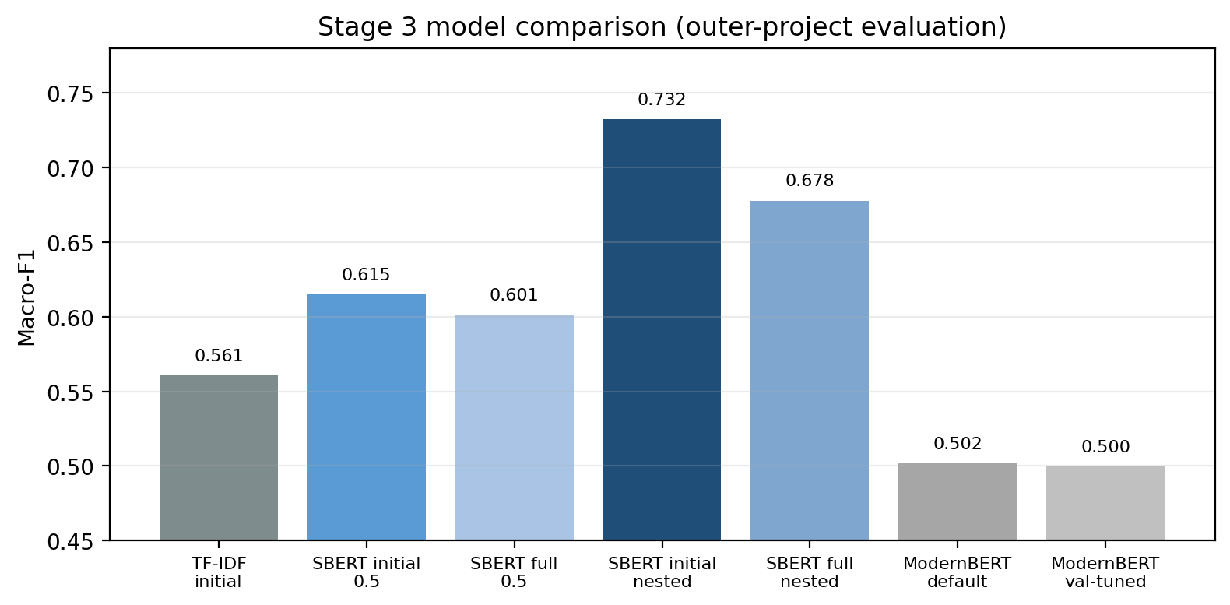
Figure 1. Macro-F1 across the principal Stage 3 experimental conditions. The nested initial-evidence SBERT condition is the final standalone selection.

6. Final Nested SBERT Result
The final Stage 3 model retains the strongest representation (SBERT initial @512) and changes the decision procedure. For each held-out project, class weighting and the ARB threshold are selected only from inner predictions on the other training projects. No outer-project labels participate in selection.
Metric | SBERT initial 0.5 | SBERT initial nested | Absolute change
Macro-F1 | 0.6149 | 0.7322 | +0.1172
Accuracy | 0.8282 | 0.8397 | +0.0115
Balanced accuracy | 0.5976 | 0.7116 | +0.1141
MCC | 0.3802 | 0.4745 | +0.0943
ARB F1 | 0.3284 | 0.5625 | +0.2341
ARB recall | 0.2000 | 0.4909 | +0.2909
Final confusion matrix (rows=true, columns=predicted; label order NAM, ARB): [[193, 14], [28, 27]]. Nested selection changes the operating point from 44 ARB false negatives at threshold 0.5 to 28, while accepting 14 NAM→ARB false positives.

6.1 Per-project final results
Project | Macro-F1 | Accuracy | Balanced Acc. | MCC | ARB PR-AUC | NAM F1 | ARB F1 | ARB recall
AXIS | 0.7321 | 0.7333 | 0.7411 | 0.4910 | 0.8816 | 0.7500 | 0.7143 | 0.6250
HTTPD | 0.8333 | 0.8400 | 0.8333 | 0.6667 | 0.9248 | 0.8667 | 0.8000 | 0.8000
Linux | 0.5977 | 0.8552 | 0.5792 | 0.3226 | 0.4310 | 0.9195 | 0.2759 | 0.1667
MySQL | 0.7493 | 0.8312 | 0.8065 | 0.5237 | 0.7388 | 0.8926 | 0.6061 | 0.7692
Mean held-out-project Macro-F1 is 0.7281. The mean of the four project-specific ARB PR-AUC values is approximately 0.7441. Project-level PR-AUC is preferred for nested runs because raw probabilities come from separately fitted outer-fold models and are not guaranteed to share a common cross-fold scale.

6.2 Selected class weights and thresholds
Outer project | Selected class weight | Selected ARB threshold | Inner Macro-F1
AXIS | None | 0.305 | 0.7249
HTTPD | balanced | 0.600 | 0.7216
Linux | balanced | 0.550 | 0.7980
MySQL | balanced | 0.560 | 0.7016
The variation in selected thresholds and the AXIS choice of an unweighted classifier show that a single global operating point is not stable across project composition. This is why selection is nested inside the outer training projects rather than tuned on pooled outer predictions.

7. Evidence-Depth Ablation: Initial vs Full Discussion
Condition | Macro-F1 | Accuracy | Balanced Acc. | MCC | NAM F1 | ARB F1 | ARB recall
Initial evidence / nested | 0.7322 | 0.8397 | 0.7116 | 0.4745 | 0.9019 | 0.5625 | 0.4909
Full evidence / nested | 0.6778 | 0.7863 | 0.6778 | 0.3556 | 0.8647 | 0.4909 | 0.4909
Initial minus full | +0.0544 | +0.0534 | +0.0338 | +0.1188 | +0.0371 | +0.0716 | 0.0000
Full evidence does not increase ARB recall; both nested conditions recall 27 of 55 ARBs. Instead, full evidence doubles NAM→ARB false positives from 14 to 28, reducing precision and class balance. The later issue discussion therefore adds project-specific or ambiguous signals without improving minority coverage.
Project | Initial nested Macro-F1 | Full nested Macro-F1 | Change (full - initial)
AXIS | 0.7321 | 0.7222 | -0.0099
HTTPD | 0.8333 | 0.8727 | +0.0393
Linux | 0.5977 | 0.5712 | -0.0265
MySQL | 0.7493 | 0.5935 | -0.1558
Mean | 0.7281 | 0.6899 | -0.0382
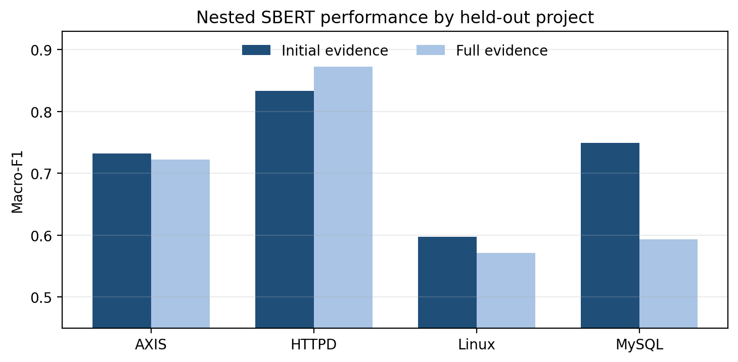
Figure 2. Per-project evidence-depth effect under nested SBERT selection. Full discussion helps HTTPD but hurts the other projects, especially MySQL.

8. Targeted Error Analysis
The selected initial-evidence nested SBERT model produces 42 errors across 262 held-out predictions: 28 ARB→NAM false negatives and 14 NAM→ARB false positives. Errors are not evenly distributed across projects.
Project | ARB→NAM | NAM→ARB | Total errors | Error rate
AXIS | 3 | 1 | 4 | 26.7%
HTTPD | 2 | 2 | 4 | 16.0%
Linux | 20 | 1 | 21 | 14.5%
MySQL | 3 | 10 | 13 | 16.9%
Total | 28 | 14 | 42 | 16.0%
Linux is the dominant source of ARB misses: 20 of its 24 true ARBs are predicted as NAM under the held-out-project model. MySQL exhibits the opposite error profile, contributing 10 of the 14 NAM→ARB false positives. AXIS has the highest percentage error rate because its fold is only 15 examples, but contributes only four absolute errors.
Representative high-confidence mistakes include ARB reports such as "Socket Timeouts for Axis Clients" and "Deadlock in Axis when using HttpClient" being scored strongly toward NAM. This illustrates the semantic overlap between timing/concurrency symptoms and aging-related behavior in short initial descriptions; the model cannot rely on surface cue words alone.
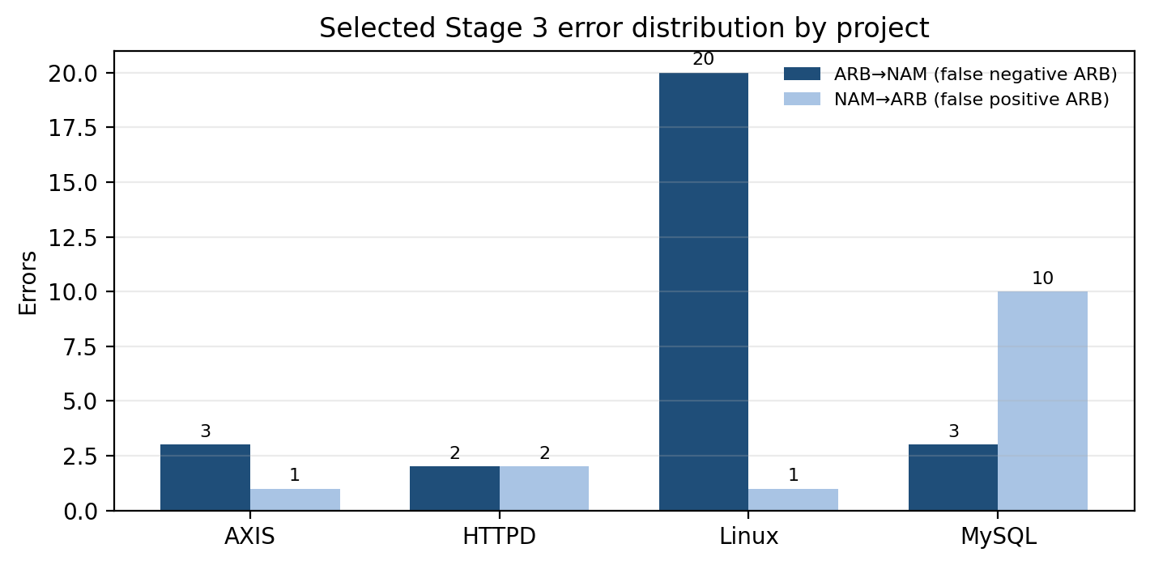
Figure 3. Selected Stage 3 errors by project. Linux dominates ARB false negatives; MySQL dominates NAM false positives.

9. ModernBERT Comparator and Negative Result
The original architecture plan assumed ModernBERT transfer learning for Stage 3. Stage 2 had already shown fixed SBERT embeddings to generalize better, so Stage 3 treated ModernBERT as a controlled screen rather than an assumed final architecture. The screen used initial evidence, 512 tokens, balanced loss, seed 42, five epochs, learning rate 2e-5, batch size 8, four outer held-out projects, and a validation-only threshold option.
Condition | Macro-F1 | Accuracy | Balanced Acc. | MCC | ARB F1 | ARB recall
SBERT initial @512 nested | 0.7322 | 0.8397 | 0.7116 | 0.4745 | 0.5625 | 0.4909
ModernBERT seed42 / 0.5 | 0.5016 | 0.5802 | 0.5274 | 0.0456 | 0.3038 | 0.4364
ModernBERT seed42 / val-tuned | 0.4996 | 0.5725 | 0.5292 | 0.0484 | 0.3086 | 0.4545
Validation threshold tuning does not rescue ModernBERT. Relative to the selected SBERT model, tuned ModernBERT is lower by 0.2326 Macro-F1, 0.1824 balanced accuracy, 0.4261 MCC, and 0.2539 ARB F1. Because the gap is large and consistent with the Stage 2 representation finding, the screen was not expanded to seeds 13/97 or a full nested transformer study.

9.1 ModernBERT per-project screen
Project | Selected threshold | Validation Macro-F1 | Outer tuned Macro-F1 | Accuracy | Balanced Acc. | MCC | ARB F1 | ARB recall
AXIS | 0.50 | 0.7669 | 0.4976 | 0.5333 | 0.5536 | 0.1336 | 0.3636 | 0.2500
HTTPD | 0.55 | 0.6069 | 0.5994 | 0.6000 | 0.6333 | 0.2722 | 0.6154 | 0.8000
Linux | 0.50 | 0.8125 | 0.4871 | 0.6552 | 0.4928 | -0.0122 | 0.1935 | 0.2500
MySQL | 0.47 | 0.6810 | 0.3956 | 0.4156 | 0.5258 | 0.0406 | 0.2857 | 0.6923
Screening caveat. ModernBERT used an 80/20 validation subset stratified by project×class within each outer-training set, whereas the selected SBERT condition used inner project-aware LOPO. The ModernBERT result is therefore a screening result, not a fully symmetric final comparator. The performance gap is large enough that further compute was not justified.

10. Reproducibility and Engineering Notes
Shared trainer hardening. During the ModernBERT screen, the generic transformer trainer still contained a Stage-1-specific diagnostic assumption requiring a literal BUG class. The repository was corrected so shared class weighting is label-agnostic: the most frequent training class is used only as a diagnostic reference, while the actual weighted cross-entropy remains based on the existing generic class-weight resolver. Legacy manifest migration for the old class_weight_ratios_to_bug key is retained only for checkpoint compatibility.
GPU execution. ModernBERT failed under legacy torch.nn.DataParallel when two Kaggle GPUs were visible. The Stage 3 screen therefore exposed a single GPU to each training subprocess. This changes execution strategy, not data, model, seed, threshold protocol, or training hyperparameters.
SBERT determinism. The selected SBERT path uses fixed embeddings plus logistic regression and is effectively deterministic under the current implementation. The final conclusion therefore relies on project-held-out variation rather than interpreting repeated seeds as stochastic uncertainty.

10.1 Core artifact set
Artifact | Purpose / status
stage3.parquet | Frozen 262-row NAM/ARB supervised dataset
sbert_initial_512_nested/predictions.parquet | Final 262 outer-held-out predictions
sbert_initial_512_nested/per_fold_metrics.csv | Per-project metrics and selected fold settings
sbert_initial_512_nested/nested_calibration.csv | Inner model/threshold selection record
sbert_initial_512_nested/aggregate_metrics.json | Headline Stage 3 metrics
error_analysis/all_errors.parquet | 42 selected-model errors with issue metadata
sbert_full_512_nested/* | Full-evidence nested ablation artifacts
modernbert screen result files | Seed-42 ModernBERT default/tuned metrics, per-project table, predictions and manifest

11. Interpretation and Research Takeaways
- Sentence-level semantic embeddings are the strongest representation for this low-data cross-project task. TF-IDF misses most ARBs, while ModernBERT fine-tuning is unstable and substantially weaker.
- The main Stage 3 gain comes from leakage-free decision selection, not from changing the encoder. Nested class-weight/threshold selection raises Macro-F1 by +0.1172 and ARB F1 by +0.2341 over the same initial-evidence SBERT model at threshold 0.5.
- Initial evidence is the final deployment-facing condition. Full comments do not improve ARB recall and increase NAM→ARB false positives, especially on MySQL.
- Project identity matters. The selected model is strong on HTTPD and MySQL, moderate on AXIS, and weak on Linux ARB recall. Pooled metrics alone hide this transfer asymmetry.
- The minority-class problem is not solved by weighting alone. AXIS prefers no class weighting, while the other three folds select balanced weighting, and the thresholds vary from 0.305 to 0.600.
- The remaining errors are semantically structured rather than purely near-boundary noise: timing, deadlock, concurrency, environment, and performance language can occur in both NAM and ARB descriptions.

12. Current Limitations
- The dataset is small: 262 total examples and only 55 ARBs. Fold-level ARB support ranges from 8 to 24, so per-project estimates have high variance.
- Project prevalence differs strongly. AXIS is nearly balanced, whereas Linux and MySQL are strongly NAM-dominant, entangling project and class distribution.
- The selected thresholds are training-composition dependent. They must be re-estimated from training projects when transferring to a new project; outer-test labels must never be used for threshold selection.
- Pooled PR-AUC across nested outer models should be interpreted cautiously because scores from separately fitted, differently weighted classifiers are not guaranteed to have identical cross-fold calibration.
- Full comments may contain post-diagnosis information and should not be described as pure early-triage evidence.
- ModernBERT was screened at seed 42 only and was not expanded to a full three-seed nested study because it was far below the selected SBERT reference.
- No domain-adaptive pretraining (DAPT) was run for Stage 3 after the supervised ModernBERT screen failed to establish competitiveness.
- A fifth independent labelled project is not available; all generalization evidence comes from four-project outer LOPO.
- This report intentionally excludes oracle and predicted hierarchical routing, Stage 1 gating on the Mandelbugs benchmark, and Stage 4 subtype classification.

13. Final Stage 3 Conclusion and Next Steps
Final Stage 3 conclusion
Cross-project NAM vs ARB classification is feasible but materially harder than the parent BOH/MANDELBUG task because only 55 ARB examples are available and project distributions differ sharply. The final standalone Stage 3 reference is SBERT all-mpnet-base-v2 on initial evidence at 512 tokens with nested project-aware class-weight and threshold selection: Macro-F1 0.7322, MCC 0.4745, NAM F1 0.9019, and ARB F1 0.5625. Full evidence is inferior and ModernBERT is rejected as the primary Stage 3 representation under the completed screen. Stage 3 standalone model development is therefore frozen.
Recommended next work:
- Archive/freeze the selected Stage 3 predictions, fold settings, dataset hash, error-analysis artifacts, and ModernBERT negative result.
- Evaluate the hierarchy separately under oracle parent routing and predicted Stage 2→Stage 3 routing; report error propagation as a routing result rather than mixing it into the standalone Stage 3 model report.
- Evaluate Stage 1 BUG retention on the 806 known-bug Mandelbugs benchmark before claiming a full Stage 1→2→3 deployable cascade result.
- Before training Stage 4A/4B subtype heads, perform a project×subtype support audit for ARB subtypes (MEM/STO/LOG/NUM/TOT) and NAM subtypes (LAG/ENV/TIM/SEQ). Do not force multiclass training if some subtypes lack viable held-out support.
- If an independent fifth project becomes available, use it as external validation without tuning on its labels.

Appendix A. Key Numeric Results
Condition | Macro-F1 | Accuracy | Balanced Acc. | MCC | ARB F1 | ARB recall
TF-IDF initial | 0.5606 | 0.8015 | 0.5606 | 0.2275 | 0.2353 | 0.1455
SBERT initial @512 / 0.5 | 0.6149 | 0.8282 | 0.5976 | 0.3802 | 0.3284 | 0.2000
SBERT full @512 / 0.5 | 0.6013 | 0.8244 | 0.5885 | 0.3594 | 0.3030 | 0.1818
SBERT initial @512 / nested | 0.7322 | 0.8397 | 0.7116 | 0.4745 | 0.5625 | 0.4909
SBERT full @512 / nested | 0.6778 | 0.7863 | 0.6778 | 0.3556 | 0.4909 | 0.4909
ModernBERT seed42 / 0.5 | 0.5016 | 0.5802 | 0.5274 | 0.0456 | 0.3038 | 0.4364
ModernBERT seed42 / val-tuned | 0.4996 | 0.5725 | 0.5292 | 0.0484 | 0.3086 | 0.4545
Selected Stage 3 reference: SBERT initial @512 with nested project-aware class-weight and threshold selection. Routing metrics are intentionally omitted from this report.

Appendix B. Experiment Lineage
Step | Outcome
Dataset audit | 262 unique rows; 207 NAM / 55 ARB; no duplicate issue_key values; all four LOPO folds have both classes.
TF-IDF baseline | Macro-F1 0.5606; ARB recall 0.1455.
SBERT default threshold | Initial @512 Macro-F1 0.6149; full @512 0.6013.
Nested SBERT selection | Initial @512 rises to 0.7322 Macro-F1 and 0.5625 ARB F1.
Evidence-depth ablation | Full nested falls to 0.6778 Macro-F1; initial evidence retained.
Targeted error analysis | 42 errors: 28 ARB→NAM and 14 NAM→ARB; Linux and MySQL dominate different failure modes.
ModernBERT screen | Seed-42 tuned Macro-F1 0.4996; not expanded to multi-seed.
Final decision | Freeze SBERT initial @512 nested as standalone Stage 3 model.

