Assigning an extra class “None of these” in MNIST Digit Recognizer

The problem of assigning a “None of these” or “NaN” class to some random images if included in a MNIST dataset of handwritten digits can be solved in two steps-

1. **Choosing the correct function for predicting the class probabilities for various entries of the dataset.**

* The classifier used in the code is a very simple ANN with one hidden layer.
* The activation function of the final layer has to be either ‘softmax’ or ‘sigmoid’ with the loss parameter to be ‘categorical _crossentropy’ to predict class probabilities instead of direct class values.
* SOFTMAX vs SIGMOID

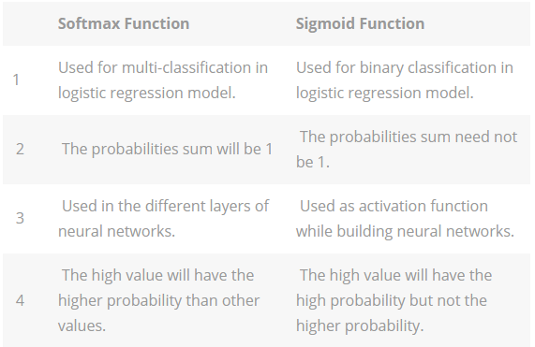

**If you use softmax instead of sigmoid, you’re prejudicing your network to think “it must be one of these classes for sure” (i.e. all “probabilities” must add up to 1.) But Sigmoid says, it might be any of these classes, but it may not be, I’m not prejudiced, it could be none, and you just leave it at that.**

So, obviously, using the sigmoid function for the final layer activation we have the probabilities of a data entry to belong to a certain class or not.

* We could also use Naïve Bayes classifier which, similar to this, calculates the conditional probabilities for each class.
* Clearly, entries which do not match with any of the classes have low values for each class and hence do not belong to any class.

1. **Selecting a threshold for “NaN”**

* We set the values of predicted class “NaN” where the maximum probabilities of the predicted classes are less than a certain threshold.
* The threshold value can be randomly chosen based on guess and tuned in case of availability of a large dataset.

**Drawbacks:** The model is successful in suggesting a class “NaN” if the image is a random image and not a handwritten digit. However, a few drawbacks-

* The images which are handwritten digits but could not be allotted appropriate probabilities are allotted class “NaN” which shouldn’t be the case.
* Selection criteria of threshold is sceptical.

**Link To Code** : https://github.com/GuptaAbhinavv/MNISTnewClass