**TESTING TABLEAU/ POWER BI REPORTS IN SQL**

**Create Table**

create table hrdata

(

emp_no int8 PRIMARY KEY,

gender varchar(50) NOT NULL,

marital_status varchar(50),

age_band varchar(50),

age int8,

department varchar(50),

education varchar(50),

education_field varchar(50),

job_role varchar(50),

business_travel varchar(50),

employee_count int8,

attrition varchar(50),

attrition_label varchar(50),

job_satisfaction int8,

active_employee int8

)

**Employee Count:**

select sum(employee_count) as Employee_Count from hrdata;

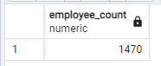

**Attrition Count:**

select count(attrition) from hrdata where attrition='Yes';

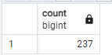

**Attrition Rate:**

select

round (((select count(attrition) from hrdata where attrition='Yes')/

sum(employee_count)) * 100,2)

from hrdata;

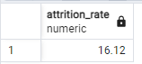

**Active Employee:**

select sum(employee_count) - (select count(attrition) from hrdata where attrition='Yes') from hrdata;

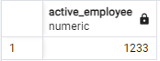

**Average Age:**

select round(avg(age),0) from hrdata;

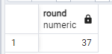

**Attrition by Gender**

select gender, count(attrition) as attrition_count from hrdata

where attrition='Yes'

group by gender

order by count(attrition) desc;

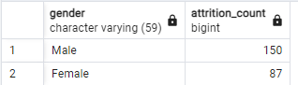

**Department wise Attrition:**

select department, count(attrition), round((cast (count(attrition) as numeric) /

(select count(attrition) from hrdata where attrition= 'Yes')) * 100, 2) as pct from hrdata

where attrition='Yes'

group by department

order by count(attrition) desc;

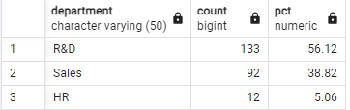

**No of Employee by Age Group**

SELECT age, sum(employee_count) AS employee_count FROM hrdata

GROUP BY age

order by age;

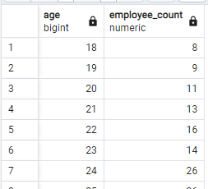

**Education Field wise Attrition:**

select education_field, count(attrition) as attrition_count from hrdata

where attrition='Yes'

group by education_field

order by count(attrition) desc;

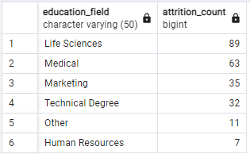

**Attrition Rate by Gender for different Age Group**

select age_band, gender, count(attrition) as attrition,

round((cast(count(attrition) as numeric) / (select count(attrition) from hrdata where attrition = 'Yes')) * 100,2) as pct

from hrdata

where attrition = 'Yes'

group by age_band, gender

order by age_band, gender desc;

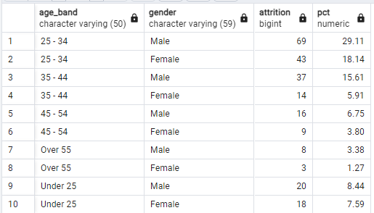

**Job Satisfaction Rating**

-Run this query first to activate the cosstab() function in postgres

CREATE EXTENSION IF NOT EXISTS tablefunc;

-Then run this to get o/p-

SELECT *

FROM crosstab(

'SELECT job_role, job_satisfaction, sum(employee_count)

FROM hrdata

GROUP BY job_role, job_satisfaction

ORDER BY job_role, job_satisfaction'

) AS ct(job_role varchar(50), one numeric, two numeric, three numeric, four numeric)

ORDER BY job_role;

