1. **Write a program to replace a substring inside a string with other string ?**

import java.util.Scanner;

public class ReplaceSubstring {

public static void main(String[] args) {

Scanner sc = new Scanner(System.in);

System.out.println("Enter a String");

String str = sc.nextLine();

System.out.println("Enter a substring to be replaced");

String toReplaceStr = sc.nextLine();

System.out.println("Enter a substring by which replaced");

String replacedStr = sc.nextLine();

String resultStr = null;

if (str.contains(toReplaceStr)) {

resultStr = str.replace(toReplaceStr, replacedStr);

} else

System.out.println("Does not contain substring");

System.out.println("Resultant String " + resultStr);

}

}

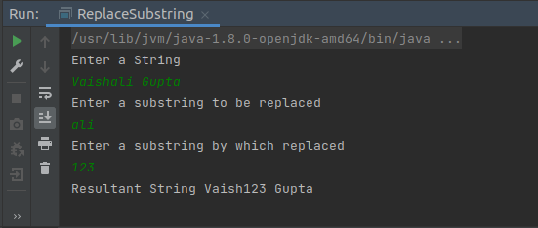

**2. Write a program to find the number of occurrences of the duplicate words in a string and print them ?**

import java.util.HashMap;

import java.util.Scanner;

public class Ques2 {

public static void main(String[] args) {

Scanner sc = new Scanner(System.in);

String str = sc.nextLine();

String[] strArr = str.split(" ");

HashMap<String,Integer> mp = new HashMap<String,Integer>();

for(int i=0;i< strArr.length;i++){

String word = strArr[i];

int count = 0;

if(mp.containsKey(word)){

int val = mp.get(word);

mp.put(word,++val);

}

else

mp.put(word,++count);

}

if(mp!=null)

mp.forEach((key, value) -> System.out.println(key + " " + value));

}

}

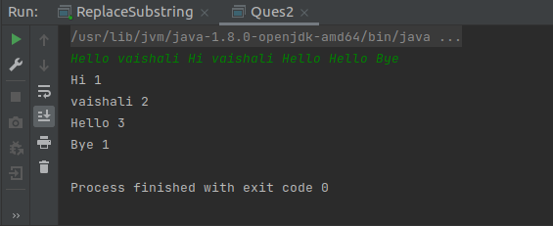

**3. Write a program to find the number of occurrences of a character in a string without using a loop?**

import java.util.Scanner;

public class Ques3 {

public static void main(String[] args) {

Scanner sc = new Scanner(System.in);

System.out.println("Enter a string");

String str = sc.next();

System.out.println("Enter a character to find occurance");

char ch = sc.next().charAt(0);

int count = 0;

System.out.printf("Count of %c = %d" , ch, countFrequency(str,ch,count));

}

static int countFrequency(String str, char ch,int count){

if(str.length() == 0)

return count;

else if(str.charAt(0) == ch)

return countFrequency(str.substring(1),ch,++count);

else

return countFrequency(str.substring(1),ch,count);

}

}

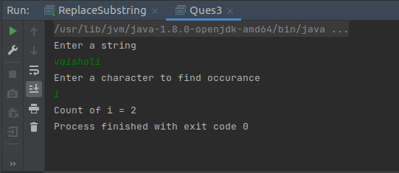

**4. Calculate the number & Percentage Of Lowercase Letters,Uppercase Letters, Digits And Other Special Characters In A String.**

import java.util.Scanner;

public class Ques4 {

public static void main(String[] args) {

Scanner sc = new Scanner(System.in);

System.out.println("Enter a string");

String str = sc.nextLine();

int lc =0,uc =0,spc = 0,dc = 0;

for(int i=0;i<str.length();i++){

if(str.charAt(i) >=97 && str.charAt(i) <=122)

lc++;

else if(str.charAt(i) >=65 && str.charAt(i) <= 92)

uc++;

else if(str.charAt(i) >=48 && str.charAt(i) <= 57)

dc++;

else

spc++;

}

System.out.printf("lowercase characters count %d and Percentage %3.2f\n", lc , (((double)lc/str.length()))*100);

System.out.printf("uppercase characters count %d and Percentage %3.2f\n", uc , (((double)uc/str.length()))*100);

System.out.printf("Digits characters count %d and Percentage %3.2f\n", dc , (((double)dc/str.length()))*100);

System.out.printf("Special characters count %d and Percentage %3.2f\n", spc , (((double)spc/str.length()))*100);

}

}

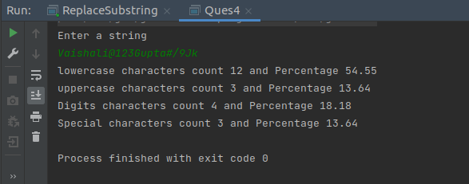

**5. Find common elements between two arrays.**

import java.util.Arrays;

import java.util.HashSet;

import java.util.Scanner;

public class Ques5 {

public static void main(String[] args) {

Scanner sc = new Scanner(System.in);

System.out.println("Enter the size of array1");

int n = sc.nextInt();

String[] arr1 = new String[n];

System.out.println("Enter the size of array2");

int m = sc.nextInt();

String[] arr2 = new String[m];

System.out.println("Enter the elements of array1");

for (int i = 0; i < n; i++) {

arr1[i] = sc.next();

}

System.out.println("Enter the elements of array2");

for (int j = 0; j < m; j++) {

arr2[j] = sc.next();

}

HashSet<String> set1 = new HashSet<>(Arrays.asList(arr1));

HashSet<String> set2 = new HashSet<>(Arrays.asList(arr2));

set1.retainAll(set2);

System.out.println("Common Elements: ");

set1.forEach((val) -> System.out.println(val));

}

}

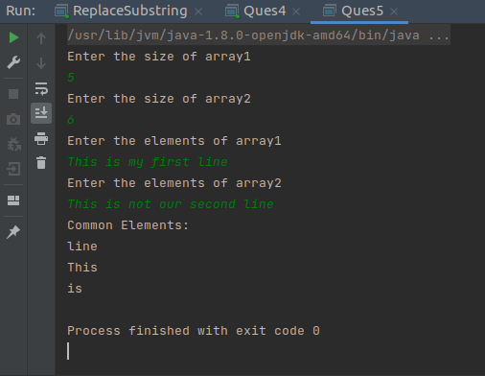

**6. There is an array with every element repeated twice except one. Find that element.**

//import java.util.Arrays;

import java.util.HashMap;

import java.util.Scanner;

public class Ques6 {

public static void main(String[] args) {

Scanner sc = new Scanner(System.in);

System.out.println("Enter the size of array");

int n = sc.nextInt();

int[] arr = new int[n];

System.out.println("Enter the elements of array");

for(int i=0;i<n;i++){

arr[i] = sc.nextInt();

}

/* Arrays.sort(arr);

int unique_element = -1;

boolean isThere = false;

for(int i=0;i<arr.length-1;i+=2){

if(arr[i] != arr[i+1]){

unique_element = arr[i];

isThere = true;

break;

}

}

if(!isThere)

unique_element = arr[arr.length -1];

if(unique_element != -1)

System.out.println("Unique Element is = " + unique_element);

else

System.out.println("Unique Element is not present in array"); */

/* int ans = arr[0];

for(int i=1;i<arr.length;i++){

ans = ans ^ arr[i];

}

System.out.println("Unique Element is = " + ans); */

HashMap<Integer,Integer> mp = new HashMap<>();

for (int element : arr) {

int count = 0;

if (mp.containsKey(element)) {

int val = mp.get(element);

mp.put(element, ++val);

} else

mp.put(element, ++count);

}

mp.forEach((key, value) -> {

if(value == 1)

System.out.println("Unique Element is = " + key);

}

);

}

}

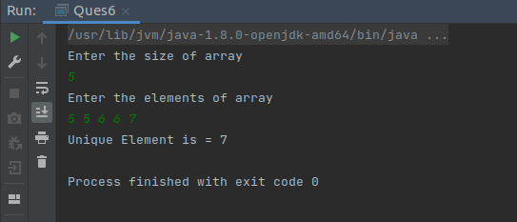

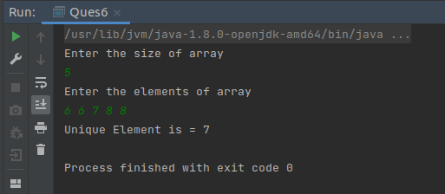

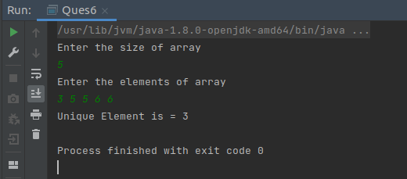

**7. Write a program to print your Firstname,LastName & age using static block,static method & static variable respectively.**

public class Ques7 {

private static String firstName;

private static String lastName;

private static int age;

static{

firstName = "Vaishali";

lastName = "Gupta";

age = 24;

System.out.println("FirstName = " + firstName);

}

static void printLastName(){

System.out.println("LastName = " + lastName);

}

public static void main(String[] args) {

printLastName();

System.out.println(age);

}

}

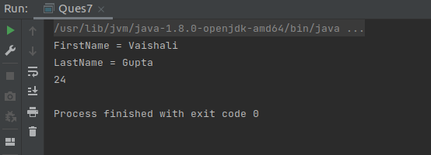

**8. Write a program to reverse a string and remove character from index 4 to index 9 from the reversed string using String Buffer.**

import java.util.Scanner;

public class Ques8 {

public static void main(String[] args) {

Scanner sc = new Scanner(System.in);

System.out.println("Enter a String");

String str = sc.nextLine();

StringBuffer sb = new StringBuffer(str);

System.out.println("Reversed String = " + sb.reverse());

System.out.println("After Deleting character from 4 to 9 = " + sb.delete(4,10));

}

}

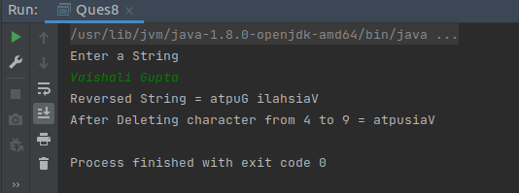

**9. Write a program to display values of enums using a constructor & getPrice() method (Example display house & their prices).**

package Ques9_Enum;

public enum HousePrice {

BEACHVILLA(10),

VILLA(50),

FLAT(100),

BUNGLOW(500),

PENTHOUSE(1000);

private final int price;

HousePrice(int price) {

this.price = price;

}

public int getPrice() {

return this.price;

}

}

package Ques9_Enum;

public class Ques9 {

public static void main(String[] args) {

for(HousePrice hp:HousePrice.values()){

System.out.println(hp + " HAS PRICE OF " + hp.getPrice() + " LAKHS");

}

}

}

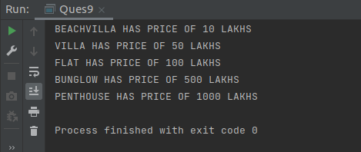

**Q10. Write a single program for following operation using overloading**

**A) Adding 2 integer number**

**B) Adding 2 double**

**C) multiplying 2 float**

**D) multiplying 2 int**

**E) concate 2 string**

**F) Concate 3 String**

class Operations{

int add(int num1,int num2){

return num1 + num2;

}

double add(double num1,double num2){

return num1+num2;

}

int multiply(int num1,int num2){

return num1*num2;

}

float multiply(float num1,float num2){

return num1*num2;

}

String concatenate(String str1,String str2){

return str1 + str2;

}

String concatenate(String str1,String str2,String str3){

return str1 + str2 + str3;

}

}

public class Ques10 {

public static void main(String[] args) {

Operations op = new Operations();

System.out.println(op.add(2,3));

System.out.println(op.add(2.5,3.50));

System.out.println(op.multiply(2,3));

System.out.println(op.multiply(3.2f,4.5f));

System.out.println(op.concatenate("Vaishali ","Gupta"));

System.out.println(op.concatenate("Tek ","Chand ","Gupta"));

}

}

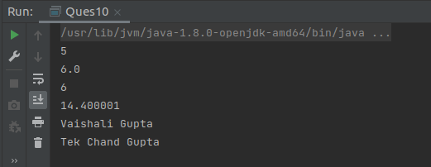

**Q11. Create 3 sub class of bank SBI,BOI,ICICI all 4 should have method called getDetails which provide there specific details like rateofinterest etc,print details of every banks.**

package Ques11;

public abstract class Bank {

String bankName;

String bankLocation;

double rateOfInterest;

abstract void getDetails();

}

package Ques11;

public class SBI extends Bank{

SBI(){

this.bankName = "State Bank Of India";

this.bankLocation = "Delhi";

this.rateOfInterest = 3.5;

}

void getDetails(){

System.out.println("Bank Name = " + bankName);

System.out.println("Bank Location = " + bankLocation);

System.out.println("Rate of Interest = " + rateOfInterest);

}

}

package Ques11;

public class BOI extends Bank{

BOI(){

this.bankName = "Bank Of India";

this.bankLocation = "Gurgaon";

this.rateOfInterest = 8.5;

}

@Override

void getDetails() {

System.out.println("Bank Name = " + bankName);

System.out.println("Bank Location = " + bankLocation);

System.out.println("Rate of Interest = " + rateOfInterest);

}

}

package Ques11;

public class ICICI extends Bank{

ICICI(){

this.bankName = "Bank Of India";

this.bankLocation = "Faridabad";

this.rateOfInterest = 6.5;

}

@Override

void getDetails() {

System.out.println("Bank Name = " + bankName);

System.out.println("Bank Location = " + bankLocation);

System.out.println("Rate of Interest = " + rateOfInterest);

}

}

package Ques11;

public class MainClass {

public static void main(String[] args) {

Bank b = new SBI();

b.getDetails();

System.out.println();

b = new BOI();

b.getDetails();

System.out.println();

b = new ICICI();

b.getDetails();

}

}

