# A

# PROJECT

# REPORT

### On

ABHI ECOMMERCE

*Submitted*

*In partial fulfilment*

*For the award of the Certificate of*

***Full Stack Web Development Training***

***From***



|  |  |
| --- | --- |
| Submitted By: | Submitted To: |
| Abhishek Gupta | Mr. Sanjay Rathore |
| Khush Gupta | Training Instructor |

***Candidate’s Declaration***

I hereby declare that the work, which is being presented in the Project Report, entitled **“ABHI ECOMMERCE”** in partial fulfilment for the award of the Certificate of “**Full Stack Web Development**” from **Grras Solutions Pvt. Ltd.** and submitted to the Training Instructor, It is a record of my own investigations carried under the Guidance of **Mr. Sanjay Rathore.**

I have not submitted the matter presented in this Project Report anywhere for the award of any other Certificate.

**(Name and Signature of Candidate)**

Abhishek Gupta

Khush Gupta

# ACKNOWLEDGEMENT

It is my pleasure to be indebted to various people, who directly or indirectly contributed in the development of this work and who influenced our thinking, behavior and acts during the course of study.

We express our sincere gratitude to **Grras Solutions Pvt. Ltd.** for providing us an opportunity to undergo this Training.

We are thankful to **Mr. Sanjay Rathore** for his support, cooperation, and motivation provided to us during the training for constant inspiration, presence and blessings.

Lastly, we would like to thank the almighty and our parents for their moral support and friends with whom we shared our day-to-day experience and received lots of suggestions that improved our quality of work.

#### Abhishek Gupta Khush Gupta

**ABSTRACT**

Our project is ABHI ECOMMERCE. This is a website which helps peoples to find and buy all type of products on internet. It is useful in the way that it makes an easier way to buy and sell products online. **ABHI ECOMMERCE** is an interactive e-commerce solution providing users with an opportunity to buy and sell products. ABHI ECOMMERCE is the similar online platform which deals with all the products of all fields.

In this website we have basically 2 modules. The first module includes the customer module and second module includes admin module.

The customer have to register for any enquiry related to products. The registered customer can view details of products and he/she can buy or sell the products of his/her need. He/she has to pay and will get home delivery.

The admin module contains the access of admin page on the website. The admin can change everything in the website. He have the ability to add, delete, and update any information regarding the products.

# Table of Content

|  |  |  |
| --- | --- | --- |
|  | **Title** | **Page No.** |
|  | List of Tables…………………………………………………….. |  |
|  | List of Figures |  |
| 1. | Introduction………………………………………………………  1.1 Objectives | 8 |
| 2. | Web Development……………………………………………….. | 9-10 |
|  | 2.1 Web Site |  |
|  | 2.2 Web Page |  |
| 3. | The Steps to Create a Web site…………………………………… | 11-21 |
|  | 3.1 UI development |  |
|  | 3.1.1 HTML |  |
|  | 3.1.2 CSS |  |
|  | 3.1.3 Bootstrap |  |
|  | 3.2 Scripting |  |
|  | 3.2.1 Server side scripting |  |
|  | 3.2.2 Server side scripting languages |  |
|  | 3.2.3 Client side scripting |  |
|  | 3.3 Database |  |
|  | 3.4 MongoDB |  |
| 4. | Scripting Languages…………………………………………………………………… | 22-23 |
|  | 4.1 Java Script |  |
|  | 4.2 JQuery |  |
| 5. | Front-end Framework…………………………………………… | 24 |
|  | 5.1 React Js |  |
| 6. | Back-end………………………………………………………… | 25 |
|  | 6.1 Firebase |  |
| 5. | Software Requirement Specification (SRS)………………….… | 26 |
|  | 5.1 Hardware Requirement |  |
|  | 5.2 Software Requirement |  |
| 6. | Data Flow Diagram……………………………………………… | 27-30 |

|  |  |  |
| --- | --- | --- |
|  | 6.1 DFD-1 |  |
|  | 6.2 DFD-2 |  |
|  | 6.3 DFD-3 |  |
| 7. | Project……………………………………………………………. | 31 |
|  | 7.1 Project(Advanced Technologies) |  |
|  | 7.2 Technologies Used |  |
|  | 7.3 Technical details |  |
| 8. | Screenshots………………………………………………………. | 32-36 |
| 9. | Maintenance……………………………………………………… | 37 |
| 10. | Future scope and future enhancement…………………………… | 38 |
| 11. | Conclusion………………………………………………………. | 39 |

**List of Figures**

Figure 3.1 Steps to create a website…… …………………………….

Figure 3.2 Login form without CSS ………………………………...

Figure 3.3 Login form without CSS. ...……………………………….

Figure 3.2.1 Programming language popularity. …………………….…

Figure 3.2.2 Scripting ……………… ………………………………….

Figure 4.1.1 JavaScript & jQuery………………………………………

Figure 6.1 DFD. ..………………………………………………………

Figure 6.1.1 DFD-1……...…………………………………………….…

Figure 6.2.1 DFD-2……………………………………………………….

Figure 6.2.2 DFD-2 …………………………………………………….….

Figure 6.3.1 DFD-3 ………………………………………………………..

Figure 8.1.1 Front Page……………….……………………………..….

Figure 8.1.2 Front Page products …….……………………………..….

Figure 8.1.3 Single Product..………….……………………………..….

Figure 8.1.4 Login Page...…………….……………………………..….

Figure 8.1.5 Sign up Page…………….……………………………..….

Figure 8.1.6 Check out…..…………….……………………………..….

Figure 8.1.7 Sell Request..…………….……………………………..….

Figure 8.1.8 Admin Panel.…………….……………………………..….

Figure 8.1.9 Contact Us and about us...……………………………..….

CHAPTER-1

#### INTRODUCTION

Education, An integral part of our Indian Society and it is important for every individual to succeed in his life and help bring change to our world. In a country with more than 1.3 billion people living, for everyone individual education is essential. To keep learning and developing themselves and helping our environment, economy, social life be sustainable.

**ABHI ECOMMERCE** is an interactive e-commerce solution providing users with an opportunity to buy and sell products. ABHI ECOMMERCE is the first online platform which deals with new and old products of all fields, we deliver a constructive service to each and every person of India to furnish their needs in terms of learning, education and technology by providing them with an online platform where they can Buy and sell products for affordable price and even they can sell their used products on our website. ABHI ECOMMERCE provides users with wide range of pre-owned products which get a check based on their condition and fixed to its best and delivered to consumer’s doorsteps.

#### 1.1 OBJECTIVES

Online Shopping is the process whereby consumers directly buy goods and services without any intermediary service over the internet. The goal of this website is to develop a web based interface for students of India, the website would be easy to use and hence the shopping experience pleasant for the users. The main goal of this website is:

1. To develop an easy to use web based interface where students can search for products (products), view a complete description of the product and order the product.
2. A student can buy and sell products from home.

CHAPTER-2

#### WEB-DEVELOPMENT:

**Web development** is a broad term for the work involved in developing a [web site](https://en.wikipedia.org/wiki/Web_site) for the [Internet](https://en.wikipedia.org/wiki/Internet) ([World Wide Web](https://en.wikipedia.org/wiki/World_Wide_Web)) or an [intranet](https://en.wikipedia.org/wiki/Intranet) (a private network). Web development can range from developing the simplest static single page of [plain text](https://en.wikipedia.org/wiki/Plain_text) to the most complex web-based [internet applications](https://en.wikipedia.org/wiki/Internet_application), [electronic businesses](https://en.wikipedia.org/wiki/Electronic_business), and [social network services](https://en.wikipedia.org/wiki/Social_network_service). A more comprehensive list of tasks to which web development commonly refers, may include [web](https://en.wikipedia.org/wiki/Web_engineering) [engineering](https://en.wikipedia.org/wiki/Web_engineering), [web design](https://en.wikipedia.org/wiki/Web_design), [web content development](https://en.wikipedia.org/wiki/Web_content_development), client liaison, [client-side](https://en.wikipedia.org/wiki/Client-side_scripting)/side scripting, [web server](https://en.wikipedia.org/wiki/Web_server) and [network security](https://en.wikipedia.org/wiki/Network_security) configuration, and [e-commerce](https://en.wikipedia.org/wiki/E-commerce) development. Among web professionals, "web development" usually refers to the main non-design aspects of building web sites: writing [markup](https://en.wikipedia.org/wiki/Markup_language) and [coding](https://en.wikipedia.org/wiki/Computer_programming). Most recently Web development has come to mean the creation of [content management systems](https://en.wikipedia.org/wiki/Content_management_system) or CMS. These CMS can be made from scratch, proprietary or open source. In broad terms the CMS acts as middleware between the database and the user through the browser. A principle benefit of a CMS is that it allows non-technical people to make changes to their web site without having technical knowledge.

For larger organizations and businesses, web development teams can consist of hundreds of people ([web developers](https://en.wikipedia.org/wiki/Web_developer)) and follow standard methods like [Agile methodologies](https://en.wikipedia.org/wiki/Agile_software_development) while developing websites. Smaller organizations may only require a single permanent or contracting developer, or secondary assignment to related job positions such as a [graphic](https://en.wikipedia.org/wiki/Graphic_designer) [designer](https://en.wikipedia.org/wiki/Graphic_designer) or [information systems](https://en.wikipedia.org/wiki/Information_systems) technician. Web development may be a collaborative effort between departments rather than the domain of a designated department. There are three kind of web developer specialization: front-end developer, back-end developer, and full-stack developer.

#### WEB-SITE

A **website** is a collection of related [web pages](https://en.wikipedia.org/wiki/Web_page), including [multimedia](https://en.wikipedia.org/wiki/Multimedia) content, typically identified with a common [domain name,](https://en.wikipedia.org/wiki/Domain_name) and published on at least one [web server](https://en.wikipedia.org/wiki/Web_server). A website may be accessible via a public [Internet Protocol](https://en.wikipedia.org/wiki/Internet_Protocol) (IP) network, such as the [Internet](https://en.wikipedia.org/wiki/Internet), or a private [local area network](https://en.wikipedia.org/wiki/Local_area_network) (LAN), by referencing a [uniform resource locator](https://en.wikipedia.org/wiki/URL) (URL) that identifies the site.

Websites have many functions and can be used in various fashions; a website can be a [personal website](https://en.wikipedia.org/wiki/Personal_website), a commercial website for a company, a [government website](https://en.wikipedia.org/wiki/E-Government) or a [non-profit](https://en.wikipedia.org/wiki/Nonprofit_organization) [organization](https://en.wikipedia.org/wiki/Nonprofit_organization) website. Websites are typically dedicated to a particular topic or purpose, ranging from entertainment and [social networking](https://en.wikipedia.org/wiki/Social_networking) to providing news and education. All publicly accessible websites collectively constitute the [World Wide Web](https://en.wikipedia.org/wiki/World_Wide_Web), while private websites, such as a company's website for its employees, and are typically a part of an [intranet.](https://en.wikipedia.org/wiki/Intranet)

Web pages, which are the [building blocks](https://en.wikipedia.org/wiki/Building_block) of websites, are [documents](https://en.wikipedia.org/wiki/Document), typically composed in [plain text](https://en.wikipedia.org/wiki/Plain_text) interspersed with formatting instructions of Hypertext Markup Language ([HTML,](https://en.wikipedia.org/wiki/HTML) [XHTML](https://en.wikipedia.org/wiki/XHTML)). They may incorporate elements from other websites with

suitable [markup anchors](https://en.wikipedia.org/wiki/HTML_anchor). Web pages are accessed and transported with the [Hypertext Transfer](https://en.wikipedia.org/wiki/Hypertext_Transfer_Protocol) [Protocol](https://en.wikipedia.org/wiki/Hypertext_Transfer_Protocol) (HTTP), which may optionally employ encryption ([HTTP Secure](https://en.wikipedia.org/wiki/HTTP_Secure), HTTPS) to provide security and privacy for the user. The user's application, often a [web browser](https://en.wikipedia.org/wiki/Web_browser), renders the page content according to its HTML markup instructions onto a [display terminal](https://en.wikipedia.org/wiki/Computer_monitor).

[Hyperlinking](https://en.wikipedia.org/wiki/Hyperlink) between web pages conveys to the reader the [site structure](https://en.wikipedia.org/wiki/Site_map) and guides the navigation of the site, which often starts with a [home page](https://en.wikipedia.org/wiki/Home_page) containing a directory of the site [web content](https://en.wikipedia.org/wiki/Web_content). Some websites require user registration or [subscription](https://en.wikipedia.org/wiki/Subscription) to access content. Examples of [subscription websites](https://en.wikipedia.org/wiki/Paywall) include many business sites, news websites, [academic](https://en.wikipedia.org/wiki/Academic_journal) [journal](https://en.wikipedia.org/wiki/Academic_journal) websites, gaming websites, file-sharing websites, [message boards](https://en.wikipedia.org/wiki/Internet_forum), web-based [email](https://en.wikipedia.org/wiki/Email), [social networking](https://en.wikipedia.org/wiki/Social_networking) websites, websites providing real-time [stock market](https://en.wikipedia.org/wiki/Stock_market) data, as well as sites providing various other services. As of 2016 [end users](https://en.wikipedia.org/wiki/End_user) can access websites on a range of devices, including [desktop](https://en.wikipedia.org/wiki/Desktop_computer) and [laptop computers](https://en.wikipedia.org/wiki/Laptop), [tablet computers](https://en.wikipedia.org/wiki/Tablet_computer), [smartphones](https://en.wikipedia.org/wiki/Smartphone) and [smart](https://en.wikipedia.org/wiki/Smart_TV) [TVs.](https://en.wikipedia.org/wiki/Smart_TV)

A web site consists of web pages which are interconnected to each other and contain various data and functionalities.

#### WEB-PAGE

A **web page**, or **webpage**, is a document that is suitable for the [World Wide Web](https://en.wikipedia.org/wiki/World_Wide_Web) and [web browsers](https://en.wikipedia.org/wiki/Web_browser). A web browser displays a web page on a [monitor](https://en.wikipedia.org/wiki/Computer_display) or [mobile device](https://en.wikipedia.org/wiki/Mobile_device). The web page is what displays, but the term also refers to a [computer file](https://en.wikipedia.org/wiki/Computer_file), usually written in [HTML](https://en.wikipedia.org/wiki/HTML) or comparable [markup language](https://en.wikipedia.org/wiki/Markup_language). Web browsers coordinate the various [web resource](https://en.wikipedia.org/wiki/Web_resource) elements for the written web page, such as [style sheets](https://en.wikipedia.org/wiki/Cascading_Style_Sheets), [scripts](https://en.wikipedia.org/wiki/Client-side_scripting), and [images](https://en.wikipedia.org/wiki/Image), to present the web page.

Typical web pages provide [hypertext](https://en.wikipedia.org/wiki/Hypertext) that includes a [navigation bar](https://en.wikipedia.org/wiki/Navigation_bar) or a [sidebar](https://en.wikipedia.org/wiki/Sidebar_%28computing%29) [menu](https://en.wikipedia.org/wiki/Menu_%28computing%29) to other web pages via [hyperlinks](https://en.wikipedia.org/wiki/Hyperlink), often referred to as links.

On a network, a web browser can retrieve a web page from a remote [web server](https://en.wikipedia.org/wiki/Web_server). On a higher level, the web server may restrict access to only a private network such as a corporate [intranet](https://en.wikipedia.org/wiki/Intranet) or it provides access to the World Wide Web. On a lower level, the web browser uses the [Hypertext Transfer Protocol](https://en.wikipedia.org/wiki/Hypertext_Transfer_Protocol) (HTTP) to make such requests.

A [static web page](https://en.wikipedia.org/wiki/Static_web_page) is delivered exactly as stored, as [web content](https://en.wikipedia.org/wiki/Web_content) in the web server's [file](https://en.wikipedia.org/wiki/File_system) [system,](https://en.wikipedia.org/wiki/File_system) while a [dynamic web page](https://en.wikipedia.org/wiki/Dynamic_web_page) is generated by a [web application](https://en.wikipedia.org/wiki/Web_application) that is driven by [server-](https://en.wikipedia.org/wiki/Server-side_scripting) [side software](https://en.wikipedia.org/wiki/Server-side_scripting) or client-side scripting. Dynamic website pages help the browser (the [client](https://en.wikipedia.org/wiki/Client_%28computing%29)) to enhance the web page through user input to the server.

CHAPTER-3

#### THE STEPS TO CREATE A WEB SITE

Creating a web site requires multiple steps which includes the following:

* Creating a UI(User interface)
* Scripting(Both at server end and client end)
* Creating a backend or the database

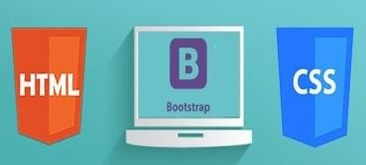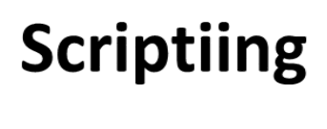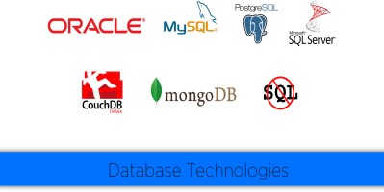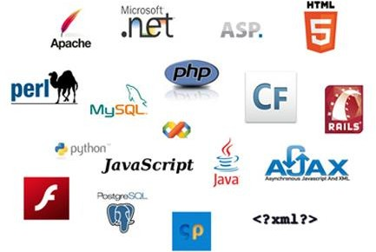

**Web Site**

**UI**

**Data Base**

**Fig 3.1**

#### UI DEVELOPMENT

Technologies that are mostly used to develop a User Interface are:

* + HTML
  + CSS
  + Bootstrap.

#### HTML

**Hypertext Markup Language** (**HTML**) is the standard [markup language](https://en.wikipedia.org/wiki/Markup_language) for creating [web pages](https://en.wikipedia.org/wiki/Web_page) and [web applications](https://en.wikipedia.org/wiki/Web_application). With [Cascading Style Sheets](https://en.wikipedia.org/wiki/Cascading_Style_Sheets) (CSS) and [JavaScript](https://en.wikipedia.org/wiki/JavaScript) it forms a triad of cornerstone technologies for the [World Wide Web](https://en.wikipedia.org/wiki/World_Wide_Web). [Web browsers](https://en.wikipedia.org/wiki/Web_browser) receive HTML documents from a [webserver](https://en.wikipedia.org/wiki/Webserver) or from local storage and render them into multimedia web pages. HTML describes the structure of a web page [semantically](https://en.wikipedia.org/wiki/Semantic) and originally included cues for the appearance of the document.

[HTML elements](https://en.wikipedia.org/wiki/HTML_element) are the building blocks of HTML pages. With HTML constructs, [images](https://en.wikipedia.org/wiki/Img_%28HTML_element%29) and other objects, such as [interactive forms,](https://en.wikipedia.org/wiki/Fieldset) may be embedded into the rendered page. It provides a means to create [structured documents](https://en.wikipedia.org/wiki/Structured_document) by denoting structural [semantics](https://en.wikipedia.org/wiki/Semantics) for text such as headings, paragraphs, lists, [links](https://en.wikipedia.org/wiki/Hyperlink), quotes and other items. HTML elements are delineated by tags, written using [angle brackets](https://en.wikipedia.org/wiki/Bracket#Angle_brackets). Tags such as <img /> and <input /> introduce content into the page directly. Others such as <p>...</p> surround and provide information about document text and may include other tags as sub-elements. Browsers do not display the HTML tags, but use them to interpret the content of the page.

HTML can embed programs written in a [scripting language](https://en.wikipedia.org/wiki/Scripting_language) such as [JavaScript](https://en.wikipedia.org/wiki/JavaScript) which affect the behavior and content of web pages. Inclusion of CSS defines the look and layout of content. The [World Wide Web Consortium](https://en.wikipedia.org/wiki/World_Wide_Web_Consortium) (W3C), maintainer of both the HTML and the CSS standards, has encouraged the use of CSS over explicit presentational HTML since 1997.

HTML markup consists of several key components, including those called tags (and their attributes), character-based data types, character references and entity references. HTML tags most commonly come in pairs like <h1> and </h1>, although some represent empty elements and so are unpaired, for example <img>. The first tag in such a pair is the start tag, and the second is the end tag (they are also called opening tags and closing tags).

Another important component is the HTML [document type declaration](https://en.wikipedia.org/wiki/Document_type_declaration), which triggers [standards mode](https://en.wikipedia.org/wiki/Standards_mode) rendering.

The following is an example of the classic [Hello world program,](https://en.wikipedia.org/wiki/Hello_world_program) a common test employed for comparing [programming languages](https://en.wikipedia.org/wiki/Programming_language), [scripting languages](https://en.wikipedia.org/wiki/Scripting_language) and [markup languages](https://en.wikipedia.org/wiki/Markup_language). This example is made using 9 [lines of code](https://en.wikipedia.org/wiki/Lines_of_code):

#### General Syntax of HTML

<!DOCTYPE html>

<html>

<head>

<title>This is a title</title>

</head>

<body>

<p>Hello world!</p>

</body>

</html>

(The text between <html> and </html> describes the web page, and the text between <body> and </body> is the visible page content. The markup text "<title>This is a title</title>" defines the browser page title.)

The Document Type Declaration <!DOCTYPE html> is for HTML5. If a declaration is not included, various browsers will revert to "[quirks mode](https://en.wikipedia.org/wiki/Quirks_mode)" for rendering.

#### CSS

**Cascading Style Sheets** (**CSS**) is a [style sheet language](https://en.wikipedia.org/wiki/Style_sheet_language) used for describing the [presentation](https://en.wikipedia.org/wiki/Presentation_semantics) of a document written in a [markup language](https://en.wikipedia.org/wiki/Markup_language). Although most often used to set the visual style of [web pages](https://en.wikipedia.org/wiki/Web_page) and user interfaces written in [HTML](https://en.wikipedia.org/wiki/HTML) and [XHTML](https://en.wikipedia.org/wiki/XHTML), the language can be applied to any [XML](https://en.wikipedia.org/wiki/XML) document, including [plain XML](https://en.wikipedia.org/wiki/Plain_Old_XML), [SVG](https://en.wikipedia.org/wiki/Scalable_Vector_Graphics) and [XUL](https://en.wikipedia.org/wiki/XUL), and is applicable to rendering in [speech](https://en.wikipedia.org/wiki/Speech_synthesis), or on other media. Along with HTML and [JavaScript](https://en.wikipedia.org/wiki/JavaScript), CSS is a cornerstone technology used by most websites to create visually engaging webpages, user interfaces for [web applications](https://en.wikipedia.org/wiki/Web_applications), and user interfaces for many mobile applications.

CSS is designed primarily to enable the separation of presentation and content, including aspects such as the [layout](https://en.wikipedia.org/wiki/Page_layout), [colors](https://en.wikipedia.org/wiki/Color), and [fonts](https://en.wikipedia.org/wiki/Typeface). This separation can improve content [accessibility](https://en.wikipedia.org/wiki/Accessibility), provide more flexibility and control in the specification of presentation characteristics, enable multiple HTML pages to share formatting by specifying the relevant CSS in a separate .css file, and reduce complexity and repetition in the structural content.

Separation of formatting and content makes it possible to present the same markup page in different styles for different rendering methods, such as on-screen, in print, by voice (via speech-based browser or [screen reader](https://en.wikipedia.org/wiki/Screen_reader)), and on [Braille-based](https://en.wikipedia.org/wiki/Braille_display) tactile devices. It can also display

the web page differently depending on the screen size or viewing device. Readers can also specify a different style sheet, such as a CSS file stored on their own computer, to override the one the author specified.

Changes to the [graphic design](https://en.wikipedia.org/wiki/Graphic_design) of a document (or hundreds of documents) can be applied quickly and easily, by editing a few lines in the CSS file they use, rather than by changing markup in the documents.

The CSS specification describes a priority scheme to determine which style rules apply if more than one rule matches against a particular element. In this so-called cascade, priorities (or weights) are calculated and assigned to rules, so that the results are predictable.

The CSS specifications are maintained by the [World Wide Web Consortium](https://en.wikipedia.org/wiki/World_Wide_Web_Consortium) (W3C). Internet media type ([MIME type](https://en.wikipedia.org/wiki/MIME_media_type)) text/css is registered for use with CSS by [RFC 2318](https://tools.ietf.org/html/rfc2318) (March 1998). The W3C operates a free [CSS validation service](https://en.wikipedia.org/wiki/W3C_Markup_Validation_Service#CSS_validation) for CSS documents.

##### Types of CSS:

* Inline CSS:

In this CSS is applied in between the tags

* Internal CSS:

Eg: <tag style=”styling”>Hello World</tag>

In this Thecss code is defined inside the style tag in the head section of the HTML page.

##### General Syntax:

<html>

<head>

<style>

<! -- CSS STYLING -- >

</style>

</head>

</html>

* External CSS:

In this the CSS code is written on another page and is linked to the HTML page. It is advantageous to use this type of styling as we can use the same file to style various HTML pages.

External CSS uses the extension .css and is applied using the following syntax

<html>

<head>

<link relation=”stylesheet” type=”css” href=”url to the page”>

</head>

</html>

All the CSS style types are important but can be used in different situations.

* Inline CSS is used when only small changes are to be done to the HTML tag and the changes are to be reflected only to that specific tag
* Internal CSS is used when the individual HTML pages have to be designed differently. This also slows the page load system if the internal styling is long.
* External CSS files are maintained to design multiple pages and use common styles over various pages. It is useful as it helps in managing the resources in an easy manner.

*Both HTML and CSS are used to create a UI but CSS behaves like a makeup on the face of an actress which makes her look even more beautiful than she is in reality.*

And here is the difference:

###### Before using CSS in HTML page:

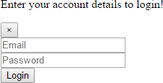

**Fig 3.2**

###### After using CSS in HTML Page:

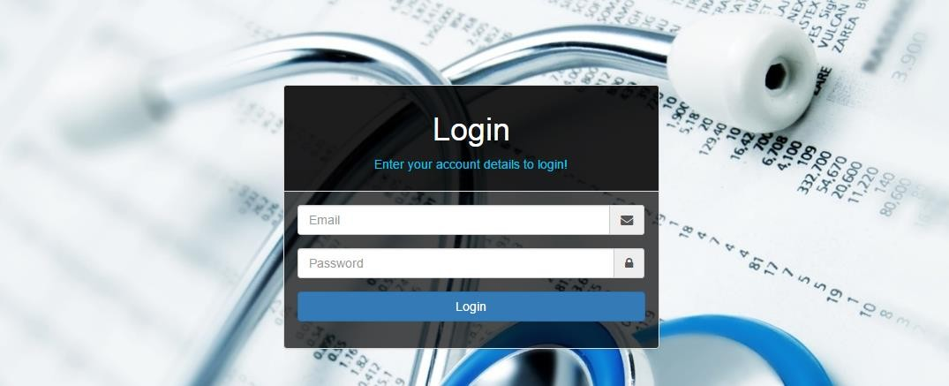

**Fig 3.3**

#### BOOTSTRAP

**Bootstrap** is a [free and open-source](https://en.wikipedia.org/wiki/Free_and_open-source_software) front-end [web framework](https://en.wikipedia.org/wiki/Web_framework) for designing [websites](https://en.wikipedia.org/wiki/Website) and [web applications](https://en.wikipedia.org/wiki/Web_application). It contains [HTML](https://en.wikipedia.org/wiki/HTML)- and [CSS](https://en.wikipedia.org/wiki/CSS)-based design templates for [typography](https://en.wikipedia.org/wiki/Typography), forms, buttons, navigation and other interface components, as well as optional [JavaScript](https://en.wikipedia.org/wiki/JavaScript) extensions. Unlike many web frameworks, it concerns itself with [front-end development](https://en.wikipedia.org/wiki/Front-end_web_development) only.

Bootstrap is the second most-starred project on [GitHub](https://en.wikipedia.org/wiki/GitHub), with more than 107,000 stars and 48,000 forks.

Bootstrap, originally named Twitter Blueprint, was developed by Mark Otto and Jacob Thornton at [Twitter](https://en.wikipedia.org/wiki/Twitter) as a framework to encourage consistency across internal tools. Before Bootstrap, various libraries were used for interface development, which led to inconsistencies and a high maintenance burden. According to [twitter](https://en.wikipedia.org/wiki/Twitter) developer Mark Otto:

“A super small group of developers and I got together to design and build a new internal tool and saw an opportunity to do something more. Through that process, we saw ourselves build something much more substantial than another internal tool. Months later, we ended up with an early version of Bootstrap as a way to document and share common design patterns and assets within the company.”

After a few months of development by a small group, many developers at Twitter began to contribute to the project as a part of Hack Week, a [hackathon](https://en.wikipedia.org/wiki/Hackathon)-style week for the Twitter development team. It was renamed from Twitter Blueprint to Bootstrap, and released as an

open source project on August 19, 2011. It has continued to be maintained by Mark Otto, Jacob Thornton, and a small group of core developers, as well as a large community of contributors.

On January 31, 2012, Bootstrap 2 was released, which added a twelve-column [responsive](https://en.wikipedia.org/wiki/Responsive_web_design) grid layout system, inbuilt support for Glyphicons, several new components, as well as changes to many of the existing components.

On August 19, 2013, Bootstrap 3 was released, which redesigned components to use [flat design](https://en.wikipedia.org/wiki/Flat_design), and a [mobile first](https://en.wikipedia.org/wiki/Responsive_web_design#Mobile_first.2C_unobtrusive_JavaScript.2C_and_progressive_enhancement) approach.

On October 29, 2014, Mark Otto announced that Bootstrap 4 was in development. The first alpha version of Bootstrap 4 was released on August 19, 2015.

Bootstrap 3 supports the latest versions of the [Google Chrome](https://en.wikipedia.org/wiki/Google_Chrome), [Firefox](https://en.wikipedia.org/wiki/Firefox), [Internet](https://en.wikipedia.org/wiki/Internet_Explorer) [Explorer](https://en.wikipedia.org/wiki/Internet_Explorer), [Opera](https://en.wikipedia.org/wiki/Opera_%28web_browser%29), and [Safari](https://en.wikipedia.org/wiki/Safari_%28web_browser%29) (except on Windows). It additionally supports back to [IE8](https://en.wikipedia.org/wiki/Internet_Explorer_8) and the latest [Firefox](https://en.wikipedia.org/wiki/Firefox) Extended Support Release (ESR).

Since 2.0, Bootstrap supports [responsive web design](https://en.wikipedia.org/wiki/Responsive_Web_Design). This means the layout of web pages adjusts dynamically, taking into account the characteristics of the device used (desktop, tablet, mobile phone).

Starting with version 3.0, Bootstrap adopted a [mobile-first design](https://en.wikipedia.org/wiki/Mobile-first_design) philosophy, emphasizing responsive design by default.

The version 4.0 alpha release added [Sass](https://en.wikipedia.org/wiki/Sass_%28stylesheet_language%29) and [flexbox](https://en.wikipedia.org/wiki/CSS_Flex_Box_Layout) support.

#### Installing and linking bootstrap to the HTML page:

* Install bootstrap from <https://getbootstrap.com/>
* Copy the bootstrap.min.css file to your CSS folder and link it to the HTML page in the similar manner to how any other CSS file is linked.
* Link the bootstrap.min.js file which is present in the JS folder of the bootstrap. It can be linked using script tag.

Eg: <script src=”url to bootstrap.min.js”></script>

* Now use bootstrap classes to reduce the work of designing which was earlier done through CSS.

#### SCRIPTING

There are two scripting methodologies.

* 1. Server side scripting: This scripting is done at the server end
  2. Client side scripting: This scripting is done at the client end or the browser.

#### SERVER SIDE SCRIPTING

**Server-side scripting** is a technique used in [web development](https://en.wikipedia.org/wiki/Web_development) which involves employing [scripts](https://en.wikipedia.org/wiki/Scripting_language) on a web server which produce a response customized for each user’s (client’s) request to the website. The alternative is for the web server itself to deliver a [static](https://en.wikipedia.org/wiki/Static_web_page) [web page](https://en.wikipedia.org/wiki/Static_web_page). Scripts can be written in any of a number of server-side scripting languages that are available (see below). Server-side scripting is distinguished from [client-side scripting](https://en.wikipedia.org/wiki/Client-side_scripting) where embedded scripts, such as [JavaScript](https://en.wikipedia.org/wiki/JavaScript), are run client-side in a [web browser](https://en.wikipedia.org/wiki/Web_browser), but both techniques are often used together.

Server-side scripting is often used to provide a customized interface for the user. These scripts may assemble client characteristics for use in customizing the response based on those characteristics, the user’s requirements, access rights, etc. Server-side scripting also enables the website owner to hide the source code that generates the interface, whereas with client-side scripting, the user has access to all the code received by the client. A down-side to the use of server-side scripting is that the client needs to make further requests over the network to the server in order to show new information to the user via the web browser. These requests can slow down the experience for the user, place more load on the server, and prevent use of the application when the user is disconnected from the server.

When the server serves data in a commonly used manner, for example according to the [HTTP](https://en.wikipedia.org/wiki/Hypertext_Transfer_Protocol) or [FTP](https://en.wikipedia.org/wiki/File_Transfer_Protocol) [protocols](https://en.wikipedia.org/wiki/Protocol_%28computing%29), users may have their choice of a number of client programs (most modern web browsers can request and receive data using both of those protocols). In the case of more specialized applications, programmers may write their own server, client, and communications protocol that can only be used with one another.

Programs that run on a user’s local computer without ever sending or receiving data over a network are not considered clients, and so the operations of such programs would not be considered client-side operations.

#### Server Side scripting Languages

There are several languages that can be used for server-side programming:

* PHP
* ASP.NET (C# OR Visual Basic)
* C++
* Java and JSP
* Python
* Ruby on Rails and so on.

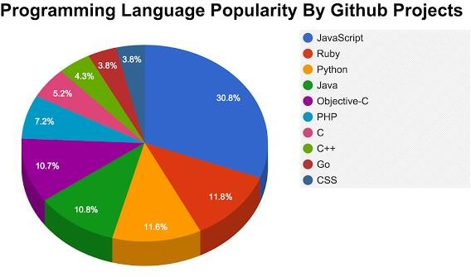

**Fig 3.2.1**

#### CLIENT SIDE SCRIPTING

Client-side scripting is changing interface behaviors within a specific web page in response to mouse or keyboard actions, or at specified timing events. In this case, the dynamic behavior occurs within the [presentation](https://en.wikipedia.org/wiki/Look_and_feel). The client-side content is generated on the user's local computer system.

Such web pages use presentation technology called [rich interfaced pages](https://en.wikipedia.org/wiki/Rich_Internet_application#Methods_and_techniques). Client-side scripting languages like [JavaScript](https://en.wikipedia.org/wiki/JavaScript) or [ActionScript](https://en.wikipedia.org/wiki/ActionScript), used for [Dynamic HTML](https://en.wikipedia.org/wiki/Dynamic_HTML) (DHTML) and [Flash](https://en.wikipedia.org/wiki/Adobe_Flash) technologies respectively, are frequently used to orchestrate media types (sound, animations, changing text, etc.) of the presentation. Client-side scripting also allows the use of

[remote scripting](https://en.wikipedia.org/wiki/Remote_scripting), a technique by which the DHTML page requests additional information from a server, using a [hidden frame](https://en.wikipedia.org/wiki/HTML_element#Frames), [XML Http Requests](https://en.wikipedia.org/wiki/XMLHttpRequest), or a [Web service](https://en.wikipedia.org/wiki/Web_service).

The first widespread use of JavaScript was in 1997, when the language was standardized as [ECMAScript](https://en.wikipedia.org/wiki/ECMAScript) and implemented in [Netscape 3](https://en.wikipedia.org/wiki/Netscape).

Example:

The client-side content is generated on the client's computer. The web browser retrieves a page from the server, then processes the code embedded in the page (typically written in [JavaScript](https://en.wikipedia.org/wiki/JavaScript)) and displays the retrieved page's content to the user.

The most popularly used client side scripting languages is **Java Script**. Flow of request from browser to server:

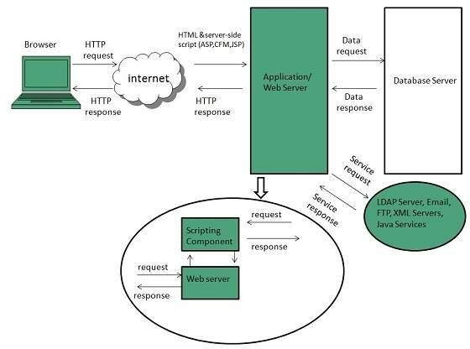

**Fig 3.2.2**

#### 4.3 DATABASE

A **database** is an organized collection of [data.](https://en.wikipedia.org/wiki/Data_%28computing%29) It is the collection of [schemas,](https://en.wikipedia.org/wiki/Database_schema) [tables](https://en.wikipedia.org/wiki/Table_%28database%29), [queries](https://en.wikipedia.org/wiki/Query_language), reports, [views](https://en.wikipedia.org/wiki/View_%28SQL%29), and other objects. The data are typically organized to model aspects of reality in a way that supports [processes](https://en.wikipedia.org/wiki/Process_%28computing%29) requiring information, such as modelling the availability of rooms in hotels in a way that supports finding a hotel with vacancies.

A **database management system** (**DBMS**) is a [computer software](https://en.wikipedia.org/wiki/Computer_software) application that interacts with the user, other applications, and the database itself to capture and analyze data. A general-purpose DBMS is designed to allow the definition, creation, querying, update, and administration of databases. Well-known DBMSs include [MySQL,](https://en.wikipedia.org/wiki/MySQL) [PostgreSQL,](https://en.wikipedia.org/wiki/PostgreSQL) [MongoDB](https://en.wikipedia.org/wiki/MongoDB), [MariaDB](https://en.wikipedia.org/wiki/MariaDB), [Microsoft SQL Server](https://en.wikipedia.org/wiki/Microsoft_SQL_Server), [Oracle](https://en.wikipedia.org/wiki/Oracle_Database), [Sybase](https://en.wikipedia.org/wiki/Sybase), [SAP HANA,](https://en.wikipedia.org/wiki/SAP_HANA) [MemSQL](https://en.wikipedia.org/wiki/MemSQL) and [IBM DB2.](https://en.wikipedia.org/wiki/IBM_DB2) A

database is not generally [portable](https://en.wikipedia.org/wiki/Software_portability) across different DBMSs, but different DBMS can interoperate by using [standards](https://en.wikipedia.org/wiki/Technical_standard) such as [SQL](https://en.wikipedia.org/wiki/SQL) and [ODBC](https://en.wikipedia.org/wiki/ODBC) or [JDBC](https://en.wikipedia.org/wiki/JDBC) to allow a single application to work with more than one DBMS. Database management systems are often classified according to the [database model](https://en.wikipedia.org/wiki/Database_model) that they support; the most popular database systems since the 1980s have all supported the [relational model](https://en.wikipedia.org/wiki/Relational_model) as represented by the [SQL](https://en.wikipedia.org/wiki/SQL) language. Sometimes a DBMS is loosely referred to as a "database".

#### MongoDB

****MongoDB**** is a document-oriented NoSQL database used for high volume data storage. Instead of using tables and rows as in the traditional relational databases, MongoDB makes use of collections and documents. Documents consist of key-value pairs which are the basic unit of data in MongoDB. Collections contain sets of documents and function which is the equivalent of relational database tables. MongoDB is a database which came into light around the mid-2000s.

CHAPTER-4

#### SCRIPTING LANGUAG

#### JAVA SCRIPT

**JavaScript**, often abbreviated as "JS", is a [high-level](https://en.wikipedia.org/wiki/High-level_programming_language), [dynamic,](https://en.wikipedia.org/wiki/Dynamic_programming_language) [untyped](https://en.wikipedia.org/wiki/Untyped_language), and [interpreted](https://en.wikipedia.org/wiki/Interpreted_language) run-time [language](https://en.wikipedia.org/wiki/Programming_language). It has been standardized in the [ECMAScript](https://en.wikipedia.org/wiki/ECMAScript) language specification. Alongside [HTML](https://en.wikipedia.org/wiki/HTML) and [CSS,](https://en.wikipedia.org/wiki/CSS) JavaScript is one of the three core technologies of [World Wide Web](https://en.wikipedia.org/wiki/World_Wide_Web) [content production](https://en.wikipedia.org/wiki/Content_engineering); the majority of [websites](https://en.wikipedia.org/wiki/Website) employ it, and all modern [Web](https://en.wikipedia.org/wiki/Web_browser) [browsers](https://en.wikipedia.org/wiki/Web_browser) support it without the need for [plug-ins](https://en.wikipedia.org/wiki/Browser_extension). JavaScript is [prototype-based](https://en.wikipedia.org/wiki/Prototype-based_programming) with [first-class](https://en.wikipedia.org/wiki/First-class_function) [functions](https://en.wikipedia.org/wiki/First-class_function), making it a [multi-paradigm](https://en.wikipedia.org/wiki/Multi-paradigm) language, supporting [object-oriented](https://en.wikipedia.org/wiki/Object-oriented_programming), [imperative](https://en.wikipedia.org/wiki/Imperative_programming), and [functional](https://en.wikipedia.org/wiki/Functional_programming) [programming styles](https://en.wikipedia.org/wiki/Programming_paradigm). It has an [API](https://en.wikipedia.org/wiki/Application_programming_interface) for working with text, [arrays](https://en.wikipedia.org/wiki/Array_data_type), dates and [regular](https://en.wikipedia.org/wiki/Regular_expression) [expressions](https://en.wikipedia.org/wiki/Regular_expression), but does not include any [I/O](https://en.wikipedia.org/wiki/Input/output), such as networking, storage, or graphics facilities, relying for these upon the host environment in which it is embedded.

Although there are strong outward similarities between JavaScript and Java, including language name, [syntax](https://en.wikipedia.org/wiki/Syntax_%28programming_languages%29), and respective [standard libraries](https://en.wikipedia.org/wiki/Standard_library), the two are distinct languages and

differ greatly in their design. JavaScript was influenced by programming languages such as [self](https://en.wikipedia.org/wiki/Self_%28programming_language%29) and [Scheme.](https://en.wikipedia.org/wiki/Scheme_%28programming_language%29)

JavaScript is also used in environments that are not Web-based, such as [PDF](https://en.wikipedia.org/wiki/Portable_Document_Format) documents, [site-specific browsers](https://en.wikipedia.org/wiki/Site-specific_browser), and [desktop widgets](https://en.wikipedia.org/wiki/Desktop_widget). Newer and faster JavaScript [virtual](https://en.wikipedia.org/wiki/Virtual_machine) [machines](https://en.wikipedia.org/wiki/Virtual_machine) (VMs) and platforms built upon them have also increased the popularity of JavaScript for [server-side](https://en.wikipedia.org/wiki/Server-side) [Web applications](https://en.wikipedia.org/wiki/Web_application). On the [client side](https://en.wikipedia.org/wiki/Client_side), developers have traditionally implemented JavaScript as an [interpreted](https://en.wikipedia.org/wiki/Interpreter_%28computing%29) language, but more recent browsers perform [just-in-time](https://en.wikipedia.org/wiki/Just-in-time_compilation) [compilation](https://en.wikipedia.org/wiki/Just-in-time_compilation). Programmers also use JavaScript in [video-game development](https://en.wikipedia.org/wiki/Video_game_development), in crafting desktop and mobile applications, and in server-side [network programming](https://en.wikipedia.org/wiki/Computer_network_programming) with [run-time environments](https://en.wikipedia.org/wiki/Runtime_system) such as [Node.js](https://en.wikipedia.org/wiki/Node.js).

#### JQUERY

**JQuery** is a [cross-platform](https://en.wikipedia.org/wiki/Cross-platform) [JavaScript library](https://en.wikipedia.org/wiki/JavaScript_library) designed to simplify the [client-side](https://en.wikipedia.org/wiki/Client-side_scripting) [scripting](https://en.wikipedia.org/wiki/Client-side_scripting) of [HTML.](https://en.wikipedia.org/wiki/HTML) It is [free, open-source software](https://en.wikipedia.org/wiki/Free_and_open_source_software) using the permissive [MIT license](https://en.wikipedia.org/wiki/MIT_license). [Web](https://en.wikipedia.org/wiki/World_Wide_Web) analysis indicates that it is the most widely deployed JavaScript library by a large margin.

jQuery's syntax is designed to make it easier to navigate a document, select [DOM](https://en.wikipedia.org/wiki/Document_Object_Model) elements, create [animations](https://en.wikipedia.org/wiki/Animation), handle [events](https://en.wikipedia.org/wiki/Event_%28computing%29), and develop [Ajax](https://en.wikipedia.org/wiki/Ajax_%28programming%29) applications. jQuery also provides capabilities for developers to create [plug-ins](https://en.wikipedia.org/wiki/Plug-in_%28computing%29) on top of the JavaScript library. This enables developers to create [abstractions](https://en.wikipedia.org/wiki/Abstraction_%28computer_science%29) for low-level interaction and animation, advanced effects and high-level, themeable widgets. The modular approach to the jQuery library allows the creation of powerful [dynamic web pages](https://en.wikipedia.org/wiki/Dynamic_web_page) and Web applications.

The set of [jQuery core features](https://en.wikipedia.org/wiki/JQuery#Features)—DOM element selections, traversal and manipulation—enabled by its selector engine (named "Sizzle" from v1.3), created a new "programming style", fusing algorithms and DOM data structures. This style influenced the architecture of other [JavaScript frameworks](https://en.wikipedia.org/wiki/Comparison_of_JavaScript_frameworks) like [YUI v3](https://en.wikipedia.org/wiki/YUI_Library) and [Dojo](https://en.wikipedia.org/wiki/Dojo_Toolkit), later stimulating the creation of the standard Selectors API.

[Microsoft](https://en.wikipedia.org/wiki/Microsoft) and [Nokia](https://en.wikipedia.org/wiki/Nokia) bundle jQuery on their platforms. Microsoft includes it with [Visual Studio](https://en.wikipedia.org/wiki/Microsoft_Visual_Studio) for use within Microsoft's [ASP.NET AJAX](https://en.wikipedia.org/wiki/ASP.NET_AJAX) and [ASP.NET MVC](https://en.wikipedia.org/wiki/ASP.NET_MVC) frameworks while Nokia has integrated it into the Web Run-Time widget development platform.

CHAPTER-5

#### FRONT_END FRAMEWORK

#### 5.1 REACT JS

React is the most popular front-end JavaScript library in the field of web development. It is used by large, established companies and newly-minted startups alike (Netflix, Airbnb, Instagram, and the New York Times, to name a few). React brings many advantages to the table, making it a better choice than other frameworks like Angular.js.

What is React?

React is a JavaScript library created for building fast and interactive user interfaces for web and mobile applications. It is an open-source, component-based, front-end library responsible only for the application’s view layer. In Model View Controller (MVC) architecture, the view layer is responsible for how the app looks and feels. React was created by Jordan Walke, a [software engineer](https://www.simplilearn.com/how-to-become-a-software-engineer-article" \t "https://www.simplilearn.com/tutorials/reactjs-tutorial/_blank) at Facebook.

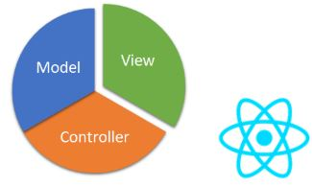

**Fig:**MVC architecture

Let’s take a look at an Instagram webpage example, entirely built using React, to get a better understanding of how React works. As the illustration shows, React divides the UI into multiple components, which makes the code easier to debug. This way, each component has its property and function.

CHAPTER-6

#### BACKEND

#### 6.1 FIREBASE



Hello! I’m Firebase!

It seems like there’s an app for everything these days. Well, almost everything. I haven’t found an app that helps me remove impacted earwax. It happens to me sometimes, and it’s super obnoxious. But someone could build it! I’ll contribute to your Kickstarter.

If you’re the enterprising sort of person that tackles humanity’s urgent needs with a mobile app, you’ll want to know about [Firebase](https://firebase.google.com/). Firebase is Google’s mobile application development platform that helps you build, improve, and grow your app.

Firebase is a toolset to “build, improve, and grow your app”, and the tools it gives you cover a large portion of the services that developers would normally have to build themselves, but don’t really want to build, because they’d rather be focusing on the app experience itself. This includes things like analytics, authentication, databases, configuration, file storage, push messaging, and the list goes on. The services are hosted in the cloud, and scale with little to no effort on the part of the developer.

CHAPTER-7

SOFTWARE REQUIREMENT SPECIFICATION

7.1 Hardware Requirements

The selection of hardware is very important in the existence and proper working of any software. When selecting hardware, the size and requirements are also important.

|  |  |
| --- | --- |
| Processor | Intel CORE i3 (Minimum) |
| RAM | **4.0 GB** |
| Hard Disk Drive | **500 GB** |

## 7.2 Software Requirements

|  |  |
| --- | --- |
| **Number** | **Description** |
| 1 | Windows 7,8,10 |
| 2 | HTML/Css/JavaScript/ N ode /React Js/Firebase |
| 3 | MongoDB |
| 4 | Compiler: Visual Studio Code |

#### CHAPTER-8 DATA FLOW DIAGRAM

Data Flow Diagrams show the flow of data from external entities into the system, and from one process to another within the system. There are four symbols for drawing a DFD:

1. Rectangles representing external entities, which are sources or destinations of data.
2. Ellipses representing processes, which take data as input, validate and process it and output it.
3. Arrows representing the data flows, which can either, be electronic data or physical items.
4. Open-ended rectangles or a Disk symbol representing data stores, including electronic stores such as databases or XML files and physical stores such as filing cabinets or stacks of paper.

Figures below are the Data Flow Diagrams for the current system. Each process within the system is first shown as a Context Level DFD and later as a Detailed DFD. The Context Level DFD provides a conceptual view of the process and its surrounding input, output and data stores. The Detailed DFD provides a more detailed and comprehensive view of the interaction among the sub-processes within the system.

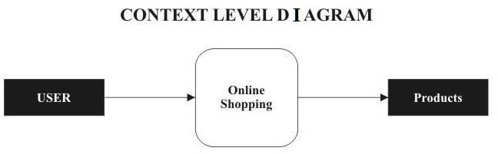

Fig 8.1

#### 8.1 DFD-1

Fig 8.1.1

#### 8.2 DFD-2

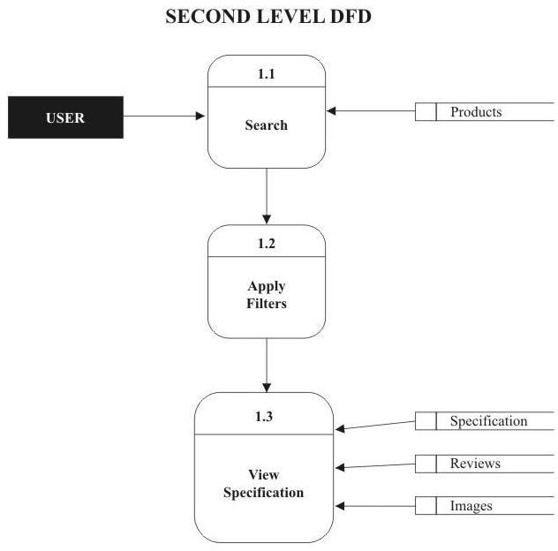

Fig 8.2.1

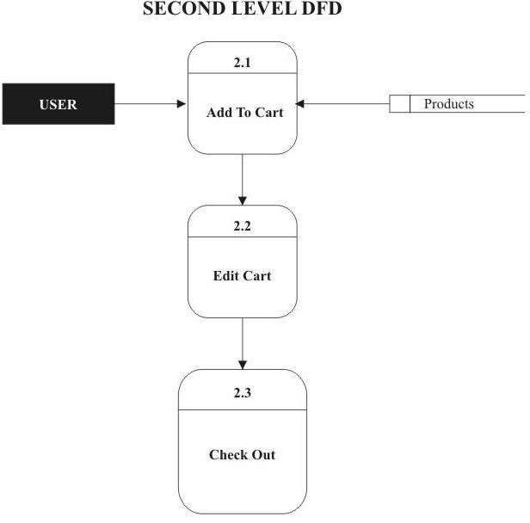

Fig 8.2.2

#### 8.3 DFD-3

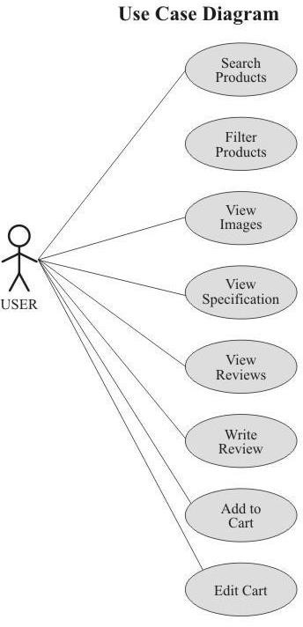

Fig 8.3.1

CHAPTER-9

PROJECT

**9.1 PROJECT (Advanced Technologies):**

**Name: ABHI ECOMMERCE**

###### 9.2 Technologies Used:

* + - HTML
    - CSS
    - Bootstrap
    - Java Script
    - Jquery

**Server:** Node js

**Database:** MongoDB

**Operating System:** Windows7/8/8.1/10

**Front-end Framework:** React Js

**Team Size: 2**

9.3 TECHNICAL DETAILS:

* + - Front end is designed using HTML, CSS and Bootstrap. JavaScript used to perform behind the screen requests and used to perform client side scripting.
    - Backend is based on Firebase model.
    - Backend online host includes a centralized database resident on the server, the script which is built in project used to query the database on user’s request for transaction of data.
    - The forms are made using the HTML, Bootstrap, Javascript, React Js for designing and Firebase for back-end.
    - JavaScript and JQuery used for client side scripting and Node Js for the server side development.

CHAPTER-10

SCREENSHOTS

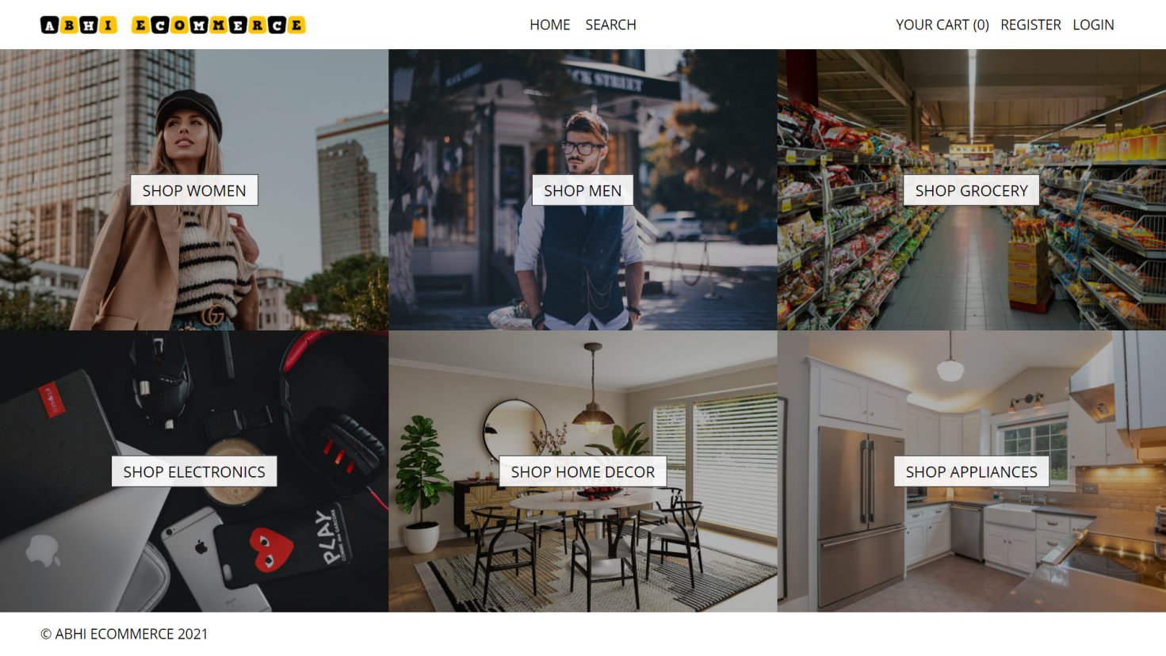

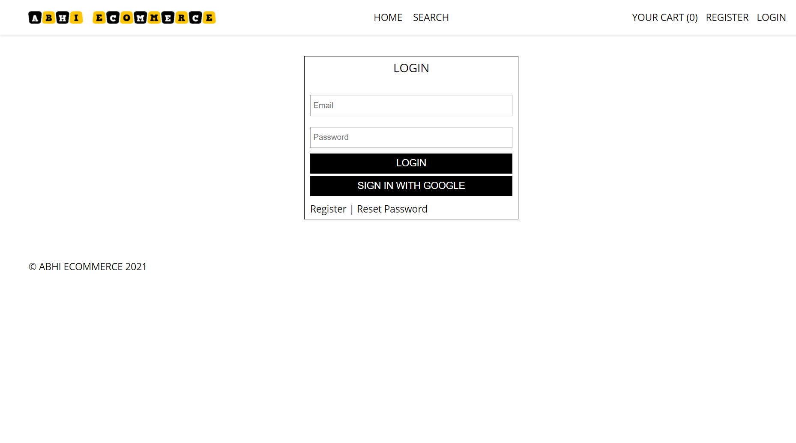

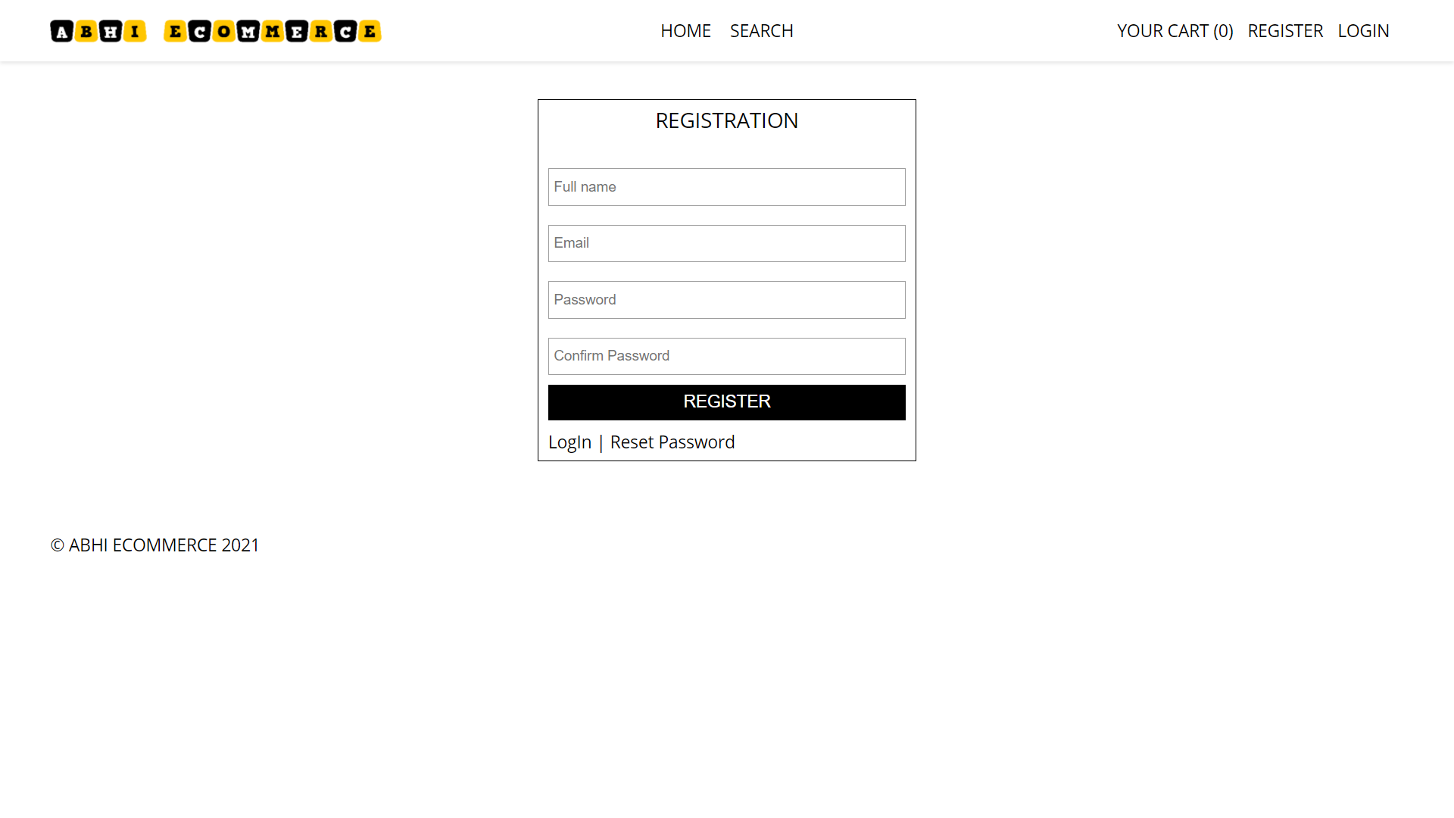

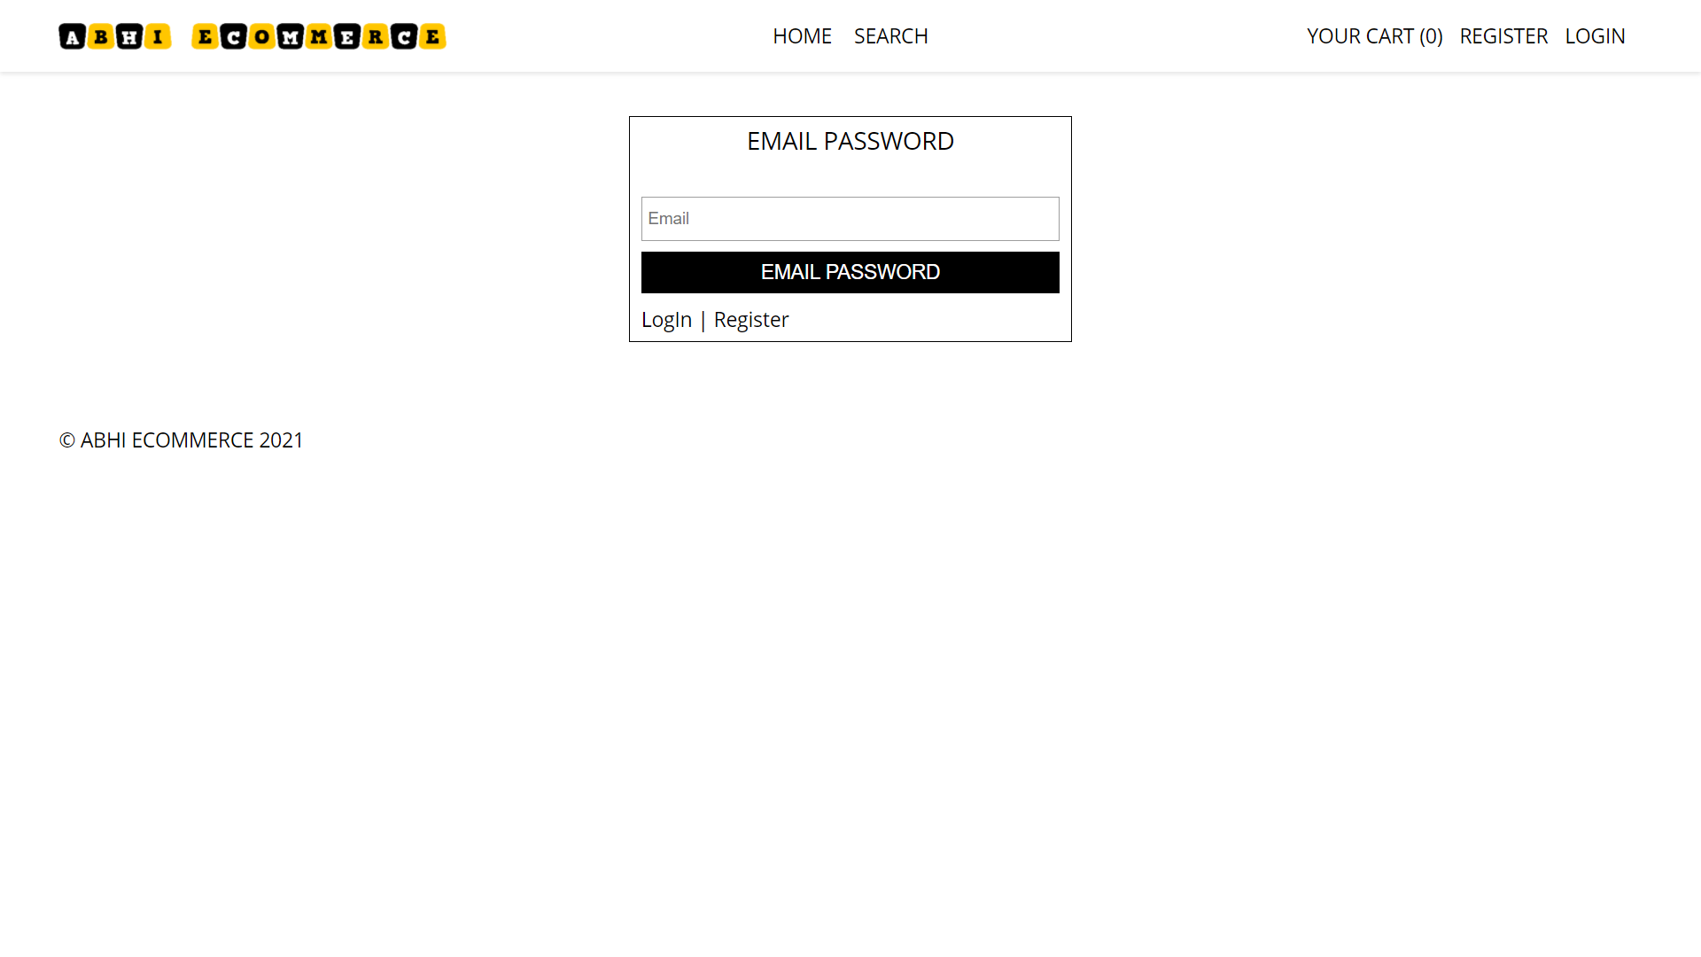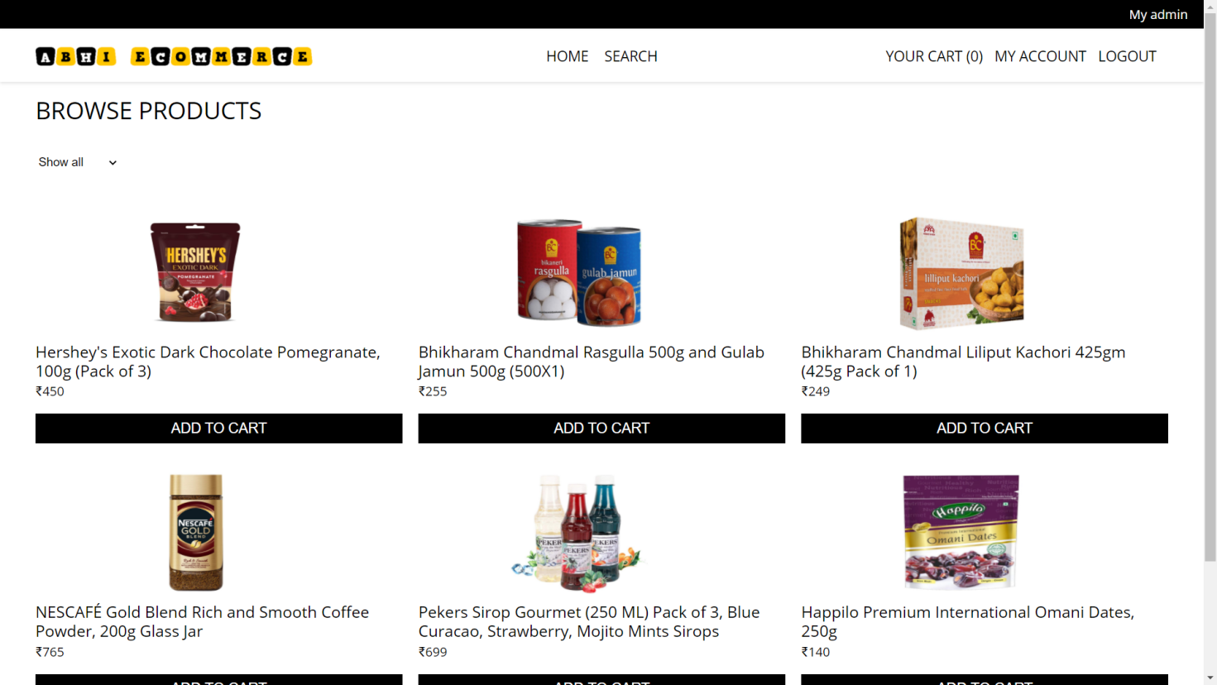

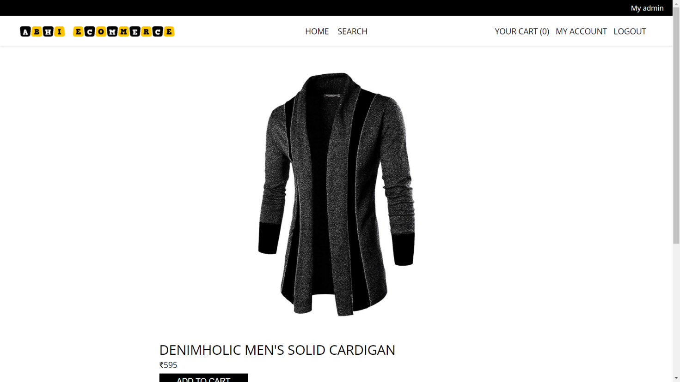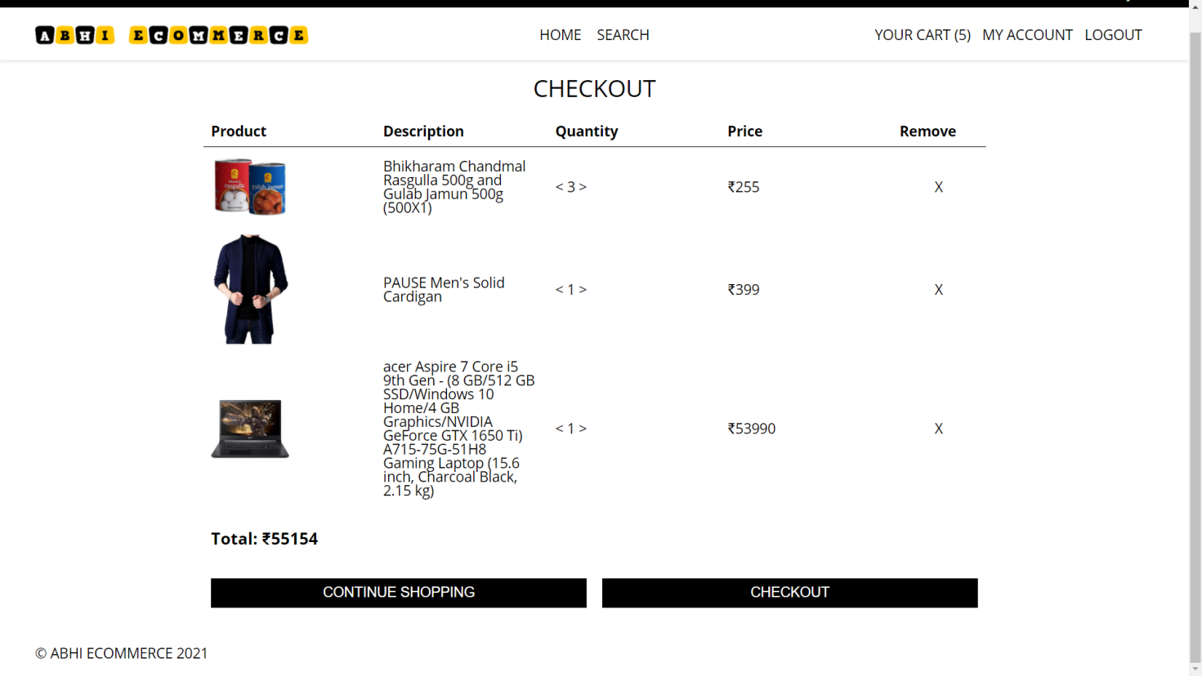

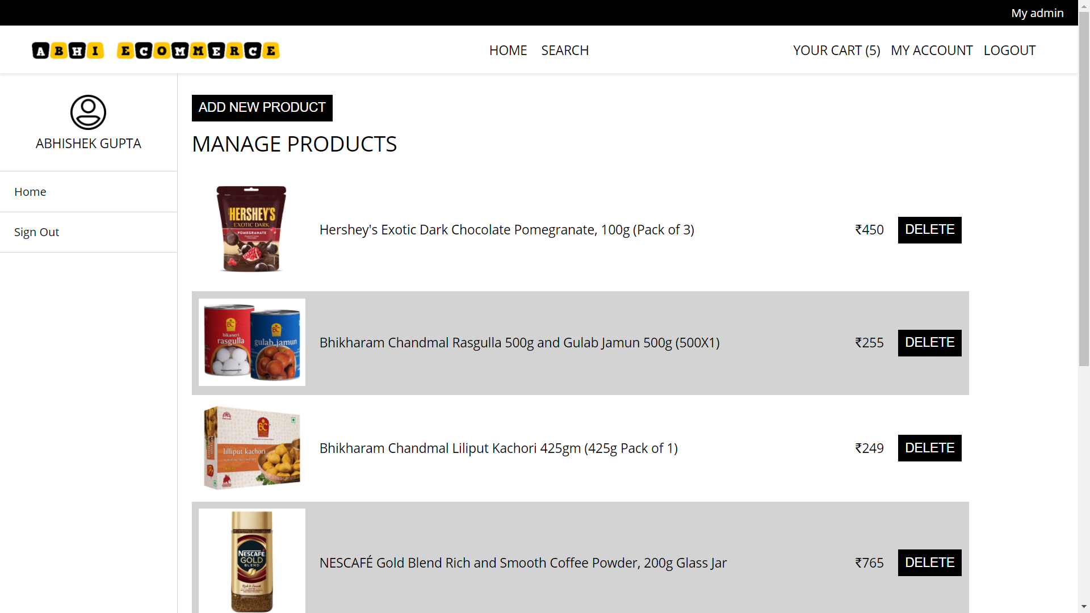

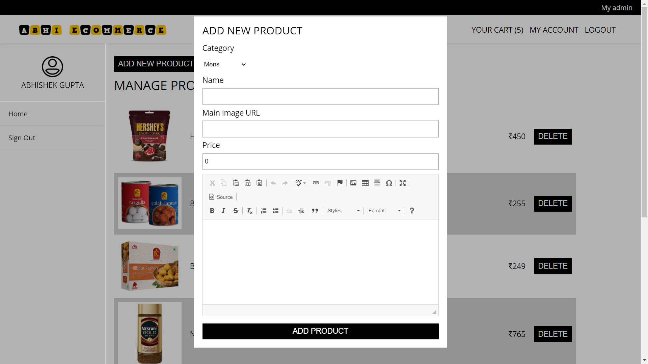

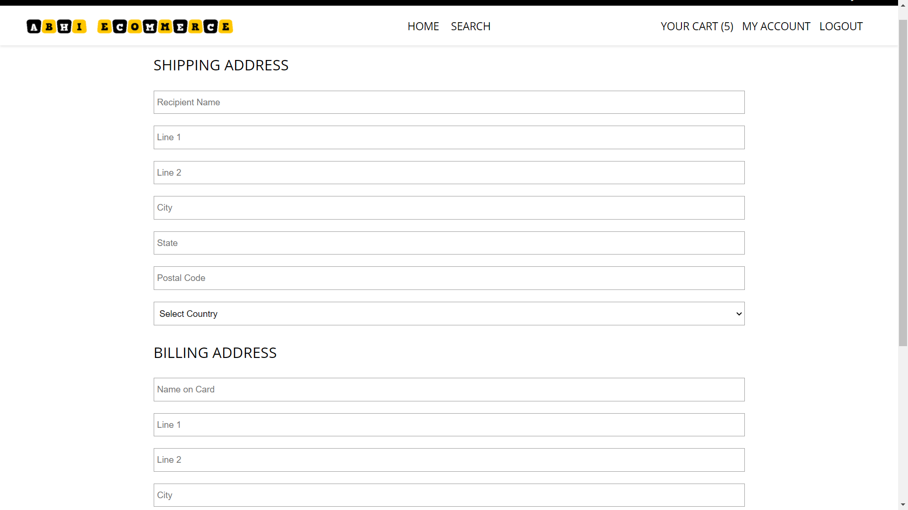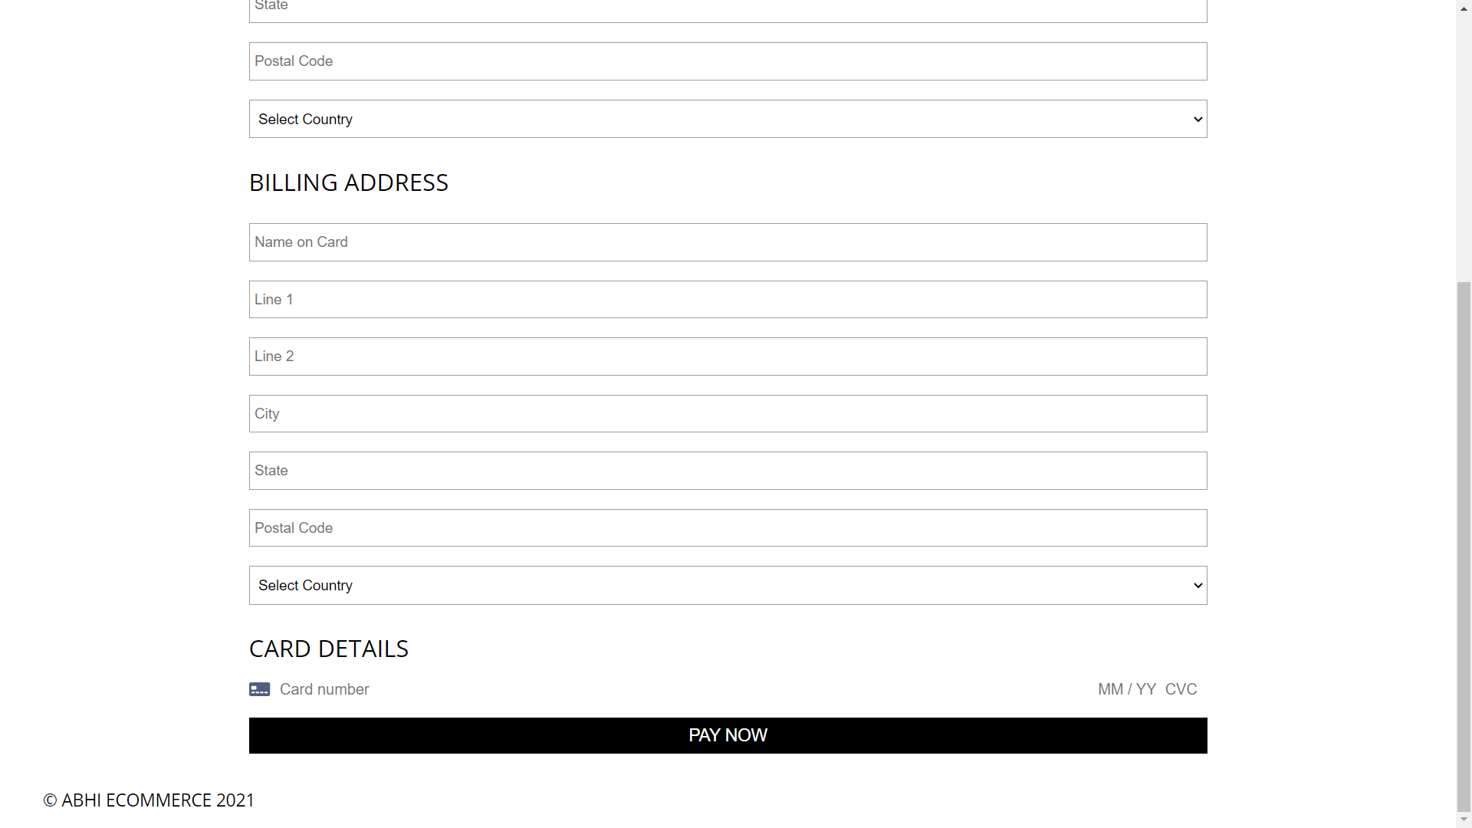

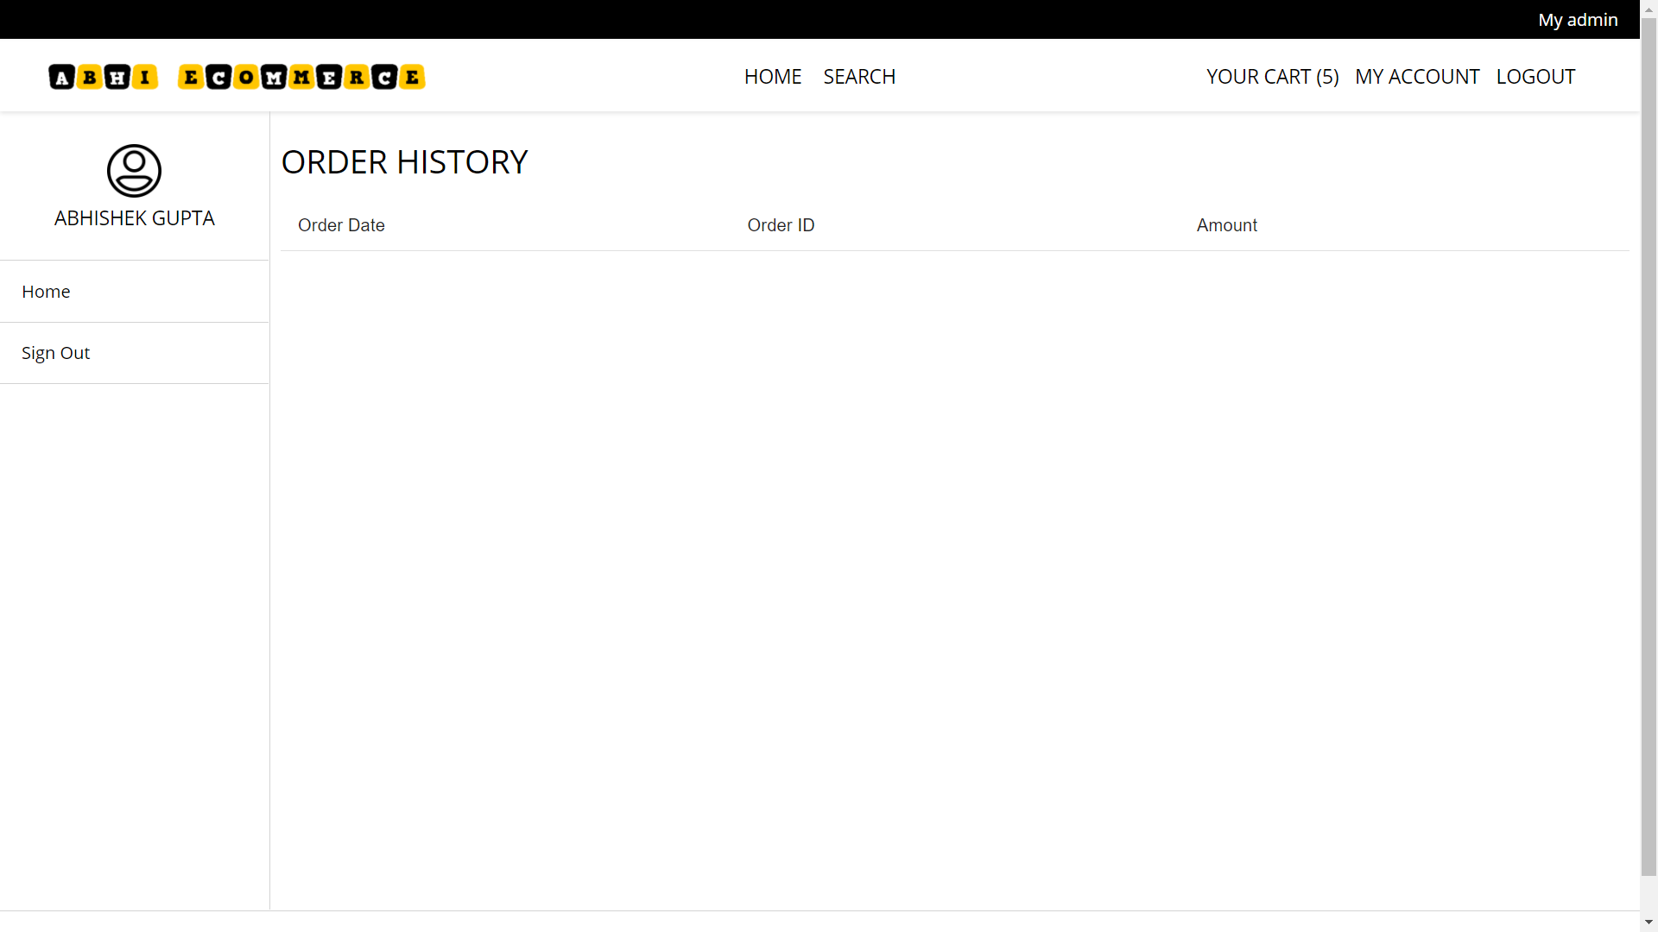

CHAPTER-11

#### MAINTENANCE

The maintenance phase involves making changes to hardware, software, and documentation to support its operational effectiveness. It includes making changes to improve a system’s performance, correct problems, enhance security, or address user requirements. To ensure modifications do not disrupt operations or degrade a system’s performance or security, organizations should establish appropriate change management standards and procedures.

Routine changes are not as complex as major modifications and can usually be implemented in the normal course of business. Routine change controls should include procedures for requesting, evaluating, approving, testing, installing, and documenting website modifications. Maintaining accurate, up-to-date hardware and software inventories is a critical part of all change management processes. Management should carefully document all modifications to ensure accurate system inventories. Management should coordinate all technology related changes through an oversight committee and assign an appropriate party responsibility for administering software patch management programs. Quality assurance, security, audit, regulatory compliance, network, and end-user personnel should be appropriately included in change management processes. Risk and security review should be done whenever a system modification is implemented to ensure controls remain in place.

For maintenance of the website:

1. The database has to be updated regularly according to new available information.
2. Redundant and false information must be removed from the database.
3. Newer version of FIREBASE can be used for up gradation of website and to improve the overall performance of the system.

CHAPTER-12

#### FUTURE SCOPE & FUTURE ENHANCEMENT

**PROJECT NAME:**

### ABHI ECOMMERCE

1. ABHI ECOMMERCE would help each and every person to find any product via our website and get it at home it will save their time.
2. It would provide huge collection of products of all fields.

CHAPTER-13

#### CONCLUSION

We have successfully implemented the site ‘ABHI ECOMMERCE’. With the help of various links and tools, we have been able to provide a site which will be live soon and running on the web. We have been successful in our attempt to take care of the needs of both the user as well as the administrator. Finally we hope that this will go a long way in popularizing.

### BIBLIOGRAPHY

1. [www.javatutpoint.com](http://www.javatutpoint.com/)
2. [www.w3schools.com](http://www.w3schools.com/)
3. [www.getbootstrap.com](http://www.getbootstrap.com/)
4. [www.codeigniter.com](http://www.codeigniter.com/)
5. [www.stackoverflow.com](http://www.stackoverflow.com/)
6. [www.fontawesome.io](http://www.fontawesome.io/)
7. Learn HTML and CSS faster(Mark Myers)
8. Wikipedia