**Q1. Retrieve the total numbers of order placed.**



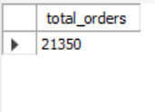

**Q2. Calculate the total revenue generated from pizza sales.**

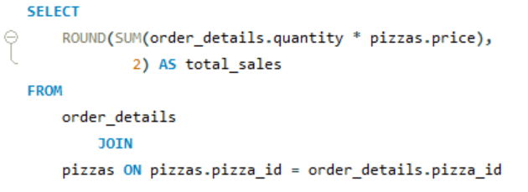

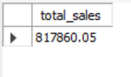

**Q3. Identify the highest-priced pizza.**

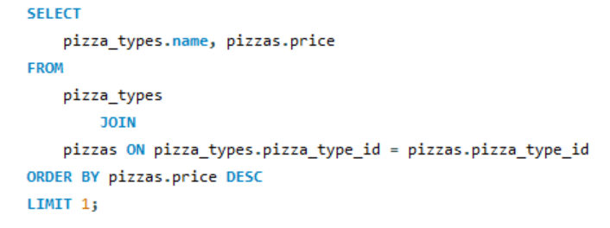

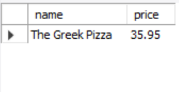

**Q4. Identify the most common pizza size ordered.**

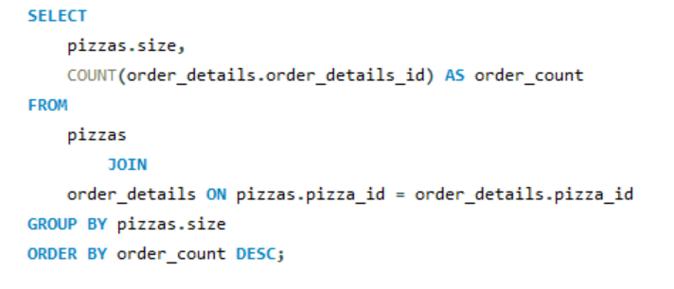

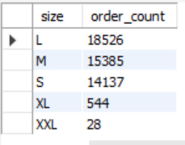

**Q5. List the top 5 most ordered pizza types along with their quantities.**

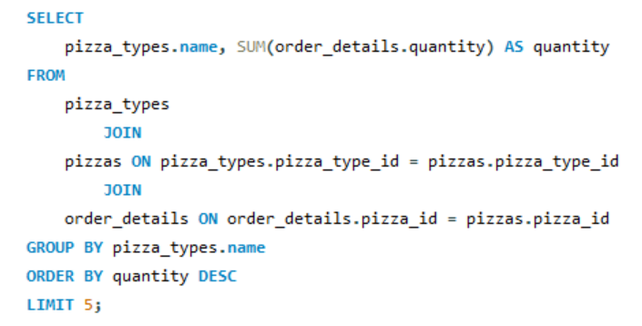

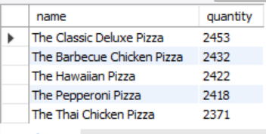

**Q6. Join the necessary tables to find the total quantity of each pizza category ordered.**

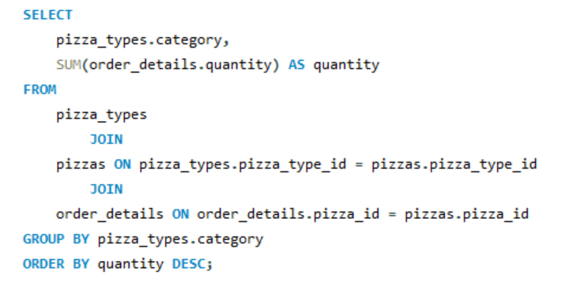

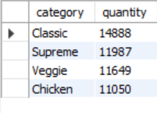

**Q7. Determine the distribution of orders by hour of the day.**

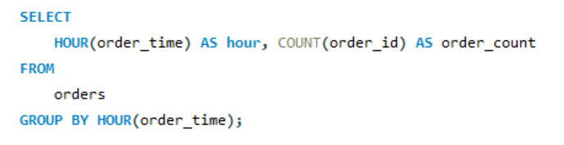

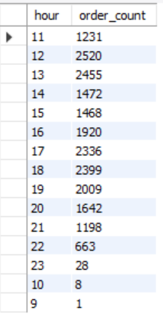

**Q8. Join relevant tables to find the category-wise distribution of pizzas.**

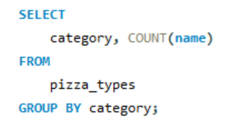

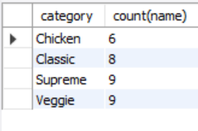

**Q9. Group the orders by date and calculate the average number of pizzas ordered per day.**

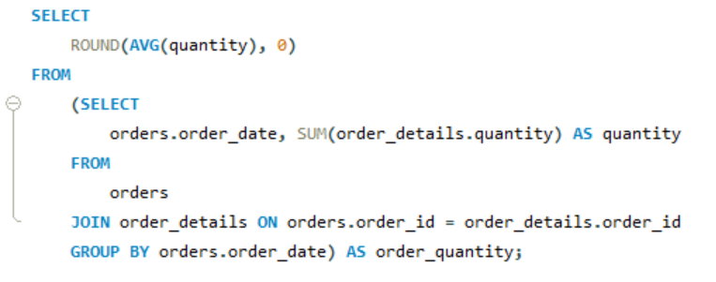

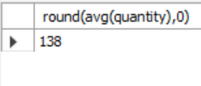

**Q10. Determine the top 3 most ordered pizza types based on revenue.**

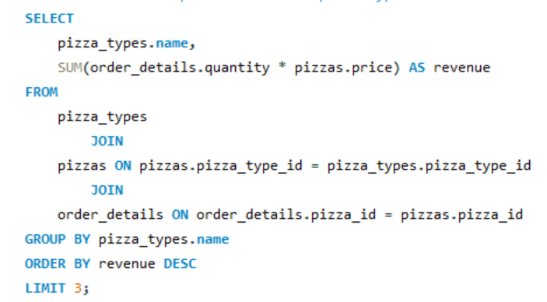

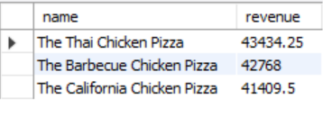

**Q11. Calculate the percentage contribution of each pizza type to total revenue.**

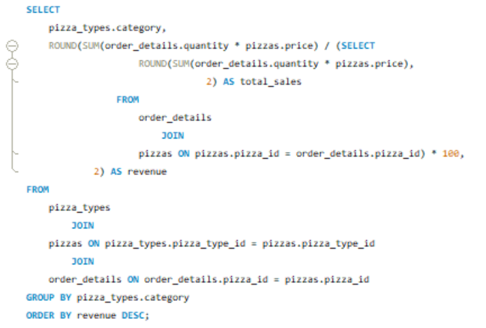

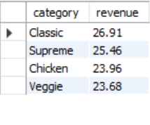

**Q12. Analyze the cumulative revenue generated over time.**

