1. Write a Java program to print "Hello, World!" to the console.

**Code:-**

**package** course;

**public** **class** hello {

**public** **static** **void** main(String[] args) {

System.***out***.println("Hello World...");

}

}

**Output:-**

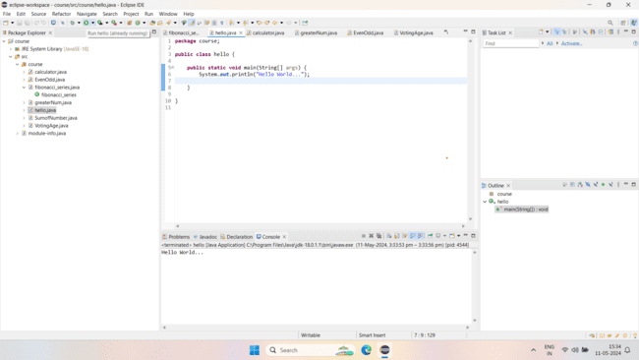

2.Write a program to find the sum of two numbers entered by the user.

**Code:-**

**package** course;

**import** java.util.Scanner;

**public** **class** SumofNumber {

**public** **static** **void** main(String[] args) {

// **TODO** Auto-generated method stub

Scanner sc = **new** Scanner(System.***in***);

//Taking two numbers

System.***out***.println("Enter the two number for addition:: ");

**float** a = sc.nextFloat();

**float** b = sc.nextFloat();

//sum of two numbers.

**float** sum = a + b;

System.***out***.println("Sum of two number is "+sum);

sc.close();

}

}

**Output:-**

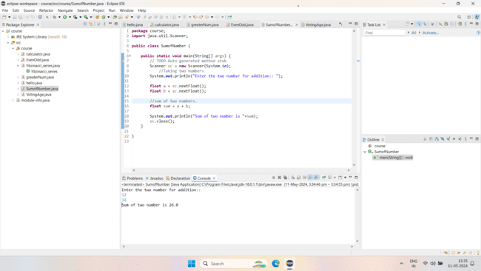

3.Write a Java program to check whether a given number is even or odd.

**Code:-**

**package** course;

**import** java.util.Scanner;

**public** **class** EvenOdd {

**public** **static** **void** main(String[] args) {

// **TODO** Auto-generated method stub

Scanner sc = **new** Scanner(System.***in***);

//Taking the number for checking even or odd.

System.***out***.println("Enter the number::");

**int** a = sc.nextInt();

//Condition for numbers are even or odd.

**if**(a%2==0) {

//when the reminder is 0 so the number is even.

System.***out***.println(a+" is "+"Even Number.");

}

**else** **if**(a%2!=0) {

//when the reminder is not 0 so the number is odd.

System.***out***.println(a+" is "+"Odd Number.");

}

**else**

{

//when the number is 0.

System.***out***.println("Re-Enter the number.");

}

sc.close();

}

}

**Output:-**

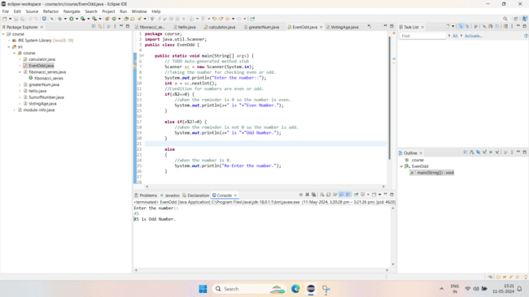

1. Write a java program to find greatest of 2 numbers.

**Code:-**

**package** course;

**import** java.util.Scanner;

**public** **class** greaterNum {

**public** **static** **void** main(String[] args) {

// **TODO** Auto-generated method stub

Scanner sc = **new** Scanner(System.***in***);

//Take two number to compare which one is greater.

System.***out***.println("Enter two numbers for comparing which is greater::");

**int** a = sc.nextInt();

**int** b = sc.nextInt();

//start the condition two verify the greater number.

//This for first number when it is greater than second number.

**if**(a>b) {

System.***out***.println(a+" is greater than "+b+".");

}

//This for second number when it is greater than first number.

**else** **if**(b>a) {

System.***out***.println(b+" is greater than "+a+".");

}

//This for when both number are same

**else**

{

System.***out***.println("Re-enter the numbers.");

}

sc.close();

}

}

**Output:-**

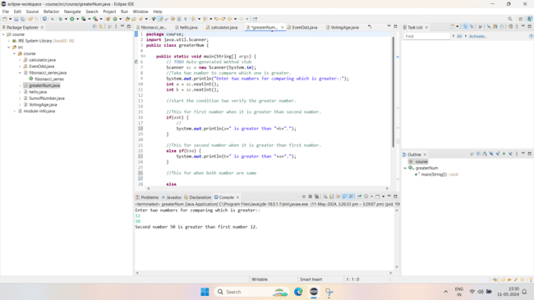

1. Write a program to implement a basic calculator that takes input as a string expression and evaluates it.

**Code:-**

**package** course;

**import** java.util.Scanner;

**public** **class** calculator {

**public** **static** **void** main(String[] args) {

Scanner sc = **new** Scanner(System.***in***);

// taking input from the user using the Scanner

// class

System.***out***.print(

"Enter the first and the Second number - ");

**int** a = sc.nextInt();

**int** b = sc.nextInt();

// selecting the operand for the calculations

System.***out***.print(

"Choose and Enter the type of operation you want to perform (+, -, *, /, %) - ");

**char** op = sc.next().charAt(0);

*solve*(a, b, op);

}

**public** **static** **int** solve(**int** a, **int** b, **char** op)

{

**int** ans = 0;

// addition

**if** (op == '+') {

ans = a + b;

// subtraction

}

**else** **if** (op == '-') {

ans = a - b;

// multiplication

}

**else** **if** (op == '*') {

ans = a * b;

// modulo

}

**else** **if** (op == '%') {

ans = a % b;

// division

}

**else** **if** (op == '/') {

ans = a / b;

}

// printing the final result

System.***out***.println("Your answer is - " + ans);

**return** ans;

}

}

**Output:-**

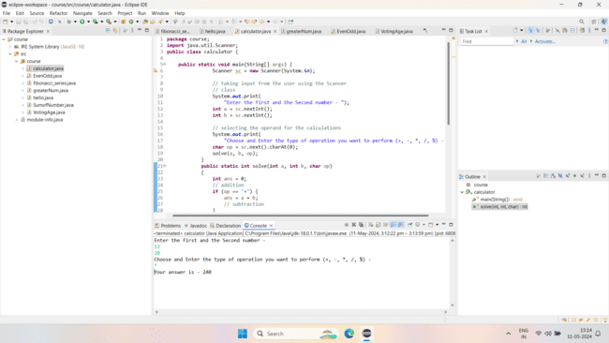

1. Write a Java program to check if a given number is even or odd.

**Code:-**

**package** course;

**import** java.util.Scanner;

**public** **class** EvenOdd {

**public** **static** **void** main(String[] args) {

// **TODO** Auto-generated method stub

Scanner sc = **new** Scanner(System.***in***);

//Taking the number for checking even or odd.

System.***out***.println("Enter the number::");

**int** a = sc.nextInt();

//Condition for numbers are even or odd.

**if**(a%2==0) {

//when the reminder is 0 so the number is even.

System.***out***.println(a+" is "+"Even Number.");

}

**else** **if**(a%2!=0) {

//when the reminder is not 0 so the number is odd.

System.***out***.println(a+" is "+"Odd Number.");

}

**else**

{

//when the number is 0.

System.***out***.println("Re-Enter the number.");

}

sc.close();

}

}

**Output:-**



1. Create a Java program that compares two numbers and prints the larger one.

**Code:-**

**package** course;

**import** java.util.Scanner;

**public** **class** greaterNum {

**public** **static** **void** main(String[] args) {

// **TODO** Auto-generated method stub

Scanner sc = **new** Scanner(System.***in***);

//Take two number to compare which one is greater.

System.***out***.println("Enter two numbers for comparing which is greater::");

**int** a = sc.nextInt();

**int** b = sc.nextInt();

//start the condition two verify the greater number.

//This for first number when it is greater than second number.

**if**(a>b) {

System.***out***.println(a+" is greater than "+b+".");

}

//This for second number when it is greater than first number.

**else** **if**(b>a) {

System.***out***.println(b+" is greater than "+a+".");

}

//This for when both number are same

**else**

{

System.***out***.println("Re-enter the numbers.");

}

sc.close();

}

}

**Output:-**



1. Write a Java program that takes an age input from the user and determines if they are eligible to vote (considering the legal voting age).

**Code:-**

**package** course;

**import** java.util.Scanner;

**public** **class** VotingAge {

**public** **static** **void** main(String[] args) {

// **TODO** Auto-generated method stub

Scanner sc = **new** Scanner(System.***in***);

System.***out***.println("Enter your age::");

**int** age = sc.nextInt();

**if**(age >= 18) {

System.***out***.println("You are eligible for voting.");

}

**else** {

System.***out***.println("You are not eligible for voting.");

}

sc.close();

}

}

**Output:-**

