1.     Write a program that takes a student's score as input and outputs the corresponding grade based on the following scale:

A: 90-100,B: 80-89,C: 70-79,D: 60-69,F: 0-59

Program=

import java.util.Scanner;

public class labq1 {

import java.util.Scanner; // Import the Scanner class to read input from the console

public class GradeCalculator {

public static void main(String[] args) {

Scanner scanner = new Scanner(System.in); // Create a Scanner object to read input

try {

System.out.print("Enter the student's score: "); // Prompt the user to enter the student's score

int score = scanner.nextInt(); // Read the student's score from the console

// Determine the grade based on the score

String grade = calculateGrade(score);

// Print the grade

System.out.println("The grade is: " + grade);

} catch (Exception e) { // Catch any exceptions that may occur during input reading or calculation

System.out.println("Please enter a valid score."); // Print an error message if an exception occurs

} finally {

scanner.close(); // Close the Scanner object to release system resources

}}

// Method to calculate the grade based on the score

public static String calculateGrade(int score) {

// Determine the grade based on the score range

if (score >= 90 && score <= 100) {

return "A";

} else if (score >= 80 && score <= 89) {

return "B";

} else if (score >= 70 && score <= 79) {

return "C";

} else if (score >= 60 && score <= 69) {

return "D";

} else if (score >= 0 && score <= 59) {

return "F";

} else {

return "Invalid score"; // Return an invalid score message if the score is out of range

}}}

output=

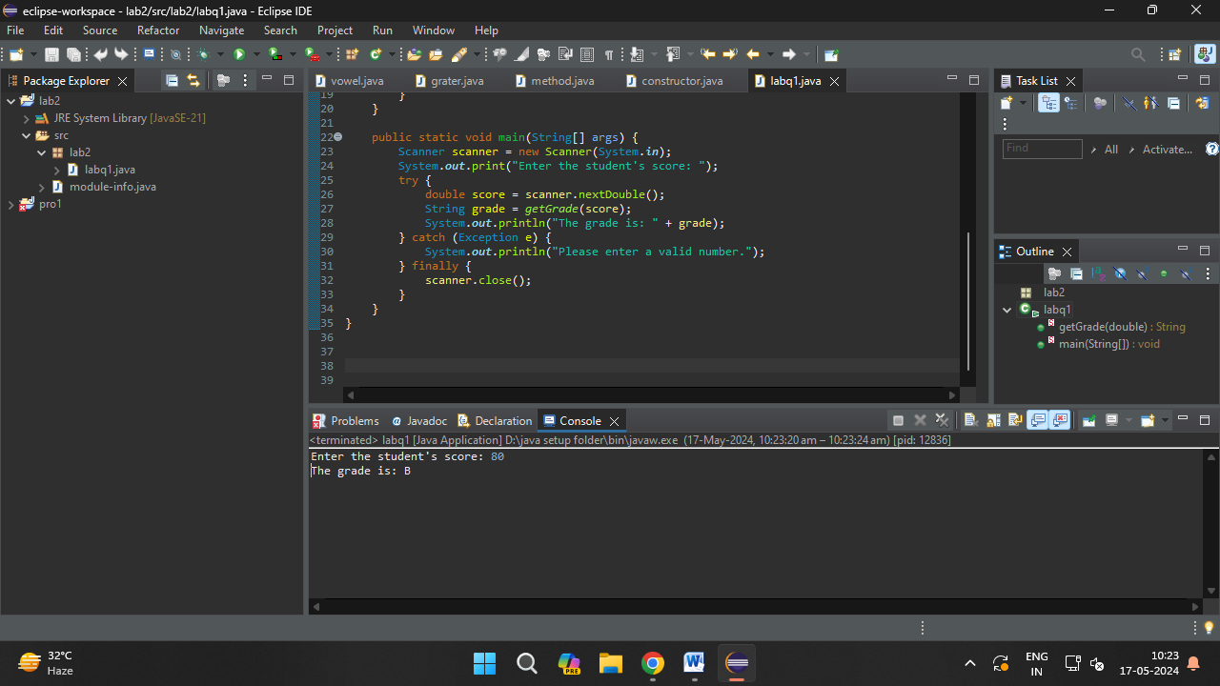

2.     Write a program to check if a given year is a leap year. (A year is a leap year if it is divisible by 4 but not by 100, or it is divisible by 400.)

Program=

import java.util.Scanner;

public class labq1 {

public static boolean isLeapYear(int year) {

if (year % 400 == 0) {

return true;

} else if (year % 100 == 0) {

return false;

} else if (year % 4 == 0) {

return true;

} else {

return false; } }

public static void main(String[] args) {

Scanner scanner = new Scanner(System.in);

System.out.print("Enter a year: ");

try {

int year = scanner.nextInt();

boolean leapYear = isLeapYear(year);

if (leapYear) {

System.out.println(year + " is a leap year.");

} else {

System.out.println(year + " is not a leap year."); }

} catch (Exception e) {

System.out.println("Please enter a valid year.");

} finally {

scanner.close(); } }}

output=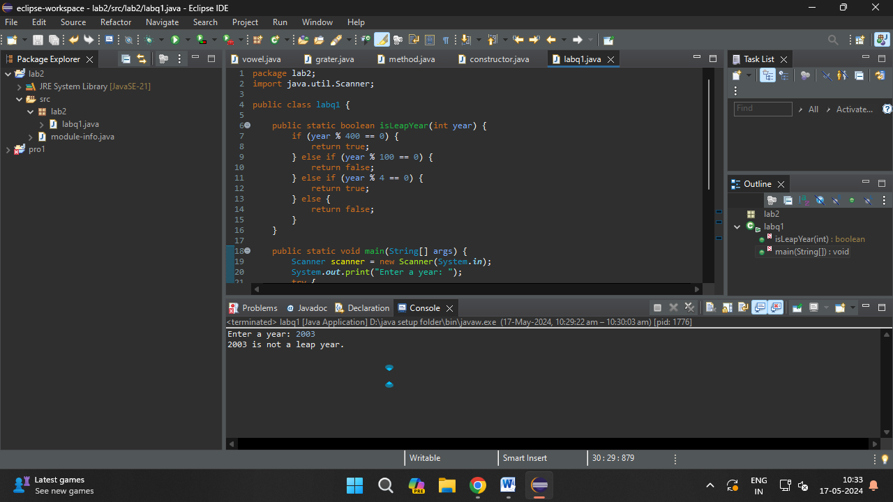

3.     Write a program that takes an integer as input and checks if it is positive, negative, or zero.

Program=import java.util.Scanner;

public class labq1 {

public static void main(String[] args) {

Scanner scanner = new Scanner(System.in);

System.out.print("Enter an integer: ");

try {

int number = scanner.nextInt();

if (number > 0) {

System.out.println("The number is positive.");

} else if (number < 0) {

System.out.println("The number is negative.");

} else {

System.out.println("The number is zero."); }

} catch (Exception e) {

System.out.println("Please enter a valid integer.");

} finally {

scanner.close(); }}}

output=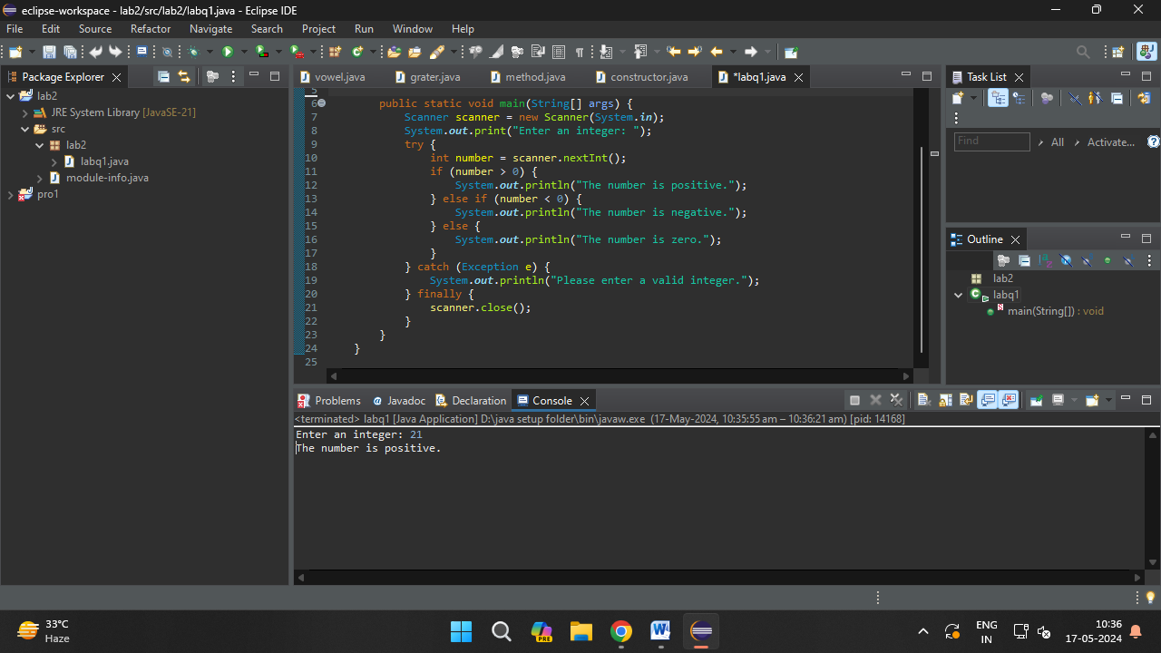

4.     Write a program that prints numbers from 1 to 10 using a loop.

Program=public class labq1{

public static void main(String[] args) {

for (int i = 1; i <= 10; i++) {

System.out.println(i); } }}

Output=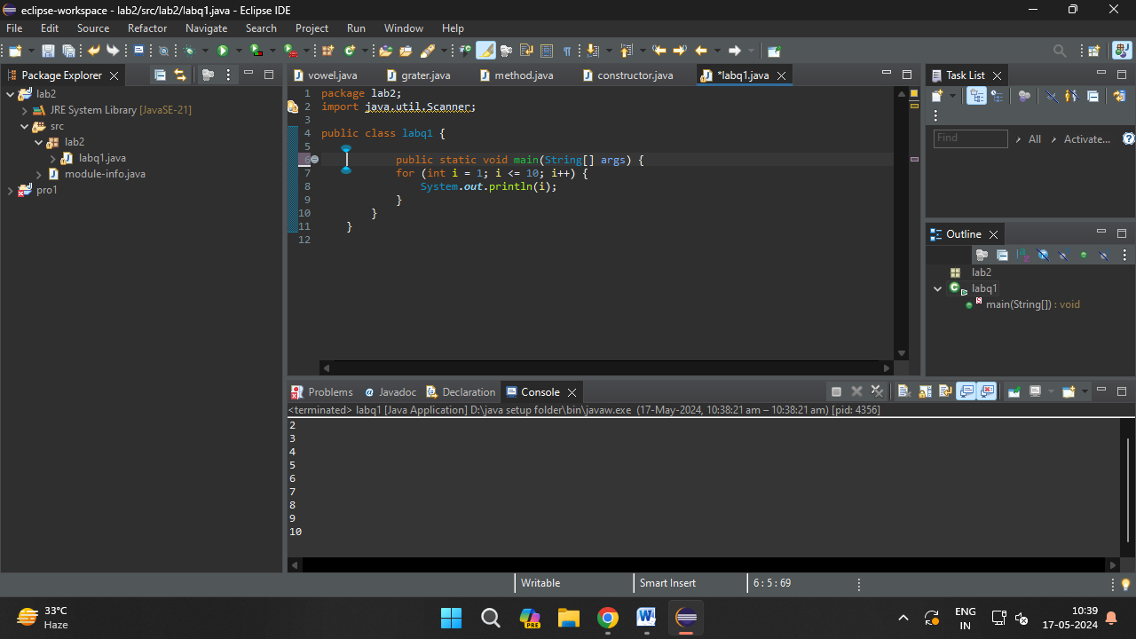

5.     Write a program that takes an integer N as input and calculates the sum of entered numbers.

Program= import java.util.Scanner; // Import the Scanner class to read input from the console

public class labq1 {

public static void main(String[] args) {

Scanner scanner = new Scanner(System.in); // Create a Scanner object to read input

try {

System.out.print("Enter the number of elements (N): "); // Prompt the user to enter N

int N = scanner.nextInt(); // Read the value of N from the console

int sum = 0; // Initialize a variable to store the sum

// Loop to iterate N times to read N numbers from the user and calculate the sum

for (int i = 1; i <= N; i++) {

System.out.print("Enter number " + i + ": "); // Prompt the user to enter the i-th number

int number = scanner.nextInt(); // Read the int number from the console

sum += number; // Add the int number to the sum

}

System.out.println("The sum of the entered numbers is: " + sum); // Print the sum

} catch (Exception e) { // Catch any exceptions that may occur during input reading or calculation

System.out.println("Please enter valid integers."); // Print an error message if an exception occurs

} finally {

scanner.close(); // Close the Scanner object to release system resources

}}}

output=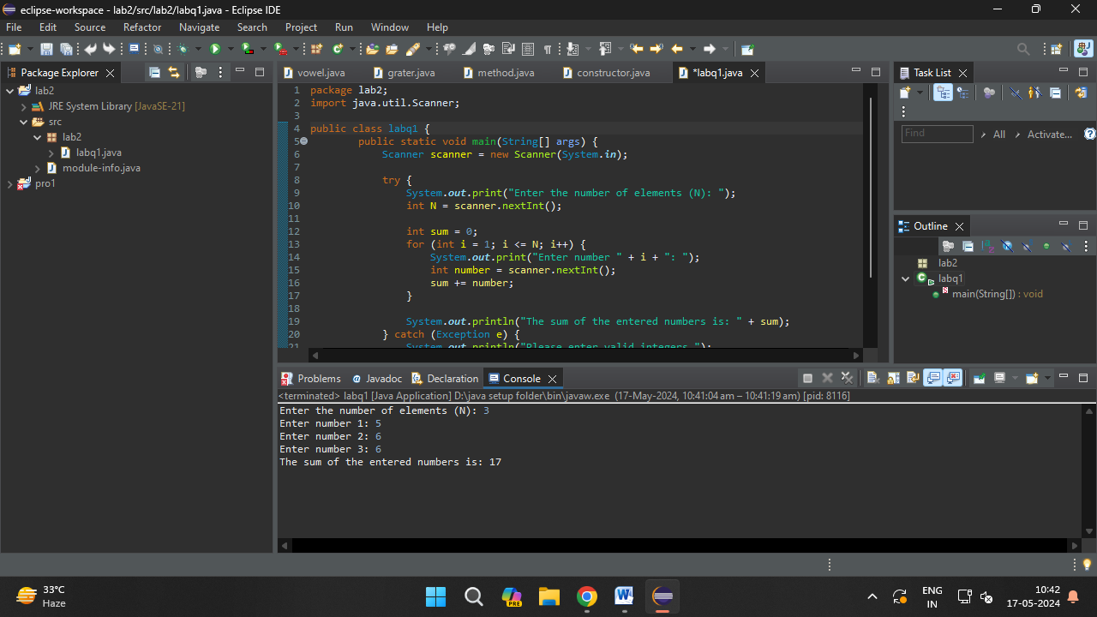

6.     Write a program that takes an integer as input and prints its multiplication table up to 10.

Program=import java.util.Scanner;

public class labq1{

public static void main(String[] args) {

Scanner scanner = new Scanner(System.in);

try {

System.out.print("Enter an integer: ");

int number = scanner.nextInt();

System.out.println("Multiplication table for " + number + ":");

for (int i = 1; i <= 10; i++) {

System.out.println(number + " x " + i + " = " + (number \* i));

}

} catch (Exception e) {

System.out.println("Please enter a valid integer.");

} finally {

scanner.close();}}}

output=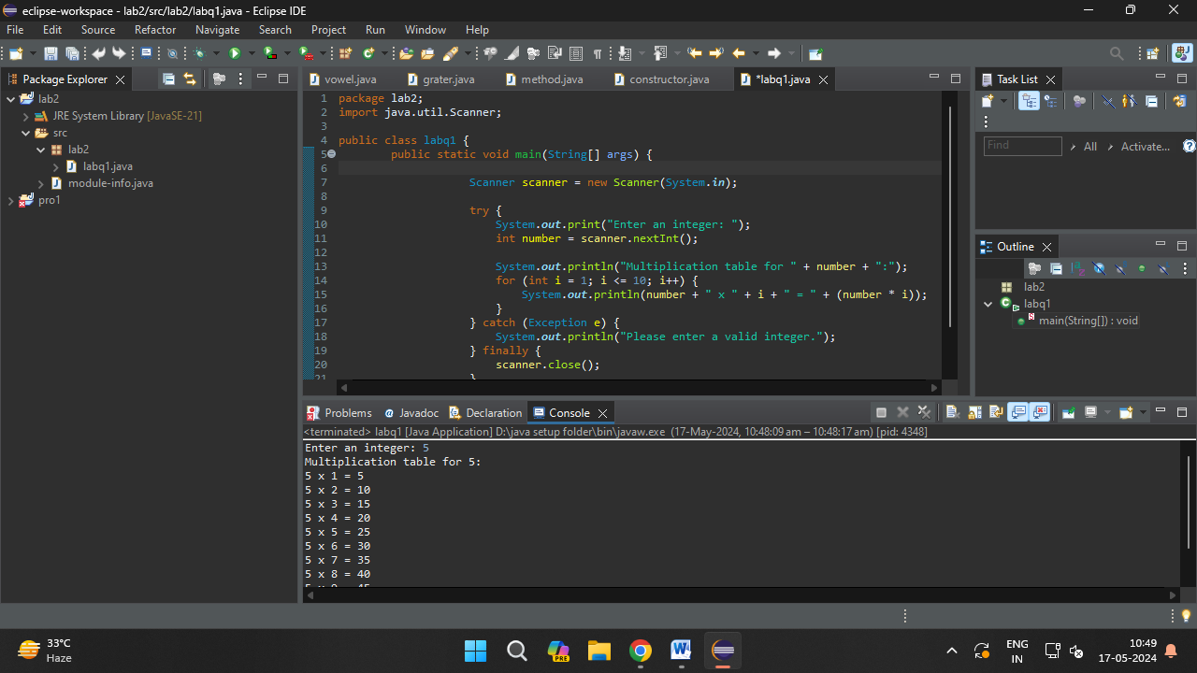

7.     Write a program that takes a positive integer as input and prints its digits in reverse order.

Program=import java.util.Scanner;

public class labq1{

public static void main(String[] args) {

Scanner scanner = new Scanner(System.in);

try {

System.out.print("Enter a positive integer: ");

int number = scanner.nextInt();

if (number < 0) {

System.out.println("Please enter a positive integer.");

} else {

System.out.print("The digits in reverse order are: ");

while (number > 0) {

int digit = number % 10;

System.out.print(digit);

number /= 10;

} System.out.println(); // To move to the next line after printing digits.

}

} catch (Exception e) {

System.out.println("Please enter a valid positive integer.");

} finally {

scanner.close();}}}

output=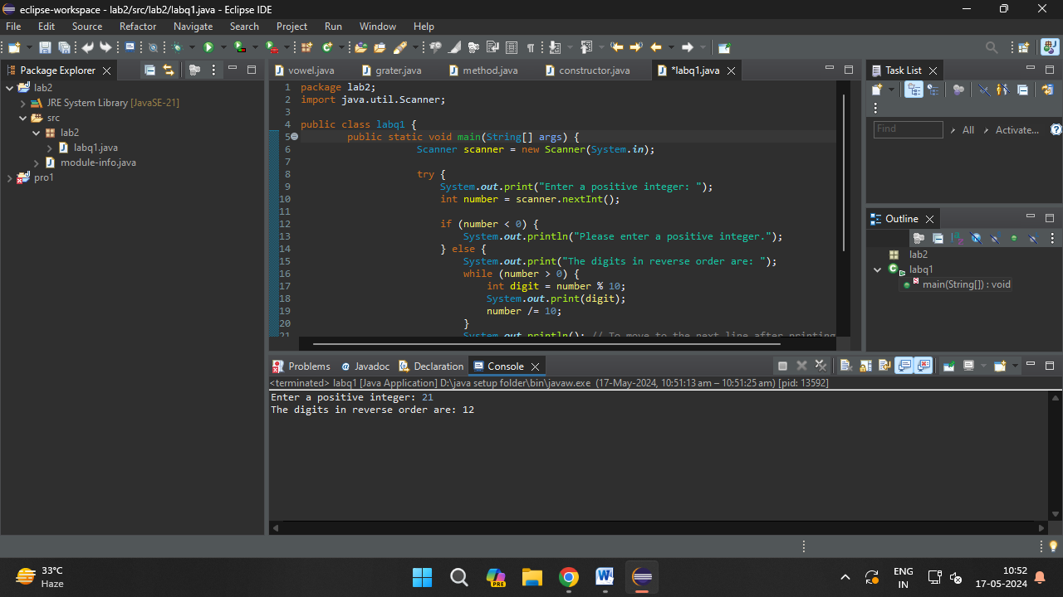

8.     Create a class Animal with a method makeSound() that prints "Some generic animal sound". Create another class Dog that extends Animal and overrides the makeSound() method to print "Bark". Write a main method to demonstrate calling the makeSound() method on an Animal reference holding a Dog object.

Program=

// Define the Animal class

class Animal {

// Method to make sound

public void makeSound() {

System.out.println("Some generic animal sound");

}}

// Define the Dog class, which extends Animal

class Dog extends Animal {

// Override the makeSound method to make a specific sound for Dog

public void makeSound() {

System.out.println("Bark");

} }

// Main class to demonstrate calling the makeSound method on an Animal reference holding a Dog object

public class Main {

public static void main(String[] args) {

// Create an Animal reference holding a Dog object

Animal myAnimal = new Dog();

// Call the makeSound method

myAnimal.makeSound(); // Calls the makeSound method of Dog class

}}

Output= 