To create a mobile app feature that allows users to deposit checks, including traveler's cheques and demand drafts, by uploading an image of the cheque—and restricts deposits based on the currency mentioned—you'll need to build a responsive front-end that captures the image and sends it for backend processing (e.g., OCR, bank-specific paper validation, currency validation).
Below is a basic prototype in HTML5, CSS, and Bootstrap. The backend logic (currency check, OCR, security paper verification) would be handled with server-side tools (e.g., Python, Node.js) and machine learning models—but here’s how your front-end can be designed:

📱 HTML5 + Bootstrap Front-End (Mobile-Responsive)
html

<!DOCTYPE html>
<html lang="en">
<head>
<meta charset="UTF-8">
<meta name="viewport" content="width=device-width, initial-scale=1">
<title>Cheque Deposit</title>
<link href="https://cdn.jsdelivr.net/npm/bootstrap@5.3.3/dist/css/bootstrap.min.css" rel="stylesheet">
<style>
body {
background: #f9f9f9;
padding: 20px;
}
.card {
border-radius: 15px;
box-shadow: 0 4px 8px rgba(0,0,0,0.1);
}
#preview {
width: 100%;
max-height: 300px;
object-fit: contain;
margin-top: 10px;
}
</style>
</head>
<body>

<div class="container mt-4">
<div class="card p-4">
<h3 class="text-center mb-3">Deposit Your Cheque</h3>
<form id="chequeForm">
<div class="mb-3">
<label for="chequeType" class="form-label">Type of Cheque</label>
<select class="form-select" id="chequeType" required>
<option value="">Select...</option>
<option value="standard">Standard Cheque</option>
<option value="traveler">Traveler's Cheque</option>
<option value="demandDraft">Demand Draft</option>
</select>
</div>

<div class="mb-3">
<label for="currency" class="form-label">Currency</label>
<select class="form-select" id="currency" required>
<option value="">Select Currency</option>
<option value="USD">USD</option>
<option value="EUR">EUR</option>
<option value="INR">INR</option>
<option value="GBP">GBP</option>
<!-- Add more as needed -->
</select>
</div>

<div class="mb-3">
<label for="chequeImage" class="form-label">Upload Cheque Image</label>
<input class="form-control" type="file" id="chequeImage" accept="image/*" required>
<img id="preview" src="#" alt="Preview" style="display: none;" />
</div>

<button type="submit" class="btn btn-primary w-100">Deposit</button>
</form>
</div>
</div>

<script>
// Image preview logic
document.getElementById('chequeImage').onchange = function (evt) {
const [file] = this.files;
if (file) {
const preview = document.getElementById('preview');
preview.src = URL.createObjectURL(file);
preview.style.display = 'block';
}
};

// Form submit handler
document.getElementById('chequeForm').addEventListener('submit', function (e) {
e.preventDefault();

// Placeholder for server-side verification
alert("Cheque submitted for verification and currency match.");
// Use AJAX/fetch to send the image and selected currency/type to backend
});
</script>

</body>
</html>

🛡️ Next Steps for Security and Verification (Backend Ideas)
- Currency Validation: Use OCR (Tesseract.js or backend with Tesseract/Python) to extract text and confirm the currency matches the selected one.
- Paper Verification: Analyze image metadata, watermark patterns, hologram positioning (using OpenCV or custom ML models) based on bank-specific templates.
- Deposit Logic: Backend should identify the cheque type and pass it through appropriate verification pipelines.
- Fraud Prevention: Add watermark detection, signature matching, and MICR code parsing.
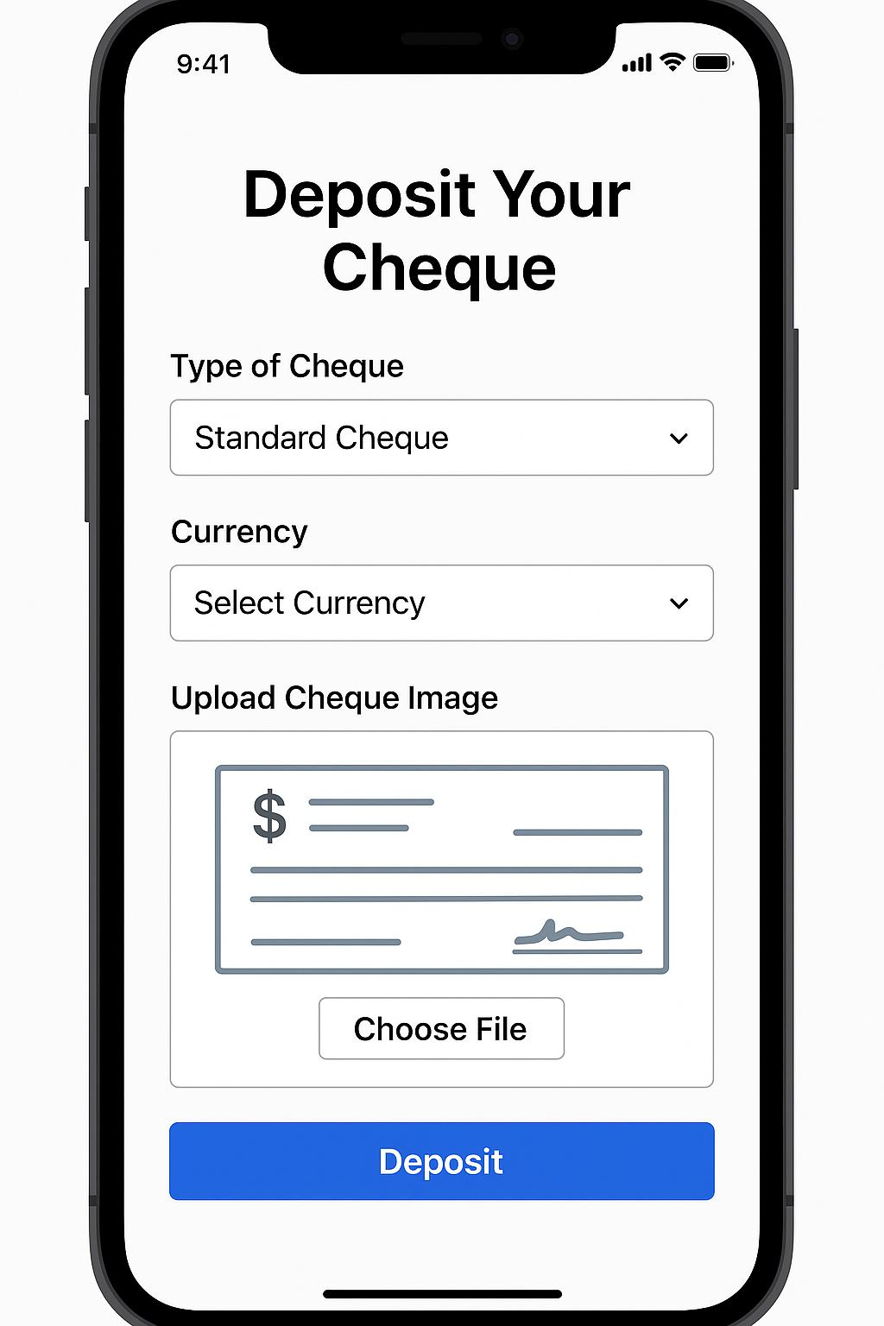

Here's a clear and concise explanation of the provided HTML code:

Overview
This is a cheque deposit form webpage that allows users to:
- Select a cheque type
- Choose a currency
- Upload an image of the cheque
- Submit the details

Key Components
- Basic Structure:
  - Uses HTML5 (<!DOCTYPE html>)
  - Responsive design with Bootstrap 5
  - Clean styling with a card layout and subtle shadow
- Form Fields:
  - Dropdown for cheque type (Standard, Traveler's, Demand Draft)
  - Currency selection (USD, EUR, INR, GBP)
  - File upload for cheque image (with image preview)
- Functionality:
  - JavaScript displays a preview of the uploaded cheque image
  - Form submission is intercepted (prevented) for client-side processing
  - Currently shows an alert on submission (would typically send data to a server)
- Styling:
  - Light gray background
  - Rounded corners (15px) for the card
  - Responsive image preview (max 300px height)

Technical Notes
- Uses CDN for Bootstrap CSS
- Image preview uses URL.createObjectURL()
- Form validation is basic (HTML5 required attribute)
- No actual backend integration (just a placeholder)
This is a frontend-only implementation that would need server-side code to process the cheque deposit request.

