Universal Multiple-Octet Coded Character Set
UCS

ISO/IEC JTC1/SC2/WG2 IRG N 1574

Date: 2009-06-12

Source:  Meeting:  Title:  Status:  Actions required:  Distribution:  Medium:  Pages: | China  IRG#32, Hong Kong, China  Activity Report  Member’s submission  FYI  IRG  Electronic  3

1. Collection of un-encoded ideographs.

The Commercial Press (商務印書館) and other publishing houses are colleting un-encoded ideographs used in traditional Chinese dictionaries (字書、韻書). Founder Group (方正集團) is checking and making glyphs for many un-encoded ideographs used for person names and geography names, collected from Ministry of Public Security and Ministry of Civil Affairs.

The collection will be proposed to IRG in future.

2. Old hanzi had been checked.

The old hanzi glyphs belonging to Radical 471-540 of Shuowen Jiezi (說文解字) were taken out from the oracle bones database for making fonts. All glyphs and fonts of Radical 471-540 (prepared by China) and of Radical 401-470 (prepared by TCA) were checked.

3. Collection of characters used in ancient Chinese music books.

We are collecting and making glyphs for some special characters used in ancient Chinese music books (古琴譜), score for a music instrument - Guqin (古琴). Guqin is an ancient music instrument of China, its history is more than 3,000 years, still a pop music instrument now. These characters are different to CJK ideographs although they look similar, they were used to record fingerings of Guqin. There are more than 60,000 characters collected and will be proposed to UCS when completed.

Examples of characters used in ancient Chinese music books (古琴譜):
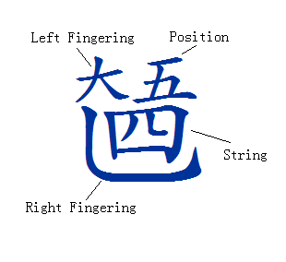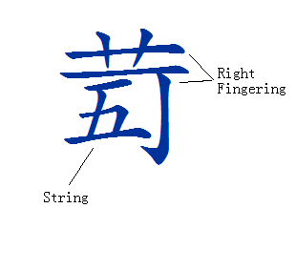
4. Some UCS related specifications were issued.

GF 0011-2009 The Table of Indexing Chinese Character Component (汉字部首表, developed and issued by the Ministry of education and the National Language Committee). This book specifies 201 major radicals and 99 attached radicals, radical table and usage rules.

GF 0011-2009 Specification for Identifying Indexing Components of GB 13000.1 Chinese Characters Set (GB13000.1字符集汉字部首归部规范, developed and issued by the Ministry of education and the National Language Committee). This book specifies principles and rules

GF 0011-2009 Specification of the Undecomposable Characters Commonly Used In the Modern Chinese (现代常用独体字规范, developed and issued by the Ministry of education and the National Language Committee). This book specifies 256 undecomposable characters.

Specification of Components and Their Names of Characters Commonly Used In the Modern Chinese (现代常用字部件及部件名称规范, developed and issued by the Ministry of education and the National Language Committee). This book specifies decomposing rules, components and their names.

