**USER’S GUIDE**

**What is this?**

This is a GUI (Graphical User Interface) built in Python that allows you to detect cells and crystals in bright-field and polarized light images at different scales (20 µm, 40 µm, 100 µm, 200 µm).

**What do I need to have installed on my PC?**

**Python, along with the following libraries:**

* numpy
* pandas
* matplotlib
* openpyxl
* xlsxwriter
* scipy
* opencv-python-headless
* scikit-image
* PyQt5
* scikit-learn

You also need an interpreter to run the Python executable file. In our case, we use PyCharm.

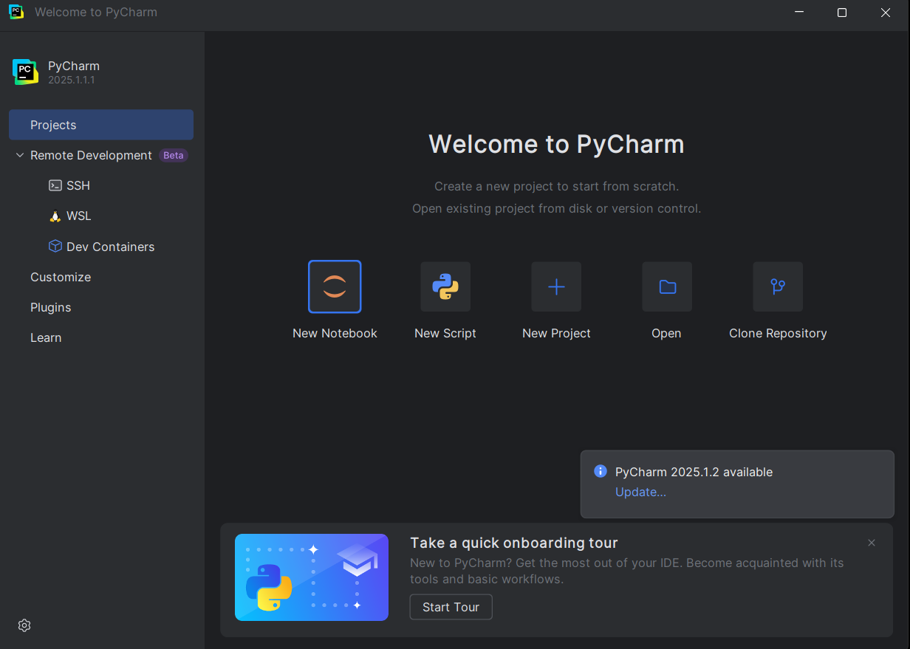

**How can I open the GUI in my PC?**

1. Open the script with double click on the file and you get the next screen:

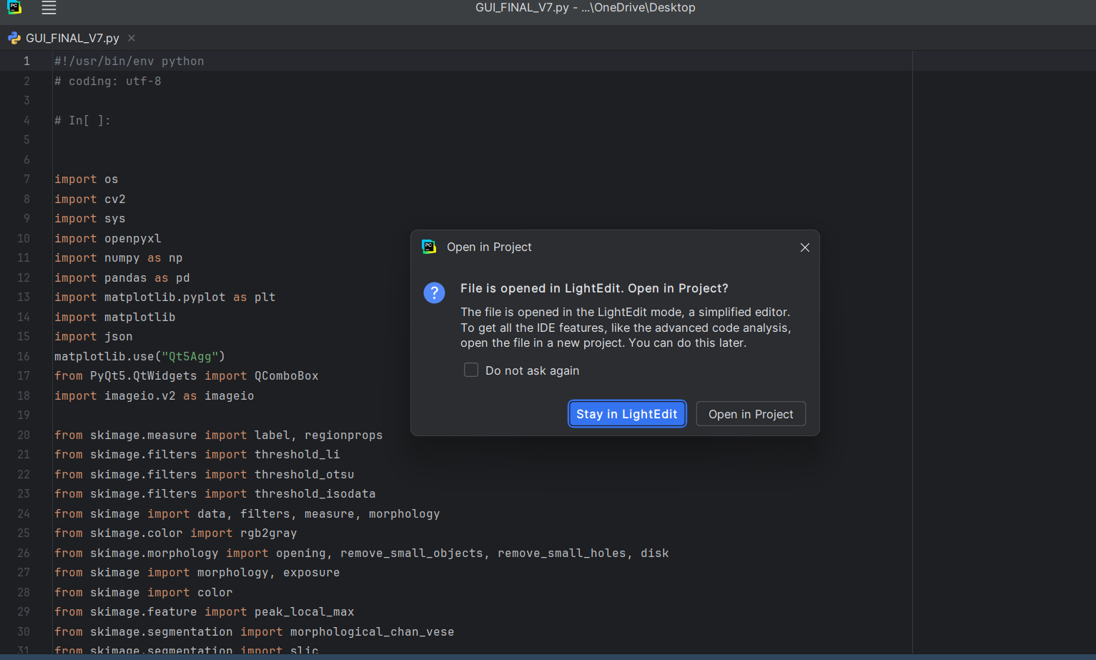

1. Choose “Open in Project” and you get the next screen:

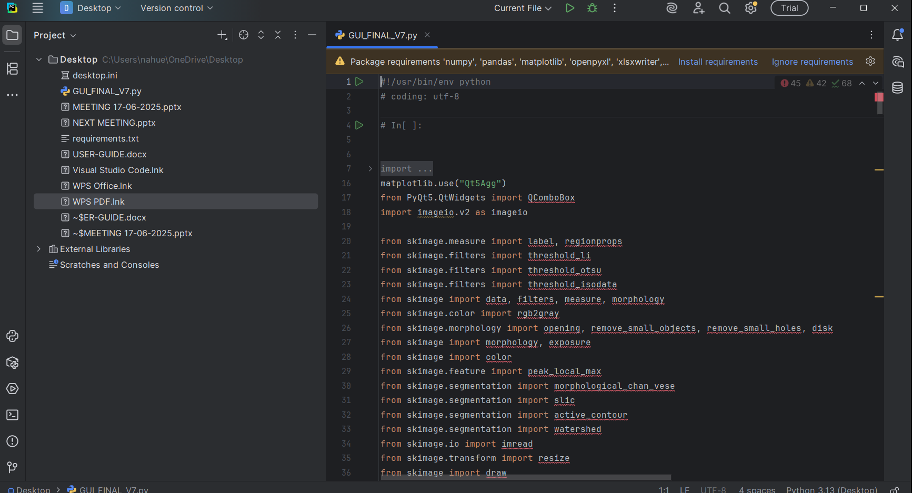

1. You go to terminal, do click or press ALT + F12

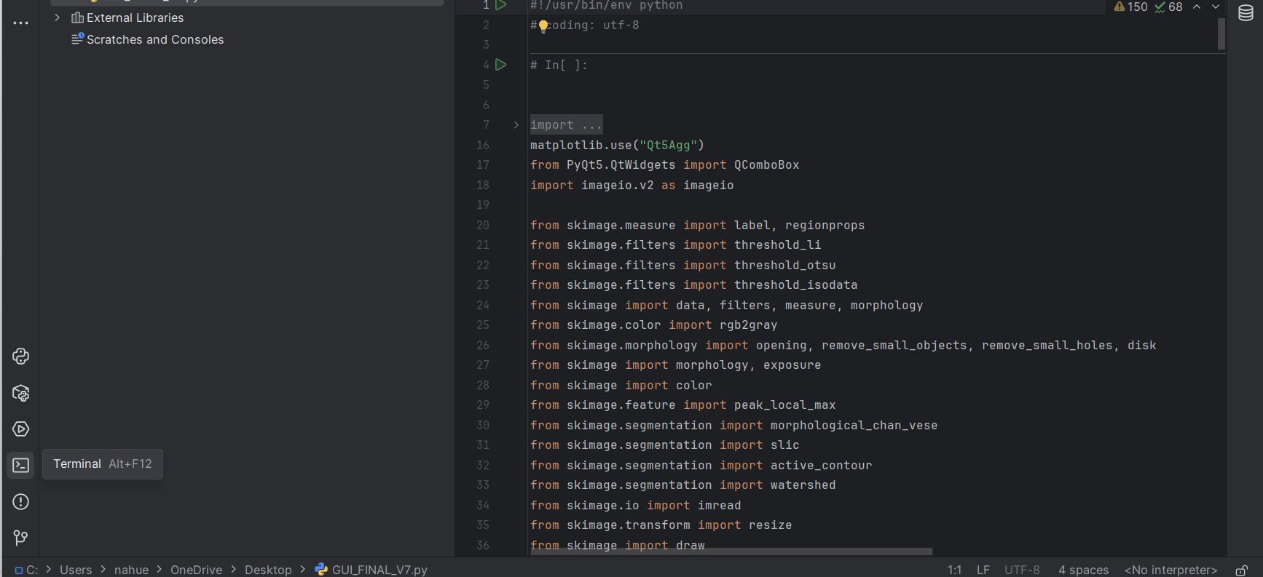

TERMINAL



You get the next screen:

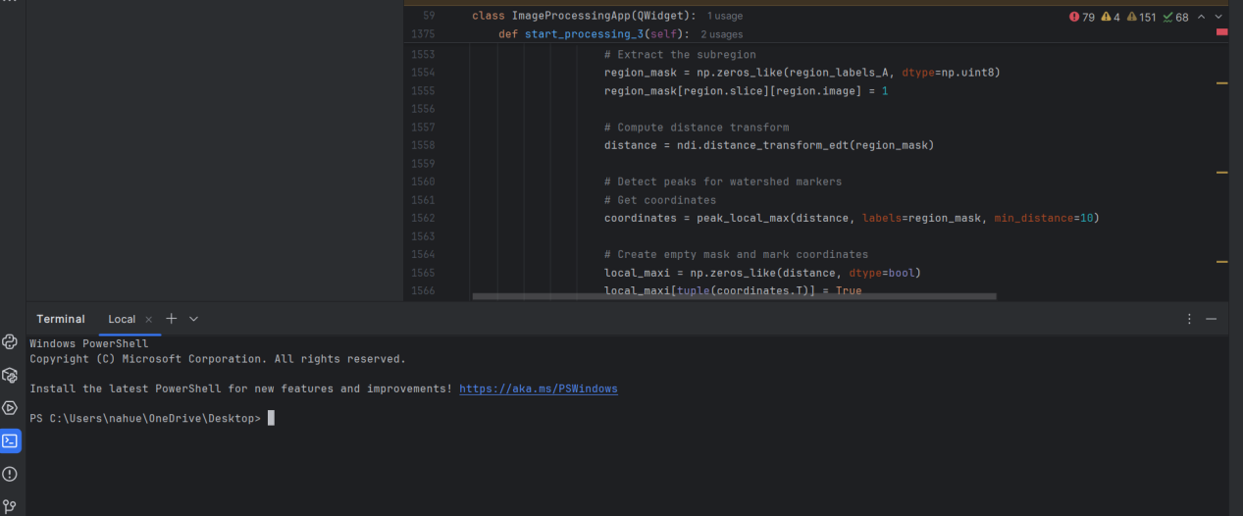

1. In Command Line you maybe to write “**python FILE_NAME”,** in this case the file is **GUI_FINAL_V7.**



Then you can open the GUI.

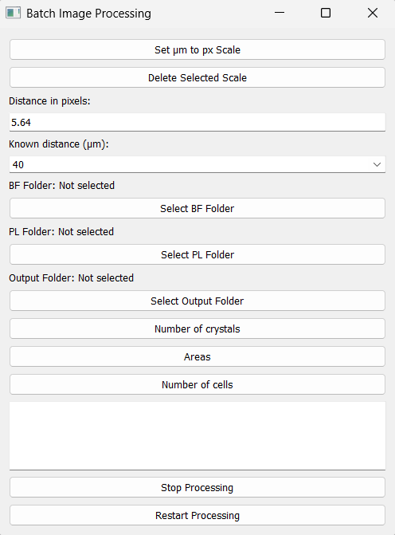

**GUI BUTTONS AND LIST**

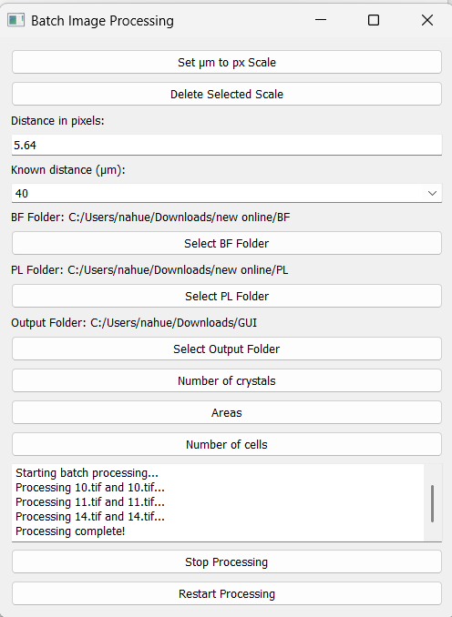

**Shows the batch processing image by image.**

11

10

9

8

7

6

5

4

3

2

1

1. **ADD SCALES**

First you need to use **ImageJ** once to get the micrometer/pixel equivalence and save the new scale permanently so you can select it from the GUI's list of scales without having to use the GUI again.

**How to install ImageJ?**

You need to go at the next link:

**<https://imagej.net/ij/>**

Download the program from this page for the operating system you have on your personal computer.

Once installed, you open the app and you will see the following screen and open an image containing the scale bar to calculate the micrometer/pixel conversion.

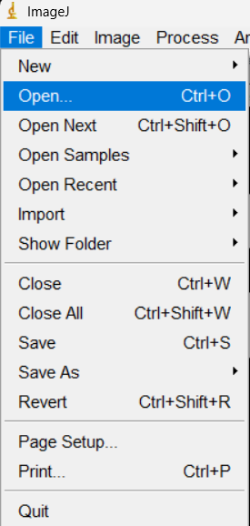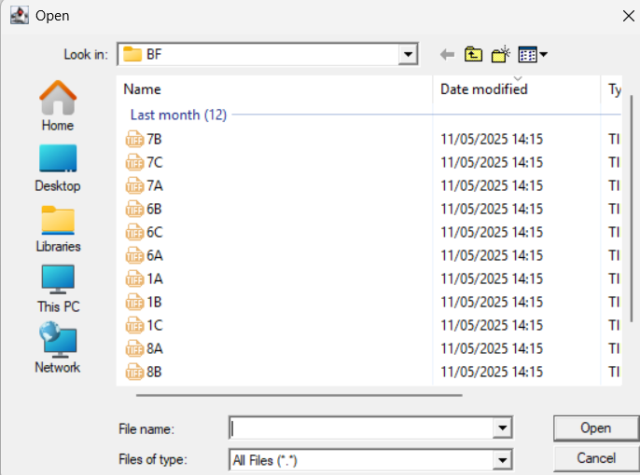

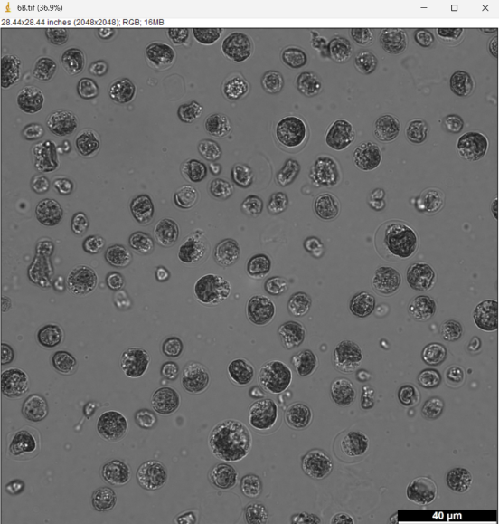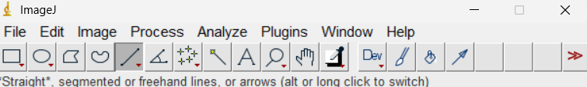

**With that button draw a line on the scale bar.**



Then go to "Analyze" and select "Measure".

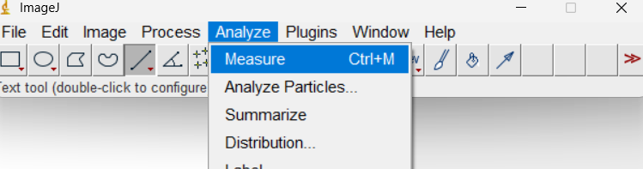

You get the next screen

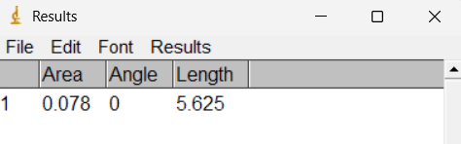

Measurements are in pixels.

In this example, this means that **40 µm is equivalent to 5,625 pixels.** With these measurements, you can add a new scale to the GUI.

Press the button **“Set um to px Scale”.**

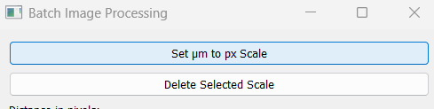

You write the scale in um, in our case 40. Press OK.

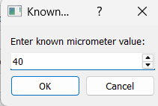

Now, write the scale in px that you obtained with ImageJ, in our case 5.625 px. Press OK.

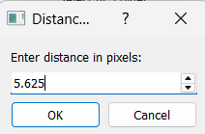

In the next dialog box, press OK and the new scale is permanently saved in the list.

1. **DELETE SCALES**

First you need to select the scale you want to delete from the list of scales.

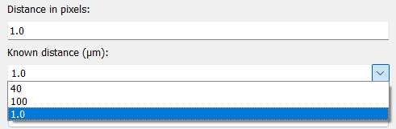

In this case select scale 1 um=1 px, which is the scale I want to delete.

Press the button **“Delete Selected Scale”.**

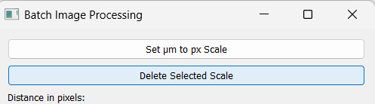

You get the next dialog box:

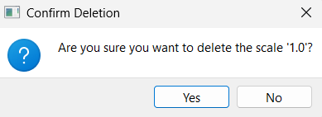

Press **Yes** to delete or **No** to cancel.

If you press **Yes** you don’t see more this scale in the list:

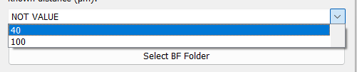

1. **List of scales**

List of all scales loaded in the GUI, as previously explained you can load new scales or delete existing scales.

----------------------------------------------------------------------------------------------------------------------------------------------------------------------------------------------------------------------------------

**Uploading images**

In order to automatically create graphics, it is important that the image names have a format with the day number and a letter, for example if you have 3 images of that day it would be A, B, C.

**For example, you have 3 folders, each folder have 3 images:**

-6/7/2025(1 folder)------->xx_00, xx_01,xx_02(3 images)----------------->**day 1**

-7/7/2025 (1 folder)------> xx_00, xx_01,xx_02(3 images)---------------->**day 2**

-8/7/2025 (1 folder)------> xx_00, xx_01,xx_02(3 images)---------------->**day 3**

**Then you need to change the name as it:**

-1A,1B,1C

-2A,2B,2C

-3A,3B,3C

----------------------------------------------------------------------------------------------------------------------------------------------------------------------------------------------------------------------------------

1. **BF Folder**

Select the folder where the BF images to be analyzed are stored.

1. **PL Folder**

Select the folder where the PL images to be analyzed are stored.

1. **Output Folder**

Select the folder where all processing results are saved.

**IMPORTANT: Every time you process a new batch, remember to change the output folder so you don't overwrite previous files and lose all the information. A second option is to move the files to another folder if you want to always use the same output folder.**

1. **Number of Crystals**

In this case, you can obtain the number and percentage of cells with crystals in each image and a plot with the percentage of cells with crystals over the time measured in days.

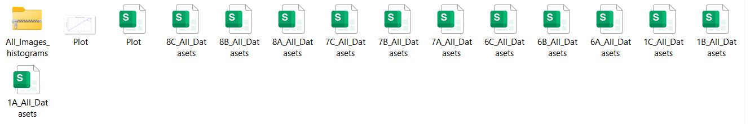

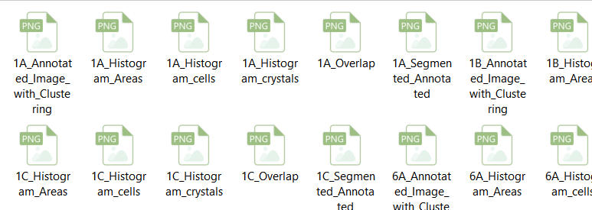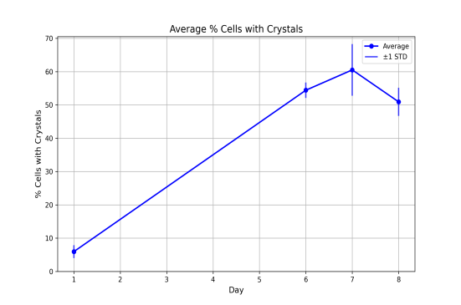

1. **Areas**

In this case, you can obtain the area of the crystals and the percentage of the area of the crystals over the area of the cells in each image, as well as a graph with the percentage of the area of the crystals over the area of the cells over time measured in days.

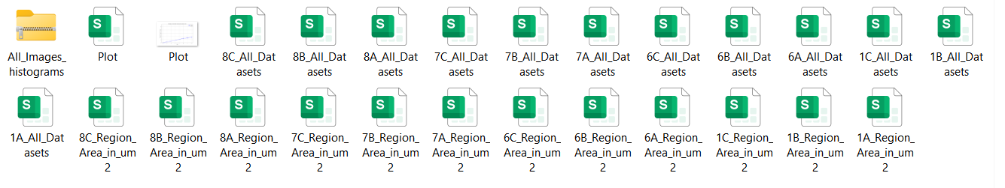

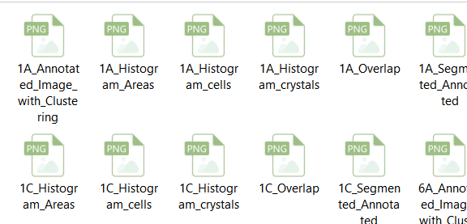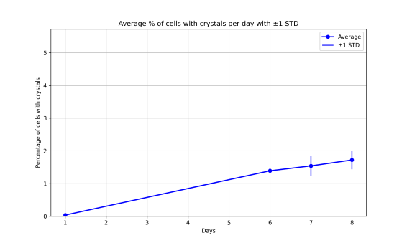

1. **Numbers of cell**

In this case, the area and number of cells per image can be obtained. There are no plots, only segmented image, overlap and histograms.

1. **Stop Processing**

Stop the batch processing.

1. **Restart Processing**

Restart the batch processing

**DATASETS**

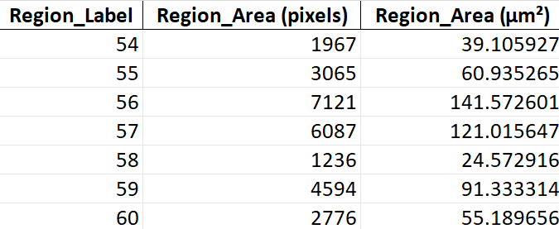

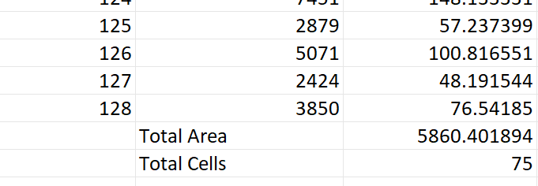

**ONE DATASET PER IMAGE.**

**REGION LABEL:** It is the number with which each cell is designated.

**REGION _AREA(PIXELS):**Area of each cell in pixels.

**REGION _AREA(um2):**Area of each cell in micrometers.

**TOTAL AREA:** Total area of all cells in the image.

**TOTAL CELLS:** Total amount of cells in the image.

------------------------------------------------------------------------------------------------------------------------------------------------------------------------------------------------------------------------------------------------------------------------------

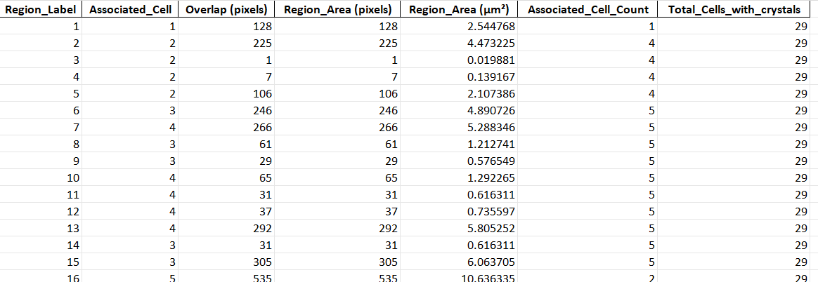

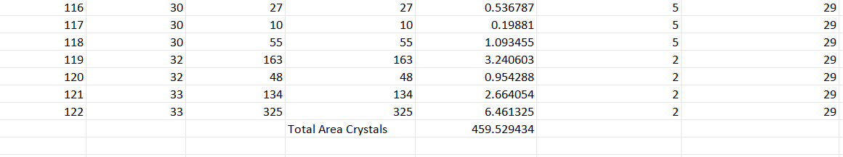

**ONE DATASET PER IMAGE.**

**REGION LABEL:** It is the number with which each crystal is designated.

**Associated_Cell:** It is the number of the cell to which each detected crystal is associated.

**Overlap:** It is the area resulting from the correlation between the BF and PL image and which coincides with the area of the crystal.

**REGION _AREA(PIXELS):**Area of each crystal in pixels.

**REGION _AREA(um2):**Area of each crystal in micrometers.

**Associated_Cell_Count:** Count the number of crystals in each cell associated with the crystals.

**Total_Cells_with_crystals:** The value is repeated in each row but it is a single value that represents the total number of cells with crystals. In our example case, it would be 29 cells that have crystals, that is, 1 or more crystals.

**Total Area Crystals:** It is the total sum of the area of the crystals in micrometers that are in the image.

------------------------------------------------------------------------------------------------------------------------------------------------------------------------------------------------------------------------------------------------------------------------------

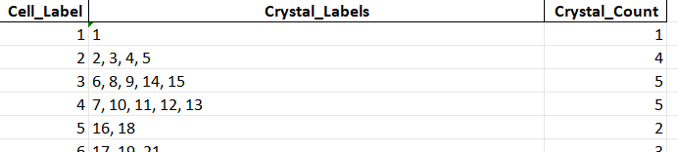

**ONE DATASET PER IMAGE.**

**Cell_Label:** It is the number assigned to each cell.

**Crystal_Labels:** It is the number assigned to each crystal.

**Crystal_Count:** It is the amount of crystals that each cell has.

------------------------------------------------------------------------------------------------------------------------------------------------------------------------------------------------------------------------------------------------------------------------------

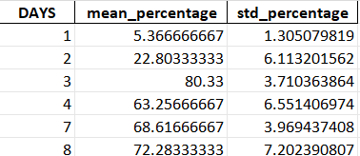

**ONE DATASET PER FOLDER.**

**DAYS:** Time sequence in days of the samples.

**Mean_percentage:** It is the average percentage of each day, in %.

**Std_percentage:** It is the standard deviation of each day, in %.