**USER’S GUIDE**

**What is this?**

This is a online app built in Python with library Streamlit that allows you to detect cells and crystals in bright-field and polarized light images at different scales (10 µm, 20 µm, 40 µm, 100 µm).

**What do I need to have installed on my PC?**

**Python, along with the following libraries:**

- Streamlit

- NumPy

- SciPy

- scikit-image

- OpenCV

- Pillow (PIL)

- Pandas

- Matplotlib

- scikit-learn

- OpenPyXL

- XlsxWriter

The application is stored in a Git Hub repository, it consists of two files, an executable ".py" file and another ".txt" file that contains the necessary libraries previously described for the application to work online.

The files are:

-app.py

-requirements.txt

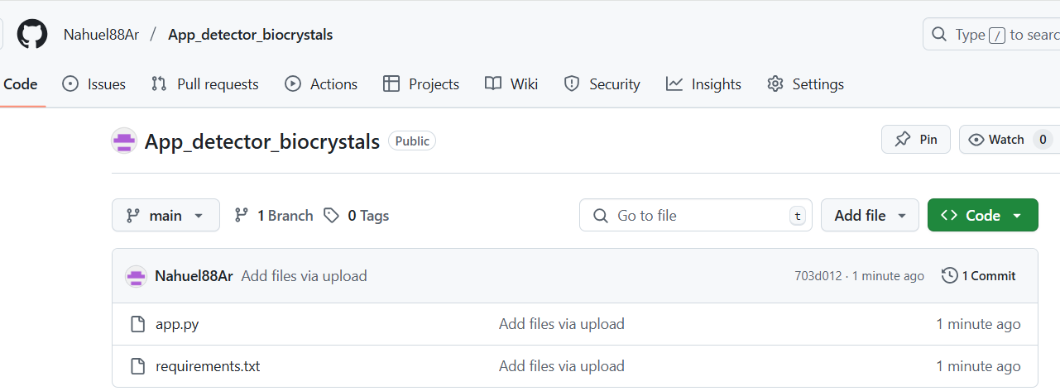

The files are stored in a Git Hub repository, which connects to the Streamlit server to generate the necessary link for online use.

LINK:

<https://appdetectorbiocrystals-m5qi2svpgqviarnjwzvh9q.streamlit.app/>

**Description of the online app**

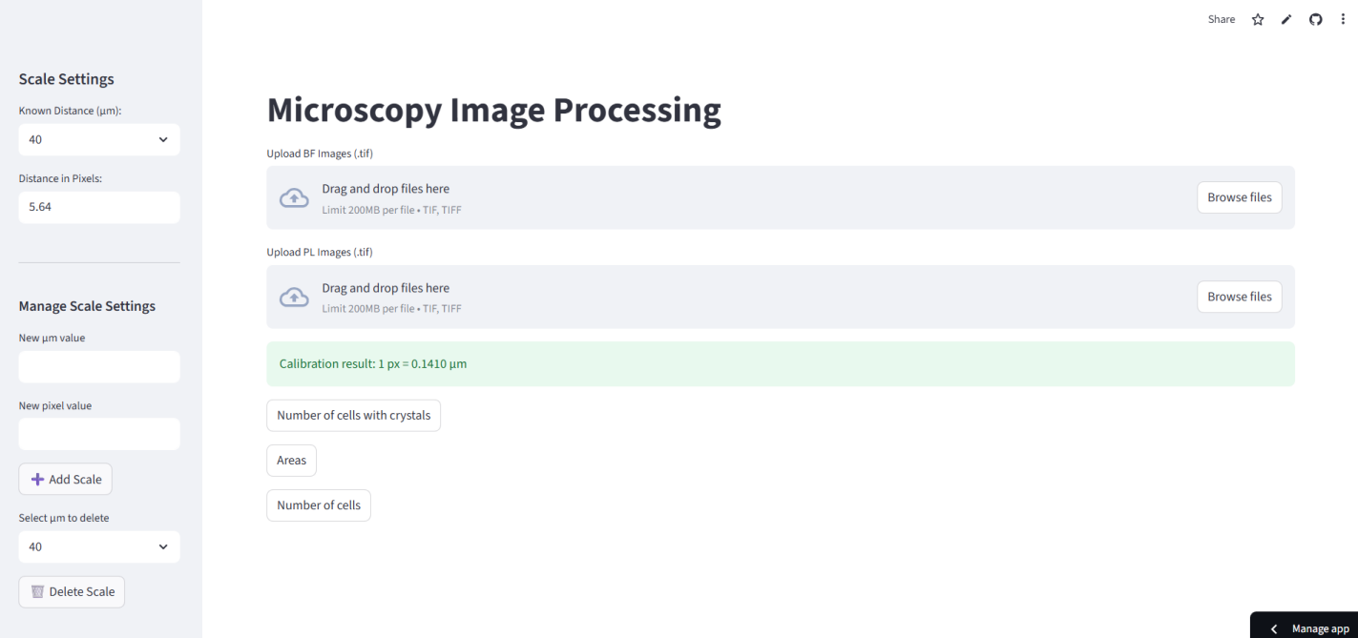

8

7

6

5

4

3

1

2

**Uploading images**

In order to automatically create graphics, it is important that the image names have a format with the day number and a letter, for example if you have 3 images of that day it would be A, B, C.

**For example, you have 3 folders, each folder have 3 images:**

-6/7/2025(1 folder)------->xx_00, xx_01,xx_02(3 images)----------------->**day 1**

-7/7/2025 (1 folder)------> xx_00, xx_01,xx_02(3 images)---------------->**day 2**

-8/7/2025 (1 folder)------> xx_00, xx_01,xx_02(3 images)---------------->**day 3**

**Then you need to change the name as it:**

-1A,1B,1C

-2A,2B,2C

-3A,3B,3C

***Output***

***All outputs are saved in the “Downloads” folder on your personal computer.***

***You can move the files at other folder where you want to save the data.***

1. **BF Folder**

Select the BF images to be analyzed. Press **“Browse files”** and you select the BF images to upload.

1. **PL Folder**

Select the PL images to be analyzed.Press **“Browse files”** and you select the PL images to upload.

**For example:** 2 BF images and 2 PL images. Name of images: 10,11

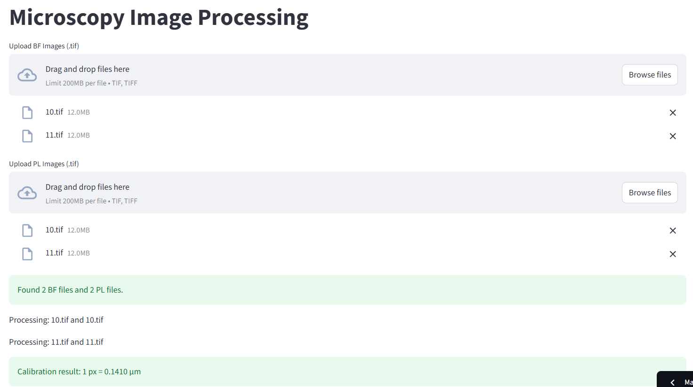

1. **Number of Crystals**

In this case, you can obtain the number and percentage of cells with crystals in each image and a plot with the percentage of cells with crystals over the time measured in days.

You need to press the next buttons to download the datasets, images, histograms and plots.

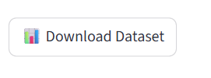1 per image

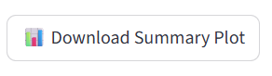

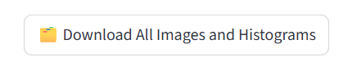only 1 for all images

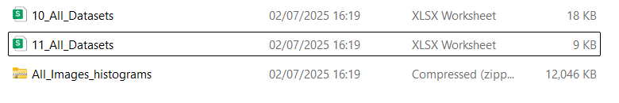

1. **Areas**

In this case, you can obtain the area of the crystals and the percentage of the area of the crystals over the area of the cells in each image, as well as a graph with the percentage of the area of the crystals over the area of the cells over time measured in days.

You need to press the next buttons to download the datasets, images, histograms and plots.

1 per image



only 1 for all images



1. **Numbers of cell**

In this case, the area and number of cells per image can be obtained. There are no plots, only segmented image, overlap and histograms.

You need to press the next buttons to download the datasets, images and histograms.

1 per image

only 1 for all images

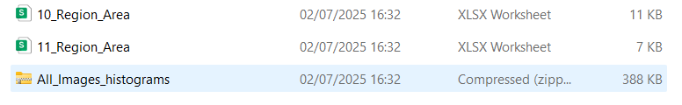

1. **List of all scales loaded in the online app.**

The list contain 2 options, 40 um and 100 um, but you have buttons to add new scales and delete currently scales.

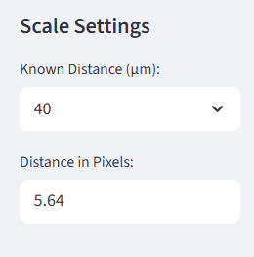

1. **ADD SCALES**

First you need to use **ImageJ** once to get the micrometer/pixel equivalence and save the new scale permanently so you can select it from the GUI's list of scales without having to use the online app again.

**How to install ImageJ?**

You need to go at the next link:

**<https://imagej.net/ij/>**

Download the program from this page for the operating system you have on your personal computer.

Once installed, you open the app and you will see the following screen and open an image containing the scale bar to calculate the micrometer/pixel conversion.

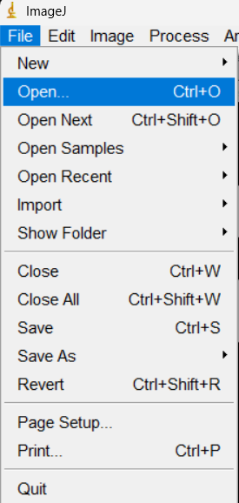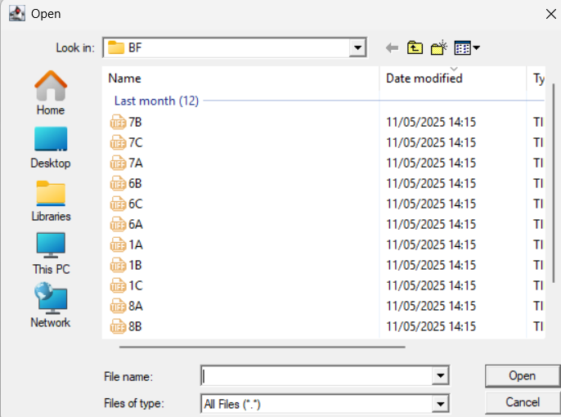

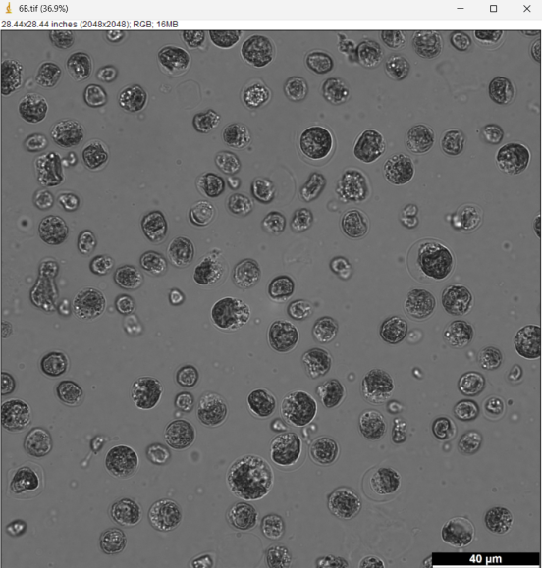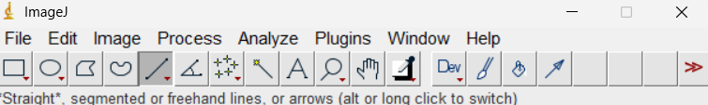

**With that button draw a line on the scale bar.**



Then go to "Analyze" and select "Measure".

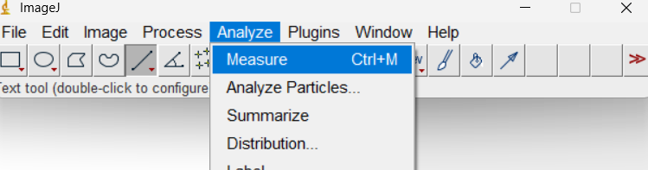

You get the next screen

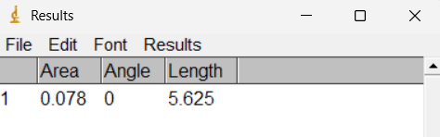

Measurements are in pixels.

In this example, this means that **40 µm is equivalent to 5,625 pixels.** With these measurements, you can add a new scale to the online app.

For example we want to add a new scale: 1 um = 1 px. You get the next screen.

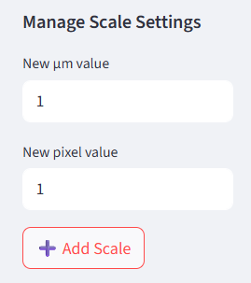

Press “Add Scale”. You get the next screen:

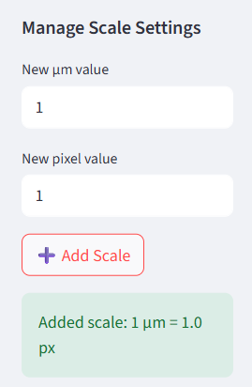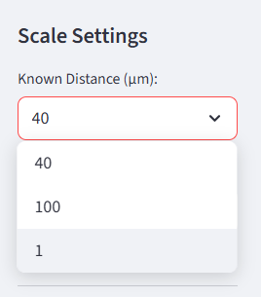

1. **DELETE SCALES**

First you need to select the scale you want to delete from the list of scales.

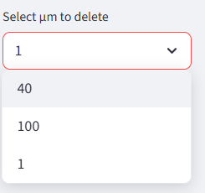

In this case select scale 1 um=1 px, which is the scale I want to delete.

Press the button **“Delete Scale”.**

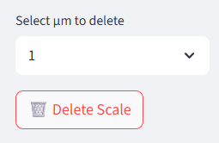

You get the next messenger:

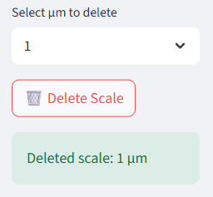

**DATASETS**

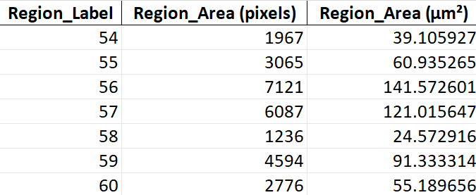

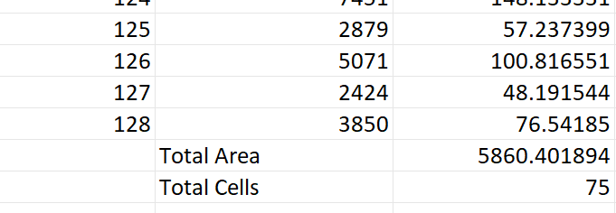

**ONE DATASET PER IMAGE.**

**REGION LABEL:** It is the number with which each cell is designated.

**REGION _AREA(PIXELS):**Area of each cell in pixels.

**REGION _AREA(um2):**Area of each cell in micrometers.

**TOTAL AREA:** Total area of all cells in the image.

**TOTAL CELLS:** Total amount of cells in the image.

------------------------------------------------------------------------------------------------------------------------------------------------------------------------------------------------------------------------------------------------------------------------------

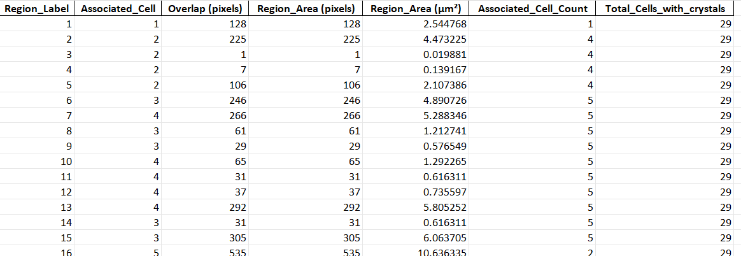

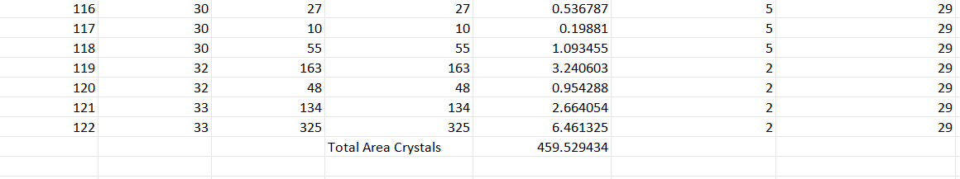

**ONE DATASET PER IMAGE.**

**REGION LABEL:** It is the number with which each crystal is designated.

**Associated_Cell:** It is the number of the cell to which each detected crystal is associated.

**Overlap:** It is the area resulting from the correlation between the BF and PL image and which coincides with the area of the crystal.

**REGION _AREA(PIXELS):**Area of each crystal in pixels.

**REGION _AREA(um2):**Area of each crystall in micrometers.

**Associated_Cell_Count:** Count the number of crystals in each cell associated with the crystals.

**Total_Cells_with_crystals:** The value is repeated in each row but it is a single value that represents the total number of cells with crystals. In our example case, it would be 29 cells that have crystals, that is, 1 or more crystals.

**Total Area Crystals:** It is the total sum of the area of the crystals in micrometers that are in the image.

------------------------------------------------------------------------------------------------------------------------------------------------------------------------------------------------------------------------------------------------------------------------------

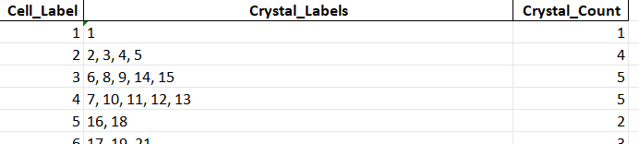

**ONE DATASET PER IMAGE.**

**Cell_Label:** It is the number assigned to each cell.

**Crystal_Labels:** It is the number assigned to each crystal.

**Crystal_Count:** It is the amount of crystals that each cell has.

------------------------------------------------------------------------------------------------------------------------------------------------------------------------------------------------------------------------------------------------------------------------------

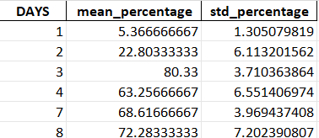

**ONE DATASET PER FOLDER.**

**DAYS:** Time sequence in days of the samples.

**Mean_percentage:** It is the average percentage of each day, in %.

**Std_percentage:** It is the standard deviation of each day, in %.



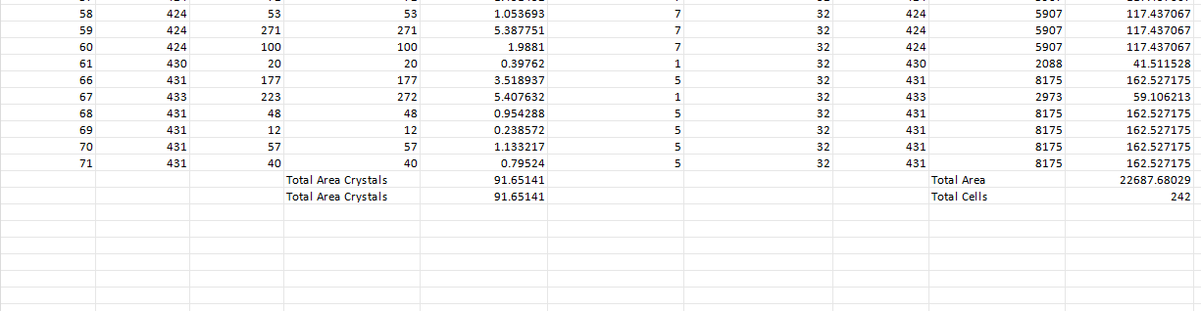

**ONE DATASET PER IMAGE**

It is a merge between the dataset with information on cells and crystals.

**Region_Label_x:** It is the number with which each crystal is designated.

**Associated_Cell:** It is the number of the cell to which each detected crystal is associated.

**Overlap:** It is the area resulting from the correlation between the BF and PL image and which coincides with the area of the crystal.

**REGION _AREA(PIXELS)_x:**Area of each crystal in pixels.

**REGION _AREA(um2)_x:**Area of each crystal in micrometers.

**Associated_Cell_Count:** Count the number of crystals in each cell associated with the crystals.

**Total_Cells_with_crystals:** The value is repeated in each row but it is a single value that represents the total number of cells with crystals. In our example case, it would be 29 cells that have crystals, that is, 1 or more crystals.

**Region_Label_y:** It is the number with which each cell is designated.

**REGION _AREA(PIXELS)_y:**Area of each cell in pixels.

**REGION _AREA(um2)_y:**Area of each cell in micrometers.

**TOTAL AREA:** Total area of all cells in the image.

**TOTAL CELLS:** Total amount of cells in the image.

**Total Area Crystals:** It is the total sum of the area of the crystals in micrometers that are in the image.

**IMPORTANT: AFTER BATCH PROCESSING IS COMPLETED, YOU NEED TO FIRST SELECT "STOP" ON THE SCREEN TO END THE PROCESS AND THEN REFRESH THE BROWSER TO UPLOAD THE IMAGES FOR A NEW BATCH AND SELECT THE REQUIRED ACTION AGAIN.**



***FIRST YOU PRESS “STOP”***

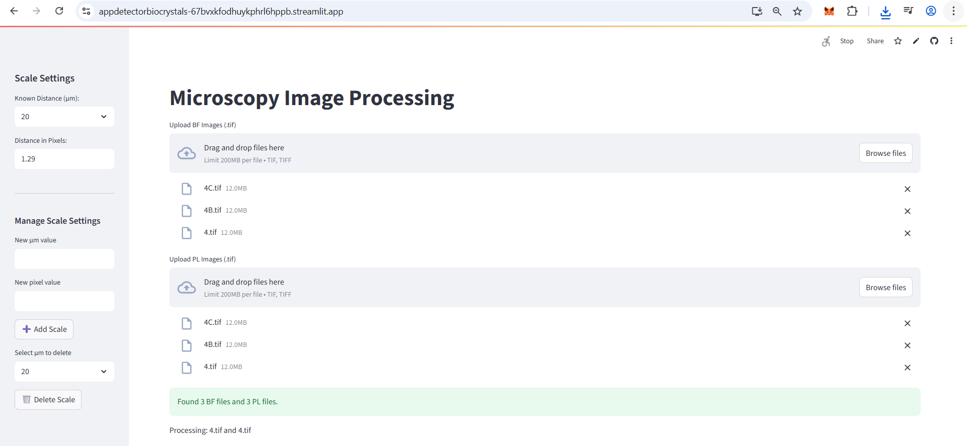



***AFTER PRESSING "STOP" REFRESH THE BROWSER***