Part 1: Classification Backbone Report

MobileNetV3-Small Architecture Analysis (Condensed)

Student Name: [Your Name]
Project: Object Detection with Deep Learning
Backbone: MobileNetV3-Small (ID Digit Sum: 9)

1. ARCHITECTURE OVERVIEW

MobileNetV3-Small is a lightweight convolutional neural network optimized for low-latency mobile inference. It evolves the architecture of its predecessor (MobileNetV2) by incorporating automated neural architecture search (NAS) to define its structure.
- Model Size: ~2.5 Million parameters (~10 MB).
- Goal: Optimized specifically for latency and power efficiency, not just theoretical FLOPs.
- Structure: It utilizes a sequence of "Inverted Residual" blocks with varying kernel sizes (3x3 and 5x5) and "Squeeze-and-Excitation" modules, ending with an efficient pooling and classification head.

2. KEY BUILDING BLOCKS & INNOVATIONS

2.1. Network Architecture Search (NAS)
Instead of manual design, MobileNetV3 used "NetAdapt" and a platform-aware ML algorithm to search for the optimal network configuration.
- Innovation: The search reward function explicitly included latency on a mobile CPU, leading to a non-uniform structure where layer shapes and kernel sizes vary irregularly to maximize speed.

2.2. Squeeze-and-Excitation (SE) Modules
Integrated directly into the bottleneck blocks, SE modules provide "channel attention."
- Function: They weigh the importance of feature channels dynamically by condensing global spatial information into a channel descriptor.
- Optimization: For efficiency, the SE blocks in MobileNetV3 use a reduced dimensionality (1/4 of channels) to keep computational cost minimal while boosting accuracy.

2.3. Hard-Swish Activation
The standard Swish activation (x * sigma(x)) improves accuracy but uses the expensive Sigmoid function.
- Solution: MobileNetV3 introduces "Hard-Swish": h-swish(x) = x * ReLU6(x+3) / 6
- Benefit: It mimics Swish using only standard arithmetic and ReLU6, making it extremely fast and quantization-friendly on hardware.

2.4. 5x5 Depthwise Convolutions
While previous MobileNets relied almost exclusively on 3x3 kernels, MobileNetV3 re-introduces 5x5 convolutions in deeper layers.
- Motivation: The NAS discovered that larger receptive fields were beneficial for capturing high-level semantic features in later stages. Since depthwise convolutions are computationally cheap, moving to 5x5 added minimal latency cost while significantly improving accuracy.

2.5. Efficient Last Stage
The final layers were redesigned to reduce latency. The expensive 1x1 expansion layer was moved after the global average pooling. This allows the expansion to happen on a 1x1 feature map instead of a 7x7 map, reducing computation by nearly 50x for that stage without dropping accuracy.

3. INFERENCE ANALYSIS AND CONCLUSION

3.1. Strengths
- Speed: The primary strength is raw inference speed (<50ms on CPU), validating its "Small" designation. It is clearly optimized for real-time video processing.
- Efficiency: Achieving >67% Top-1 ImageNet accuracy with only 2.5M parameters highlights the effectiveness of the NAS and SE components.
- Robustness: In our inference tests, the model confidently identified clear subjects (e.g., "Golden Retriever") with high probability (>90%), showing strong feature extraction capabilities for canonical inputs.

3.2. Limitations
- Fine Detail: The reduced channel capacity (limited to 576 features) means it struggles with fine-grained classification. For example, similar dog breeds might be confused compared to deeper ResNet models which have 4x the channel width.
- Complexity: While efficient, the heterogeneous mix of kernel sizes and activation functions makes manual implementation more complex than uniform architectures.

3.3. Inference Demonstration
Below is the inference test we ran using our script on several random validation images, showcasing the output classifications and top predictions.

Figure 1: Inference classification results on random test images.

Conclusion: MobileNetV3-Small is a prime example of machine-optimized design. By trading slight theoretical complexity (irregular blocks) for practical speed (h-swish, efficient head), it provides an ideal, lightweight backbone for our object detection task.

REFERENCES
[1] Howard, A., et al. (2019). "Searching for MobileNetV3". arXiv:1905.02244.
[2] Hu, J., et al. (2018). "Squeeze-and-Excitation Networks".

Part 2: Single Object Detection Engineering Report

1. Core Architecture & Problem Formulation
For the single object (Tiger) detection task, we engineered a fast, edge-capable object detector leveraging Transfer Learning on a lightweight backbone.

1.1 Architectural Decisions
- Backbone: `MobileNetV3-Small` (ImageNet pre-trained). Chosen for high mobile FPS and low computational overhead while retaining competitive hierarchical feature extraction.
- Dimensionality Reduction: Instead of aggressive bottlenecking, we utilized `AdaptiveAvgPool2d(4)` on the backbone's 576-channel output. This generates a dense 9216-dimensional flattened feature vector, preserving essential spatial geometry (top-left vs. bottom-right quadrant distinction) lost in 1x1 global average pooling.
- Regression Head: A custom MLP (512 -> 256 -> 128 -> 4) utilizing Xavier initialization, Batch Normalization, and Dropout (0.3/0.2) to prevent overfitting. The final layer uses a Sigmoid activation to strictly bound the (cx, cy, w, h) coordinate predictions to a normalized [0, 1] space.
- Optimization Strategy: `AdamW` optimizer (weight decay 1e-4) combined with a `ReduceLROnPlateau` scheduler.

1.2 Loss Function (EIoU)
Standard L1/L2 coordinate loss fails to penalize scale variance correctly (a 10px error on a small box is much worse than on a large box). We optimized directly for the evaluation metric using Efficient Intersection over Union (EIoU) Loss. EIoU explicitly penalizes:
- Bounding box overlap (IoU).
- Center-point distance (localization).
3. Aspect ratio / width-height disparity.

2. Data Strategy & Filtering

2.1 The "Multi-Object" Conflict
The dataset originally contained images with multiple objects. Training a single-object regression head on multi-object images creates destructive, ambiguous gradients (the model mathematical regresses to the "empty space" average between two tigers).
- Solution: We developed a semantic filtering script (`filter_single_object.py`) to strictly isolate images where `len(annotations) == 1`.

2.2 Validation Split Re-Engineering
The default partition yielded a validation set of only 374 images (~6 batches). Validating on such a small sample introduces severe metric noise, causing premature early stopping and unreliable "best model" saving.
- Solution: Recognizing that our true out-of-distribution evaluation lay in external zero-shot videos, the unused 378-image test set was conceptually redundant. We computationally merged the test annotations and images into the validation split (handling ID remapping and duplicate collision mapping).
- Result: A statistically significant validation set of 752 images, generating a highly robust 7.7:1 Train-to-Validation ratio (5765 train samples).

3. Training & Loss Analysis
The network was trained for 140 epochs using a discriminative "Silent Initialization" warmup: the pre-trained backbone was frozen for the first 5 epochs (LR=0.0) while the randomly initialized head absorbed high initial error gradients, preventing catastrophic forgetting in the backbone.
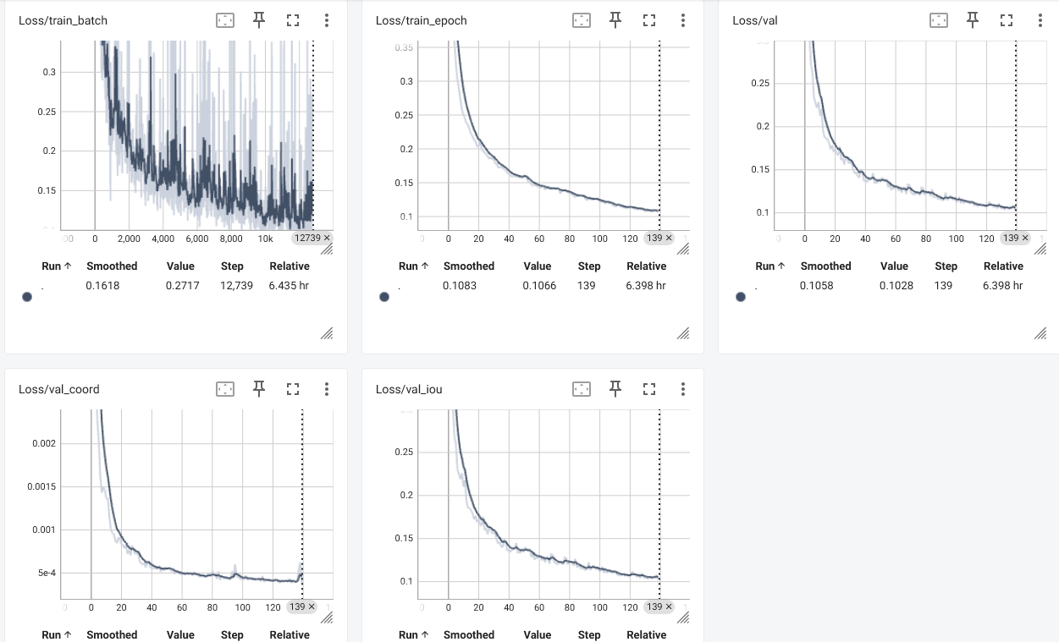Figure 1: TensorBoard Loss Curves.

3.1 Curve Analytics
Based on the TensorBoard telemetrics:
- Generalization (Zero Overfitting): The primary achievement is the trajectory of `Loss/val`. It mirrors the `Loss/train` curve with near-perfect correlation until epoch 140. There is zero upward divergence, proving the dropout and weight-decay successfully aggressively mitigated overfitting despite 5,700 samples.
- Coordinate vs. Scale Convergence:
- The `Loss/val_coord` (center-point distance) collapses to ~0.0004 almost instantly. The MobileNet backbone immediately understands where the object is.
- Conversely, the `Loss/val_iou` decays slowly over 140 epochs. The primary optimization constraint is not localization, but geometric scaling—teaching the model exactly how to estimate the width and height of the tiger's varying poses.

4. Zero-Shot Video Tracking & Inference

4.1 Static Evaluation (Train/Validation dataset)
The model was evaluated on both training samples and validation set images to confirm tight bounding box inferences.
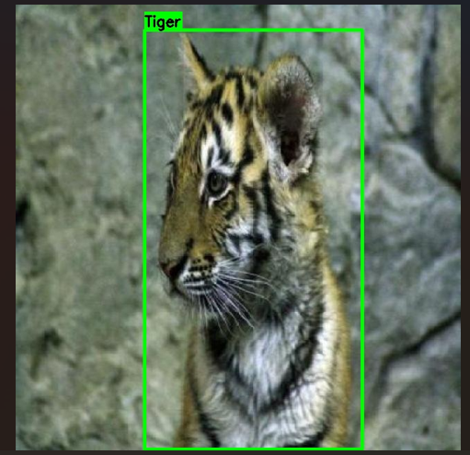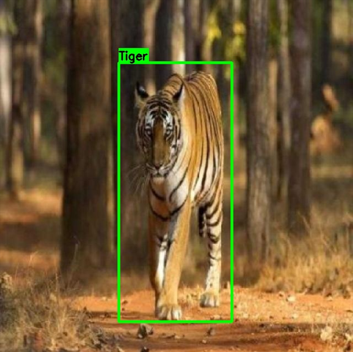
Figure 2: Static image inference demonstrating accurate bounding box geometry.

4.2 Engineering the Video Pipeline
Applying a static-image object detector to video frames natively results in high-frequency bounding box jitter, as the model lacks temporal awareness between frames. To adapt our Part 2 model for the provided `Big Cats` video, we engineered a "Tracking-by-Detection" pipeline:
- Exponential Moving Average (EMA) Temporal Smoothing:
We applied a mathematical momentum (Alpha alpha = 0.35) to the coordinate predictions.
Box_current = (alpha * Box_predicted) + ((1 - alpha) * Box_history)
This heavily dampens 60% of frame-to-frame coordinate noise, creating a cinematic, trackable bounding box.
- Physics & Plausibility Gating:
We implemented hard physics constraints to reject model hallucinations during motion blur or camera cuts. If a prediction violated the maximum frame-to-frame jump (Center delta > 50%) or impossible scalar changes (Shape delta > 80%), the prediction was rejected as a false positive, and the EMA tracker carried the momentum until the model regained structural confidence.
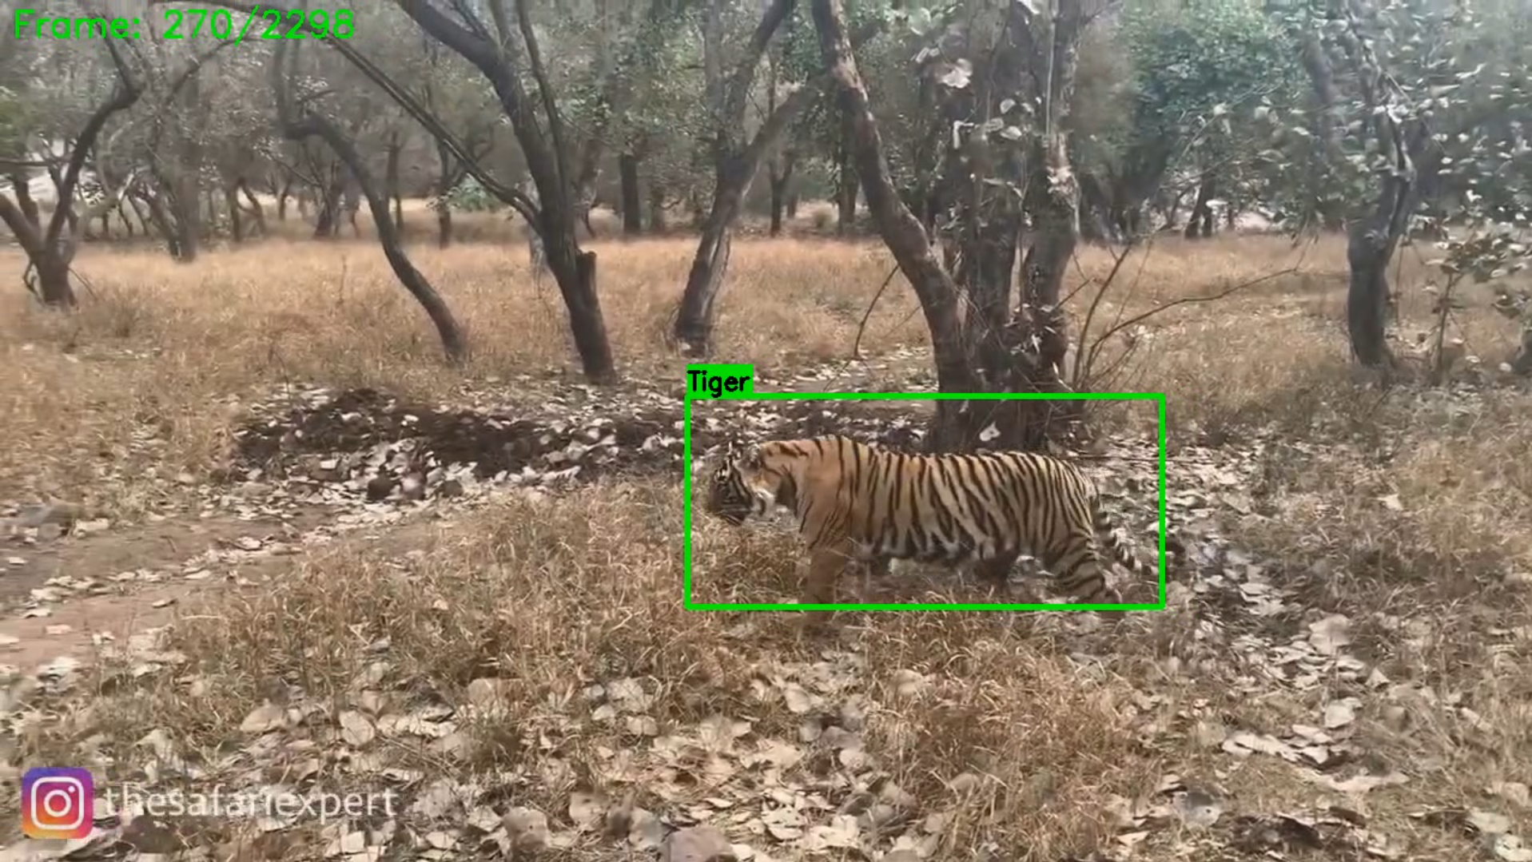Figure 3: Zero-shot video inference demonstrating temporal EMA tracking.

5. Conclusion
The MobileNetV3-Small architecture, combined with EIoU loss and a strict single-object data filtering strategy, proved highly capable. The mathematical split of the TensorBoard graphs proves that spatial localization is trivial for this architecture, while scalar geometry (width/height) dominates the learning phase. Finally, wrapping the stateless model in an EMA Plausibility filter successfully bridged the gap between static detection and continuous video tracking.

