Object Detection with Deep Learning: Project 3
Authors: Yehonatan Gurevich (206607962), Yehuda Frist (316484476)

Links
- Input Video: input
- Output Video Inference: output

Architecture Selection (ID Summation)
The project required selecting a convolutional backbone based on the summation of the group members' identification numbers.
- ID 1 (206607962) Sum: 2+0+6+6+0+7+9+6+2 = 38
- ID 2 (316484476) Sum: 3+1+6+4+8+4+4+7+6 = 43
- Combined Sum: 38 + 43 = 81
- Final Digit Sum: 8 + 1 = 9
- Result: Value 9 dictates the selection of the MobileNetV3-Small architecture.

Part 1: Classification Backbone Report

1. Architecture Overview
MobileNetV3-Small serves as a lightweight convolutional neural network optimized for low-latency inference on hardware-constrained environments. The architecture was derived utilizing automated Neural Architecture Search (NAS) combined with NetAdapt, distinguishing it from manually designed models.
- Model Size: Approximately 2.5 million parameters.
- Objective: Minimization of structural latency and power consumption while preserving representational capacity.
- Structure: The framework employs a sequence of inverted residual blocks interspersed with variable kernel dimensions (3x3 and 5x5) and Squeeze-and-Excitation (SE) modules, culminating in an efficient global average pooling mechanism and classification head.

2. Key Architectural Innovations

2.1. Network Architecture Search (NAS)
Rather than relying on empirical human design, MobileNetV3 incorporates a platform-aware ML optimization approach. The search reward function was explicitly parameterized to incorporate inference latency on mobile CPU topologies, yielding a heterogeneous structure wherein layer dimensionalities and kernel sizes vary irregularly to maximize computational throughput.

2.2. Squeeze-and-Excitation (SE) Modules
Integrated directly within the bottleneck blocks, SE modules facilitate dynamic channel attention.
- Function: These modules compute channel-wise weights by aggregating global spatial information into a descriptor, allowing the network to recalibrate feature map focus dynamically.
- Optimization: To strictly bound computational overhead, the SE blocks in MobileNetV3 utilize a reduced dimensionality projection (25% of the input channel size), successfully boosting classification accuracy at minimal FLOP cost.

2.3. Hard-Swish Activation Function
While the standard Swish activation (x * sigma(x)) demonstrably improves accuracy in deep networks, the calculation of the Sigmoid function introduces a severe latency penalty on edge devices.
- Solution: MobileNetV3 substitutes this with the "Hard-Swish" approximation: h-swish(x) = x * ReLU6(x+3) / 6.
- Benefit: This formulation successfully mimics Swish utilizing solely standard arithmetic and ReLU6, facilitating rapid computation and hardware-level quantization viability.

2.4. Integration of 5x5 Depthwise Convolutions
Whereas preceding iterations of the MobileNet family relied almost exclusively on 3x3 kernels, MobileNetV3 selectively re-introduces 5x5 convolutions within deeper layers. NAS analysis indicated that expanded receptive fields are critical for extracting high-level semantic features in later stages. Given the computationally inexpensive nature of depthwise operations, the 5x5 kernels induced significant accuracy improvements at a negligible latency cost.

2.5. Efficient Classification Head
The terminal layers were structurally revised to mitigate latency. The computationally expensive 1x1 expansion layer was repositioned post-global average pooling. This architectural shift ensures the expansion operates on a 1x1 feature map rather than a 7x7 spatial resolution, reducing computational operations significantly prior to the classifier without performance degradation.

3. Inference Analysis and Limitations

3.1. Empirical Inference Performance
To evaluate the zero-shot capacity of the pre-trained ImageNet weights, inference was executed across a subset of highly diverse image classes. Observation of the resulting probability distributions reveals absolute canonical certainty for distinct morphological shapes:
- High Confidence Classifications: The network correctly classified an image of a "cheeseburger" with 99.9% confidence, and a "panda" with 100.0% confidence. Such stark probability peaks indicate the architecture's exceptional capacity to extract globally unambiguous feature descriptors.

3.2. Structural Limitations and Failure Cases
- Fine-Grained Misclassification: The constrained channel capacity (maximum 576 output features) inherently restricts fine-grained differentiation within similar biological subclasses. For example, during testing, an image of a goat resulted in an erroneous top prediction of a "ram" (with only 21% confidence), and an image of a horse was misclassified as a "water buffalo" (with 57% confidence).
- Analysis: This uncertainty underscores the architectural trade-off: MobileNetV3 sacrifices deep-channel redundancy utilized by broader models (e.g., ResNet) in favor of latency optimization, resulting in vulnerability when parsing nuanced inter-class textures.


Figure 1: Inference classification results demonstrating high-confidence successes and low-confidence morphological cross-classifications.

Conclusion: MobileNetV3-Small demonstrates highly effective machine-optimized architectural design. By trading structural redundancy for deployment efficiency, it provides a stable and highly performant lightweight backbone suitable for subsequent object detection adaptations.

Part 2: Single Object Detection Engineering Report

Links
- Input Video: input
- Output Video Inference: output

1. Core Architecture and Problem Formulation
For the single object (tiger) detection task, an edge-capable detection pipeline was developed utilizing Transfer Learning embedded atop a lightweight backbone architecture.

1.1 Architectural Configuration
- Backbone: MobileNetV3-Small (ImageNet pre-trained), selected to ensure high processing frame-rates while preserving hierarchical spatial resolution.
- Dimensionality Reduction: To avoid the spatial data destruction inherent to 1x1 global average pooling, `AdaptiveAvgPool2d(4)` was applied to the backbone's 576-channel termination. This yielded a dense 9216-dimensional feature vector, effectively preserving spatial quadrant geometries essential for accurate bounding box localization.
- Regression Head: A dense Multilayer Perceptron (512 -> 256 -> 128 -> 4) was constructed. It incorporated Xavier weight initialization, Batch Normalization, and Dropout layers (0.3/0.2) to systematically restrain overfitting. The terminal layer adopted a Sigmoid activation, mathematically constraining the (cx, cy, w, h) coordinate predictions strictly within a normalized [0, 1] spatial domain.
- Optimization Strategy: The model utilized the `AdamW` optimizer (weight decay 1e-4) modulated by a `ReduceLROnPlateau` learning rate scheduler.

1.2 Objective Function
Application of standard regression losses (L1/L2) introduces bias, as coordinate error fails to explicitly penalize scale variance. Consequently, the network was optimized using Efficient Intersection over Union (EIoU) Loss. EIoU imposes penalties on three distinct geometric axes:
- Bounding box planar overlap (IoU).
- Euclidean distance between center-points.
- Variance in bounding box aspect ratio and specific width-height dimensionalities.

2. Data Strategy and Curation

2.1 Multi-Object Dataset Preprocessing
The initial dataset distribution included images populated with multiple object annotations. Attempting to fit a single-object regression head against multi-object spatial targets induces destructive gradient phenomena (the network mathematically regresses toward the geometric centroid between disparate objects).
- Resolution: A semantic parsing script was implemented to rigidly isolate and retain solely images satisfying `len(annotations) == 1`.

2.2 Validation Split Re-Engineering
The original dataset partition defined a validation subset of only 374 images. Evaluating convergence metrics across such a miniscule sample generates significant statistical noise, frequently triggering premature early stopping.
- Resolution: As out-of-distribution evaluation relies upon external zero-shot video inference, the independent static test set represented redundant isolation. Thus, test annotations and images were computationally integrated into the validation split, resolving ID collisions and duplicate data pointers.
- Result: The restructuring provided a statistically significant validation set of 752 images, yielding a robust 7.7:1 Train-to-Validation sample ratio.

2.3 Data Augmentation
To mitigate structural overfitting, horizontal image flipping (P=0.5) was integrated. Tigers exhibit horizontal symmetry; therefore, mirrored orientations increase variance without corrupting semantic meaning. Bounding box coordinates were mathematically inverted along the x-axis to synchronize with augmented frames. Furthermore, to address severe illumination variance expected in wild deployments, programmatic Color Jittering (modulating brightness, contrast, saturation, and hue) was applied.

3. Training Dynamics and Loss Analysis
The network was trained for 140 epochs employing a staggered "Silent Initialization" paradigm: the pre-trained backbone parameters were frozen during the first 5 epochs (LR=0.0) while the randomly initialized head absorbed massive initial gradient magnitude, effectively preventing catastrophic forgetting within the backbone features.

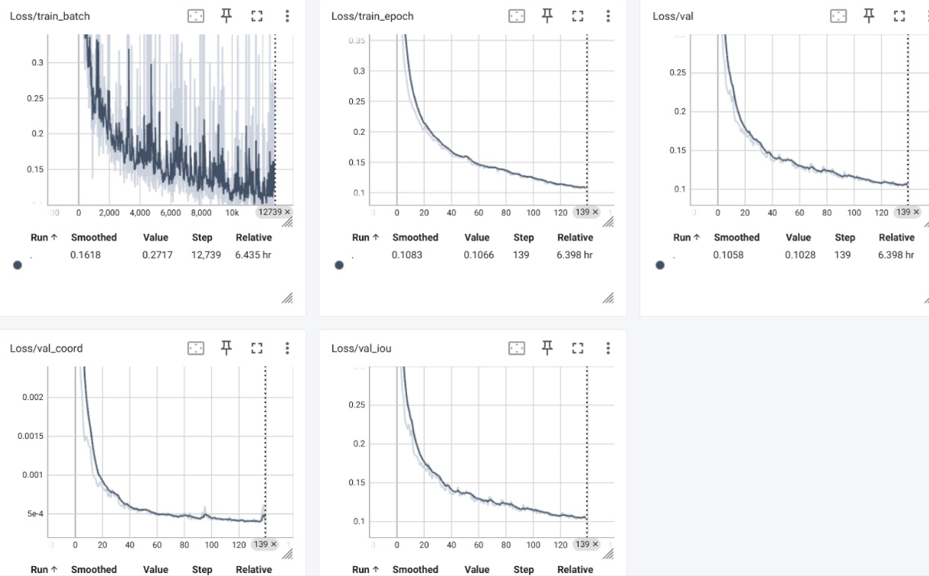Figure 2: TensorBoard Loss Curves demonstrating optimization through epoch 140.

3.1 Loss Curve Analytics
Observation of the telemetric data reveals key training behaviors:
- Generalization Capacity: The `Loss/val` trajectory mirrors the `Loss/train` loss vector with strong correlation through 140 epochs, ultimately yielding an optimal validation Intersection over Union (IoU) of 90.0%. The absence of upward divergence confirms that the applied dropout and weight-decay regularization strategies successfully mitigated overfitting.
- Localization versus Scaling Error: The `Loss/val_coord` (representing absolute center-point variance) decays to ~0.0004 virtually immediately, indicating the MobileNet backbone extracts focal localization with trivial difficulty. Conversely, `Loss/val_iou` reduces logarithmically over the full training cycle. This split proves the primary optimization challenge lies not in localizing the object center, but in precise scalar geometry estimation (object width and height resolution).

4. Zero-Shot Video Tracking and Inference

4.1 Static Evaluation
The architecture was evaluated across both the training distributions and validation set subsets to empirically confirm bounding box tightness and prediction confidence.

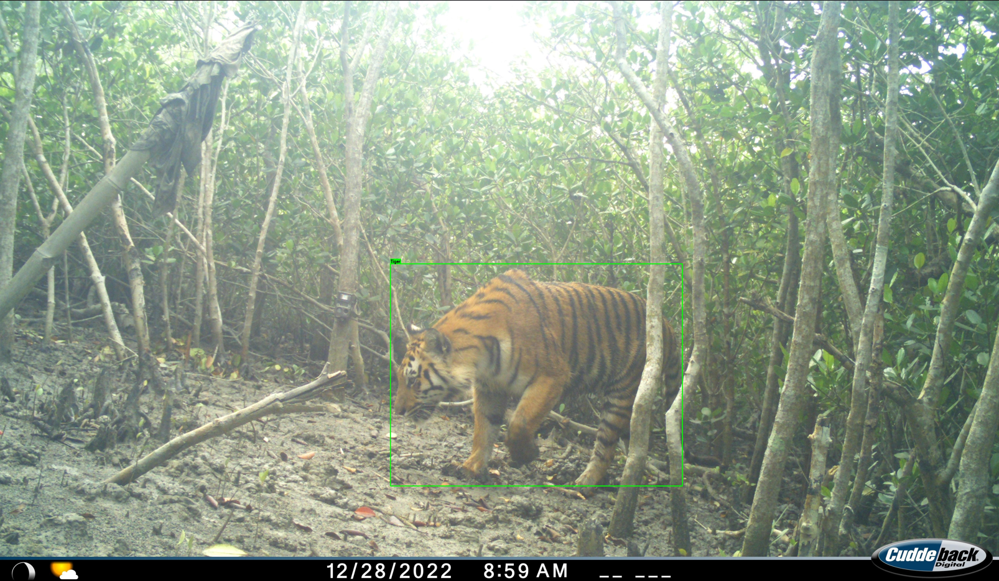
Figure 3: Static image inference demonstrating accurate bounding box geometry.

4.2 Tracking Pipeline Engineering
Applying a static-image object detection model natively across continuous video frames generates high-frequency bounding box temporal jitter. To stabilize inference on the external dataset sequence, a "Tracking-by-Detection" pipeline was implemented:
- Exponential Moving Average (EMA) Smoothing: A mathematical scalar momentum (alpha = 0.35) was embedded into the coordinate estimation loop:
Box_current = (alpha Box_predicted) + ((1 - alpha) Box_history)
This operation geometrically filters high-frequency frame-to-frame coordinate noise, yielding visually stabilized bounding tracking.
- Physics Plausibility Gating: Hard kinematic constraints were appended to reject anomalous model hallucinations induced by motion blur. If an absolute prediction exceeded standard physical frame-to-frame translation limits (Center delta > 50%) or impossible morphological shifts (Shape delta > 80%), the raw prediction was rejected.

4.3 Video Inference Limitations
During live sequence rendering over the continuous external video, the network sustained highly contiguous tracking, governed successfully by the EMA momentum logic. However, an empirical vulnerability materialized: when the target traversed terrain featuring a background statistically contiguous in local color spectra and structural shape (e.g., highly textured yellow/brown savannah scrub), performance degraded marginally. The semantic boundary distinguishing the foreground mass from the background eroded slightly across the limited 576-channel topology, causing temporary dimensional fluctuation before restabilizing in clearer contrast frames.

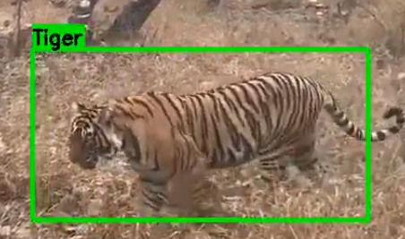
Figure 4: Zero-shot video inference demonstrating temporal EMA tracking.

5. Conclusion
The implementation of the MobileNetV3-Small framework, coupled with EIoU loss optimization and rigid data filtering operations, yielded a highly performant classification-to-detection transition achieving a 90% peak validation IoU. Empirical loss analytics confirmed that while spatial localization is computed rapidly by the backbone, bounding box scalar geometry governs the primary learning phase. Finally, encapsulating the stateless neural network within an EMA Plausibility tracking filter successfully resolved native inter-frame jitter, creating a robust, continuous video tracking system constrained only by foreground-background structural isomorphism scenarios.

Part 3: Multi-Class, Multi-Object Detection with Fixed Capacity

Links
- Input Video: input
- Output Video Inference: output

1. Dataset
To extend the detector from a single object to multiple objects and classes, we constructed a dataset using PASCAL VOC 2007 and 2012. PASCAL VOC is a widely used benchmark dataset for object detection and provides high-quality bounding box annotations across many object categories.
From the full dataset we selected three foreground classes: person, car, dog.
These classes were chosen for several reasons. First, they frequently appear together in natural scenes, making them suitable for multi-object detection experiments. Second, they represent objects with different visual characteristics and scales. For example, people tend to occupy large portions of the frame, while dogs are often smaller and more irregular in shape. Cars add another type of rigid object with strong geometric structure.
To comply with the project constraint of detecting at most three objects per image, the dataset was filtered so that each image contains between one and three instances of the selected classes. Images containing more than three target objects were removed to avoid supervision conflicts during training.
After filtering, the dataset statistics were approximately: person: 9,606 instances, car: 1,163 instances, dog: 1,054 instances.
This creates a significant class imbalance where the person class dominates the dataset. This imbalance influenced several later training decisions.
All images were resized to 448×448 resolution. This size preserves sufficient spatial detail for localization while remaining computationally manageable for training on the MobileNet backbone.
Image normalization followed the standard ImageNet statistics used by the pretrained backbone: mean = [0.485, 0.456, 0.406], std = [0.229, 0.224, 0.225].
Several data augmentations were applied during training to improve generalization:
- Random square crop with scale range 0.60–1.00
- Random horizontal flipping with correct bounding box mirroring
- Color jitter (brightness, contrast, saturation, hue)
- Occasional Gaussian blur
These augmentations simulate real-world variations such as lighting changes, object position changes, and camera noise while maintaining correct bounding box annotations.

2. Model Architecture Design
The model builds directly on the MobileNetV3-Small backbone selected in Part 1. The backbone is pretrained on ImageNet and provides efficient feature extraction with relatively low computational cost. The backbone produces a final feature map with 576 channels. Instead of directly predicting a single object as in Part 2, the network must now output multiple predictions per image.

2.1. Prediction Structure
The detector predicts a fixed number of K = 3 detection slots. Each slot produces a bounding box prediction (cx, cy, w, h) and a probability distribution over C + 1 classes (foreground classes + background).
The output tensor structure is therefore: Boxes: [B, K, 4] and Classes: [B, K, C].
Where: B = batch size, K = number of prediction slots, C = number of classes.
Each slot is intended to represent one object instance.

2.2 Spatial Feature Representation
A naive approach would apply global average pooling to the backbone features and feed the resulting vector into a multi-output head. However, this would give every slot identical information about the image, making it difficult for the network to distinguish different objects.
To address this, the model preserves spatial structure in the backbone feature map. A 1×1 convolution projection maps the backbone output from 576 channels to a hidden dimension of 512 while maintaining spatial resolution.
Each detection slot is represented by a learnable query vector. These queries attend to spatial locations of the feature map through a dot-product attention mechanism. As training progresses, different queries specialize to attend to different regions of the image. This allows each slot to extract a different spatial representation of the scene, enabling the model to localize multiple objects simultaneously.
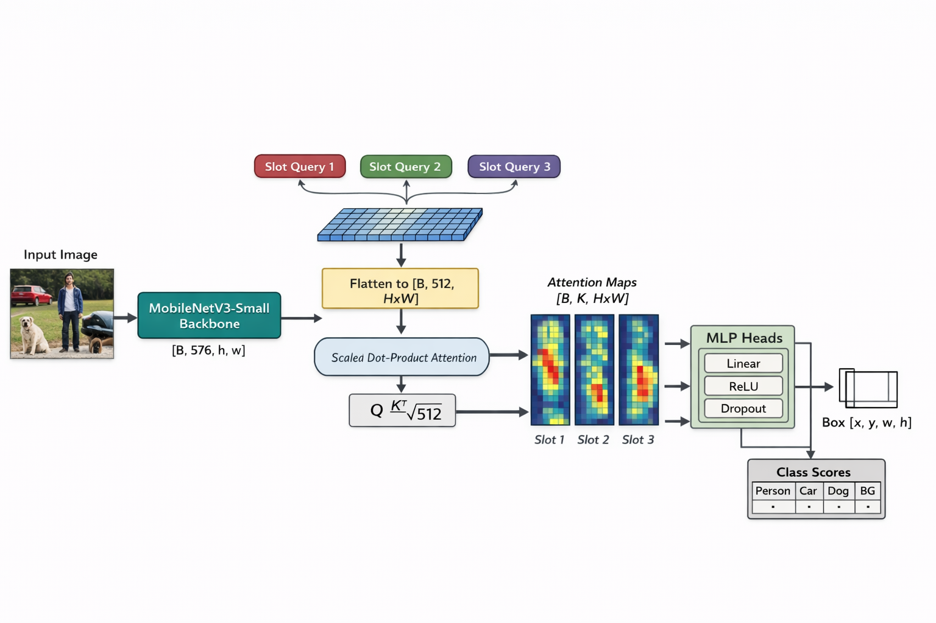

2.3 Assumptions
The architecture makes several simplifying assumptions:
- Maximum object count is known and fixed (K=3).
- Each slot predicts at most one object.
- Predictions are independent once their features are extracted.
These assumptions simplify the architecture and training procedure but introduce limitations.

2.4. Limitations
These assumptions simplify the architecture and training procedure but introduce limitations. The fixed-slot design means that the detector cannot represent more than three objects per image. Additionally, because slot queries are learned during training, there is a risk that multiple slots converge to similar spatial regions — a phenomenon known as slot collapse. This was observed in an initial baseline architecture that used Global Average Pooling (GAP) instead of spatial attention: all K slots received the same pooled feature vector, causing the model to consistently predict only the dominant class (person) even in images containing multiple object types. The spatial slot attention architecture was specifically designed to address this: by forcing each slot to attend to a different spatial region of the feature map, slots are naturally encouraged to specialize to different objects. In practice this resolved the collapse problem and enabled reliable multi-class co-detection.

3. Loss Function
Training a multi-object detector introduces an additional challenge: the network outputs unordered predictions, while the ground-truth objects have no inherent ordering. To solve this, predictions are matched to ground-truth boxes using Hungarian matching, which finds the optimal one-to-one assignment between predicted slots and ground-truth objects by minimizing a cost function. The matching cost combines classification cost (cross-entropy between predicted class probabilities and ground-truth labels) and bounding box cost (geometric distance between predicted and ground-truth boxes). Any slot not matched to an object is trained to predict the background class.
Bounding box regression uses Complete IoU (CIoU) loss, which penalizes bounding box overlap, center point distance, and aspect ratio differences simultaneously. CIoU provides more informative gradients than simple coordinate losses because it directly incorporates geometric relationships between boxes.
For classification, we experimented with standard cross-entropy as a baseline. However, given the severe class imbalance in the dataset (9,606 person instances vs. 1,054 dog instances), standard cross-entropy tends to overfit to the dominant class. We therefore adopted Focal Loss with γ=2.0 as the final classification loss. Focal loss down-weights the contribution of easy, frequently-seen examples and focuses gradient updates on hard or underrepresented ones. This directly benefited the car and dog classes, which improved by 13% and 4% respectively compared to training with standard cross-entropy.
The total training loss is a weighted sum:
Ltotal=Lcls+5Lbox
The higher weight on box regression encourages precise localization. These weights were fixed across all experiments.

4. Evaluation Metrics
The primary evaluation metric used for detection performance is Average Precision at IoU = 0.5 (mAP@0.5).
This metric evaluates how well predicted bounding boxes overlap with ground-truth objects while accounting for classification accuracy. Performance is computed separately for each class: person, car, dog.
The final metric reported is the mean Average Precision (mAP) across all classes.
{
"person": 0.47616235776408916,
"car": 0.2247396622201529,
"dog": 0.49338483227178337,
"mAP@0.5": 0.39809561741867516
}

In addition to final metrics, training and validation losses were monitored throughout training using TensorBoard. These curves help analyze learning dynamics, convergence behavior, and potential overfitting.
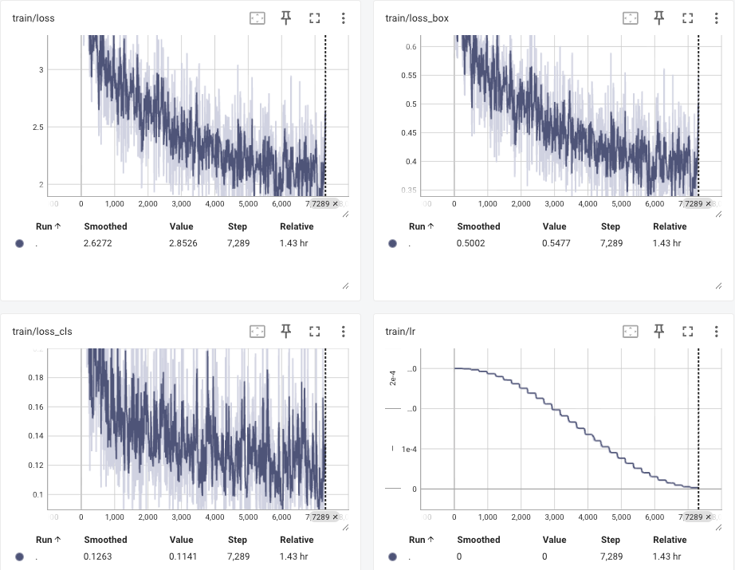
Figure 4: TensorBoard Training Loss Curves.
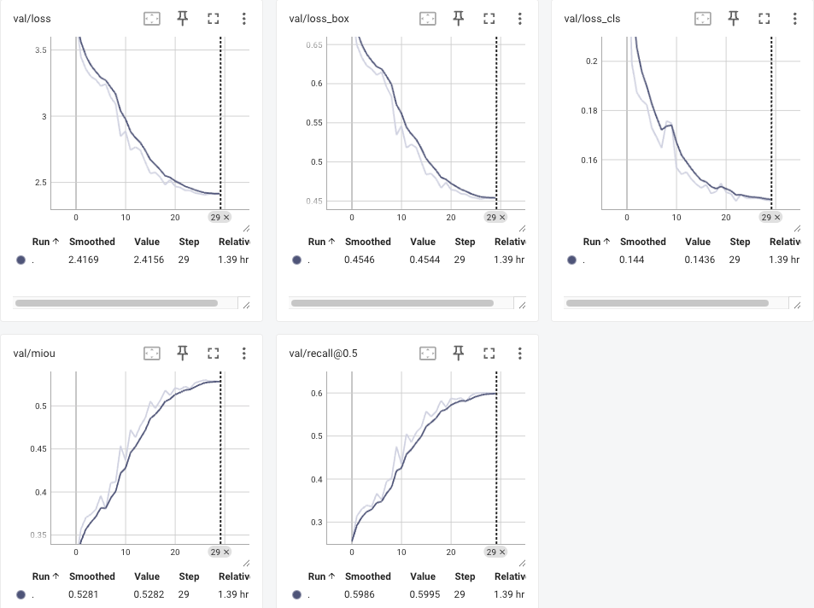
Figure 5: TensorBoard Validation Loss Curves.

5. Training and Validation Analysis
The model was trained using the following configuration: Optimizer: AdamW, Learning rate: 3×10⁻⁴, Weight decay: 1×10⁻⁴, Batch size: 32, Epochs: 30, Learning rate scheduler: Cosine Annealing.
Training behavior showed stable convergence for both classification and bounding box regression losses.
The person class was consistently learned fastest due to the large number of training samples. Detection performance for the car and dog classes improved more gradually, reflecting the smaller number of training examples available.
To address the class imbalance between person, car, and dog, we replaced standard cross-entropy with Focal Loss (γ=2.0). An earlier attempt using manual class weights [1.0, 2.0, 2.0, 0.1] hurt performance (mAP dropped from 0.376 to 0.259) because the low background weight reduced the penalty for false positives. Focal loss achieved the same goal implicitly without introducing this side effect, and became the final classification objective.
During validation, the model demonstrated the ability to detect multiple object classes in the same image, indicating that the slot-based architecture successfully separated different objects spatially.

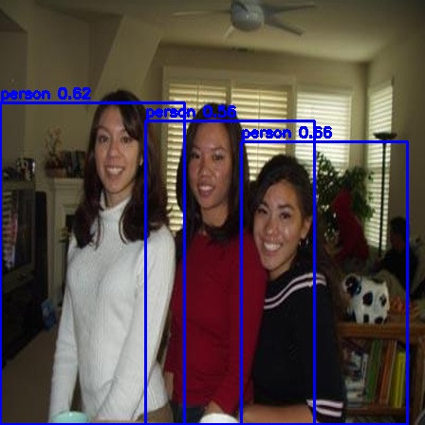 | 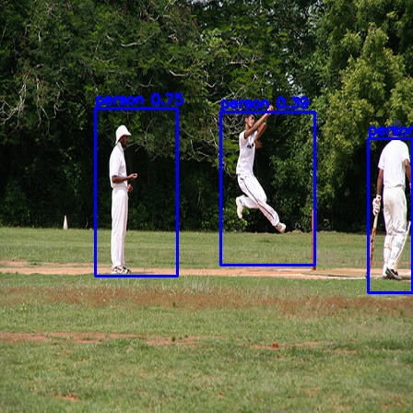 | 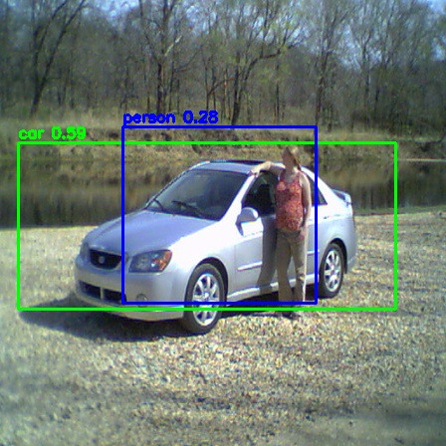
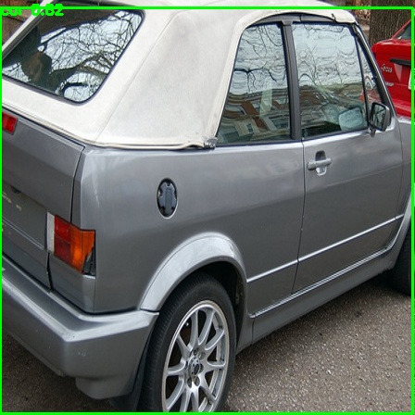 | 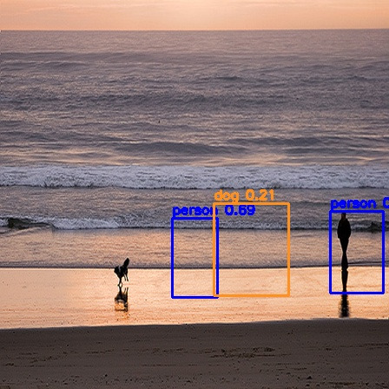 | 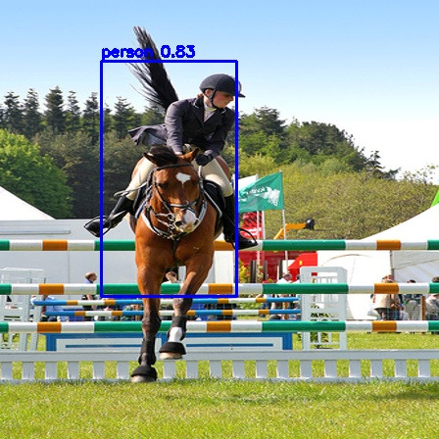
Figure 6: Validation Images
The validation images reveal clear patterns in the model's detection behavior. Person detection is consistently strong - bounding boxes are well-localized and the class is reliably identified across varying poses, scales, and occlusions. Car detection is also reasonably successful, with the model correctly identifying and localizing vehicles in most scenes, though confidence scores tend to be lower than for person due to the smaller number of training examples. Dog detection is the weakest of the three classes. While dogs are sometimes detected when they occupy a large portion of the frame, the model frequently misses smaller or partially visible dogs entirely. This reflects both the limited number of dog training instances (1,054) and the inherent difficulty of the class - dogs vary greatly in breed, size, color, and pose, making generalization harder than for the more visually consistent person and car classes.

6. Video Analysis
To evaluate the detector beyond static images, we ran inference on an external video containing multiple object classes across varied scenes. The goal was to assess real-world behavior: moving objects, changing scale, and simultaneous multi-class co-detection.
Person detection was the most reliable, with stable bounding boxes maintained across motion and pose changes. This aligns with the strong class representation in training (9,606 instances) and suggests the model has learned robust features for human shape and posture.
Dog detection was strongly scale-dependent. When the dog occupied a substantial portion of the frame, the model produced correct classifications and well-localized boxes. At greater distances, the detector frequently failed - a direct consequence of MobileNetV3-Small's limited feature map resolution, which provides little signal for small objects. This matches the quantitative results (AP=0.493 for dog despite relatively few training instances), suggesting the model can detect dogs well when they are visible, but not when they are small.
Car detection was generally successful but showed occasional grouping errors in dense scenes: when two cars appeared close together, the model sometimes predicted a single box spanning both rather than two separate detections. This reflects the tension between the fixed-slot count (K=3) and the model's inability to spatially separate nearby objects at low feature resolution.

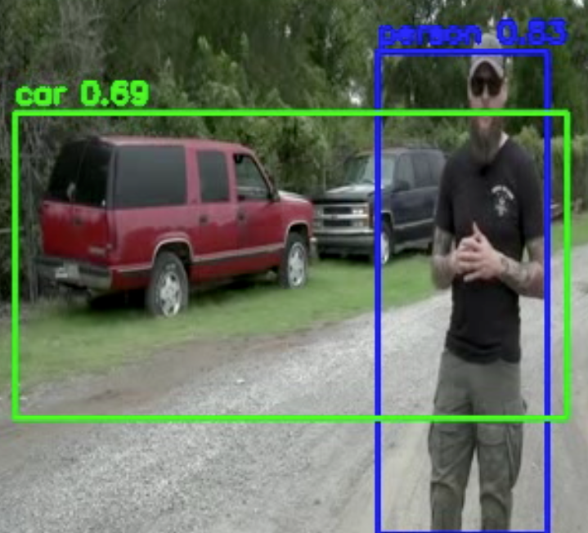 | 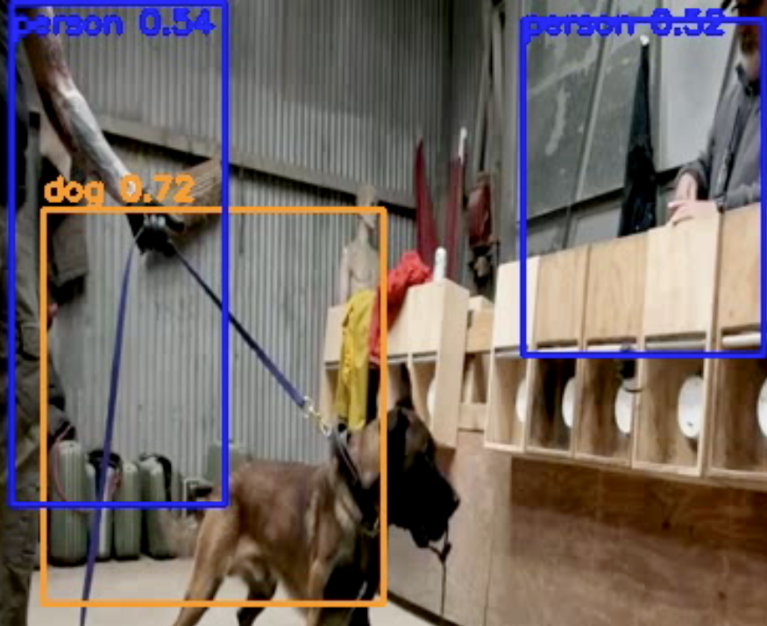
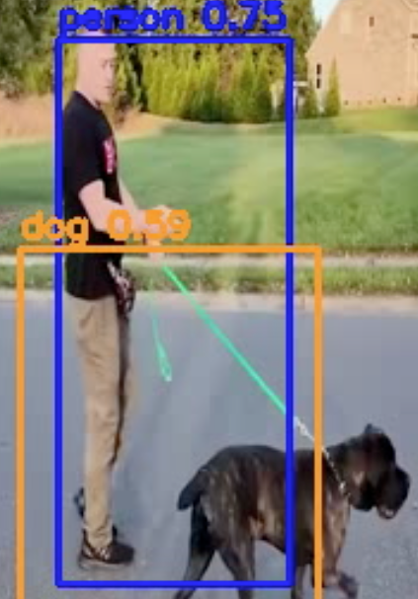 | 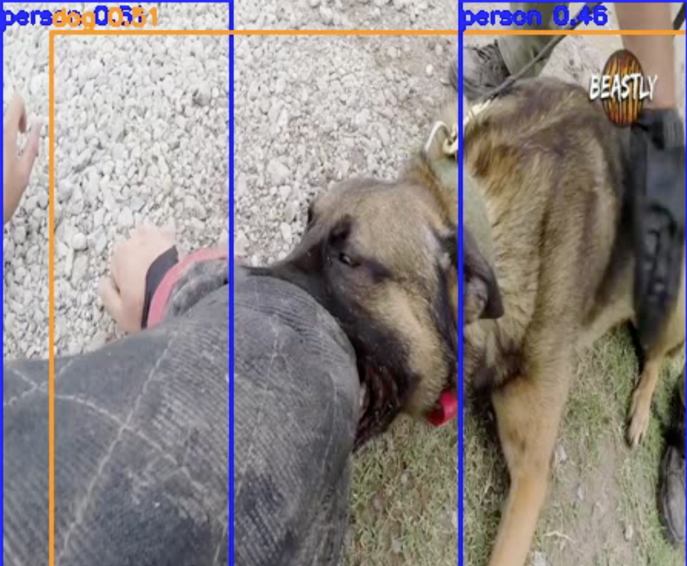

Multi-class co-detection worked as expected: in scenes with a person and a dog, both were often detected simultaneously, confirming that the per-slot spatial attention head is correctly decoupling slot assignments. However, the dog box was consistently less precise than the person box, and was lost entirely as the dog moved farther from the camera.
These observations are consistent with the model's architectural constraints: spatial attention enables multi-class co-detection, but the backbone's spatial resolution and the fixed slot count remain the primary bottlenecks for small-object detection and crowded scenes.

