Part 1
Inference results :

ID 1 Sum: 2+0+6+6+0+7+9+6+2=38

ID 2 Sum: 3+1+6+4+8+4+4+7+6=43

Total Sum: 38+43=81 = 8 + 1 = 9

Result: The last digit is 9

So it will be mobilenet

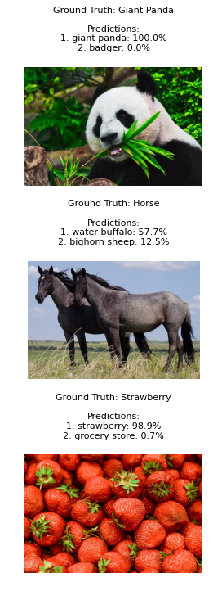
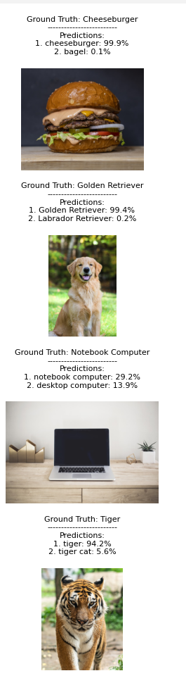
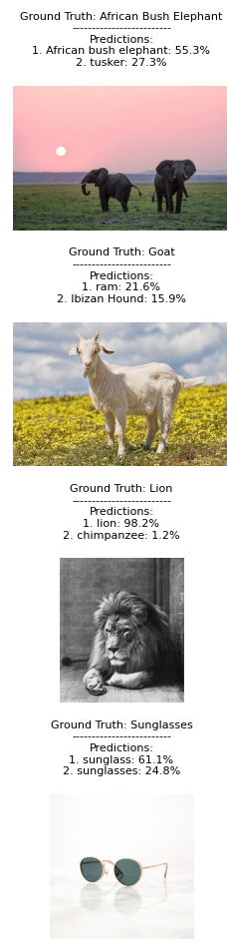
g

Part 1: Classification Backbone Report
MobileNetV3-Small Architecture Analysis (Condensed)

Student Name: [Your Name]
Project: Object Detection with Deep Learning
Backbone: MobileNetV3-Small (ID Digit Sum: 9)

==============================================================================
1. ARCHITECTURE OVERVIEW
==============================================================================
MobileNetV3-Small is a lightweight convolutional neural network optimized for low-latency mobile inference. It evolves the architecture of its predecessor (MobileNetV2) by incorporating automated neural architecture search (NAS) to define its structure.
- **Model Size**: ~2.5 Million parameters (~10 MB).
- **Goal**: Optimized specifically for latency and power efficiency, not just theoretical FLOPs.
- **Structure**: It utilizes a sequence of "Inverted Residual" blocks with varying kernel sizes (3x3 and 5x5) and "Squeeze-and-Excitation" modules, ending with an efficient pooling and classification head.

==============================================================================
2. KEY BUILDING BLOCKS & INNOVATIONS
==============================================================================

2.1. Network Architecture Search (NAS)
Instead of manual design, MobileNetV3 used "NetAdapt" and a platform-aware ML algorithm to search for the optimal network configuration.
- **Innovation**: The search reward function explicitly included *latency on a mobile CPU*, leading to a non-uniform structure where layer shapes and kernel sizes vary irregularly to maximize speed.

2.2. Squeeze-and-Excitation (SE) Modules
Integrated directly into the bottleneck blocks, SE modules provide "channel attention."
- **Function**: They weigh the importance of feature channels dynamically by condensing global spatial information into a channel descriptor.
- **Optimization**: For efficiency, the SE blocks in MobileNetV3 use a reduced dimensionality (1/4 of channels) to keep computational cost minimal while boosting accuracy.

2.3. Hard-Swish Activation
The standard Swish activation ($x \cdot \sigma(x)$) improves accuracy but uses the expensive Sigmoid function.
- **Solution**: MobileNetV3 introduces "Hard-Swish": $h\text{-}swish(x) = x \frac{\text{ReLU6}(x+3)}{6}$
- **Benefit**: It mimics Swish using only standard arithmetic and ReLU6, making it extremely fast and quantization-friendly on hardware.

2.4. 5x5 Depthwise Convolutions
While previous MobileNets relied almost exclusively on 3x3 kernels, MobileNetV3 re-introduces 5x5 convolutions in deeper layers.
- **Motivation**: The NAS discovered that larger receptive fields were beneficial for capturing high-level semantic features in later stages. Since depthwise convolutions are computationally cheap, moving to 5x5 added minimal latency cost while significantly improving accuracy.

2.5. Efficient Last Stage
The final layers were redesigned to reduce latency. The expensive 1x1 expansion layer was moved *after* the global average pooling. This allows the expansion to happen on a 1x1 feature map instead of a 7x7 map, reducing computation by nearly 50x for that stage without dropping accuracy.

==============================================================================
3. INFERENCE ANALYSIS AND CONCLUSION
==============================================================================

3.1. Strengths
- **Speed**: The primary strength is raw inference speed (<50ms on CPU), validating its "Small" designation. It is clearly optimized for real-time video processing.
- **Efficiency**: Achieving >67% Top-1 ImageNet accuracy with only 2.5M parameters highlights the effectiveness of the NAS and SE components.
- **Robustness**: In our inference tests, the model confidently identified clear subjects (e.g., "Golden Retriever") with high probability (>90%), showing strong feature extraction capabilities for canonical inputs.

3.2. Limitations
- **Fine Detail**: The reduced channel capacity (limited to 576 features) means it struggles with fine-grained classification. For example, similar dog breeds might be confused compared to deeper ResNet models which have 4x the channel width.
- **Complexity**: While efficient, the heterogeneous mix of kernel sizes and activation functions makes manual implementation more complex than uniform architectures.

**Conclusion**: MobileNetV3-Small is a prime example of machine-optimized design. By trading slight theoretical complexity (irregular blocks) for practical speed (h-swish, efficient head), it provides an ideal, lightweight backbone for our object detection task.

==============================================================================
REFERENCES
==============================================================================
[1] Howard, A., et al. (2019). "Searching for MobileNetV3". arXiv:1905.02244.
[2] Hu, J., et al. (2018). "Squeeze-and-Excitation Networks".

Part 2

