**7. Conduct other analysis (Bonus 5 points per analysis, maximum of 15 points):**

1. **Map out the chocolate rating geographically on a map**

In order to produce this map, several Python packages had to be installed using pip. As some of the team did not have these libraries as they were not part of the standard Anaconda install, and we were not certain they would be able to be seen after submission, we have included the images in the appendix and the code at the end of the code file because it is likely to give errors if those packages are not installed.

Company_Locations were converted to ISO country codes through cleaning and the pycountry package.

Then geopy, pycountry-convert and folium were installed.

pycountry-convert was used to change the country name into a continent for feature engineering

Geopy was used with Nominatim to fetch the latitutude and longitude of the country based on its ISO country name.

Folium was used to plot the longitude and latitude on a map

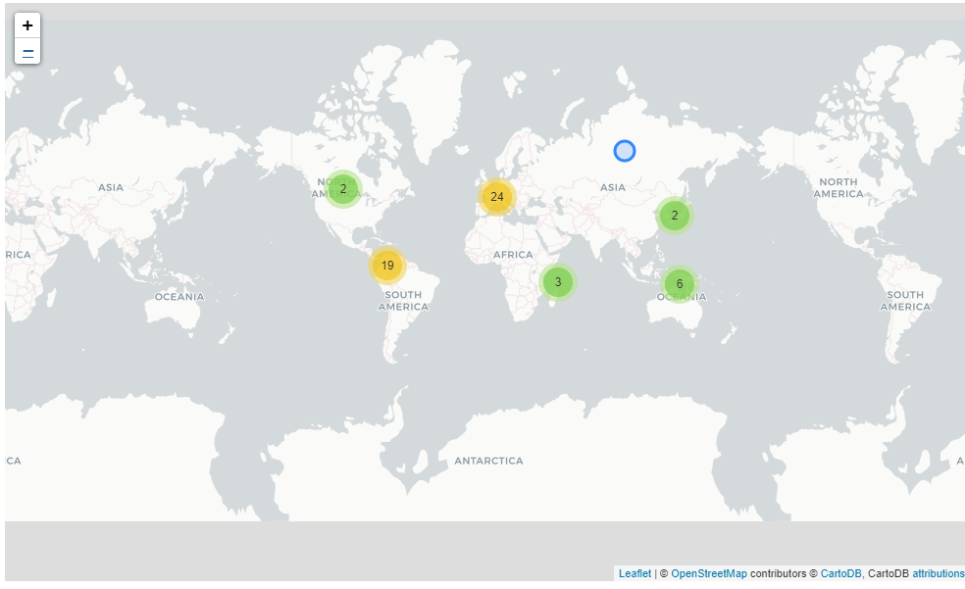

Zooming in

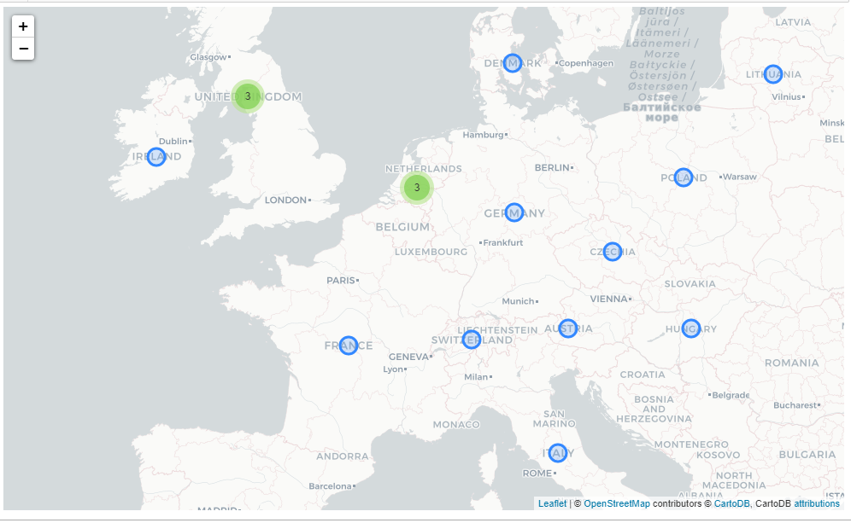

Clicking on the country’s circle reveals the average rating for that country

